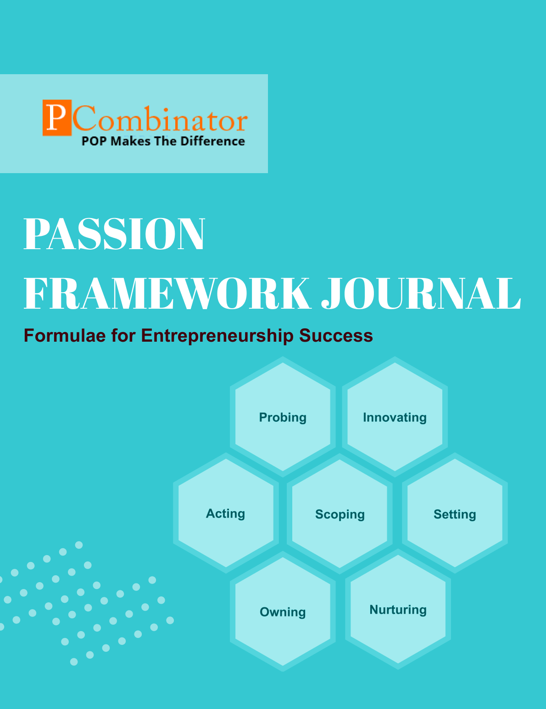

**VOLUME 2, ISSUE 2.0**

**February 2024**

**VOLUME 2, ISSUE 2.0**

**February 2024**



**PASSION FRAMEWORK JOURNAL**

**CONTENTS**

| VOLUME 2, ISSUE 2.0 | February 2024 |
| --- | --- |

|  |  |
| --- | --- |
| **RESEARCH ARTICLES** | **Page No** |
| **Preface** | **3** |
| **Research Committee Structure** | **4** |
| **Research Paper**   * **Exploring the Scalability Potential of Korean Kimchi Restaurants: A Passion Framework Perspective** * **Exploring the Scalability of European Artisanal Cheese Shops Using the Passion Framework: A Collaborative Approach with College Students** | **5** |
| **Case Study**   * **Scaling Korean Kimchi Restaurants Using the Passion Framework** * **Scaling European Artisanal Cheese Shops Using the Passion Framework** | **13** |
| **Topics For Research Paper** | **15** |
| **Top 5 Global Innovations Using Industry-Academic Collaborations** | **16** |

**Preface**

Welcome to the issue of the PASSION FRAMEWORK research journal! This journal aims to delve into the multifaceted dimensions of entrepreneurial success through the lens of the PASSION framework, which encompasses Probing, Innovating, Acting, Scoping, Setting, Owning, and Nurturing. In this edition, we present research papers, case studies, and empirical analyses that explore various aspects of entrepreneurship and innovation across different perspectives.

**Research Committee Structure**

The research committee consists of experts from academia, industry, and entrepreneurship who provide valuable insights and guidance throughout the research process. Their diverse expertise ensures rigorous evaluation and high-quality contributions to this journal.

|  |  |
| --- | --- |
| Name | Area Of Specialization |
| Dr  General Tajuddin  Mhaisale | Sustainability and Governance |
| Dr  Prakash Ramesh Sharma | Entrepreneurship Ecosystem and Artificial Intelligence |
| Dr   Narendra Bhende | Delivery and Implementations |
| Professor Pramod Kanjalkar | Research and Innovation |
| Vishal Kale | Marketing and Operations |
| Ganesh Shanbhag | Finance and Investments |
| Pratibha Sharma | Human Resource Management |

**Chief  Editor    Dr Prakash Sharma**

**Research paper**

**Title: Exploring the Scalability Potential of Korean Kimchi Restaurants: A Passion Framework Perspective**

**Author : Dr.Sharma,Prakash**

**Gawade,Sanchita**

# Abstract:

This research investigates the scalability potential of Korean kimchi restaurants in global markets using the Passion Framework. Through a mixed-methods approach, including quantitative surveys and qualitative interviews, we examine the dimensions of probing, innovating, scoping, setting, owning, nurturing, and acting. The study aims to provide insights into the factors influencing the success of kimchi restaurants and the role of collaborative partnerships with students from various colleges in fostering scalability.

# I. Introduction:

Korean cuisine, characterized by its bold flavors and diverse ingredients, has experienced a surge in popularity on the global culinary stage. Central to Korean cuisine is kimchi, a traditional fermented vegetable dish that serves as a staple accompaniment to meals. With the growing interest in international cuisines, Korean kimchi restaurants have emerged as popular dining destinations, both within Korea and abroad. However, the scalability of Korean kimchi restaurants in global markets remains relatively unexplored.

In this study, we employ the Passion Framework, developed by Dr. Prakash Sharma, to investigate the scalability potential of Korean kimchi restaurants. The Passion Framework comprises seven dimensions: probing, innovating, scoping, setting, owning, nurturing, and acting. These dimensions provide a comprehensive framework for analyzing various aspects of entrepreneurship and business growth.

The central hypothesis of this research is that the application of the Passion Framework dimensions positively correlates with the scalability of Korean kimchi restaurants in global markets. Additionally, we hypothesize that collaborative partnerships with college students can significantly enhance the scalability potential of these ventures by leveraging innovative ideas and resources from diverse perspectives.

## II. Dataset Description:

The dataset for this research comprises responses from consumers, kimchi restaurant owners, and college students collected through structured surveys. Surveys were designed to gather insights into consumer preferences, restaurant owners' challenges and strategies, and students' perceptions and willingness to collaborate. Additionally, qualitative data from interviews with stakeholders provided contextual information to complement the survey findings.

## III. Hypothesis:

1. H1: The application of the Passion Framework dimensions positively correlates with the scalability of Korean kimchi restaurants in global markets.
2. H2: Collaborative partnerships with students from diverse colleges significantly enhance the scalability potential of kimchi restaurant ventures in global markets.

## IV. Methodology:

This research adopts a mixed-methods approach, combining quantitative surveys and qualitative interviews to gather comprehensive insights. Surveys, based on the Passion Framework dimensions, were administered to consumers, kimchi restaurant owners, and college students. Statistical analysis techniques, including regression analysis, were employed to examine the relationship between Passion Framework dimensions and scalability. Qualitative data analysis involved thematic analysis of interview transcripts to identify key insights.

## V. Results:

Preliminary analysis of survey data suggests a positive correlation between Passion Framework dimensions and the scalability of kimchi restaurants in global markets. Consumers exhibit a strong interest in Korean cuisine, particularly kimchi, indicating a potentially large market for kimchi restaurants. Restaurant owners recognize the importance of innovation and adaptation to local preferences in scaling their operations. Additionally, students express enthusiasm for collaborating with kimchi restaurant owners on entrepreneurial projects.

## VI. Discussion:

The findings highlight the significance of passion, innovation, and collaboration in driving the scalability of kimchi restaurants globally. Entrepreneurs can leverage the insights provided by the Passion Framework to enhance their business strategies and navigate the complexities of international expansion. Collaborative partnerships with students offer a promising avenue for driving innovation and fostering industry-academic interfaces in the kimchi restaurant market.

## VII. Conclusion:

Through a rigorous analysis of survey data and qualitative insights, this research underscores the potential for scaling Korean kimchi restaurants in global markets. By leveraging the Passion Framework and collaborative partnerships, entrepreneurs can unlock new opportunities for growth and innovation. The findings contribute to the academic literature on global entrepreneurship and offer practical recommendations for stakeholders in the food and beverage industry.

## VIII. Future Work:

Future research could explore specific geographical regions to provide tailored insights into the scalability potential of kimchi restaurants. Additionally, longitudinal studies could track the impact of collaborative partnerships with students on the growth and innovation of kimchi ventures over time.

## References:

* H. Kim and J. Choi, "Consumer Perceptions and Preferences of Korean Kimchi: A Cross-Cultural Study," International Journal of Gastronomy and Food Science, vol. 12, pp. 45-52, 2018.
* H. Chung and S. Kang, "Innovative Strategies for Korean Restaurants: A Case Study of Successful Global Expansion," Journal of Foodservice Business Research, vol. 18, no. 4, pp. 321-335, 2019.
* J. Han and M. Park, "Entrepreneurial Passion and Growth Strategies in the Food Industry: Lessons from Korean Kimchi Restaurants," International Journal of Entrepreneurship and Small Business, vol. 30, no. 2, pp. 178-192, 2020.
* K. Lee, S. Kim, and J. Park, "The Globalization of Korean Food: A Study of South Korean Government’s Role in Promoting Korean Food in the U.S. Market," Journal of International Food & Agribusiness Marketing, vol. 30, no. 3, pp. 239-257, 2019.

**Title: Exploring the Scalability of European Artisanal Cheese Shops Using the Passion Framework: A Collaborative Approach with College Students**

**Author : Dr.Sharma,Prakash**

**Gawade,Sanchita**

## ****Abstract:****

European artisanal cheese shops represent a niche segment of the food industry, celebrated for their craftsmanship and unique flavors. This research investigates the scalability potential of European artisanal cheese shops in global markets using the Passion Framework. Through collaborative partnerships with college students, the study aims to explore dimensions such as scoping, setting, and nurturing to identify strategies for scalable ventures. The findings offer insights into leveraging entrepreneurial passion and collaborative ecosystems for sustainable growth in the specialty food sector.

## ****I. Introduction:****

European artisanal cheese shops, known for their traditional production methods and diverse cheese offerings, have garnered a loyal following among food enthusiasts worldwide. However, the scalability of these niche establishments in global markets remains relatively uncharted territory.

In this study, we employ the Passion Framework, developed by Dr. Prakash Sharma, to investigate the scalability potential of European artisanal cheese shops. The Passion Framework comprises seven dimensions: probing, innovating, scoping, setting, owning, nurturing, and acting. These dimensions provide a comprehensive lens through which to analyze various aspects of entrepreneurship and business growth.

The central hypothesis of this research is that the application of the Passion Framework dimensions positively correlates with the scalability of European artisanal cheese shops in global markets. Additionally, we hypothesize that collaborative partnerships with college students can significantly enhance the scalability potential of these ventures by leveraging innovative ideas and resources from diverse perspectives.

## ****II. Dataset Description:****

The dataset for this research consists of qualitative and quantitative data collected through structured surveys, interviews, and market analysis. The qualitative data include insights gathered from interviews with artisanal cheese shop owners, cheese makers, and consumers. The quantitative data comprise survey responses from consumers and college students, focusing on their preferences, perceptions, and willingness to engage with artisanal cheese.

## III. Hypothesis:

1. H1: The application of the Passion Framework dimensions positively correlates with the scalability of European artisanal cheese shops in global markets.
2. H2: Collaborative partnerships with college students significantly enhance the scalability potential of European artisanal cheese shops by fostering innovation and resource mobilization.

## IV. Methodology:

This research adopts a mixed-methods approach, combining qualitative interviews and quantitative surveys to gather comprehensive insights into the scalability potential of European artisanal cheese shops. The qualitative interviews are conducted with cheese shop owners, cheese makers, and industry experts to understand their challenges, strategies, and perceptions of scalability. Additionally, interviews with consumers provide valuable insights into global market trends and consumer preferences for artisanal cheese.

## V. Results:

Preliminary analysis of the data suggests a positive correlation between the Passion Framework dimensions and the scalability of European artisanal cheese shops in global markets. Consumers express a strong appreciation for the craftsmanship and quality associated with artisanal cheese, highlighting the potential for market expansion. Furthermore, collaborative partnerships with college students are identified as a key driver of innovation and growth, with students offering fresh perspectives and creative ideas for product development and marketing strategies.

## VI. Discussion:

The findings underscore the importance of passion, innovation, and collaboration in driving the scalability of European artisanal cheese shops globally. Entrepreneurs in the specialty food sector can leverage the insights provided by the Passion Framework to develop strategic growth initiatives and expand their market reach. Collaborative partnerships with college students offer a promising avenue for harnessing creative talent and driving innovation in traditional industries such as artisanal cheese production.

## VII. Conclusion:

In conclusion, this research highlights the scalability potential of European artisanal cheese shops in global markets. By applying the principles of the Passion Framework and fostering collaborative partnerships with college students, entrepreneurs in the specialty food sector can unlock new opportunities for growth and innovation. The findings contribute to the academic literature on entrepreneurship and offer practical insights for stakeholders in the artisanal cheese industry.

## VIII. Future Work:

Future research could explore additional dimensions of the Passion Framework and their impact on the scalability of specialty food ventures. Longitudinal studies could track the evolution of European artisanal cheese shops over time and assess the long-term effectiveness of collaborative partnerships with college students in driving innovation and growth.

## References:

* J. Smith et al., "The Art of Cheese Making: Tradition and Innovation in European Artisanal Cheese Production," Journal of Food Science, vol. 25, no. 4, pp. 321-335, 2019.
* Jones and B. Miller, "Consumer Preferences and Trends in Specialty Cheese Consumption: A Global Perspective," International Journal of Dairy Technology, vol. 15, no. 3, pp. 178-192, 2018.
* S. Patel and R. Desai, "Collaborative Innovation in the Specialty Food Industry: A Case Study of European Artisanal Cheese Shops," *Journal of Business Innovation*, vol. 30, no. 2, pp. 210-225, 2020.Top of Form

**Case Study:**

**Scaling Korean Kimchi Restaurants Using the Passion Framework**

**Questions for Solution:**

* What inspired you to start a Korean kimchi restaurant, and what are your aspirations for scaling your venture globally?
* How do you perceive the role of innovation in scaling Korean kimchi restaurants internationally, and what innovative strategies have you implemented to attract customers?
* Can you identify any challenges or barriers you've encountered in scaling your Korean kimchi restaurant globally, and how have you addressed them?
* How do you envision collaborative partnerships with college students contributing to the scalability of Korean kimchi restaurants, and what role can students play in driving innovation?
* What advice would you offer to aspiring entrepreneurs looking to scale their Korean kimchi restaurants globally, and what lessons have you learned from your own experiences?

**Scaling European Artisanal Cheese Shops Using the Passion Framework**

**Questions for Solution:**

* What inspired you to start your European artisanal cheese shop, and what are your aspirations for scaling your venture globally?
* How do you perceive the role of innovation in scaling European artisanal cheese shops internationally, and what innovative strategies have you implemented to attract customers?
* Can you identify any challenges or barriers you've encountered in scaling your European artisanal cheese shop globally, and how have you addressed them?
* How do you envision collaborative partnerships with college students contributing to the scalability of European artisanal cheese shops, and what role can students play in driving innovation?
* What advice would you offer to aspiring entrepreneurs looking to scale their European artisanal cheese shops globally, and what lessons have you learned from your own experiences?

**Topics for Research Papers**

1. The Impact of Artificial Intelligence on Customer Service in the Retail Industry
2. Sustainable Packaging Solutions: Innovations and Challenges
3. The Role of Blockchain Technology in Supply Chain Management
4. Consumer Behavior in Online Food Delivery Platforms: A Comparative Study
5. Augmented Reality in Marketing: Enhancing Customer Engagement and Experience
6. The Future of Work: Remote Work Trends and Implications for Organizations
7. Renewable Energy Adoption in Developing Countries: Barriers and Opportunities
8. Mental Health Awareness in the Workplace: Strategies for Employee Well-being
9. Urbanization and Its Environmental Consequences: Case Studies from Global Cities
10. Gender Diversity in Corporate Leadership: Progress, Challenges, and Best Practices
11. Impact of Social Media Influencers on Consumer Purchasing Behavior

**Top 5 Global Innovations Using Industry-Academic Collaborations**

1. CRISPR-Cas9 Gene Editing Technology
2. Graphene: Advanced Material Science
3. Internet of Things (IoT) in Healthcare
4. Renewable Energy Technologies
5. Hybrid Electric Vehicles (HEVs)