1. **Create Python Django Web Application**
   1. **Setting up the Development Environment in VS code**

  Create a new directory for your project to live in, and cd into it

* **Create Directory Django_Project**
* **cd Django_Project**

Creating a virtual environment to manage dependencies.

* **python –m venv venv**

Activating the virtual environment

* **.\venv\Scripts\activate**

Installing Django

* **(venv) $ python -m pip install Django**

Creating the project

* **(venv) $ django-admin startproject personal_portfolio**

Starting the Django development server

* **(venv) $ python manage.py runserver**

Go to <http://localhost:8000> and check if localhost is working.

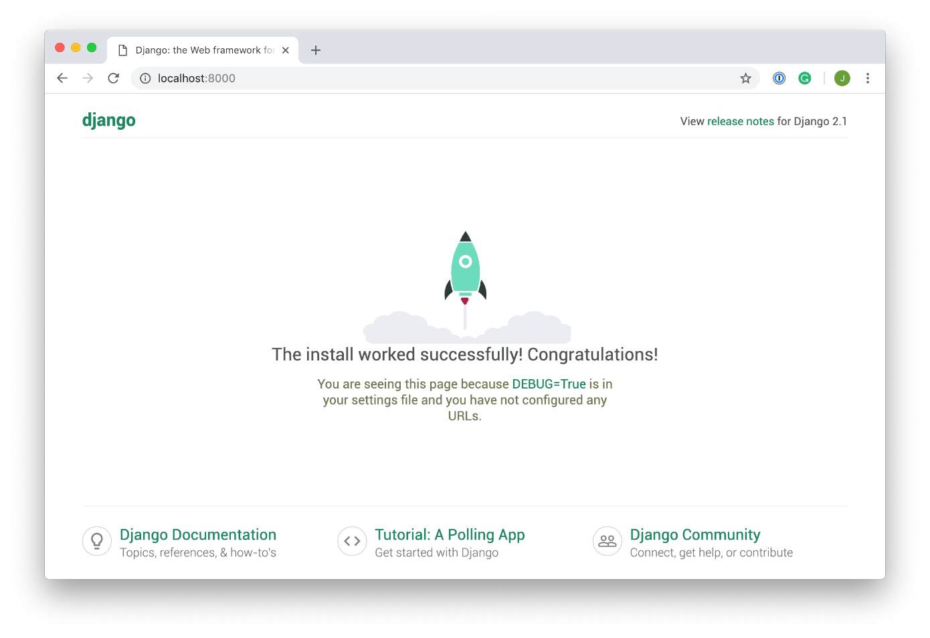

**Added the Pages App** which will contain a basic welcome for my site.

* **(venv) $ python manage.py startapp pages**

**Added the code below in settings.py**

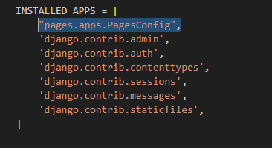

**Navigating to the views.py file in the pages/directory and add the code below**

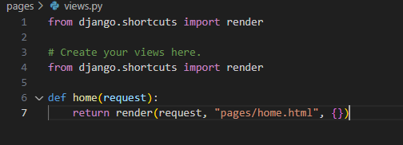

Created the template/directory, a subdirectory named pages/ and created a file named home.html inside it

**Added the following html code**

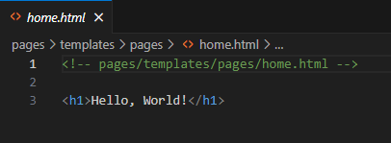

**Creating a new route**

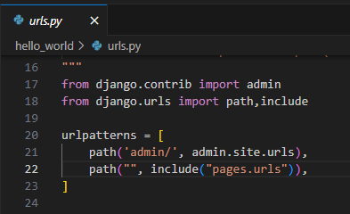

**Including the route**

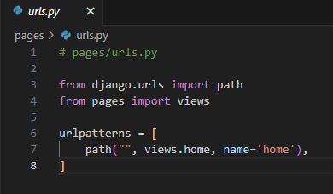

**Restarting the server**

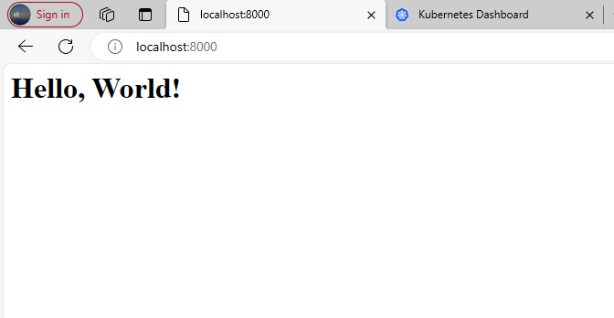

1. **Containerize Python Django Web Application**

**Setting up Docker**

* **Creating the docker image**

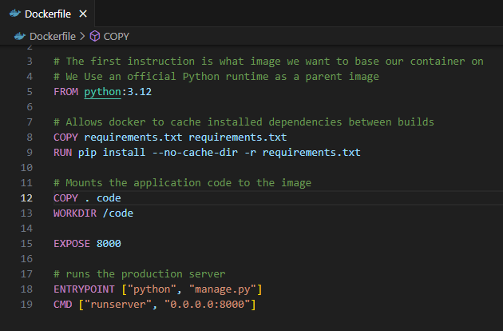

**Now we will build the docker using build command.**

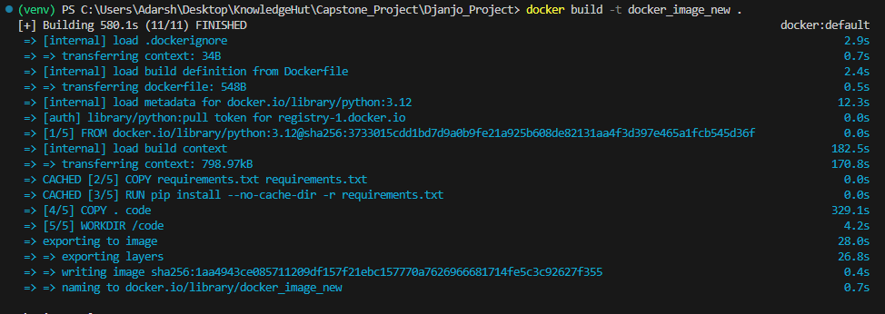

**Now we will run the container**

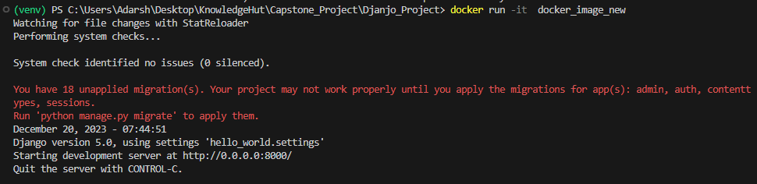

**Now checking the server.**



**Pushing the image to DockerHub**

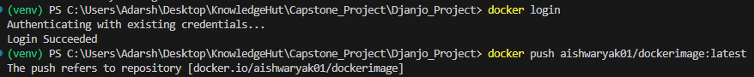

**Image pushed to DockerHub**

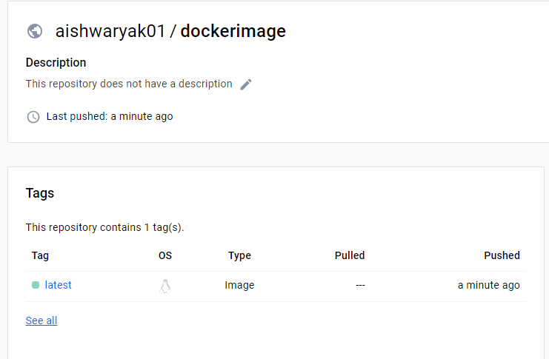

1. **Set Up Minikube Kubernetes Cluster**

**Minicube successfully installed**

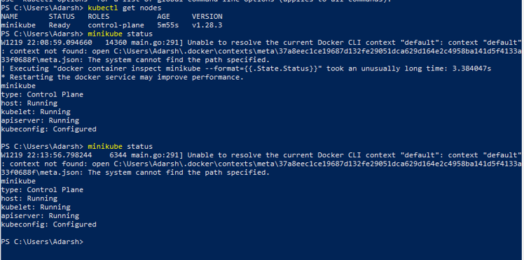

1. **Deploy Python Django Web Application on Minikube Kubernetes**

**Created a directory called Kubernetes and added two yml files in it.**

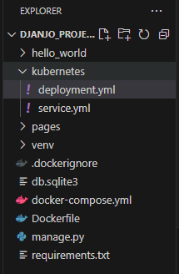

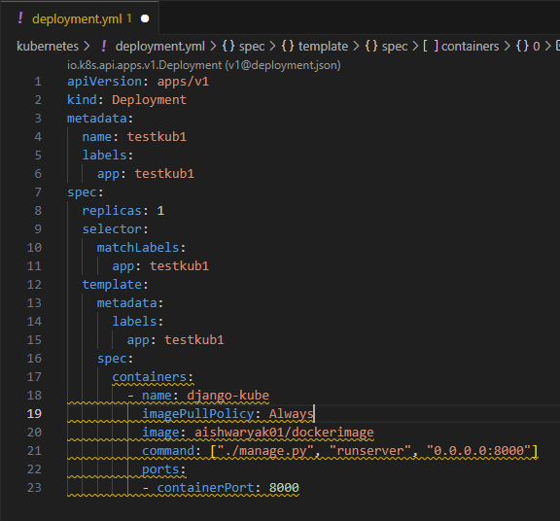

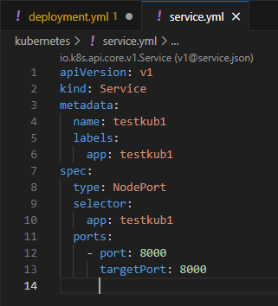

* A deployment config tells how to deploy our main backend app.This deployed app is not accessible by default. So to make them accessible, we should define service config file that can tell how to access the backend deployment.

**Using kubectl to push deployment and Services**



**Deploying the service**



**Command to check the pods**

