Assignment – 3

Problem Statement:
You have already seen how to retrieve user profiles in the previous exercise.

Now, some users want to update their profiles to include the following details.

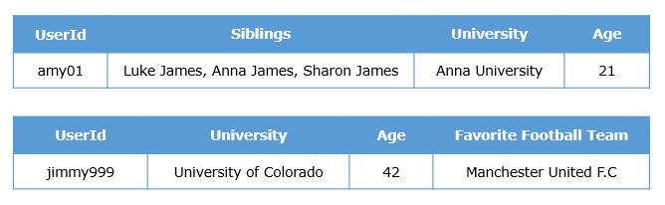

Perform the update operations using appropriate operators, if required.

Expected Output:
When you run the find() command on this collection, you should be able to see the user profiles containing all the new details.

