ESG COMPILED WORK

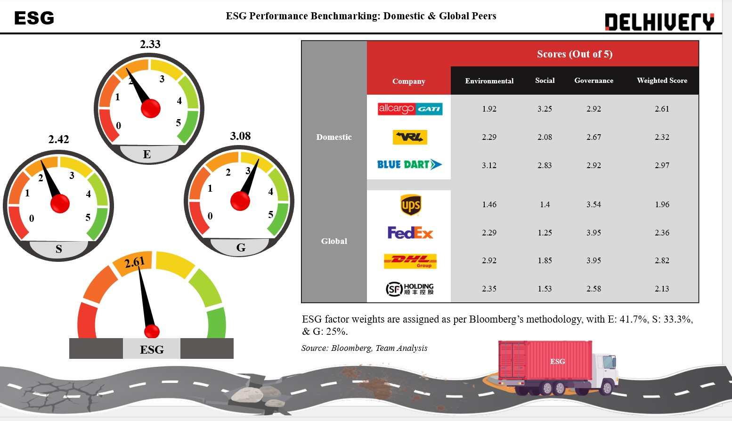
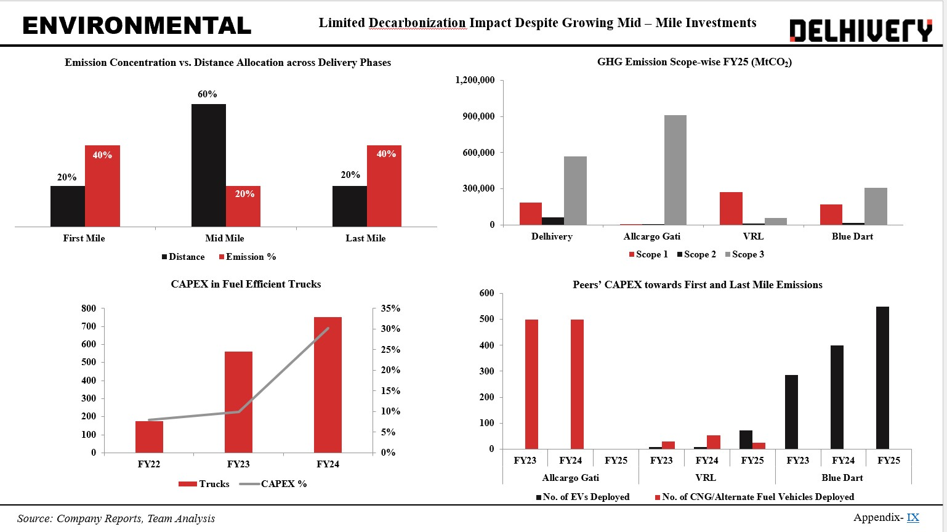

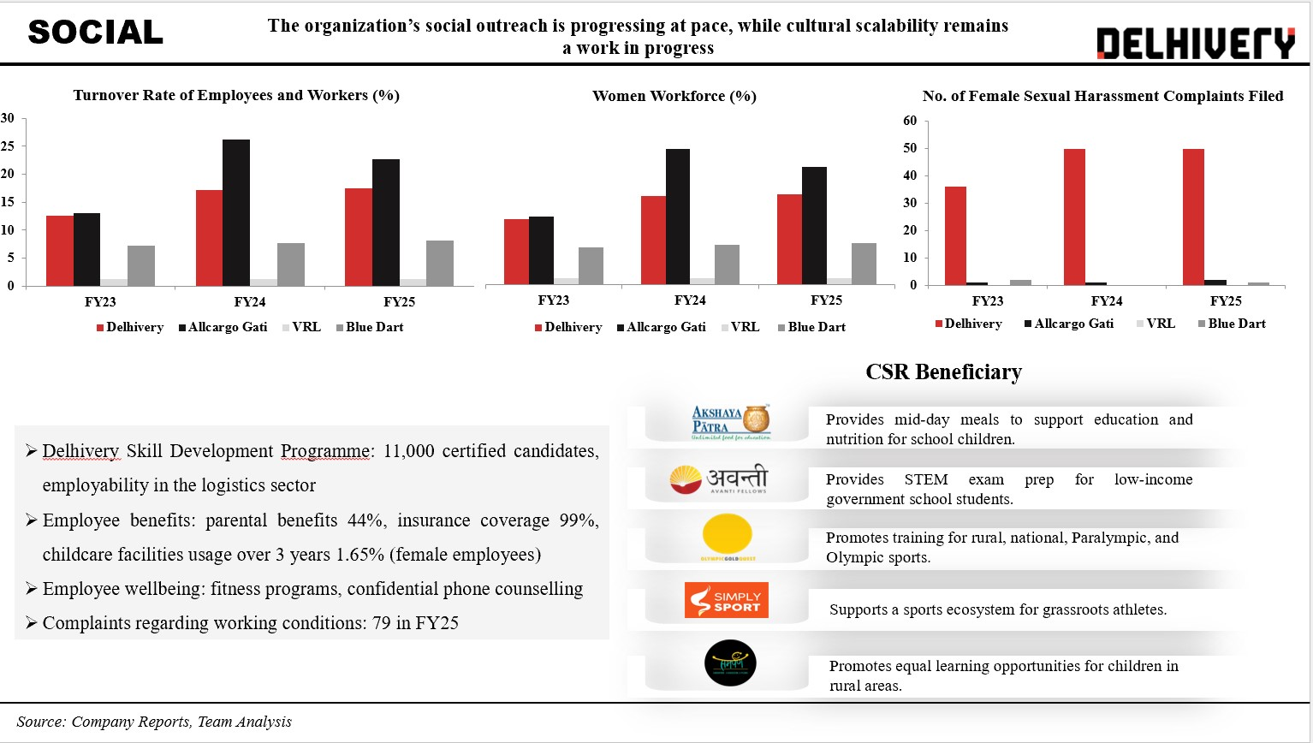
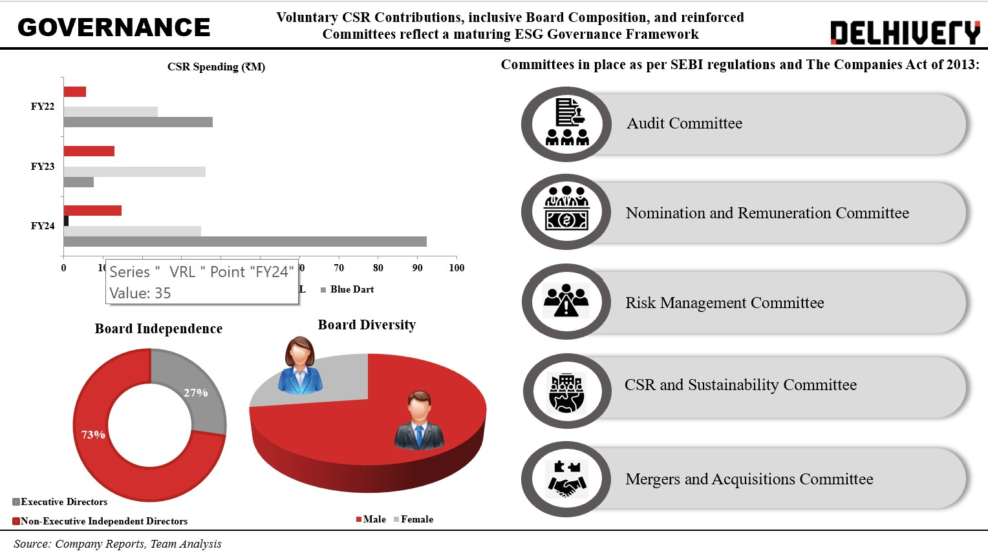

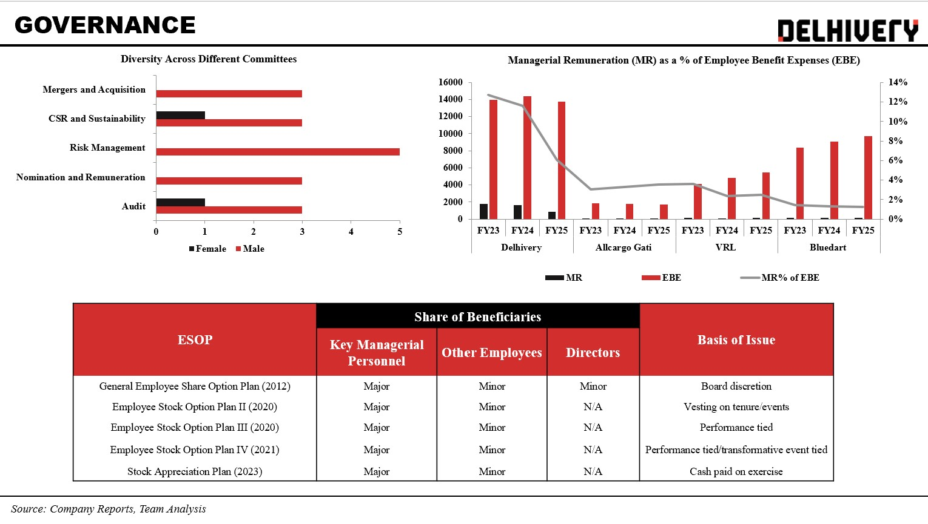
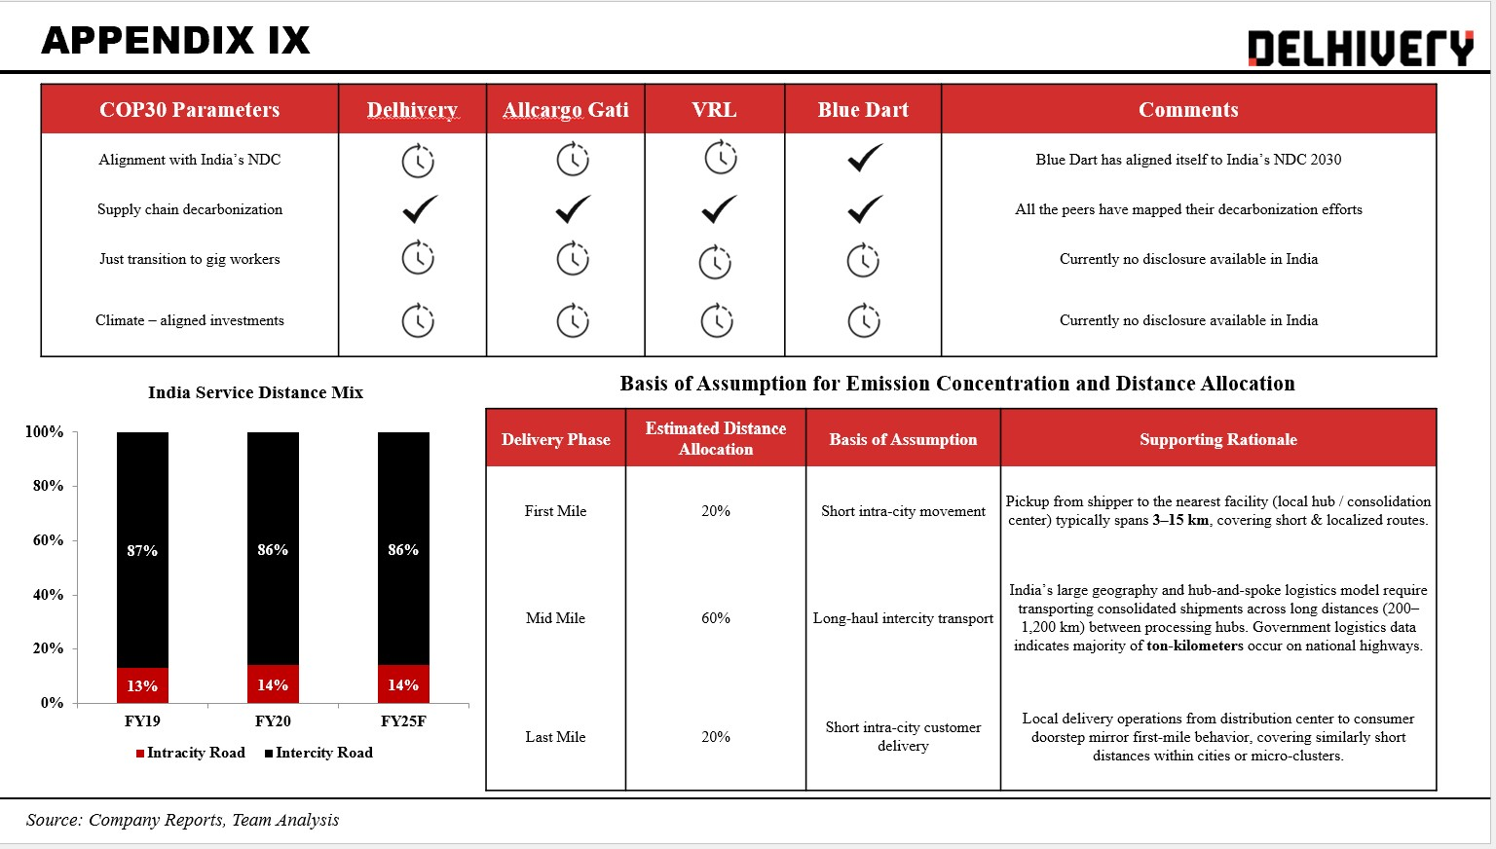
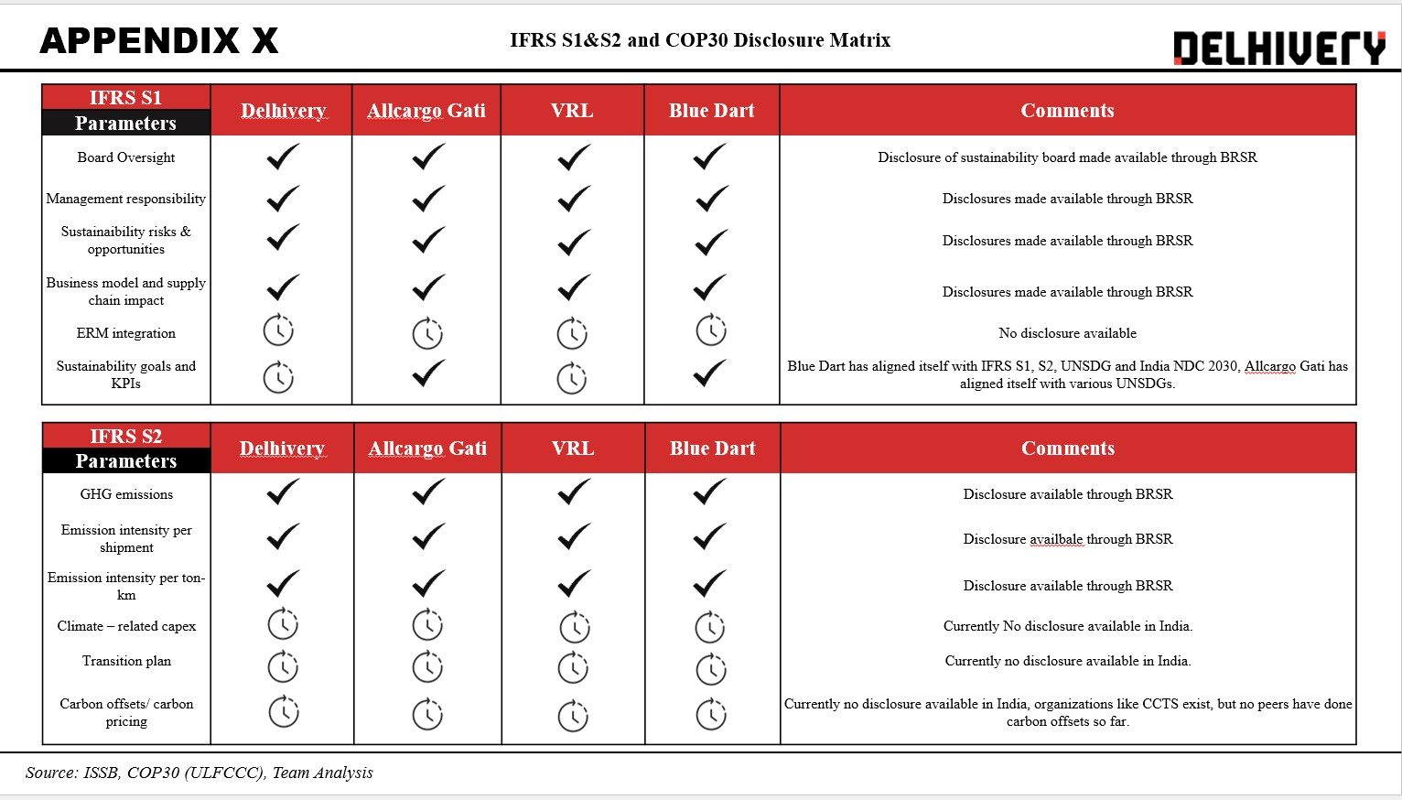
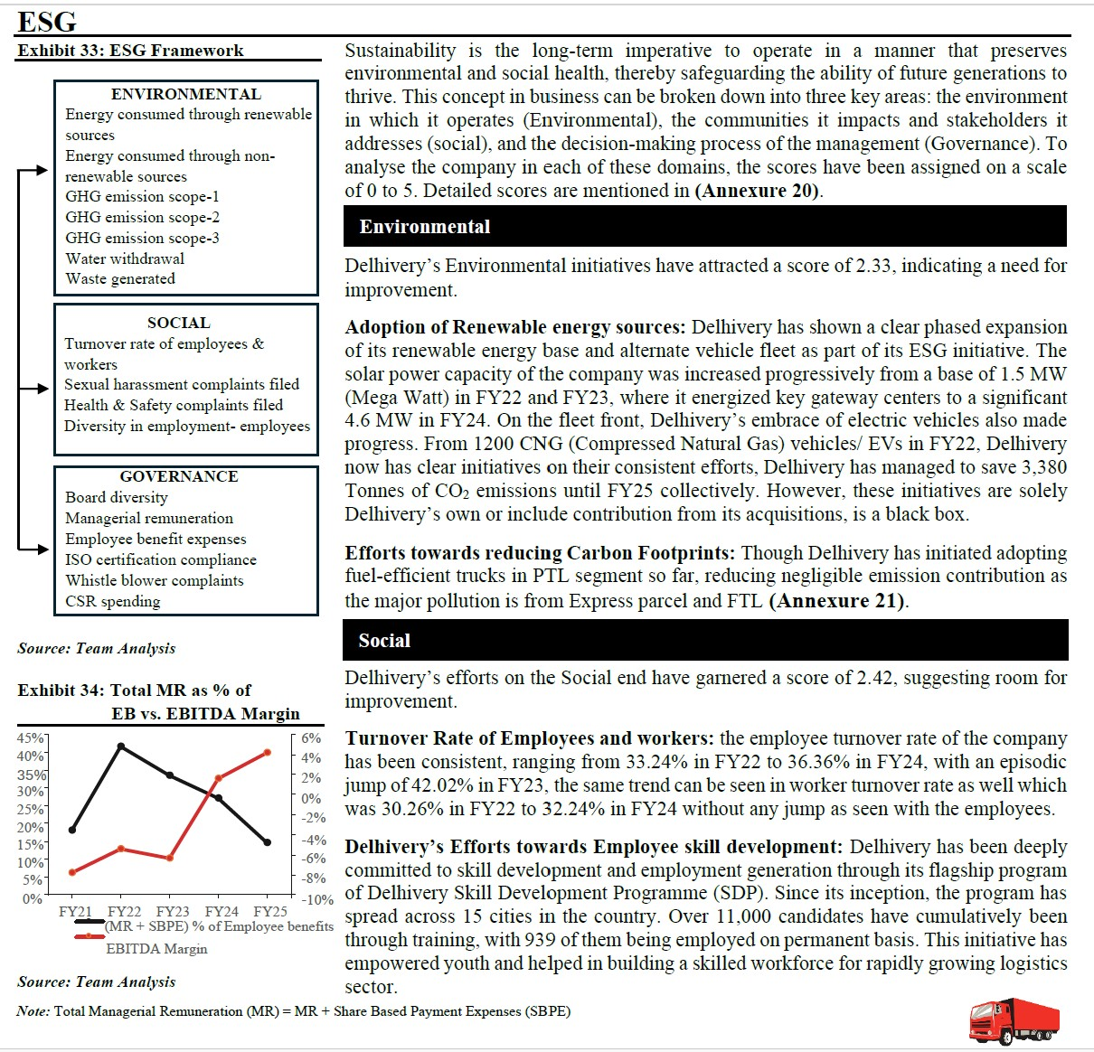

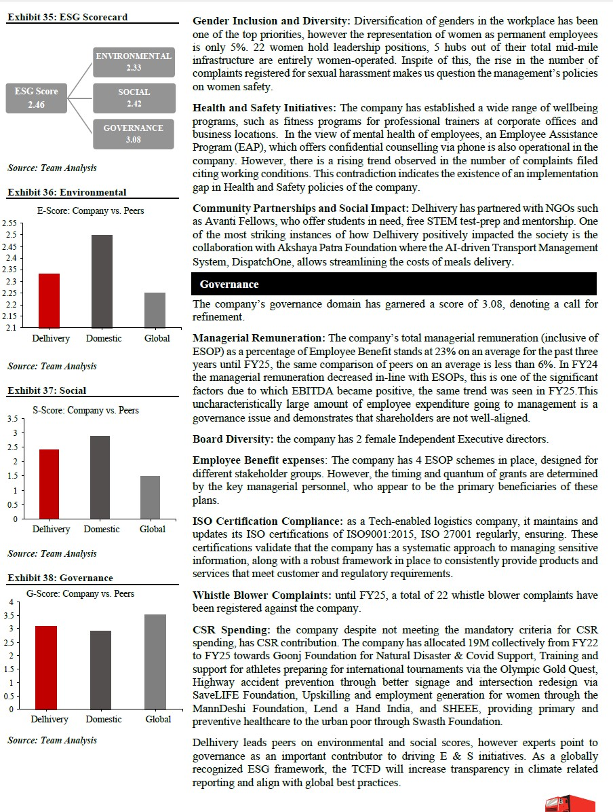

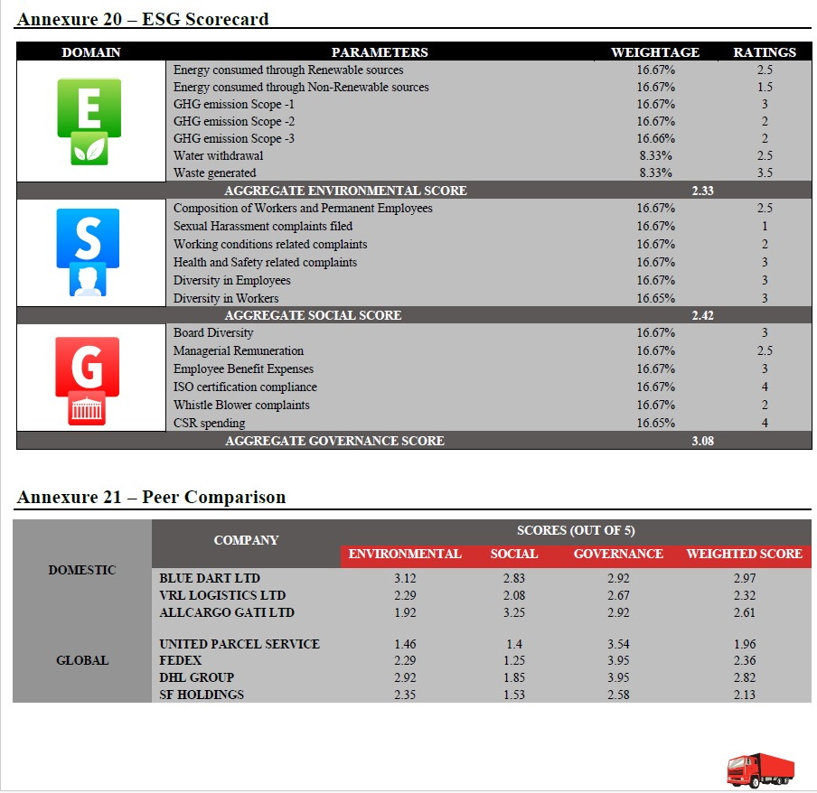

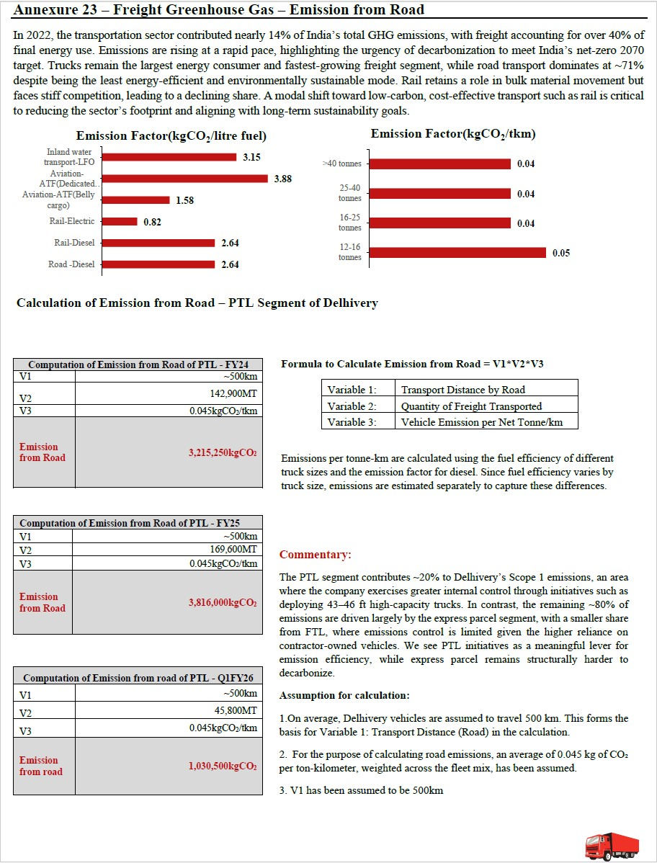

This Research offers a data-driven Environmental, Social, and Governance (ESG) analysis developed as a component of an equity research assignment to analyze sustainability performance and risk exposure over the long term in the logistics industry. A framework for ESG analysis was developed to analyze key environmental, social and governance factors, such as carbon emissions, energy consumption, workforce sustainability, governance structure, and management incentive alignment.
A weighted scoring was created keeping the Bloomberg scores scale as the base, to normalize disclosures and facilitate peer group comparisons among regional and international firms. Environmental analysis included a bottom-up emissions estimation model based on tonne-kilometer analysis to pinpoint carbon hotspots in logistics operations, where last-mile logistics emerged as the key emissions driver. Social and governance analysis examined workforce performance, stakeholder engagement, and board-level governance accountability beyond regulatory requirements.
The research also analyzed disclosures against IFRS S1 and S2 climate reporting requirements to gauge transition readiness. In summary, the analysis illustrates how ESG considerations can be systematically incorporated into equity to analyze operational risk, regulatory readiness and long-term creation.

s

