Select * from employee

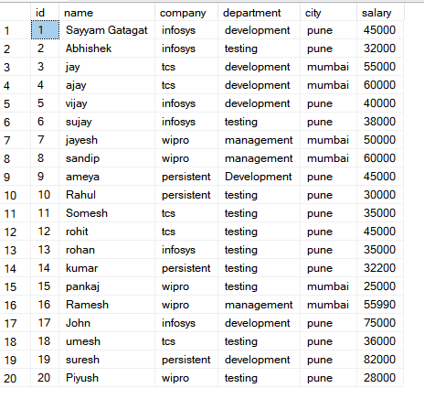

1. Rollup:

SELECT

CASE WHEN GROUPING(COMPANY)=1

THEN 'ALL' ELSE ISNULL(COMPANY,'UNKNOWN') END AS COMPANY,

CASE WHEN GROUPING(DEPARTMENT)=1

THEN 'ALL' ELSE ISNULL(DEPARTMENT,'UNKOWN') END AS DEPARTMENT,

CASE WHEN GROUPING(CITY)=1

THEN 'ALL' ELSE ISNULL(CITY,'UNKOWN') END AS CITY,

AVG(SALARY) AS SALARY_AVERAGE FROM Employee GROUP BY ROLLUP(company,Department,City);

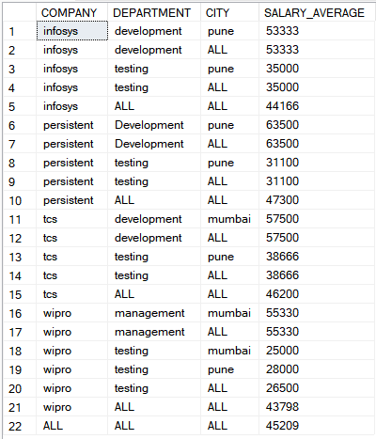

1. Slicing:

select company,avg(salary) as SALARY_AVERAGE from Employee where company='infosys' group by company;

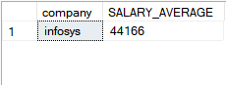

1. Dicing:

select company,avg(salary) as SALARY_AVERAGE from Employee where company='wipro' and city = 'mumbai' group by company;



1. Pivoting:

select * from Employee

pivot(avg(salary) for company in ([infosys],[tcs]))

as salary_rev

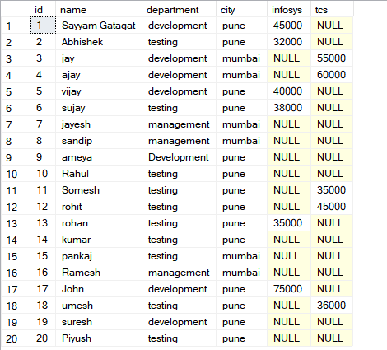

1. Drill down:

select city, avg(Salary) as SALARY_AVERAGE

from Employee

group by city;

