Weather Forecasting and Rainfall Prediction Using Data Mining Techniques

Aishwarya M
Department of Information Science and Engineering
P E S Institute of Technology Bangalore South Campus
Bangalore,India
aishwaryamukund29@gmail.com

Keerthana S
Department of Information Science and Engineering
P E S Institute of Technology Bangalore South Campus
Bangalore,India
keerthana9421@gmail.com

Mrs Sumana Sinha
Department of Information Science and Engineering
P E S Institute of Technology Bangalore South Campus
Bangalore,India
sumanasinha@pes.edu

Manish B Pissey
Department of Information Science and Engineering
P E S Institute of Technology Bangalore South Campus
Bangalore,India
manish.pissay@gmail.com

Abstract— Prediction is technologically and scientifically a challenging task for scientists and researchers around the globe. Rainfall is a liquid form of precipitation that depends on humidity, temperature, wind speed, dew point, and so on. Since rainfall depends on several parameters, its prediction becomes very complex. Various data mining techniques are used to predict the rainfall based on its dependent parameters that are measured using sophisticated equipments. In this paper an attempt is made to forecast the dependent parameters first and then using these values, rainfall is predicted. The user is asked to enter the week on which weather is to be forecasted. Data mining techniques are applied on historical weather data for the city of Bangalore. Multiple regression model is used to predict the weather parameters and decision tree algorithm is used to find the probability of rainfall. Multiple regression model is further used to find the value of rainfall approximately. This helps the naive users to predict the rainfall based on week and does not require any equipments to measure any rainfall dependent parameter. This can also help farmers decide which crops to be grown at what time based on the predicted rainfall in near future.

Index terms: weather forecasting; id3; multiple linear regression.

Introduction
Weather Forecasting is an important and necessary area of investigation in various fields. Weather parameters are the most important attributes to forecast because agriculture sectors as well as many industries are largely dependent on the weather conditions. Weather data is one of the meteorological data that is rich with important information [1]. The scientists have been trying to forecast the meteorological characteristics using a large set of methods. Data mining is a recently developed method that can be applied on historical weather data for successful predictions. Prediction is a challenging task and that too for weather is even more complex, dynamic and mind-boggling. Weather prediction poses right from the ancient times as a big herculean task, because it depends on various parameters to predict the dependent variables like temperature, rainfall, humidity, wind speed and direction, which are changing from time to time and weather calculation varies with the geographical location along with its atmospheric variables [5].
Data mining is a process that uses a variety of data analysis tools to discover patterns and relationships in data that may be used to make valid predictions. Data mining or knowledge discovery is a process of finding facts which are not known [2]. There are many data mining techniques employed for weather prediction, we have employed regression and classification techniques in this paper for predicting weather parameters such as temperature, humidity, wind speed and rainfall.
Classification is a data mining technique used to predict group membership for data instances. It is used as model to distinguish samples with unknown class labels on the basis of their similarities and dissimilarities and predict a class label for them. For example, you may wish to use classification to predict whether the weather on a particular day will be sunny, rainy or cloudy. Classification has been applied in many fields like for detecting frauds by banks and companies, by various service providers to predict their performance in future, to classify patients on the basis of their symptoms. One of the most popular classification techniques include decision trees which is presented in this paper.
In statistical analysis, regression models are often used for estimating future events or values. Trend extraction and curve fitting methods are also used to estimate the future behavior of the time series and to fit the future data according to the trend [5]. Regression analysis includes parametric and non-parametric methods, in this paper multiple linear regression is used to develop a model for forecasting weather parameters

Related work
1. Geetha and Nasira have proposed the decision tree data mining technique to predict rainfall and has been implemented using the open source data mining tool RapidMiner[2].

2. Narasimha , Mannava and Kishor have presente an elegant decision tree using entropy as an attribute selection measure is adopted in thisstudy, which increases the accuracy rate and decreases the computation time. This approach provides an average accuracy of 76.12% with a reduction of 63% in computational time over SLIQ decision trees[3].

3. Kannan , Prabhakaran and Ramachandran have proposed a simple data mining model to predict rainfall using linear regression and multiple regression[5].

4. Pinky and Hitesh have presented a rainfall prediction model using empirical statistical technique. They have also explained the various steps such as data collection, classification, model building and testing. A set of experimental have been provided to prove validity of their proposed model[4].

III. Methodology
The proposed system requires inputting historical data and predicting weather and rainfall. In this system the data is mined for patterns and analyse the data to reach valid conclusions and patterns in the form of formulae. Later these conclusions are designed as an algorithm in an application. This method will therefore be able to predict data for a large duration and will facilitate accurate prediction.[2] . We made data pre-processing and data transformation on raw weather data set so that it is used to construct the decision tree. The model is trained using the training data set and has been tested for accuracy on available test data. Multiple regression model is used to predict the weather parameters and decision tree algorithm is used to find the probability of rainfall. Multiple regression model is further used to find the value of rainfall approximately.[5]
  - DECISION TREE
The construction of decision trees from data is a longstanding discipline. Decision trees are a very effective method of supervised learning. It aims is the partition of a dataset into groups as homogeneous as possible in terms of the variable to be predicted. It takes as input a set of classified data, and outputs a tree that resembles to an orientation diagram where each end node (leaf) is a decision (a class) and each non- final node (internal) represents a test [1]. Each leaf represents the decision of belonging to a class of data verifying all tests path from the root to the leaf.
The proposed decision tree algorithm in this paper is ID3. J. Ross Quinlan originally developed ID3 (Iterative DiChaudomiser 3) at the University of Sydney.ID3 is a supervised learning algorithm, builds a decision tree from a fixed set of examples. The resulting tree is used to classify future samples [5]. ID3 algorithm builds tree based on the information (information gain) obtained from the training instances and then uses the same to classify the test data. ID3 algorithm generally uses nominal attributes for classification with no missing values.
Theories of Shannon is at the base of the ID3 algorithm. Entropy Shannon is the best known and most applied. It first defines the amount of information provided by an event: [1] the higher the probability of an event is low (it is rare), the more information it provides is great.
- Shannon Entropy
In general, if we are given a probability distribution P = (p1, p2,…, pn) and a sample S then the Information carried by this distribution, also called the entropy of P is giving by:
Entropy (p) = 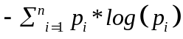
- The gain information G (p, T)
We have functions that allow us to measure the degree of mixing of classes for all sample and therefore any position of the tree in construction. It remains to define a function to select the test that must label the current node. It defines the gain for a test T and a position p

G(p,T) = 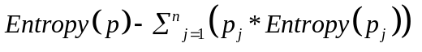

Where values (p_{j}) is the set of all possible values for attribute T. We can use this measure to rank attributes and build the decision tree where at each node is located the attribute with the highest information gain among the attributes not yet considered in the path from the root.

  - REGRESSION

Regression explains the nature of relationship[5], i.e., the average probable change in one variable given by a certain amount of change in the other variable.
The general equation of regression of on  is
= 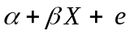 ……….….. (1)
This equation is known as the mathematical model for linear regression. As the special case the form Y = α + βX is called the deterministic model.
Multiple Linear Regression equation, which describes the linear relationship with set of dependent variable Y, and k sets of independent variables 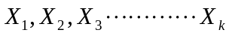 is,
….. (2)
Where is predicted and are the predictors, ‘e’ is the error which is distributed normally with zero mean and variance 2 i.e. e~N(0,s2).
To develop the proposed model, the parameters α, β₁, β₂……..β_{k} are estimated using the training sample sets. X₁, X₂, X₃………..X_{k} are the selected year, week and corresponding weather parameters.

IV. proposed model

Figure 1 proposes a model of combination of multiple regression and decision tree classifier to predict the values of weather parameters.

A. Data Collection and Pre-processing:

The data used for this work was collected from for the city of Bangalore, from Meteorology Department of GKVK Campus, UAS Bangalore. The data collected has the following observations:
1. Average temperature
2. Relative humidity (recorded in morning and evening)
3. Wind Speed
4. Rainfall
For all the weeks from the year 2000-2015.
Data relevant to the analysis was decided and retrieved from he data set. This selected data file was saved in Comma Separated Value (CSV) file format.[3]
The data set was divided into 2 phases as shown in Fig 1:[2]
1. Training Set- It includes observations of weather data between the year 2000 to 2010. It is used to build the model.
2. Testing Set- It includes observations of weather between the year 2011-15. It is used to test the model.

B. Model Overview:

The data is divided into seasons i.e. weeks 9-22 as summer, 23-43 as rainy and remaining weeks as winter.

TRAINING

DATA
MLR1
DECISION
TREE
MLR2

display value of each parameter
false
TESTING
is no rain??
display value of rainfall

true
display no rain

Fig 1. Overview of Forecasting Model

Each training set of season data is used to build the multiple linear regression model for that season. Multiple linear regression model is built to predict each weather parameter (except rainfall) given year and weeks number[4]. This model is applied to testing data to predict each weather parameter.
The continuous values of all weather parameter is grouped into classes by specifying a range. The values of every weather parameter will be divided in equal intervals, each ones having attached a number:[1]
Average temperature: 1-(25-29), 2-(30-34), 3-(3-39), 4-(10-14),5-(15-19),6-(20-24)
Relative humidity: 7-(30-34),8-(35-39),9-(40-44),10(45-49),11-(50-54),12-(55-59),13-(60-64),14-(65-69),15-(70-74),16-(75-79),17-(80-84),18-(85-89),19-(90-94),20-(95-99)
Wind Speed: 21-(4-7), 22-(8-11), 23-(12-15)
Rainfall: 0-(0), 1-(>0)

These classes of all weather parameter (including rainfall) of training set is given input to decision tree. The decision tree model is applied to testing set to determine whether rainfall occur or not. If there is no rain then it displays no rain else it is passed on to the second model of multiple linear regression to predict the values of rainfall. In second model of multiple linear regression all weather parameter (except rainfall) along with year and week no is used to predict the value of rainfall. This model runs separately for each reason.[4] If output of decision tree says rain occurs, then this model is applied to the testing input to get the value of rainfall.

C. Algorithm:
In this paper we are adopting ID3 algorithm[3]. The algorithm is as follows.
Start
1.Read the file into buffer and store all the names of the attribute in all Attributes and all the names of attributes except for target attribute in remainingAttributes. Store all the instances of attributes in a list array

2. Calculate the frequency of each target valve and calculate the entropy called globalentropy

3. Calculate the frequency of each attribute values with respect to the target value and calculate the entropy for each attribute.

4. Find gain for each attribute i.e globalentropy-entropy and find the maximum gain.

5. The attribute having maximum gain is selected for partitioning.

6. This attribute name is removed from the list of remaining attributes and the algorithm is run recursively.
End

RESULT
The resultant application would successfully predict the various parameters such as average rainfall , average temperature, relative humidity and wind speed for a specific period of time (say x years) based on the quantity of data available and the quality of data. The solution can be implemented as a client server application where the date is given as input at the client side and the computation is done on the server side.
The quality of the result depends on both the input, the computation of data and the number of mathematical models used.
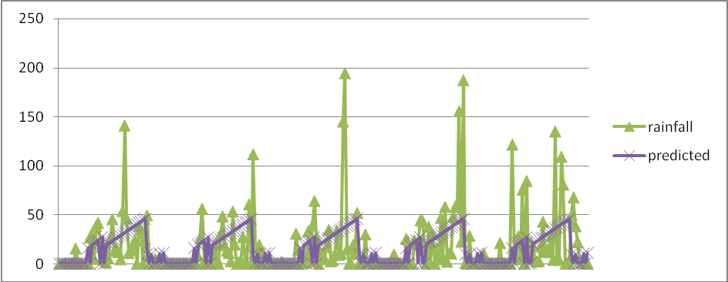Fig 2. Comparison between actual and prediction weekly rainfall

In Figure 2, the graph is plotted for rainfall versus weeks of year from 2011-15. The two curves indicates observed rainfall and predicted rainfall. It can be observed that the predicted rainfall value curve overlaps the actual rainfall curve at most of the points. It is to note that the actual rainfall value curve also consists of the various disturbances in climate such as depression, cyclonic rains etc which are not predicted by this model. Hence there are a few points of large differences between the actual and predicted value of rainfall.

References
- Elia Georgiana Petre, “A Decision Tree for Weather Prediction” Universitatea Petrol-Gaze din Ploiesti, vol. LXI No. 1/2009, pp.77-82.
[2] A.Geetha Dr. G.M.Nasira, " Data Mining for Meteorological
Applications: Decision Trees for Modeling Rainfall Prediction"

[3] Narasimha Prasad Lakkakula ,Mannava Munirathnam, Naidu
Kishor Kumar Reddy , “Entropy Based Elegant Decision Tree
Classifier to Predict” 2014 UKSim-AMSS 8th European
Modelling Symposium.

[4] Pinky Saikia, Dutta Hitesh, "Prediction Of Rainfall Using Data
Mining Technique Over Assam", Indian Journal of Computer
Science and Engineering (IJCS)

[5] Paras and Sanjay Mathur, “ A Simple Weather Forecasting
Model Using Mathematical Regression”, Indian Research
Journal of Extension Education Special Issue(Volume I), 2012

[6] Pang-Ning Tan, Micheal Steinbach , Vipin kumar: “Introduction
to data mining”, person education,2005.

[7] G.K Gupta: “Introduction to data mining with case
studies”, 3rdedition, PHI, NewDelhi,2009.

[8] Raj Jain, "The art of computer system performance and analysis"
Wiley India ed.

