Principles of Data Science (5530)-Assignment 1

Name: Aishwarya Musuku
ID:16344653
2. Answer:

Analysis 1: Average Math Scores by Race/Ethnicity

The bar plot showcasing the average math scores categorized by race/ethnicity. Each bar represents the mean math score for a specific racial or ethnic group. The x-axis denotes the different race/ethnicity categories, while the y-axis represents the average math score.

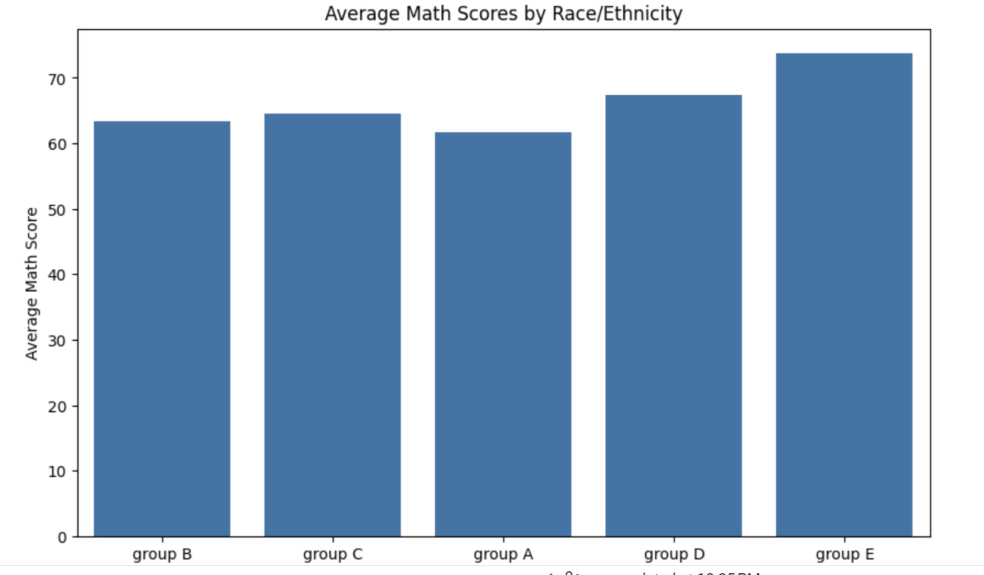

Analysis Outcome: This visualization allows us to visually compare the average math scores among different racial and ethnic groups. By examining the height of the bars, we can easily identify which groups tend to perform better or worse in math.

Analysis 2: Gender Distribution

Created a graph connecting male/female and frequency, with the x-axis representing the female and male and the y-axis represents the count or frequency of female and male category.

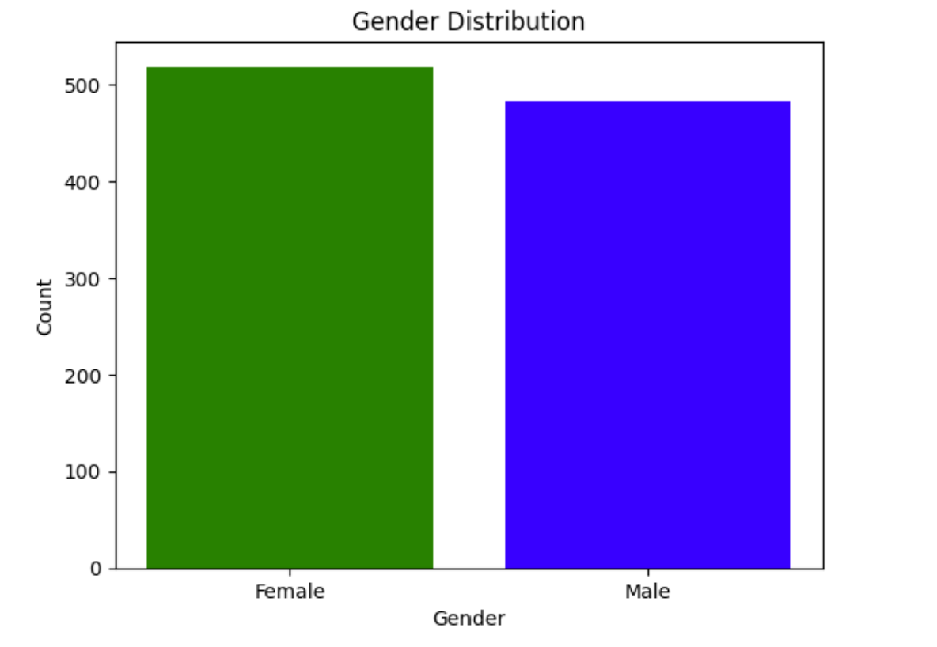

Analysis Outcome: The analysis indicates that there are more female students than male students in the dataset. This suggests a gender disparity where the number of females are more than 500 and whereas male count is near to 500.

Analysis 3: Reading Score Distribution by Lunch Type

Created the box plot graphs using the reading Score and lunch type

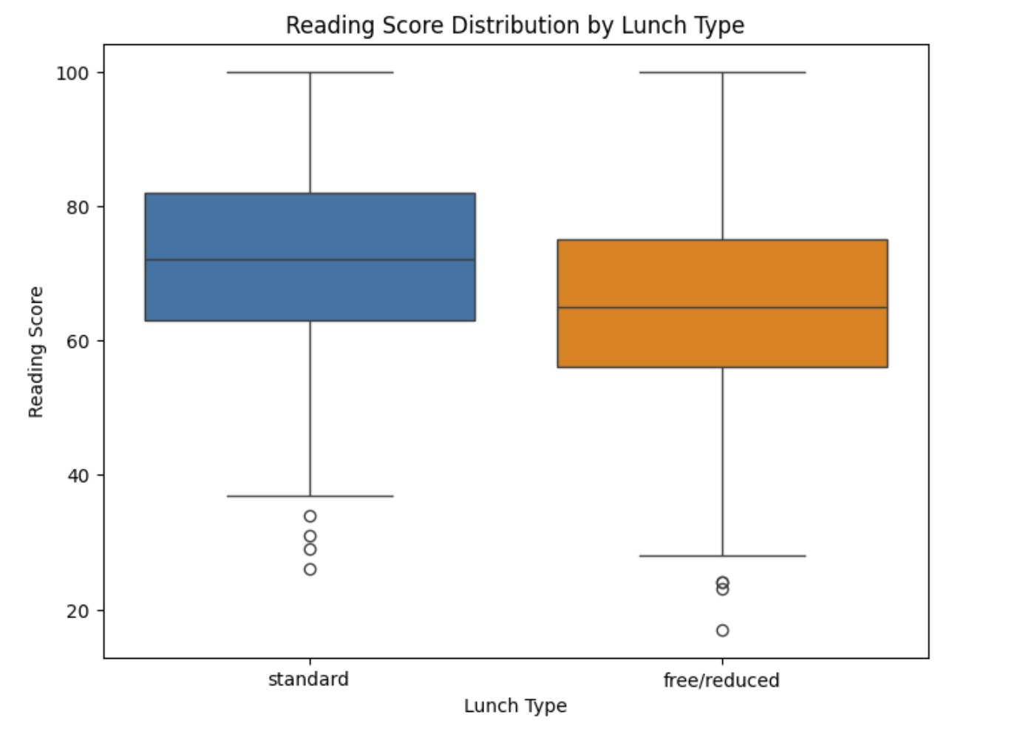

Analysis Outcome: Above analysis shows students who are having standard lunch type are getting good score in reading than students having free/reduced lunch type, which reveals potential correlations between students' socio-economic status and academic performance.

Visualization 4: Distribution between Math Score ,Reading Score and Writing Score
Plotted a histogram by connecting math, reading and writing Scores with their frequency, with the x-axis representing the math score, reading score and writing Score and their frequency or count that corresponds to each score on the y-axis.

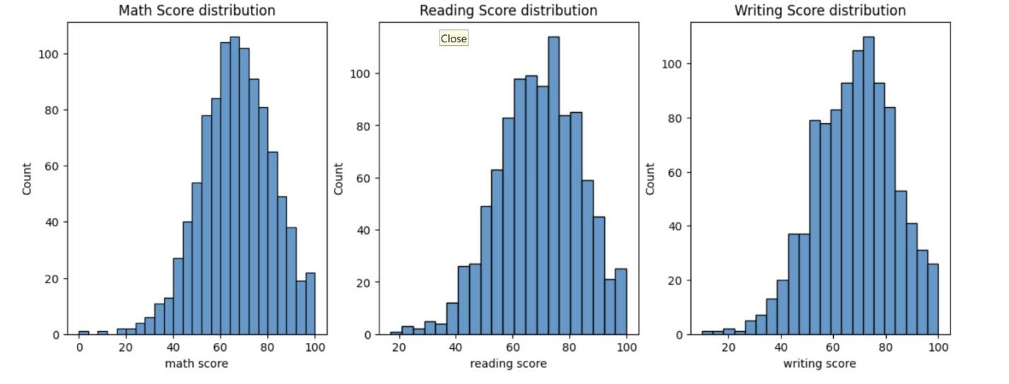
Analysis Outcome: Analyzing the distribution between math, reading, and writing scores reveals that the scores across these subjects are nearly identical, with only slight differences observed. This suggests a high level of consistency in academic performance among students across multiple subjects.

Visualization 5: Chart showing the Distribution of Scores by Gender

Let's create a scatter graph using the math scores of the male and female students on the x-axis and the reading scores on the y-axis.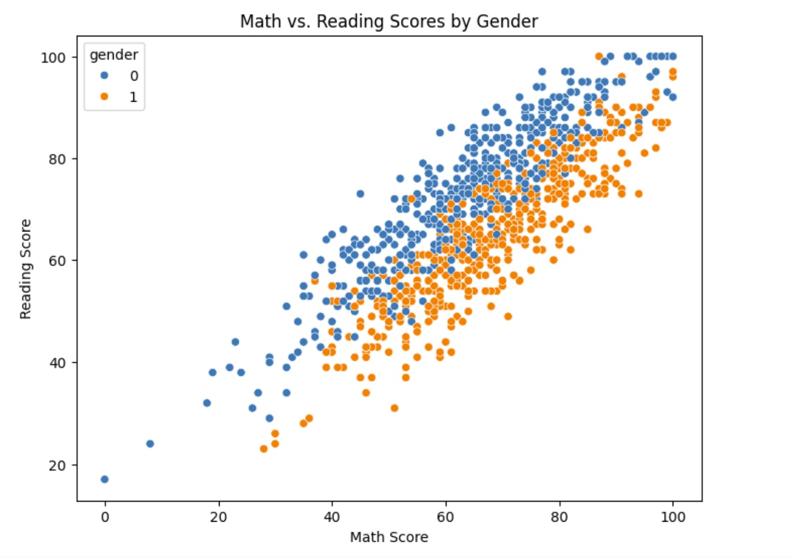

Analysis Outcome: It is evident from this scatter graph representation that male students outperformed female students in math while female students outperformed male students in reading.

Folder Structure:

