
VNR Vignana Jyothi Institute of Engineering and Technology (Affiliated to J.N.T.U, Hyderabad)
Bachupally(v), Hyderabad, Telangana, India.

INTERFACE OF KEYBOARD USING ESP332
A course project submitted in complete requirements for the award of the degree of BACHELOR OF TECHNOLOGY
IN

COMPUTER SCIENCE AND ENGINEERING - ARTIFICIAL INTELLIGENCE AND MACHINE LEARNING & INTERNET OF THINGS

Submitted by

23071A6901- | AISHWARYA
23071A6902- | BHANU SREE
23071A6903- | SAI GANESH
23071A6904- | AMULYA
23071A6905- | BHANU PRAKASH

Under the guidance of
Dr Sri Laxmi Mam
Assistant Professor
Dept. of Computer Science and Engineering - ARTIFICIAL INTELLIGENCE AND MACHINE LEARNING & Internet of Things


VNR Vignana Jyothi Institute of Engineering and Techno1ogy (Affi1iatcd to J.N.T.U, Hyderabad)
Bachupally(v), Hyderabad, Telangana, India.

CERTIFICATE

This 1s to ce11ify that 23071A6901- AISHWARYA , 23071A6902- BHANU SREE , 23071A6903- SAI GANESH , 23071A6904 – AMULYA, 24075A6903,BHANU PRAKASH – 23071A6905 – BHANU PRAKASH have completed their course project work at CSE Department of VNR VJIET, Hyderabad entitled " INTERFACE OF KEYBOARD USING ESP332" in complete fulfilment of the requirements for the award of B.Tech degree during the acaden1ic year 2020-2021. This work is carried out under my supervision and has not been submitted to any other University/Institute for award of any degree/diploma.

Dr Sri Laxmi Mam Dr. Y.Sagar

Assistant Professor Associate Professor and Head

CSE -AIML & IoT Department CSE -AIML & IOT Department

VNRVJIET VNRVJIET

DECLARATION

This is to certify that our project report titled “INTERFACE OF KEYBOARD USING ESP332” submitted to Vallurupalli Nageswara Rao Institute of Engineering and Technology in complete fulfilment of requirement for the award of Bachelor of Technology in Computer Science and Engineering is a bona fide report to the work carried out by us under the guidance and supervision of Dr Sri Laxmi Mam, Assistant Professor, Department of Computer Science and Engineering, Vallurupalli Nageswara Rao Institute of Engineering and Technology. To the best of our knowledge, this has not been submitted in any form to other university or institution for the award of any degree or diploma.

ACKNOWLEDGEMENT

Over a span of three and a half years, VNRVJIET has helped us transform ourselves from mere amateurs in the field of Computer Science into skilled engineers capable of handling any given situation in real time. We are highly indebted to the institute for everything that it has given us. We would like to express our gratitude towards the principal of our institute, Dr. Challa Dhanunjaya Naidu and the Head of the Computer Science & Engineering Department, Dr.Y.Sagar for their kind co­ operation and encouragement which helped us complete the project in the stipulated time. Although we have spent a lot of time and put in a lot effort into this project, it would not have been possible without the motivating support and help of our project guide Dr Sri Laxmi Mam. We thank her for her guidance, constant supervision and for providing necessary information to complete this project. Our thanks and appreciations also go to all the faculty members, staff members of VNRVJIET, and all our friends who have helped us put this project together.

Abstract

This project demonstrates the interfacing of a 4x4 matrix keypad with the ESP32 microcontroller to capture user input for embedded and sensor-based applications. The keypad, connected via GPIO pins, is scanned using a row-column technique to detect keypresses. A software-based debouncing algorithm ensures accurate key detection by eliminating false triggers due to mechanical bounce. The ESP32 processes the inputs in real-time and can be programmed to perform tasks such as password verification, menu navigation, or sensor configuration. Its built-in Wi-Fi and Bluetooth enable future expansion into IoT applications. The system can be easily integrated with displays and actuators for a complete interactive interface.

This project highlights fundamental concepts in embedded systems, including GPIO control, real-time processing, and human-machine interaction. It demonstrates how simple input devices like keypads can significantly enhance the usability and control features of smart systems in domains such as home automation, security, and industrial monitoring.

TABLE OF CONTENTS

S. No | Section Reference | Page No.
1. | Introduction | 7
2. | Architecture | 8
3. | Model Implementation | 9
4. | Sample Overviews | 15
5. | Conclusion | 20

INTRODUCTION

In the rapidly evolving field of embedded systems and the Internet of Things (IoT), efficient user interfaces are essential for enabling real-time interaction between humans and machines. One of the most commonly used input devices in such systems is the matrix keypad, a cost-effective and reliable solution for capturing numeric and alphanumeric data. This project explores the interfacing of a 4x4 matrix keypad with the ESP32 microcontroller, aiming to demonstrate how simple input mechanisms can significantly enhance system interactivity and functionality.

The ESP32 is a powerful, dual-core microcontroller developed by Espress if Systems, featuring integrated Wi-Fi, Bluetooth, multiple GPIOs, and support for multitasking through Free RTOS. Its low power consumption, high performance, and rich peripheral support make it ideal for sensor-based applications where real-time decision-making and connectivity are required. By combining the ESP32 with a matrix keypad, we create a system capable of taking secure user input for tasks such as password entry, device configuration, and menu navigation.

The 4x4 matrix keypad consists of 16 buttons arranged in a grid of rows and columns. When a key is pressed, it forms an electrical connection between one row and one column. The ESP32 identifies which button was pressed by systematically scanning the rows and reading the corresponding columns. However, due to the mechanical nature of the switches, key bouncing is common — this can result in multiple false detections of a single keypress. To overcome this, software debouncing is implemented to filter out unintended signals and ensure accurate input.

This project has practical relevance in a wide range of applications such as digital locks, home automation, vending machines, access control systems, and more. Furthermore, the modular design allows for the system to be extended with displays (e.g., OLED) or actuators, making it a versatile solution for both educational and industrial use.

The aim of this project is not only to implement keypad interfacing but also to understand the underlying concepts such as GPIO pin control, matrix scanning, software debouncing, and real-time processing using the ESP32. The integration of a keypad into an embedded system is a fundamental skill that lays the groundwork for more complex interactive systems in the field of smart electronics and IoT.

BLOCK DIAGRAM

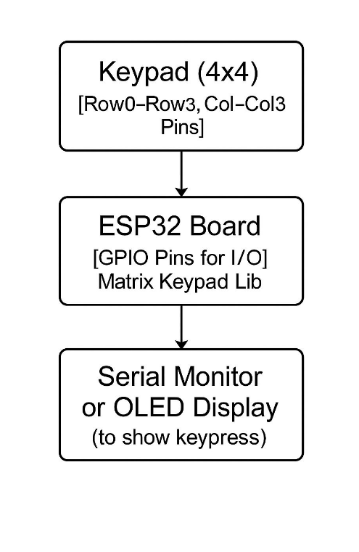

MODEL IMPLEMENTATION

model implementation

1. Components Needed:

ESP32 Dev Module

4x4 Matrix Keypad

Jumper wires

Breadboard

2. Circuit Connections:

The keypad pins are connected as:

Keypad → ESP32 GPIO

R1 → GPIO 18

R2 → GPIO 5

R3 → GPIO 17

R4 → GPIO 16

C1 → GPIO 4

C2 → GPIO 0

C3 → GPIO 2

C4 → GPIO 15

3. Arduino Code:

Install the Keypad library from Arduino Library Manager

#include <WiFi.h>

#include <WebServer.h>

#include <Keypad.h>

const char* ssid = "Bhanu";

const char* password = "12345678";

WebServer server(80);

String inputCode = "";

const String secretCode = "1234";

String resultMessage = "Waiting for input...";

const byte ROWS = 4;

const byte COLS = 4;

char keys[ROWS][COLS] = {

{'1','2','3','A'},

{'4','5','6','B'},

{'7','8','9','C'},

{'*','0','#','D'}

};

byte rowPins[ROWS] = {33, 25, 26, 14};

byte colPins[COLS] = {27, 13, 22, 4};

Keypad keypad = Keypad(makeKeymap(keys), rowPins, colPins, ROWS, COLS);

const char* htmlPage = R"rawliteral(

<!DOCTYPE html>

<html lang="en">

<head>

<meta charset="UTF-8">

<title>ESP32 Access Panel</title>

<style>

body {

font-family: 'Segoe UI', sans-serif;

background: linear-gradient(135deg, #2c3e50, #3498db);

color: #fff;

text-align: center;

padding-top: 60px;

}

h1 {

font-size: 36px;

margin-bottom: 20px;

}

#result {

margin-top: 40px;

font-size: 28px;

font-weight: bold;

padding: 20px;

border-radius: 12px;

display: inline-block;

min-width: 250px;

animation: fadeIn 1s ease-in-out;

}

.granted {

background-color: #2ecc71;

color: white;

}

.denied {

background-color: #e74c3c;

color: white;

}

.masked {

background-color: #f39c12;

color: black;

}

.cleared {

background-color: #95a5a6;

color: black;

}

@keyframes fadeIn {

from { opacity: 0; transform: scale(0.95); }

to { opacity: 1; transform: scale(1); }

}

</style>

</head>

<body>

<h1>🔐 Secure Access Panel</h1>

<div id="result" class="masked">Waiting for input...</div>

<script>

setInterval(() => {

fetch("/result")

.then(res => res.text())

.then(data => {

const result = document.getElementById("result");

result.innerText = data;

result.className = "masked"; // Reset default

if (data.includes("✅")) {

result.className = "granted";

} else if (data.includes("❌")) {

result.className = "denied";

} else if (data.includes("Cleared")) {

result.className = "cleared";

} else if (data.includes("Entered")) {

result.className = "masked";

}

});

}, 800);

</script>

</body>

</html>

)rawliteral";

void handleRoot() {

server.send(200, "text/html", htmlPage);

}

void handleResult() {

server.send(200, "text/plain", resultMessage);

}

void setup() {

Serial.begin(115200);

WiFi.begin(ssid, password);

Serial.println("Connecting to WiFi...");

while (WiFi.status() != WL_CONNECTED) {

delay(500);

Serial.print(".");

}

Serial.println("\nWiFi connected!");

Serial.println("IP Address: " + WiFi.localIP().toString());

server.on("/", handleRoot);

server.on("/result", handleResult);

server.begin();

}

void loop() {

server.handleClient();

char key = keypad.getKey();

if (key) {

Serial.print("Key Pressed: ");

Serial.println(key);

if (key == '*') {

inputCode = "";

resultMessage = "Cleared";

} else if (key == '#') {

if (inputCode == secretCode) {

resultMessage = "✅ Access Granted";

} else {

resultMessage = "❌ Access Denied";

}

inputCode = "";

} else {

inputCode += key;

String masked = "";

for (int i = 0; i < inputCode.length(); i++) {

masked += "*";

}

resultMessage = "Entered: " + masked;

}

}

}

SAMPLE OVERVIEWS

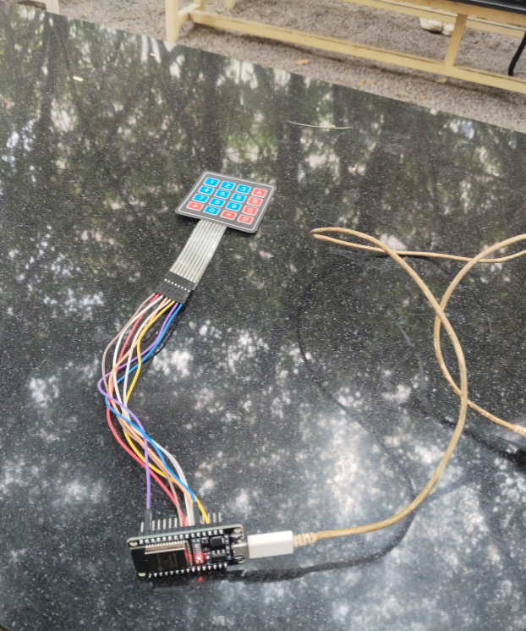

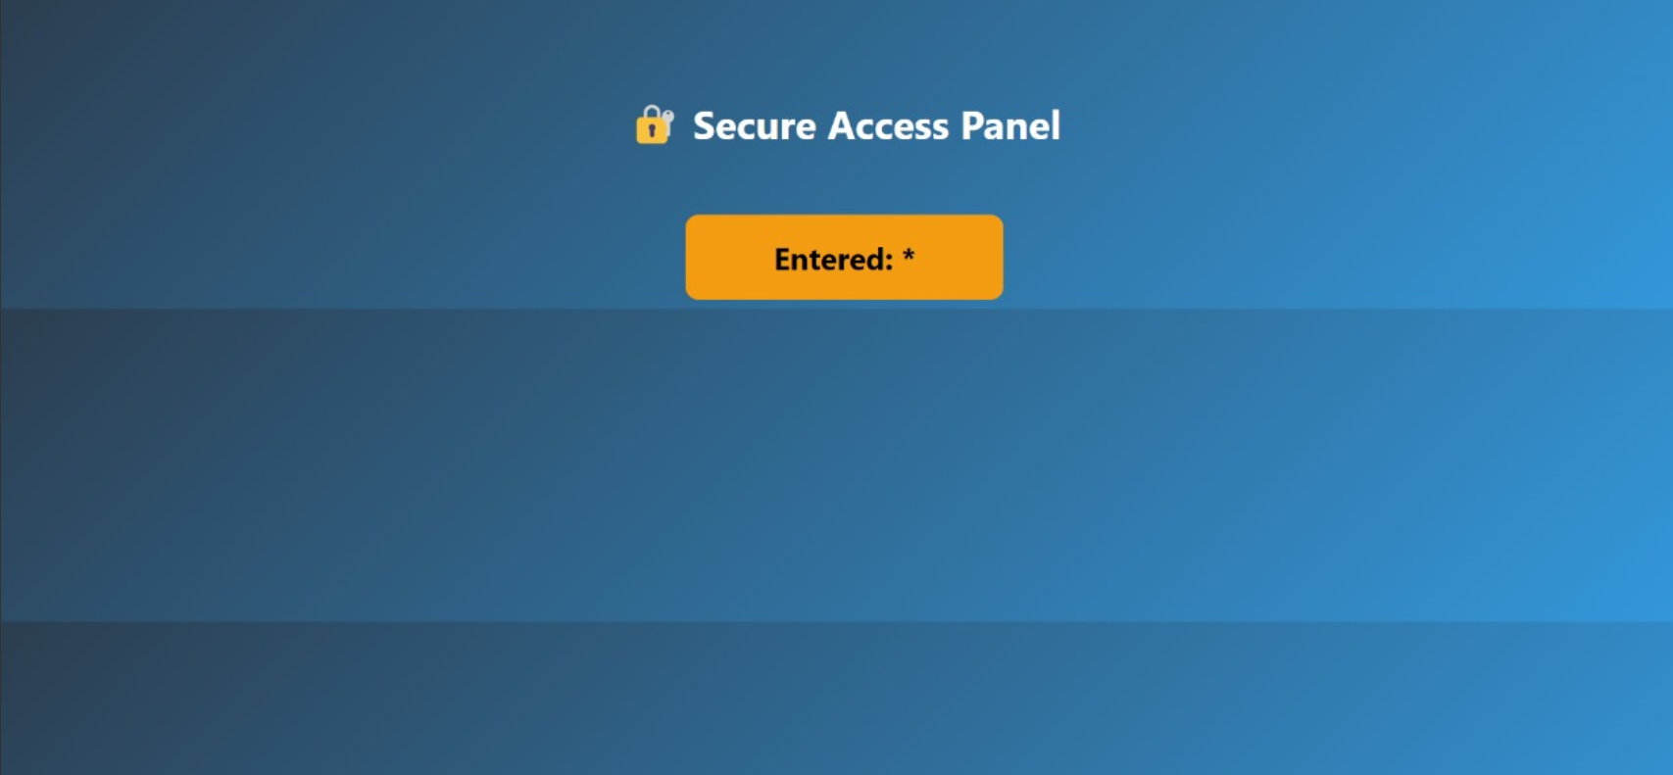

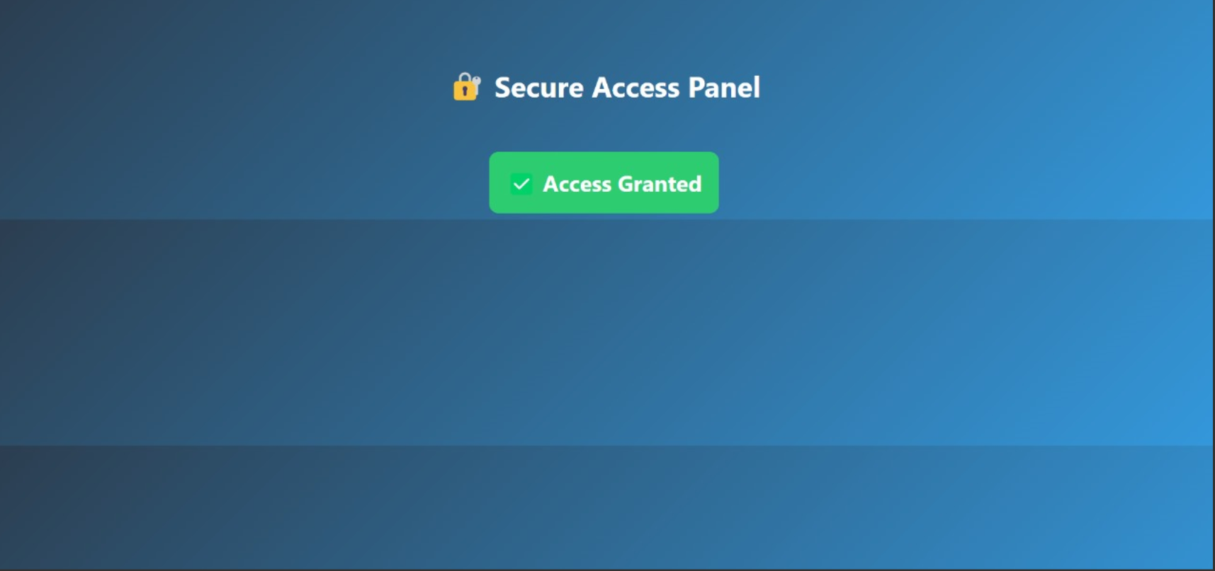

CONCLUSION

The successful interfacing of a 4x4 matrix keypad with the ESP32 microcontroller demonstrates a practical and essential application in embedded systems design. This project effectively showcases how user input devices can be integrated with microcontrollers to enable interactive functionality. The keypad serves as a robust method for user input, with a wide range of uses in systems such as digital locks, home automation controls, industrial machines, and menu-based navigation systems.

Through the use of the Keypad.h library, the complexity of scanning and debouncing the keypad matrix is greatly reduced. The software handles the detection of individual key presses, mapping each press to a specific character or function, while the ESP32 manages real-time processing and display output. This abstraction allows developers to focus more on application logic rather than the low-level handling of I/O.

