Portfolio.org

This site will be my portfolio and along with it will be my resume. I will enter my introduction, hobbies and goals. I intend to upload my pictures and some of my hobby outcomes. I chose these fonts because it is bold, classy and at the same time formal. I chose formal color scheme too.

**Heading Font**

Subheading Font

Text Font



COLOR SCHEME

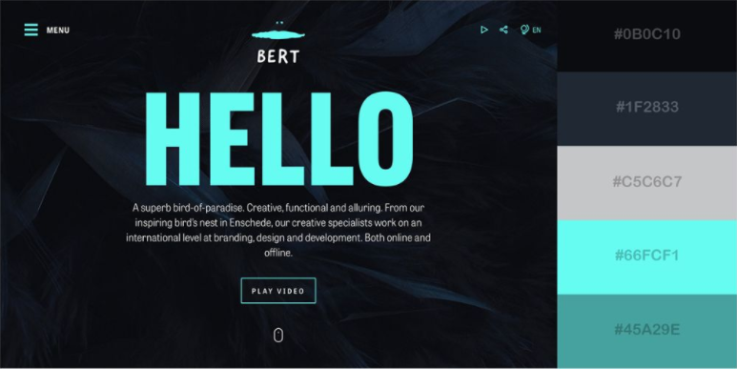 

POSSIBLE MEDIA WILL LOOK LIKE THIS