Unit Test Document
MTE Offline App – Payroll Override
Story | As a user, I want to enter payroll override rates on the MTE Offline App the same way I can on the online ATE app (AS-1991, AS-1974)
Environment | Development
Tested by
Test date
Test data | Region 102, config template Test_GC_102; work order DS_Units_test_46 - Z016517; crew LANCASTER, BELCHER, GILLIAM
Summary
Acceptance criteria | Status | Section
1. Field parity | Pass | AC1
2. Region configuration – enable/disable | Pass | AC2
3. Role-based visibility | Not yet tested | AC3
4. Data consistency (sync) | Partially verified | AC4
5. Regression | Pass (visual) | AC5
Technical note – user-scoped override data | Not yet tested | Note

AC1 – Field parity
Acceptance criteria | Offline app time entry includes payroll override fields equivalent to the ST/OT/DT override rate fields on the online ATE app Timesheet Labor grid (per AS-1991).
Steps | 1. Open the offline app and a work order in a region with Payroll Override-VEG enabled. 2. Go to People tab > employee labor row > Payroll Override. 3. Select a Job Category Override for Payroll. 4. Compare with the online Timesheet Labor grid.
Expected result | Category dropdown and a per-hour-type rate (Straight / Overtime) are shown. Selecting a category defaults the configured rate; rate is editable. Equipment shows category and rate.
Actual result | Labor: Climber 1 selected, Straight and Overtime rates default to 4.65 (configured rate). Equipment: New Eq1 selected, rate defaults to 2. Online grid shows the same fields (Job Category Override for Payroll, Payroll Override Rate, Earnings Code Straight/Overtime).
Status | Pass
Screenshots
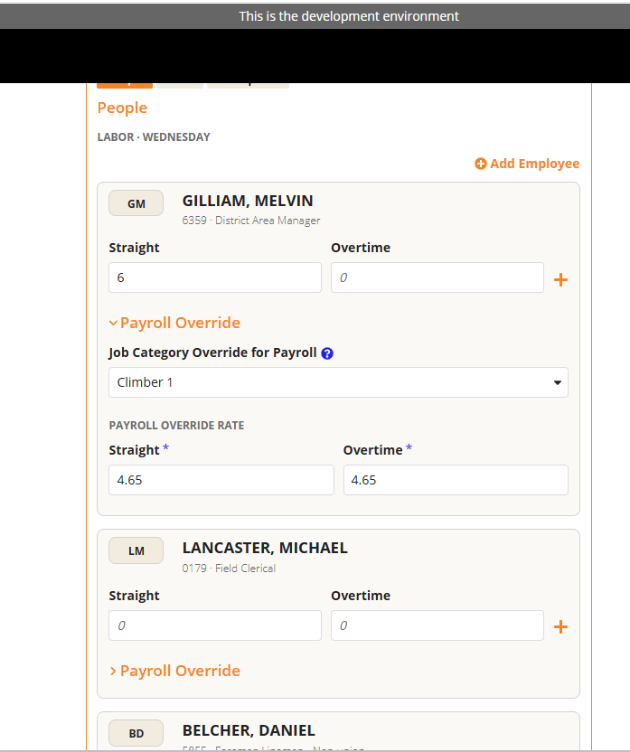
Offline – labor payroll override (category + Straight/Overtime rate)
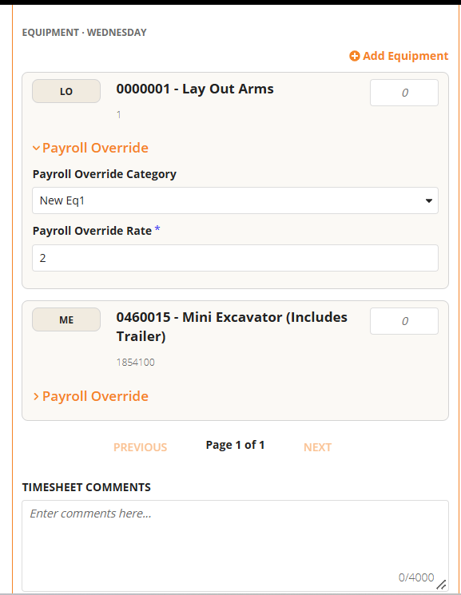
Offline – equipment payroll override (category + rate)
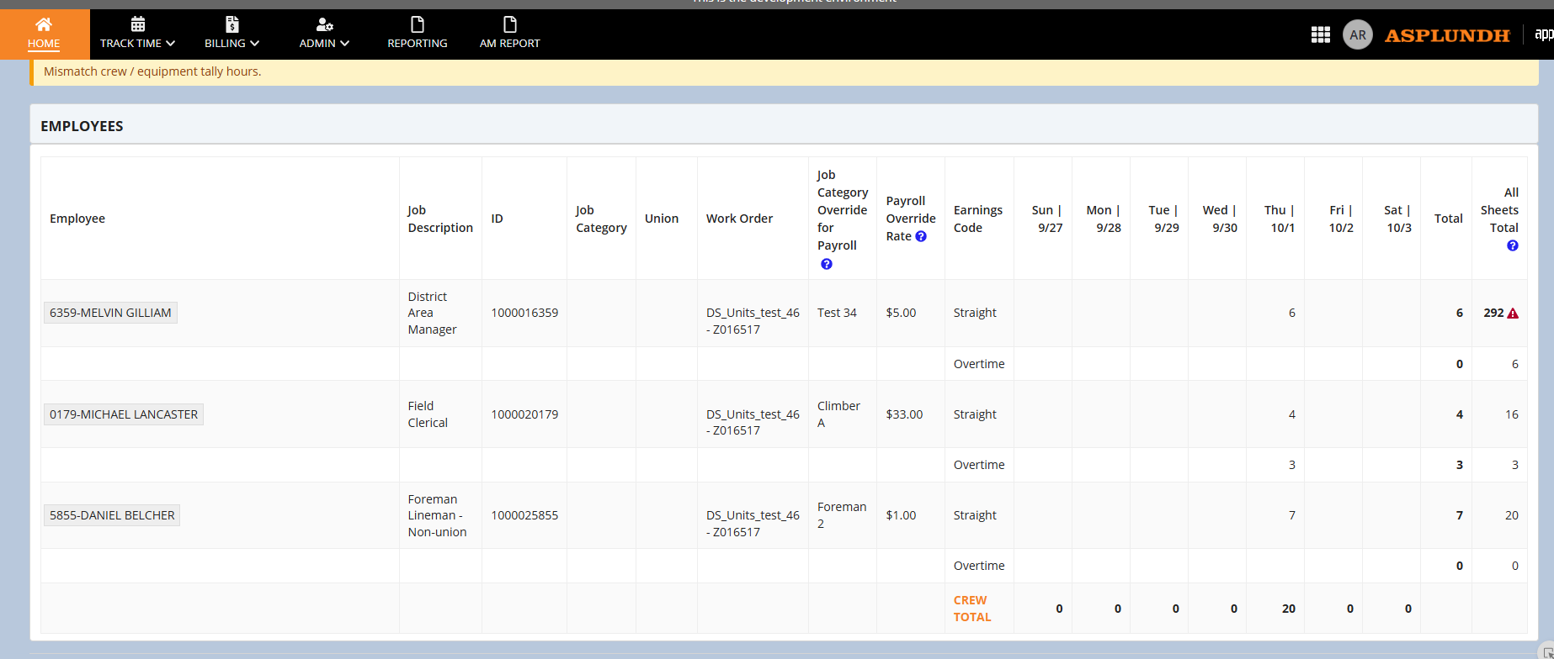
Online ATE – Timesheet Labor grid (reference)

AC2 – Region configuration (enable/disable)
Acceptance criteria | Payroll override fields display on the offline app only for regions where Payroll Override-VEG is enabled. Regions without it do not see the fields.
Steps | 1. Open a region config with Payroll Override-VEG enabled and check the offline People tab. 2. Open config Test_GC_102 (Payroll Override-VEG off, Equipment Payroll Override-VEG on) and check the offline People tab.
Expected result | Labor override fields are shown only when Payroll Override-VEG is enabled. Equipment override fields follow Equipment Payroll Override-VEG.
Actual result | Enabled region: labor Payroll Override section is shown (see AC1). Test_GC_102: labor Payroll Override section is hidden and equipment Payroll Override is shown, matching the config.
Status | Pass
Screenshots
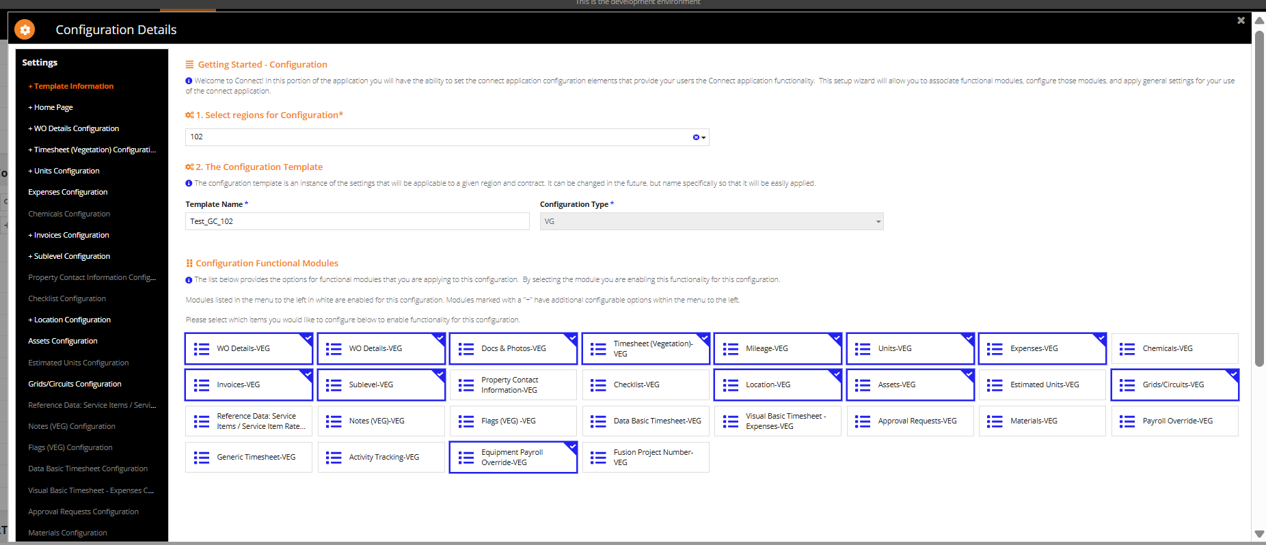
Config Test_GC_102 – Payroll Override-VEG not selected, Equipment Payroll Override-VEG selected
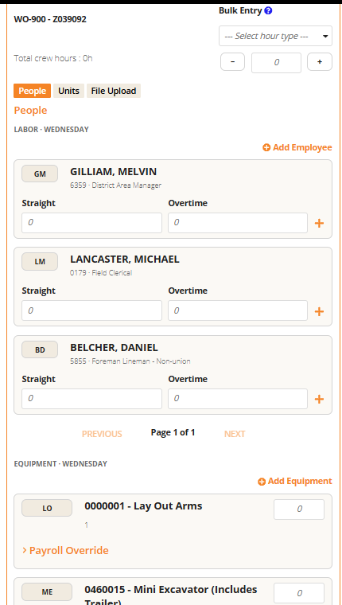
Offline – labor rows without Payroll Override section; equipment section shown

AC3 – Role-based visibility
Acceptance criteria | When "Hide Payroll Override for Forepersons" (AS-1974) is enabled, payroll override fields are hidden on the offline app for Foreperson-level and below. GF and above continue to see them regardless.
Steps | 1. Enable Hide Payroll Override for Forepersons (Labor Configuration) on a region with Payroll Override-VEG. 2. Log in as a Foreperson (or below) and open the offline People tab. 3. Log in as GF or above and repeat. 4. Disable the setting and repeat as Foreperson.
Expected result | Foreperson and below: labor override fields hidden when the setting is on, shown when off. GF and above: always shown. Existing override values are not erased when hidden fields sync.
Actual result | Not yet executed. Visibility flag still to be wired in the download/parent rule. Config setting location is shown below.
Status | Not yet tested
Screenshots
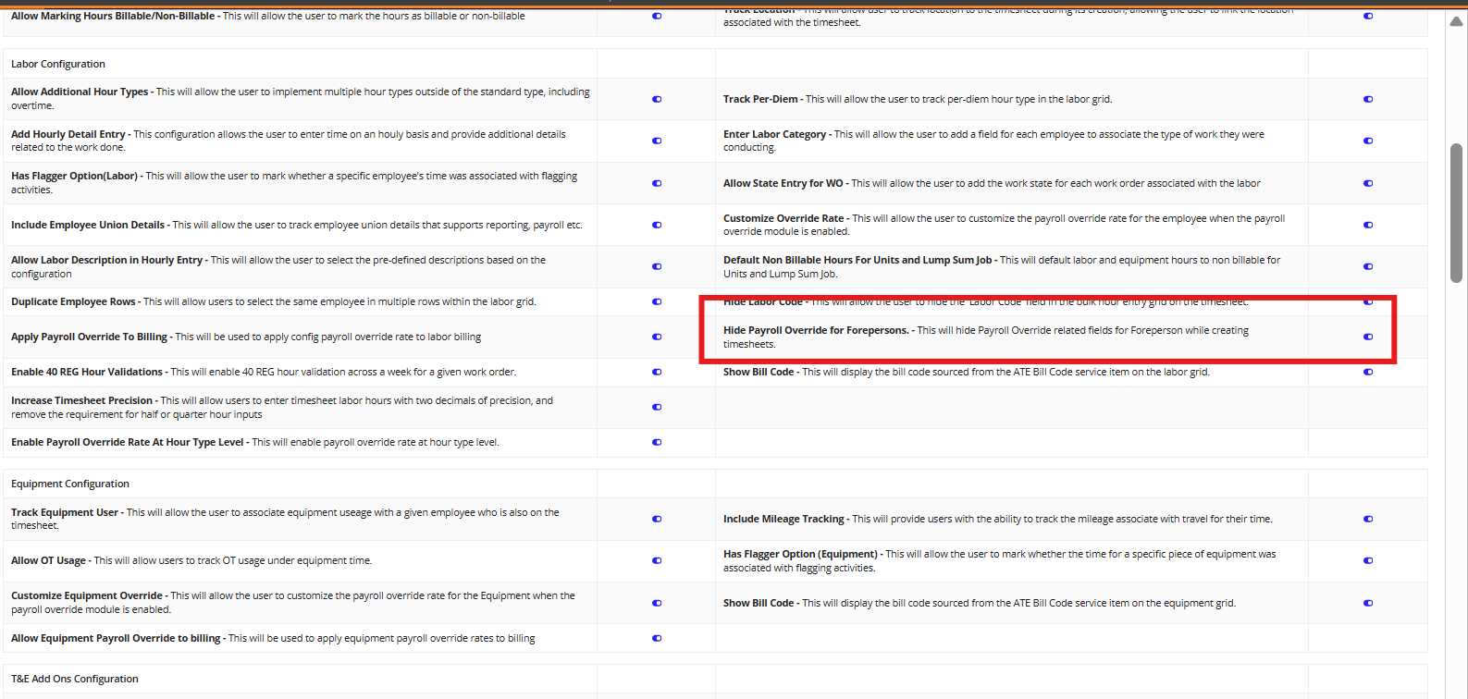
Config – "Hide Payroll Override for Forepersons" setting (highlighted)
[Add screenshots: Foreperson setting ON, GF setting ON, Foreperson setting OFF]

AC4 – Data consistency
Acceptance criteria | Payroll override values entered offline sync to the same underlying record/fields used by the online ATE app, with no duplicate or conflicting override data.
Steps | 1. Enter category and rate for a labor row and an equipment row offline. 2. Sync the offline data. 3. Open the same timesheet on the online ATE app and compare the values. 4. Confirm no duplicate rows were created.
Expected result | Online grid shows the same job category and override rate. Equipment time entry stores payrollOverrideConfigId and overrideRate. No duplicate records.
Actual result | Equipment: online record holds payrollOverrideConfigId = 11 and overrideRate = 23 on the ROME Equipment Time Entry. Labor: online grid shows override category and rate per employee; offline-to-online sync for the new labor values still to be confirmed after sync.
Status | Partially verified
Screenshots
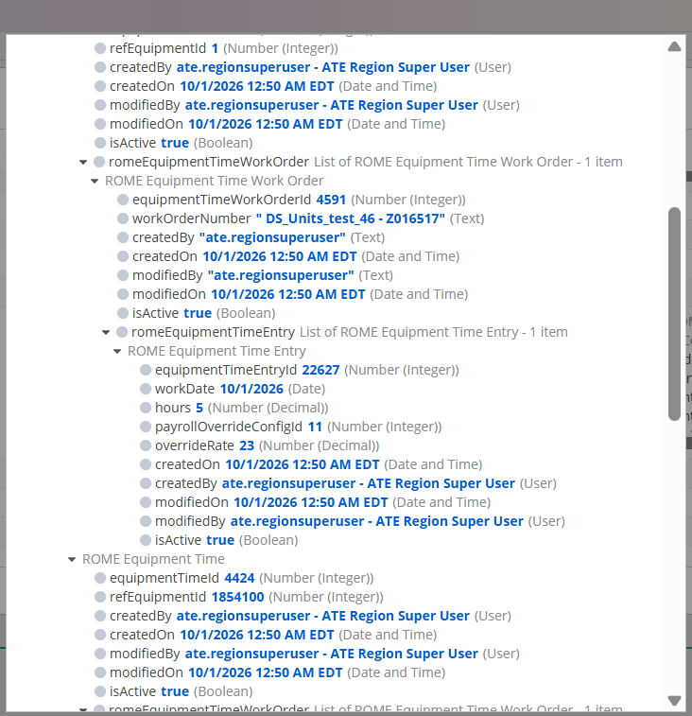
Online record – ROME Equipment Time Entry with payrollOverrideConfigId and overrideRate
Online ATE – Employees grid with Job Category Override and Payroll Override Rate
[Add screenshot: online grid after offline sync showing the offline values]

AC5 – Regression
Acceptance criteria | Existing offline time entry behavior for users/regions without payroll override enabled is unchanged.
Steps | 1. In a region without Payroll Override-VEG, open the offline People tab. 2. Enter Straight/Overtime hours, add hour types, use Bulk Entry, paging, and equipment hours.
Expected result | Hours entry, Bulk Entry, Add Employee/Equipment, paging and comments behave as before, with no payroll override fields on labor.
Actual result | People tab shows Straight / Overtime fields, "+" for hour types, Bulk Entry, Add Employee and Add Equipment as before; no payroll override on labor rows.
Status | Pass (visual)
Screenshots
Offline – People tab in a region without labor payroll override

Technical note – user-scoped override data
Acceptance criteria | When enabling payroll override offline, pull override information only for configurations strictly associated with the user.
Steps | 1. Log in as a user associated with region 102 only. 2. Download the offline data. 3. Inspect the payroll override options on the device.
Expected result | Only the override categories of the user's own configuration are present; no categories from other regions.
Actual result | Options contain only the categories of the configuration in use (Climber 1, Foreman 2, Test 34, Test New Rate, New Cat, Climber A/B/C, EmplM). Confirmation against a second region still to be done.
Status | Not yet tested
Screenshots
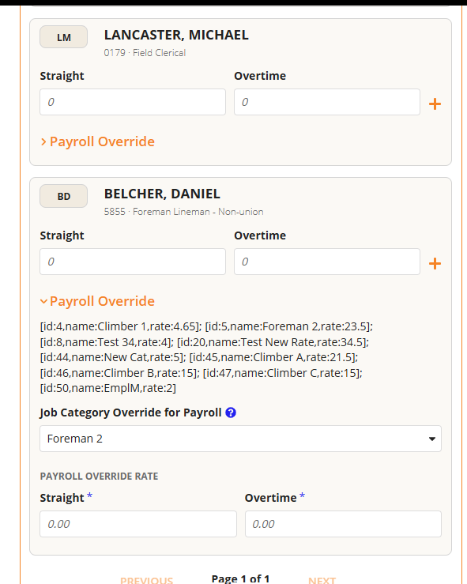
Offline – options loaded for the user's configuration (debug view)

