Assignment 1A: Create a basic webpage structure with semantic HTML5 elements

Assignment 2A: Style yesterday's HTML using all three CSS methods

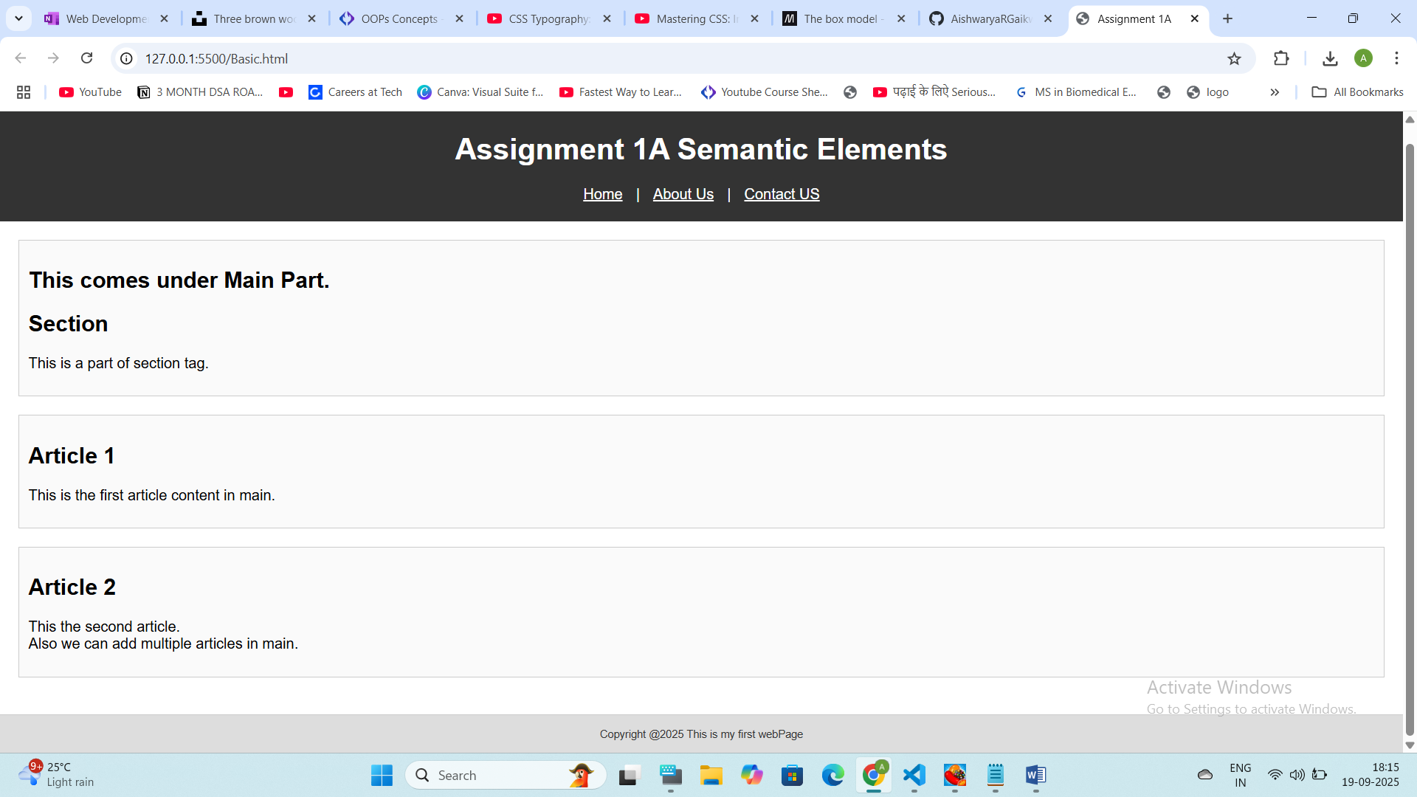

Assignment 1B: Create a product catalog using tables and a navigation menu using lists

Assignment 2D: Create a header with navigation that uses positioning and float

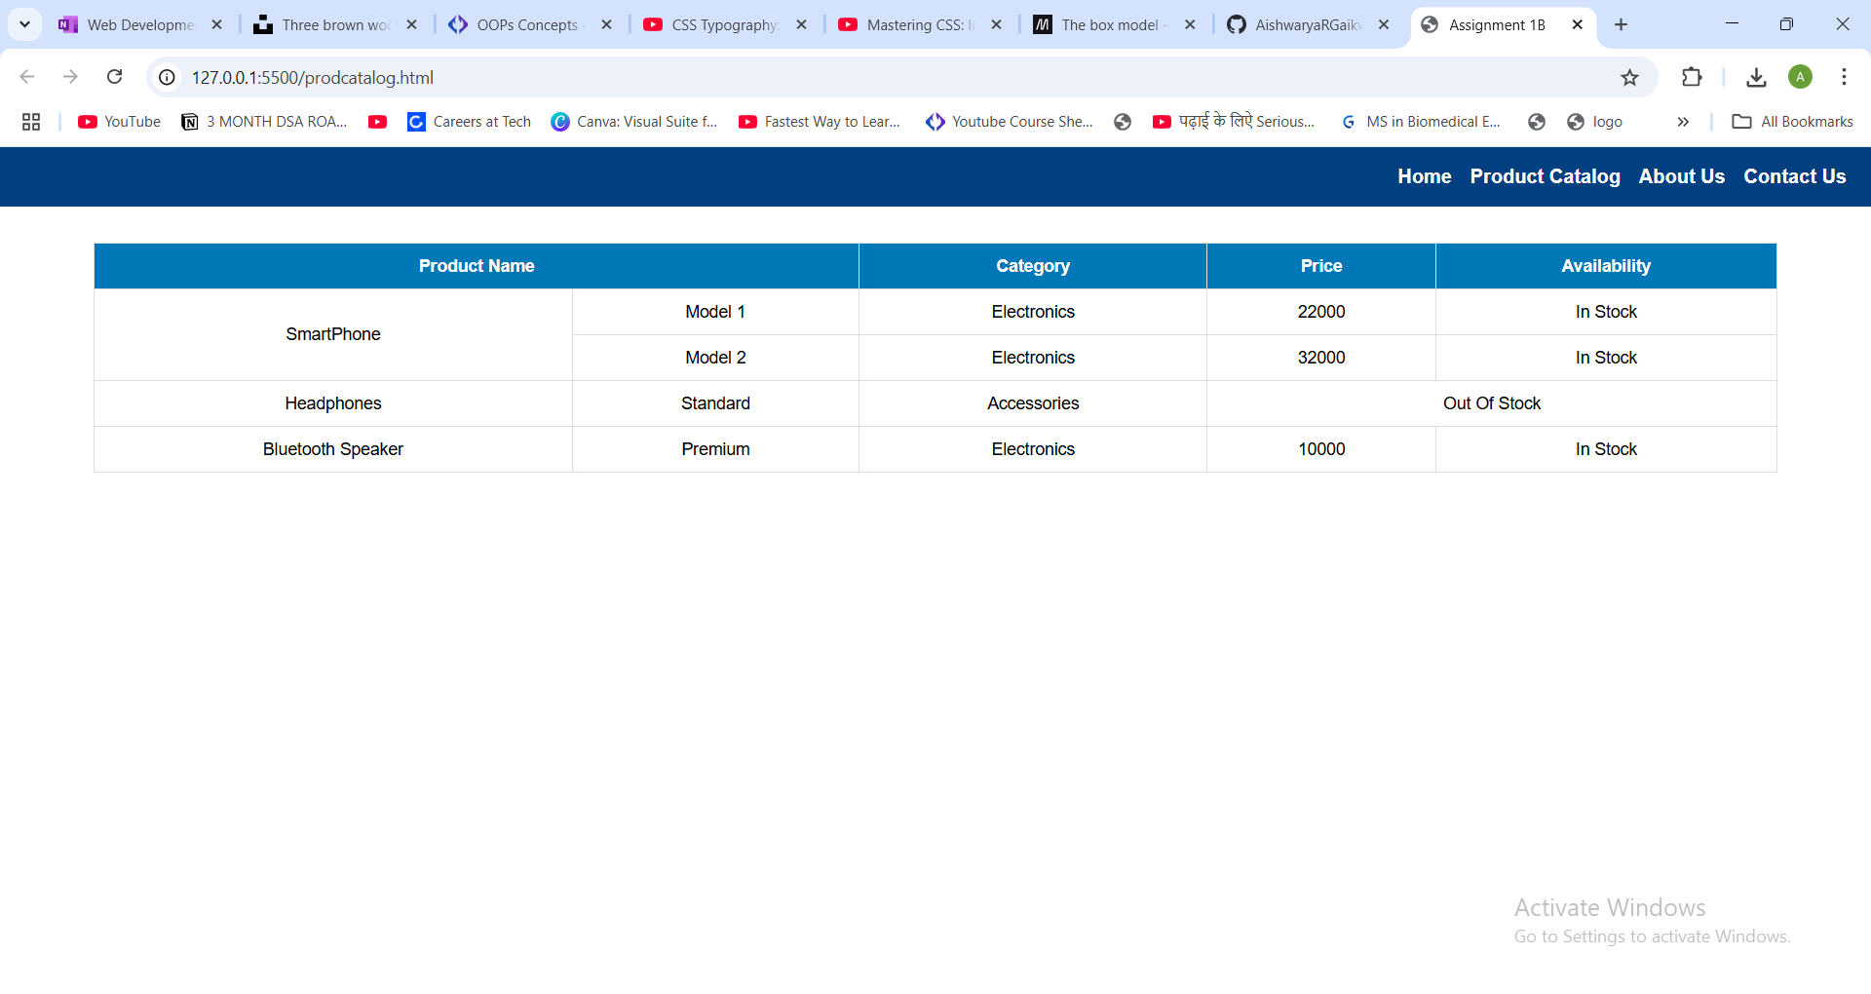

 Assignment 1C: Build a user registration form with proper labeling

Daily Project: Style the yesterday given form into a professional-looking design

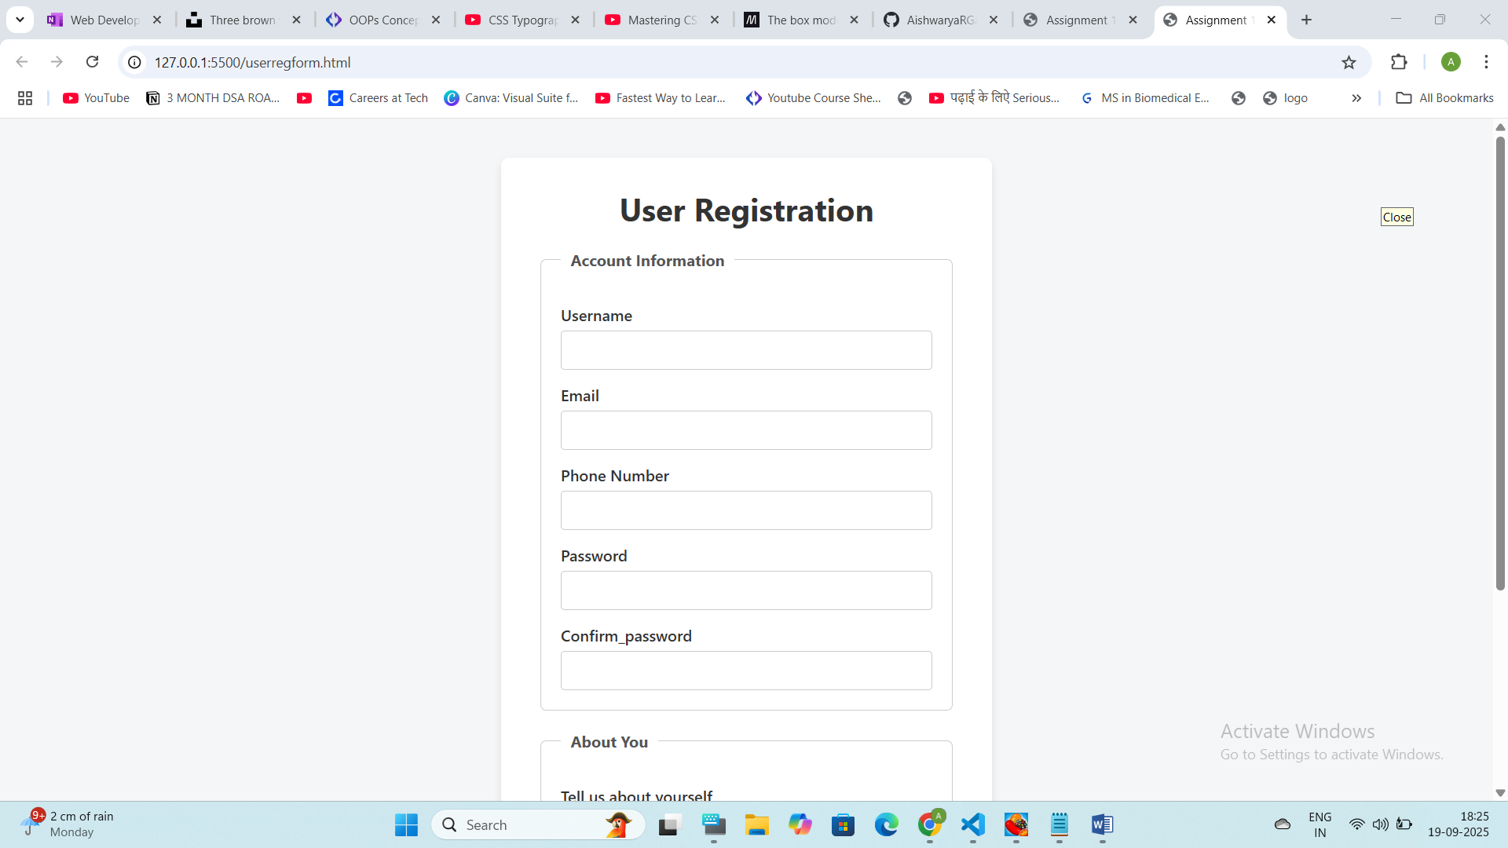

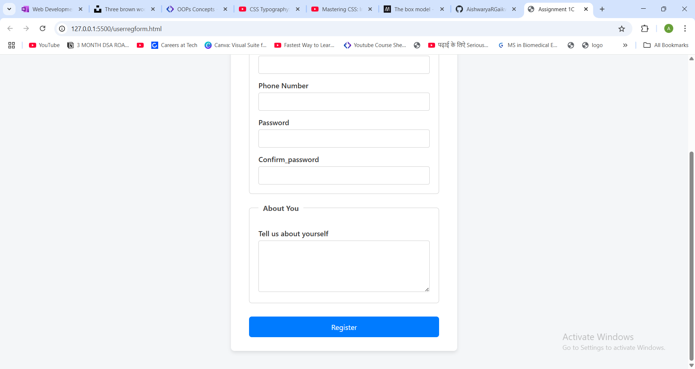

Assignment 1D: Create a comprehensive contact form with all learned elements

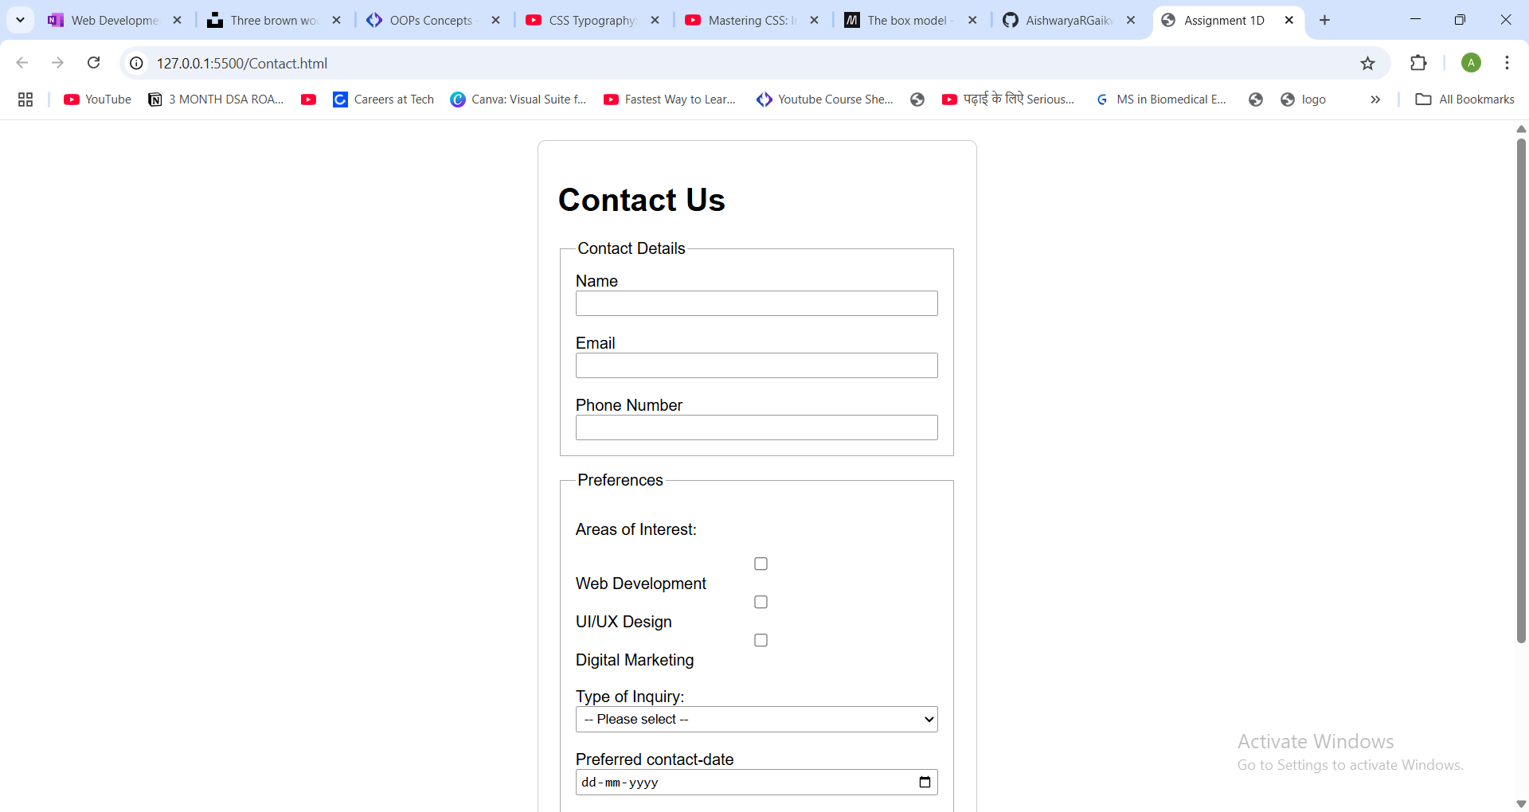

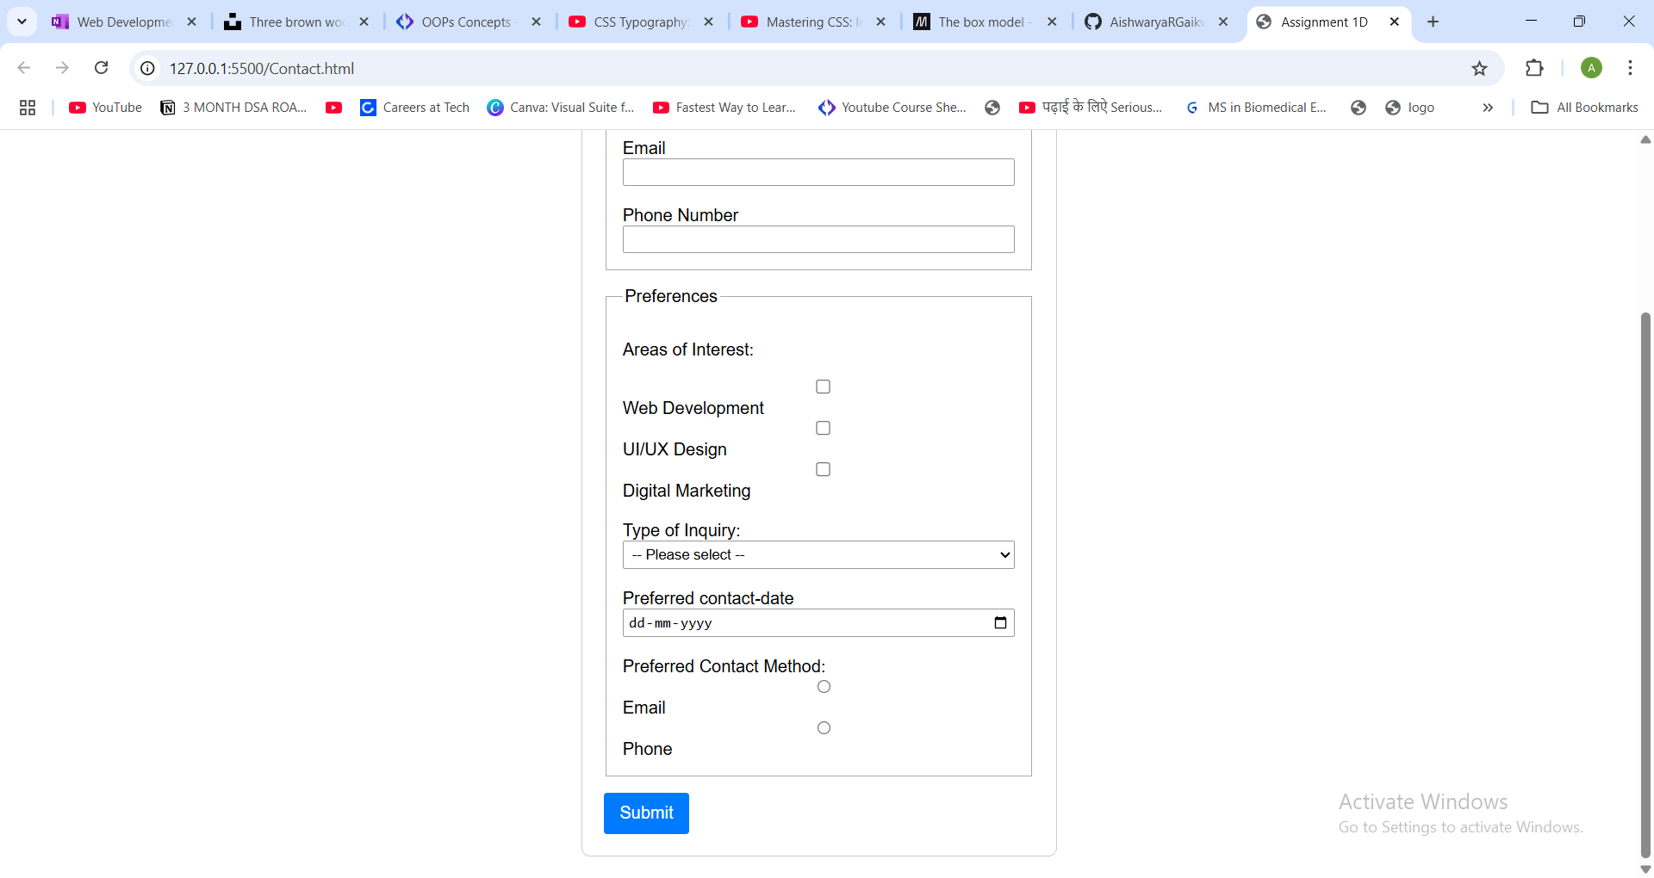

Daily Project: Build a complete "Bank statement upload Form" combining all above concepts with below field

 Excel File upload (Excel only)

 Bank name (Dropdown)

 File password

 Person Email

 Labels

 Person mobile (10 number only, and start with 6,7,8,9 )

 Statement date

 Account type (Saving, current ) Radio button

 Check box : I agree to term and condition

 Submit and reset button

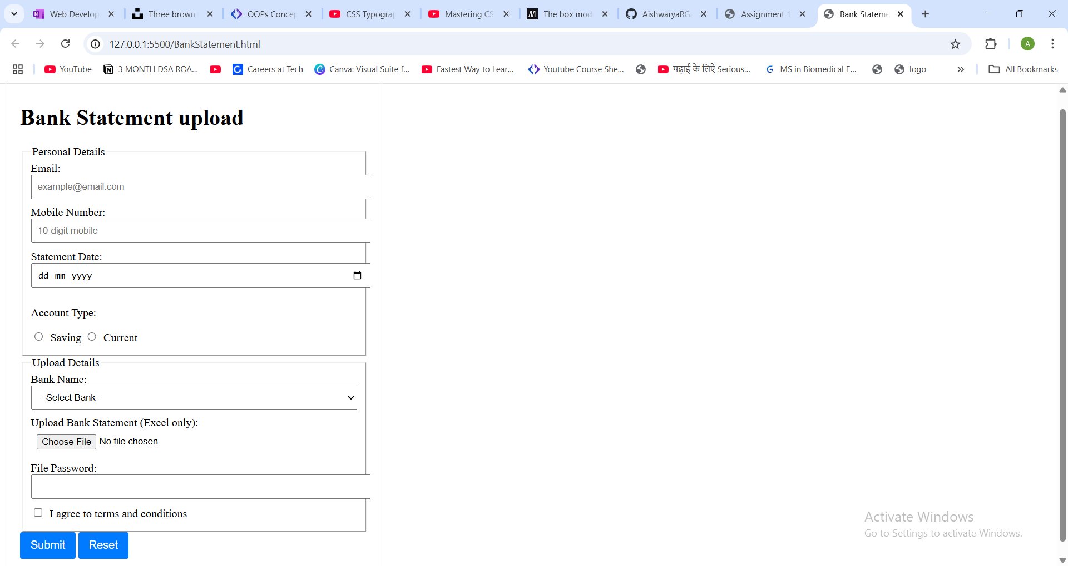

Assignment 2B: Create styled card components using box model properties

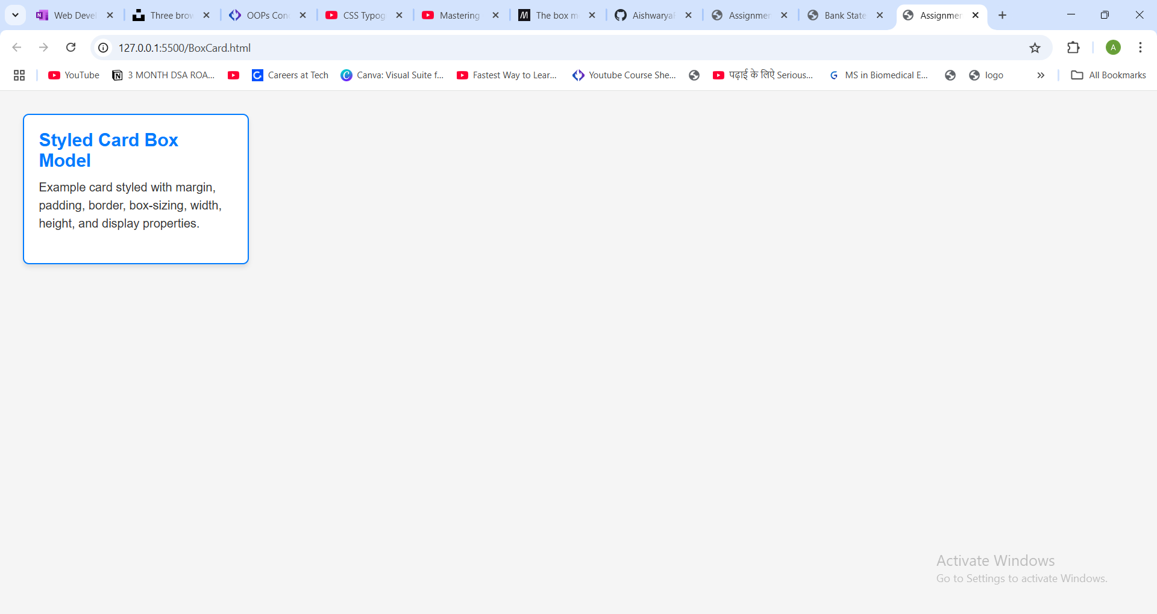

Assignment 2C: Design a typography-focused landing page section

