Practical No: 5

Aim: Perform a BLAST search on a specific gene sequence of a specify

organism.

URL: National Center for Biotechnology Information Site

<https://www.ncbi.nlm.nih.gov/>

Step 1:

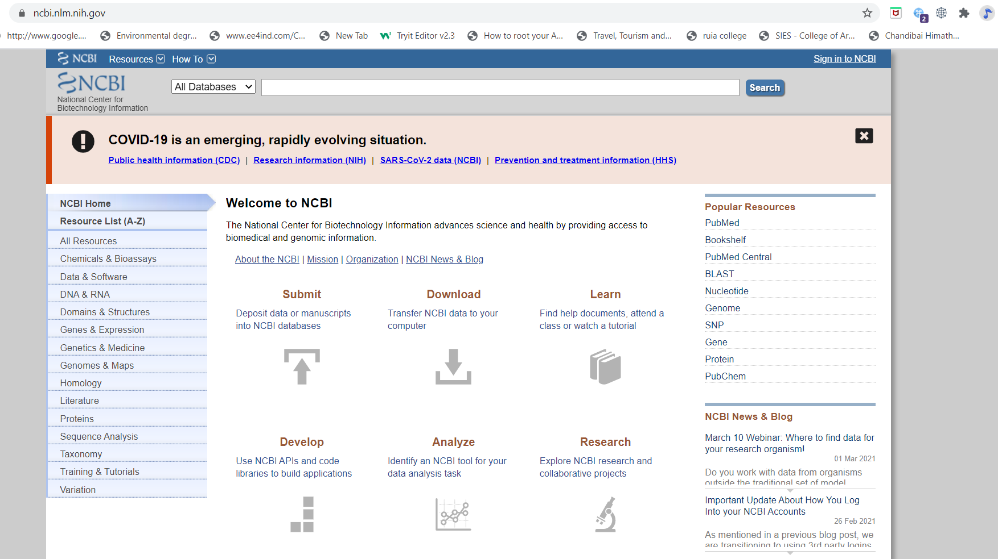

Step 2:

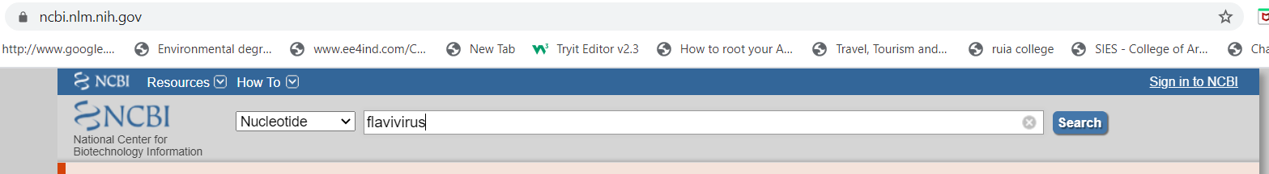

Step 3:

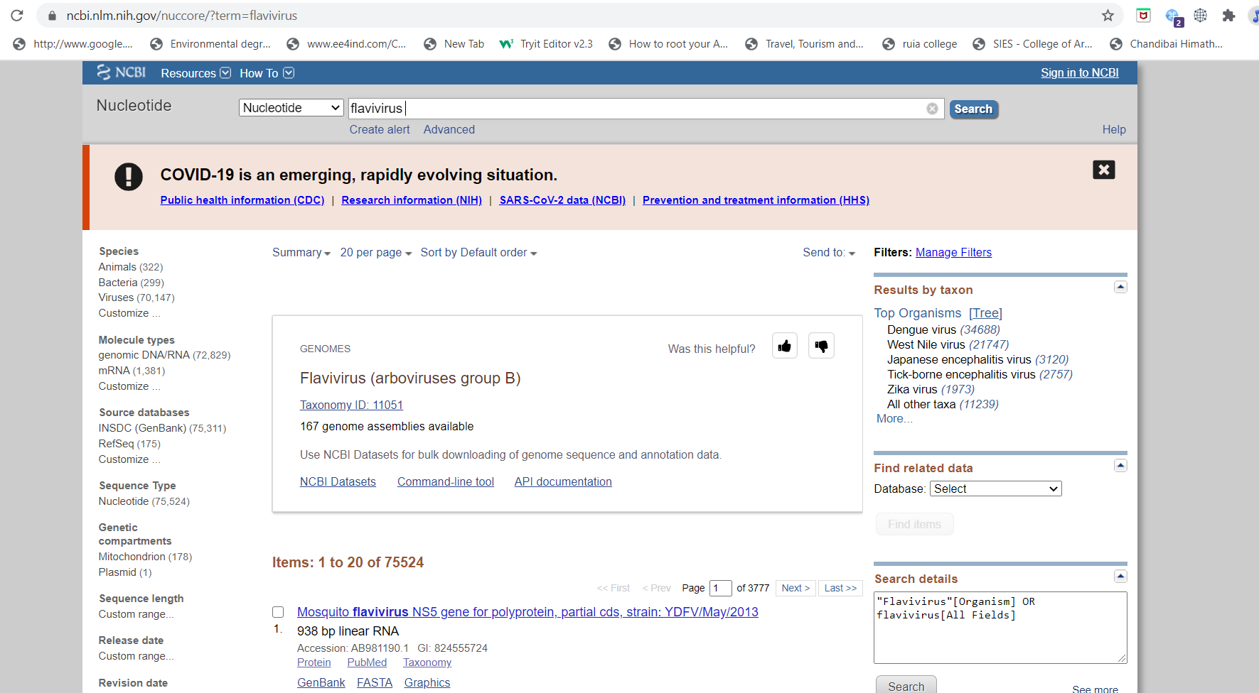

Step 4:

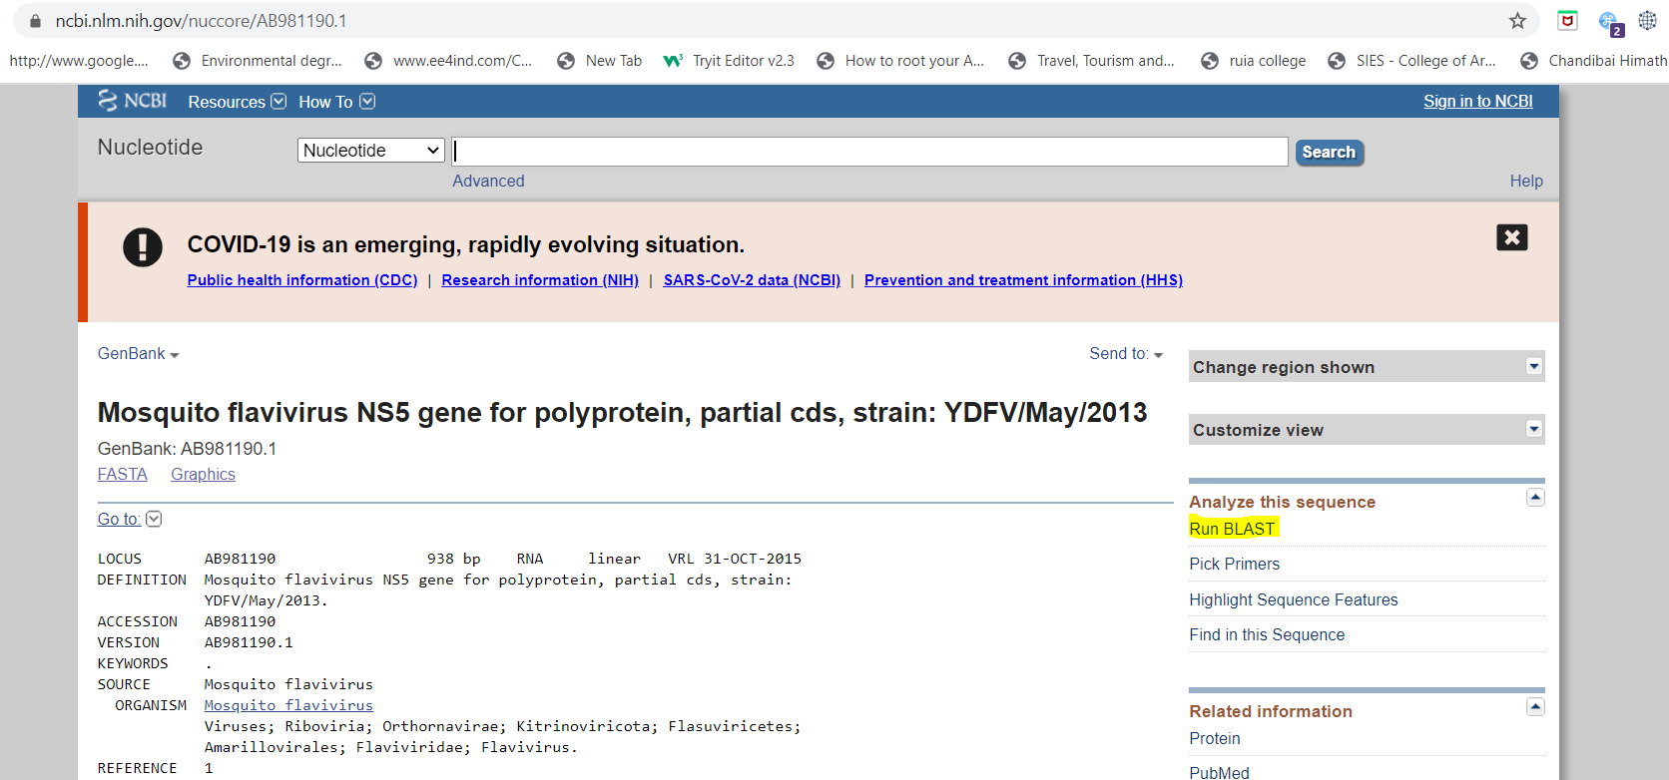

Step 5:

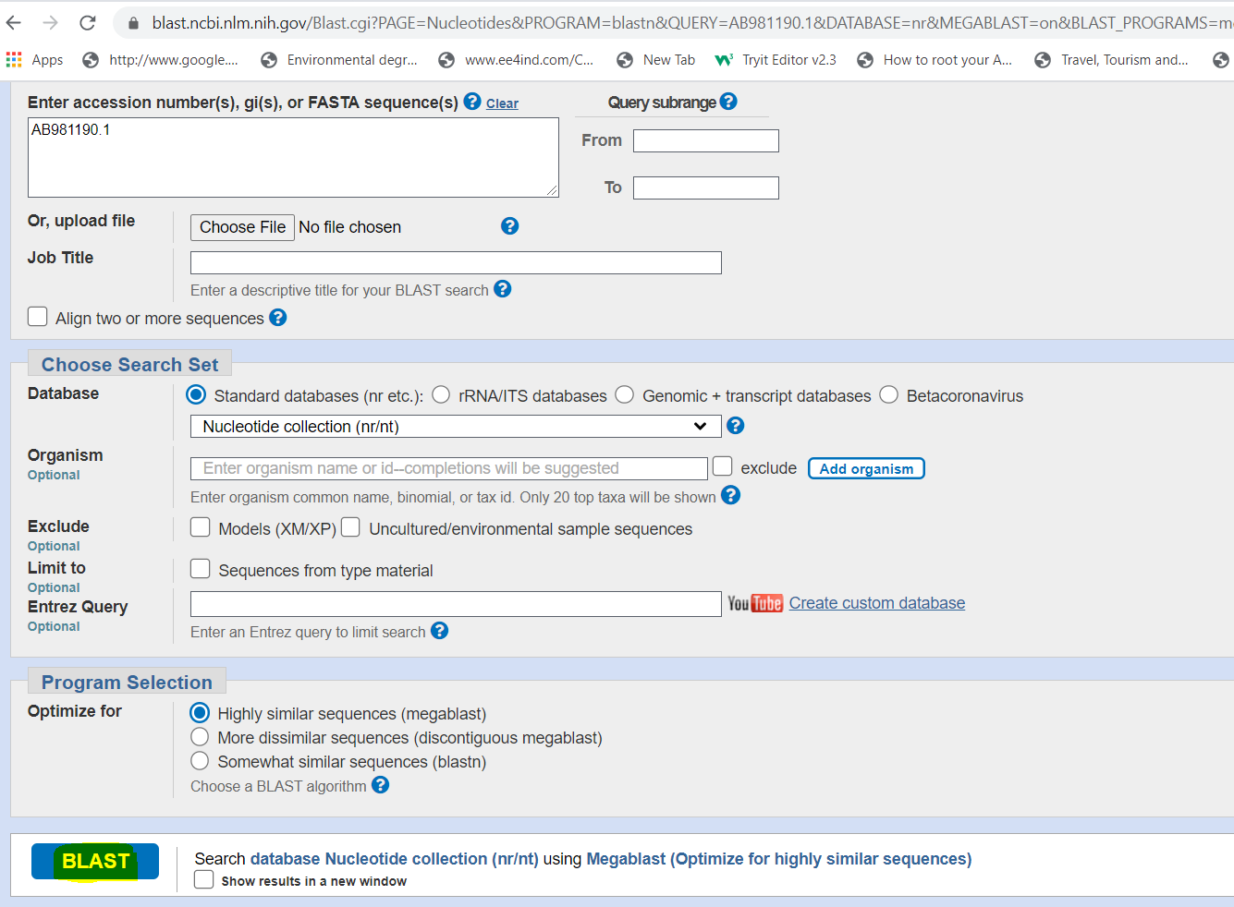

Step 6:

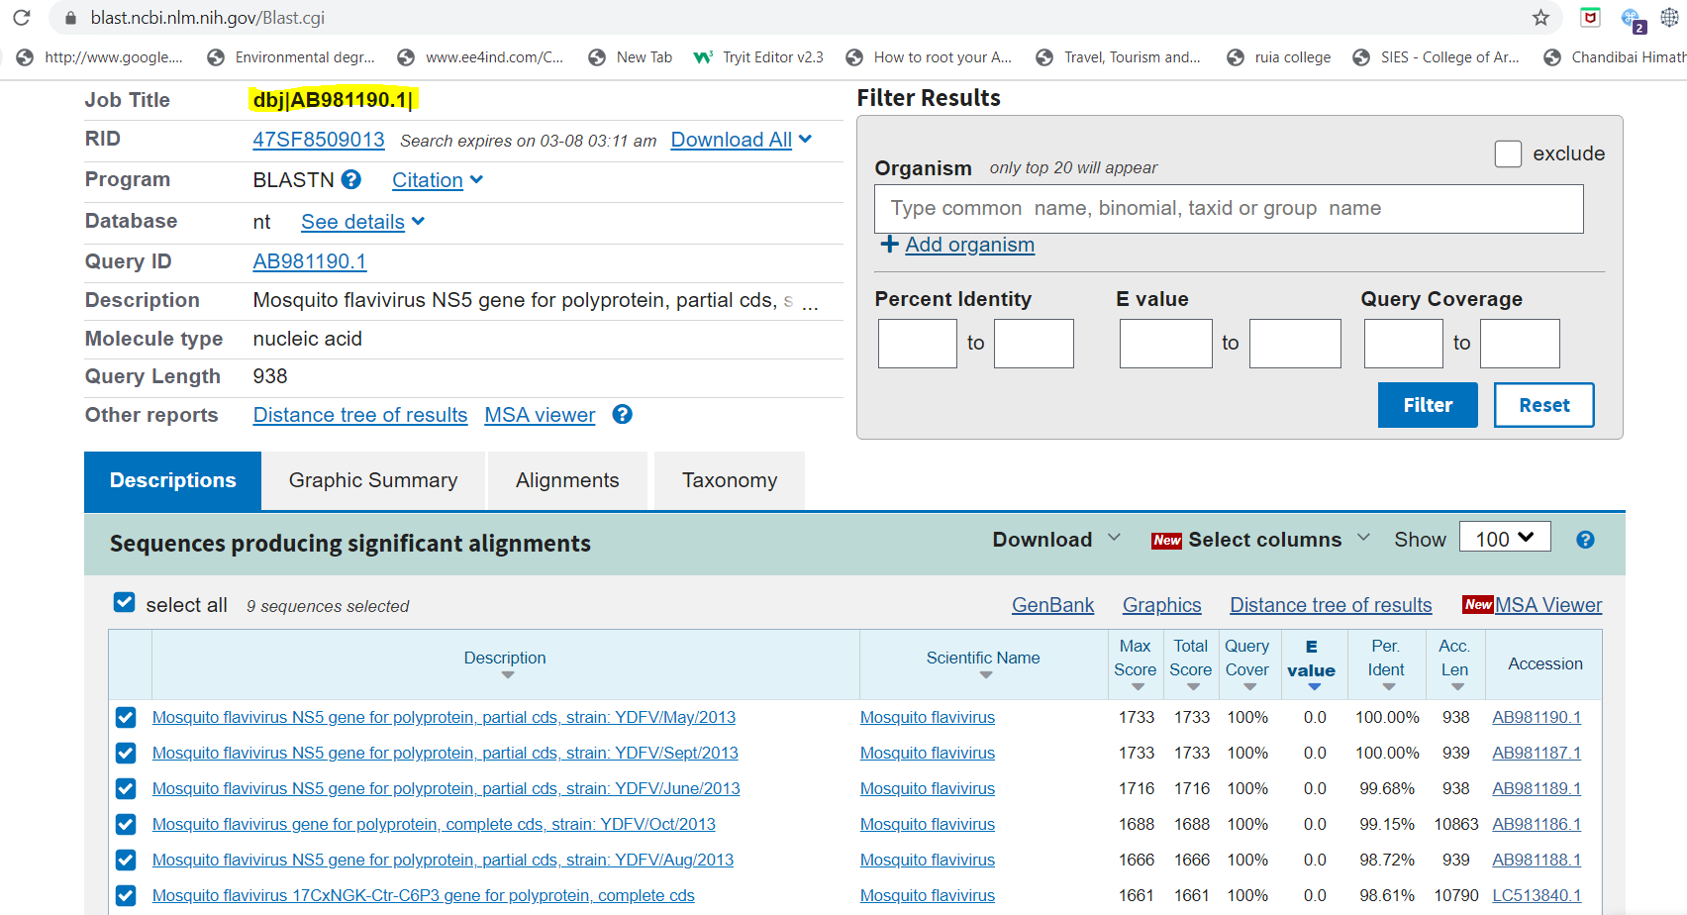

Step 7:

