**P3 : Final ERD**

**Final Entity Relationship Diagram**

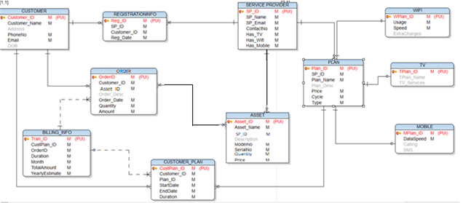

**Modifications to the final ERD**

1. We observed that the relationship between the Service Provider and Asset entities is 1:Many, as opposed to the Many:Many as mapped initially. Hence, Order table was eliminated from the final ERD.
2. Service Provider entity is now directly linked to the Asset entity with 1:M mapping.
3. Few additional attributes added to the Asset entity :
   1. Foreign Key SP_ID which references the Service Provider entity is included in this entity.
   2. Quantity attribute has been added to store the information regarding the no of each asset owned by the service provider.
4. Cust_Order_Mapping entity has been renamed to ORDER.
5. A direct link is established between Asset and ORDER entities.
6. Foreign key, AssetID, has been added to the ORDER entity, which references the Asset entity.

**Final Design Document**

