1.<https://www.google.co.in/webhp>

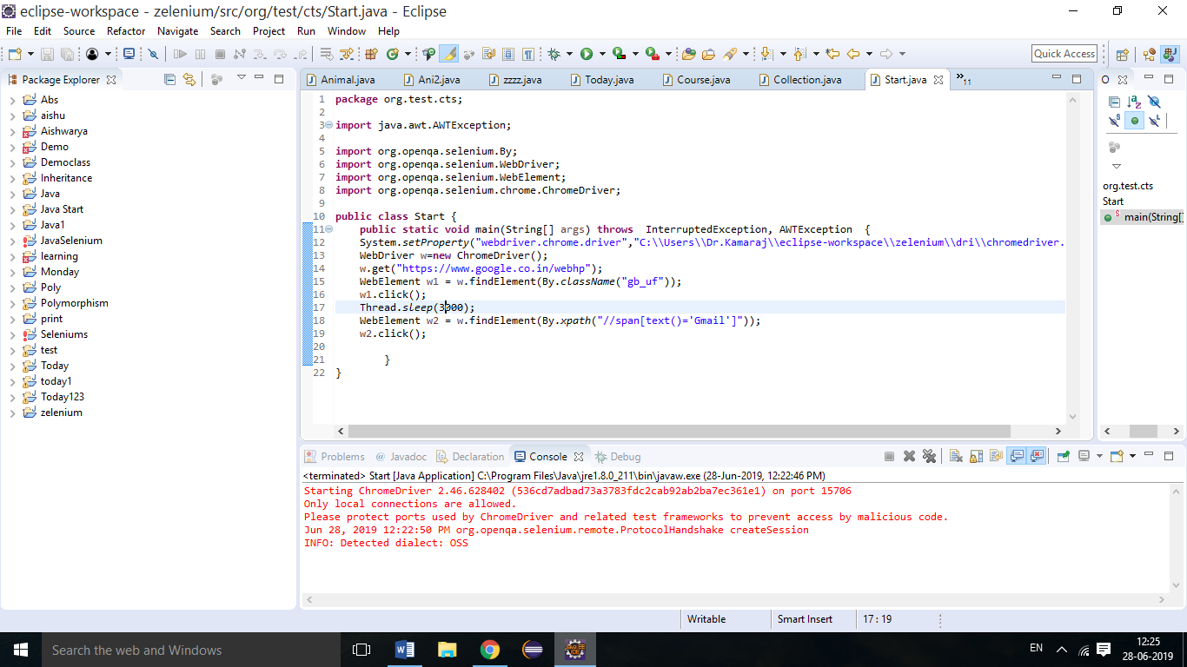

2.[http://www.greenstechnologys.com](http://www.greenstechnologys.com/)

Select first paragraph using double click then right click and select save using Robot class

