SQL

1. Overall Churn Rate
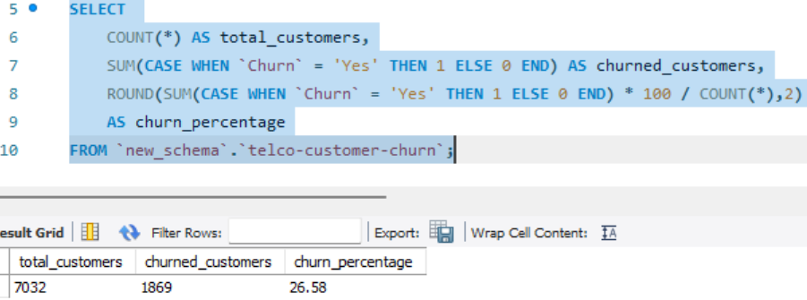

2. Churn by Gender

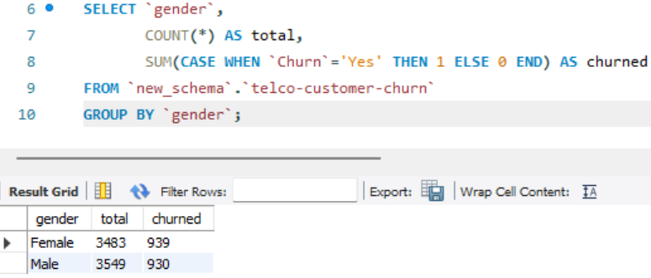

3.Churn by Contract Type
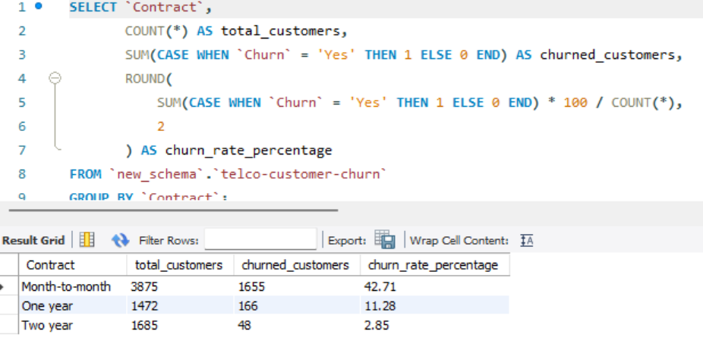

4. Churn by Tenure Group (MySQL Workbench Format)

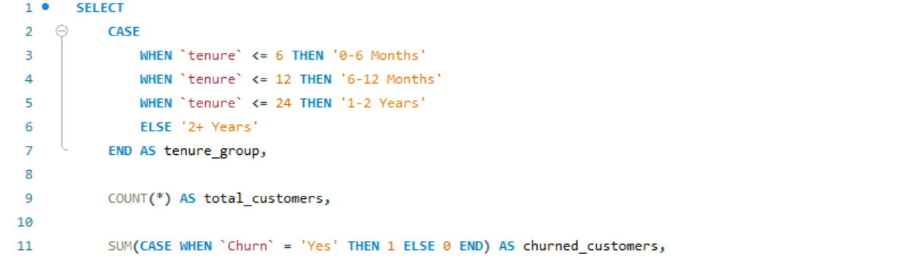
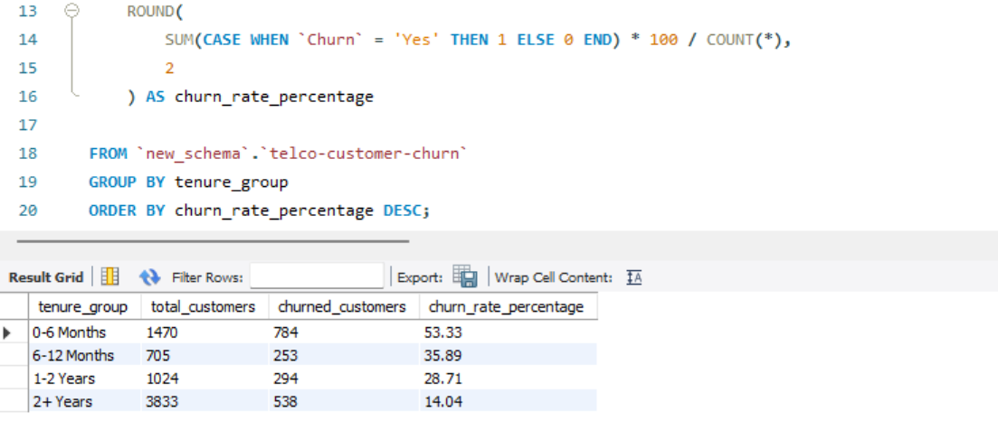

5. Average Monthly Charges of Churned vs Non-Churned

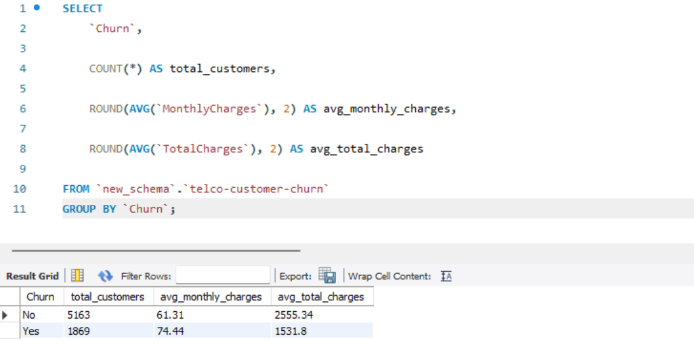

6. Top Churn Payment Method
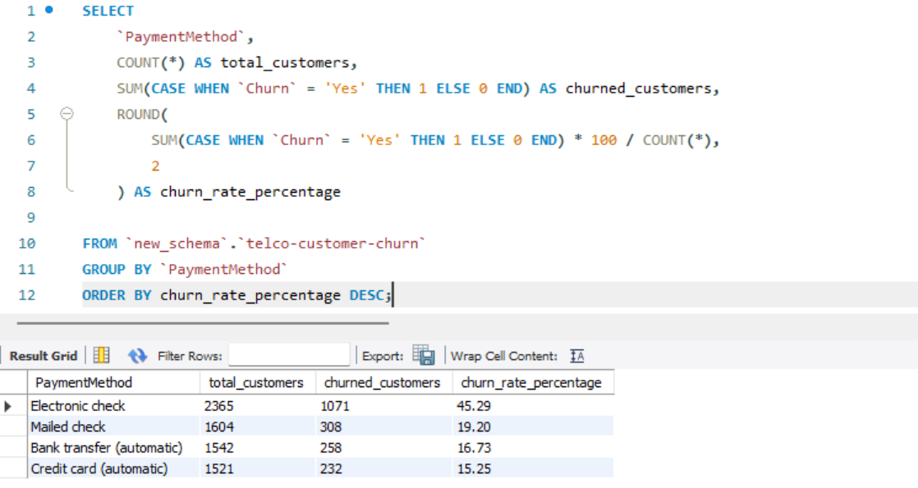

8. High Risk Customers

Contract = 'Month-to-month'
MonthlyCharges > 70
tenure < 12
Churn = 'Yes';

