**VOSK Installation steps:**

1) Create a virtual environment in Ubuntu

virtualenv -p python3.8 $HOME/tmp/masterseminar/

(vosk is compatible with python version: 3.5-3.9, pip version: 20.3 and newer)

2) Activating the environment

source $HOME/tmp/masterseminar/bin/activate

3)Install Vosk

pip3 install vosk

4) pip install ffmpeg

pip3 install pydub (Not sure if these 2 packages are required)

5) Install PyAudio

sudo apt-get install portaudio19-dev python3-pyaudio

git clone https://people.csail.mit.edu/hubert/git/pyaudio.git

6)pip install sounddevice

7) Go to the link and download test_microphone.py file

https://github.com/alphacep/vosk-api/blob/master/python/example/test_microphone.py

8) Go to the link and download any model that you want (I downloaded Lightweight Indian english Model [vosk-model-small-en-in-0.4](https://alphacephei.com/vosk/models/vosk-model-small-en-in-0.4.zip))

9) Copy both Model and test_microphone.py file in your created virtual environment folder inside bin folder

10) Run the python file using : python test_microphone.py

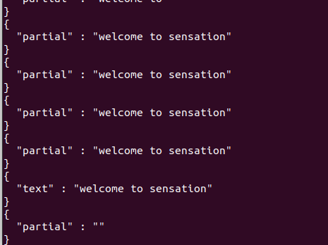You will be able to see such output recognizing your speech:

**Start SENSATION on boot:**

Open terminal

sudo nano /etc/systemd/system/sensation.service

------------------------------------

[Unit]

Description=Start SENSATION on boot

After=network.target

[Service]

ExecStart=/bin/bash -c 'cd /home/aishwarya/tmp/masterseminar/ && source bin/activate && python /home/aishwarya/tmp/masterseminar/bin/sensation.py'

WorkingDirectory=/home/aishwarya/tmp/masterseminar/bin/

User=aishwarya

Group=aishwarya

Restart=always

[Install]

WantedBy=multi-user.target

--------------------------------------

paste above code and then press Ctrl+X and then Y to save the file

sudo chmod 644 /etc/systemd/system/sensation.service

sudo systemctl enable sensation.service

sudo systemctl start sensation.service

sudo systemctl status sensation.service