Pet Health Datasets for Capstone Project.
This document provides a curated list of open-source veterinary and pet-health datasets that can be used for building a capstone project on AI-powered disease prediction in pets. The datasets include structured health records, symptom data, and veterinary images (stool, vomit, urine, skin, etc.). Each dataset includes a description, link, an explanation of how it will be utilized in the project, along with a sample example (symptom+disease or image+disease).

Animal Veterinary Health Dataset (Kaggle)
Structured dataset with records of animal health indicators, including pregnancy status and disease diagnoses.
Link: https://www.kaggle.com/datasets/sathwiknomula/animal-veterinary-health-dataset
Tables - Animal_Vet.xlsx
How We Will Use It: We will use this dataset to train models that map structured veterinary health records and symptoms to disease predictions.
Example: Example: Symptom - 'Abortion in pregnant cow' → Disease - 'Brucellosis'.
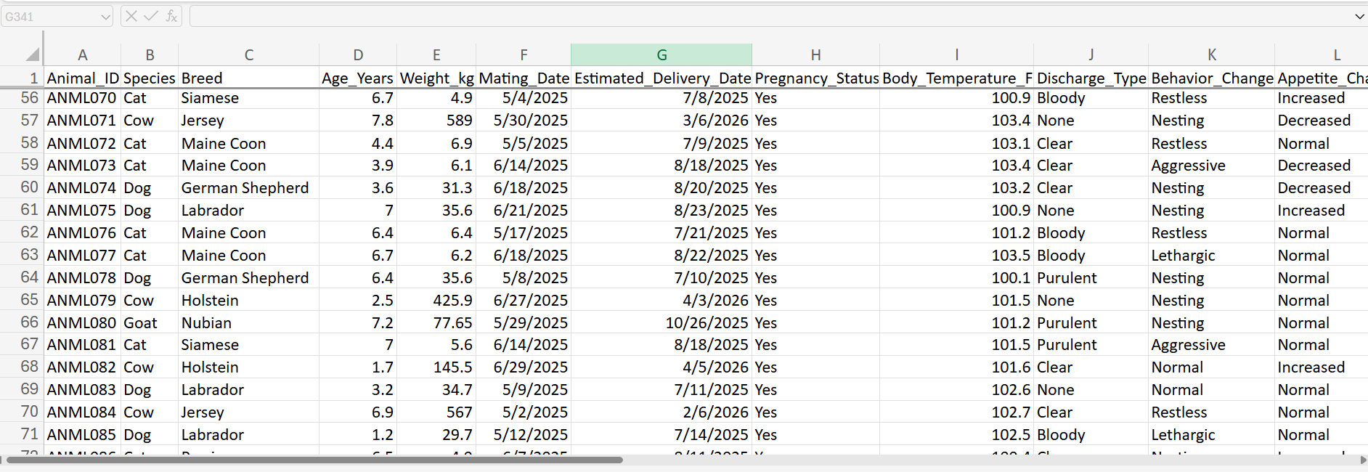

Pet Health Symptoms Dataset (Kaggle)
Synthetic text dataset with pet symptoms labeled by condition type.
Link: https://www.kaggle.com/datasets/yyzz1010/pet-health-symptoms-dataset
Tables -
How We Will Use It: This dataset will help us build an NLP model for analyzing owner-reported symptoms like 'not eating' or 'sleeping a lot'.
Example: Example: Symptoms - 'Vomiting, not eating, lethargic' → Disease - 'Gastroenteritis'.
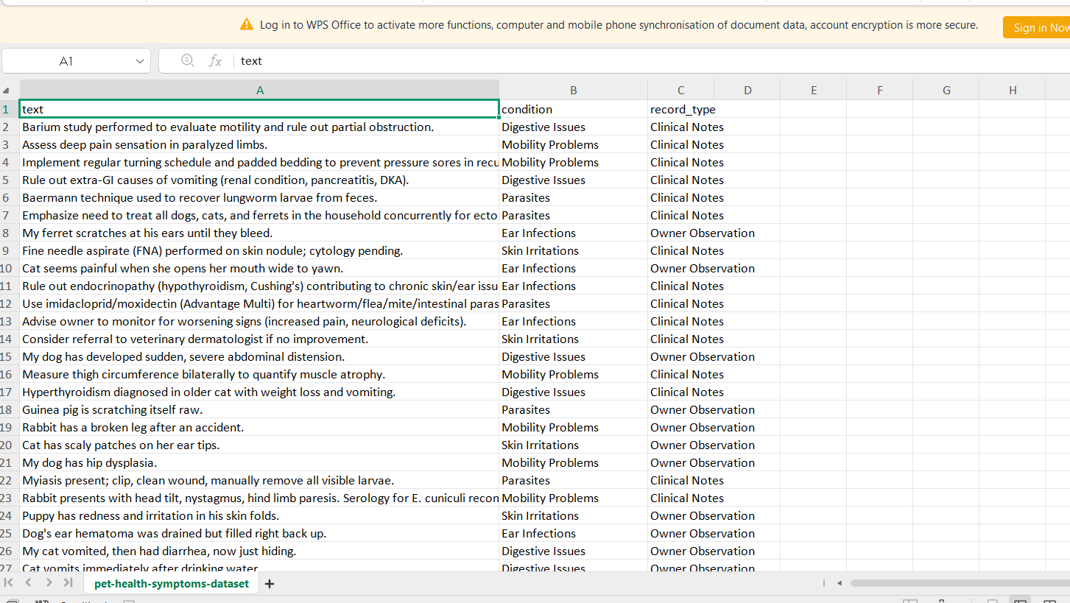

Dog Poop Dataset (Kaggle)
Image dataset focusing on canine defecation behaviors and stool classification.
Link: https://www.kaggle.com/datasets/wengjiyao/dog-poop-dataset
How We Will Use It: We will use this dataset to train a CNN to classify stool images and detect abnormalities.
Example: Example: Image - 'Loose watery stool' → Possible Disease - 'Parvovirus infection'.
[Screenshot not available]

Dog Skin Diseases Dataset (Roboflow)
Labeled images for classifying dog skin conditions like bacterial or fungal infections.
Link: https://universe.roboflow.com/pethealth/dog-skin-disease-dataset-s8tt2
How We Will Use It: This dataset will allow us to train image classification models that can detect visible dermatological diseases.
Example: Example: Image - 'Red inflamed patches on skin' → Disease - 'Fungal infection'.
[Screenshot not available]

Dog's Diseases Image Dataset (Kaggle)
Broad dataset of images for different dog diseases.
Link: https://www.kaggle.com/datasets/amartya0roy/dogs-diseases
How We Will Use It: We will use this dataset to generalize our CNN model to recognize multiple dog diseases from images.
Example: Example: Image - 'Dog with eye discharge and dull coat' → Disease - 'Canine Distemper'.
[Screenshot not available]

Classification of Pet Dog Skin Diseases (Mendeley Data)
Skin images of 95 dogs with bacterial, fungal, allergic conditions, and healthy controls.
Link: https://data.mendeley.com/datasets/5dbht54kw7/1
How We Will Use It: We will utilize this dataset for validating and benchmarking our CNN models.
Example: Example: Image - 'Crusty lesions around mouth' → Disease - 'Allergic Dermatitis'.
[Screenshot not available]
Next Steps for Your Project
- Symptom-based model: Use the Animal Veterinary Health and Pet Health Symptoms datasets for training an ML classifier.
- Image-based model: Use Dog Skin Diseases (Roboflow) and Mendeley Dog Skin Diseases datasets to develop your CNN for visual diagnosis.
- Stool/vomit/urine images: Start with Dog Poop dataset; consider collecting supplementary images if needed.
- Data integration: If VetDataHub hosts relevant datasets for vomiting or urine abnormalities, you can enrich your data further.

OUR IDEA :
- Multi-Modal Diagnosis (Symptoms + Images Together)
  - Most existing works use either symptoms (text/fuzzy systems) OR images (CNN/deep learning).
  - You can combine both:
    - Example: If the owner reports vomiting + lethargy, and uploads an image of stool/urine/skin, your system fuses both inputs to improve accuracy.
  - This makes your approach more reliable than symptom-only or image-only systems.

- Explainable AI for Pet Owners
  - Existing systems mostly give a disease label.
  - You can provide reasoning/explanations:
    - “Based on vomiting + yellowish stool + image features, there’s a 75% chance of liver infection.”
  - Adding explainability (via rule-based reasoning, SHAP, or decision trees alongside deep learning) will make your system trustworthy.

- Rarely Addressed Input Sources (Vomit/Urine/Stool Images)
  - Most papers focus on skin lesions in pets.
  - Very few tackle internal signs like vomit color/texture, urine shade, stool consistency.
  - Including these image datasets (even if partially synthetic/augmented) makes your work unique.

- Owner-Friendly, Non-Expert Inputs
  - Many papers assume veterinary-quality data (scans, medical records).
  - You can build for casual owners, who only have:
    - A smartphone camera
    - Ability to describe symptoms in plain language
  - This makes your project practical in real-world pet-owner scenarios.

- Early Warning + Recommendation System
  - Instead of just saying “Your dog has X disease”, your system could:
    - Predict likelihood of multiple possible diseases
    - Suggest next steps (visit vet urgently, or home care possible, or monitor symptoms).
  - This bridges the gap between prediction and action.

- Cross-Species Extension (Dogs + Cats, maybe more later)
  - Most studies are limited to dogs.
  - If you build your dataset/system in a way that can be extended to cats (and maybe other small pets), it increases novelty.
So in short, your differentiator could be:
A hybrid, multi-modal AI system for pets that uses both symptom descriptions and images (including less-studied data types like vomit/urine/stool), provides explainable results, and is designed specifically for non-expert pet owners.

