**Industrial Internship Report on**

**”Quiz Game”**

**Prepared by**

**[Aishwarya Waje]**

|  |
| --- |
| *Executive Summary* |
| This report provides details of the Industrial Internship provided by upskill Campus and The IoT Academy in collaboration with Industrial Partner UniConverge Technologies Pvt Ltd (UCT).  This internship was focused on a project/problem statement provided by UCT. We had to finish the project including the report in 6 weeks’ time.  My project was creating a project manager, which helps the user to save and recall the old password which were saved earlier.  This internship gave me a very good opportunity to get exposure to Industrial problems and design/implement solution for that. It was an overall great experience to have this internship. |

**TABLE OF CONTENTS**

1 Preface 3

2 Introduction 4

2.1 About UniConverge Technologies Pvt Ltd 4

2.2 About upskill Campus 8

2.3 Objective 9

2.4 Reference 9

3 Problem Statement 11

4 Existing and Proposed solution 12

5 Proposed Design/ Model 13

5.1 High Level Diagram (if applicable) 13

5.2 Low Level Diagram (if applicable) 13

6 Performance Test 14

6.1 Test Plan/ Test Cases 14

6.2 Performance Outcome 14

7 My learnings 15

8 Future work scope 16

# Preface

In this whole 6-week internship I got to learn a lot of things related with technical terms as well as terms related with industrial experience too. In this project of creating password manager, we have created a user-friendly interface which helps the user to save the password foe different websites and different E-mails, which we can get after recalling with the input of website and E-mail. We have completed this project with the help of tinker. We have submitted every week’s progress of this project where you will find the detailed slow and steady progress of our project. We are really grateful to get this opportunity from UCT/USC. There is a massive need of relevant Internship in career development, which is fulfilled by this opportunity.

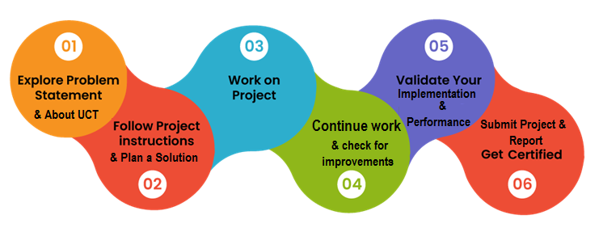

I really felt overwhelmed when I got this amazing opportunity at this stage, where a learner needs such more opportunities for inspiration and increase industrial as well as learning experiences.

# Introduction

## About UniConverge Technologies Pvt Ltd

A company established in 2013 and working in Digital Transformation domain and providing Industrial solutions with prime focus on sustainability and RoI.

For developing its products and solutions it is leveraging various**Cutting Edge Technologies e.g. Internet of Things (IoT), Cyber Security, Cloud computing (AWS, Azure), Machine Learning, Communication Technologies (4G/5G/LoRaWAN), Java Full Stack, Python, Front end**etc.



1. UCT IoT Platform **(****)**

**UCT Insight** is an IOT platform designed for quick deployment of IOT applications on the same time providing valuable “insight” for your process/business. It has been built in Java for backend and ReactJS for Front end. It has support for MySQL and various NoSql Databases.

* It enables device connectivity via industry standard IoT protocols - MQTT, CoAP, HTTP, Modbus TCP, OPC UA
* It supports both cloud and on-premises deployments.

It has features to  
• Build Your own dashboard  
• Analytics and Reporting  
• Alert and Notification  
• Integration with third party application(Power BI, SAP, ERP)  
• Rule Engine

 

1. **Smart Factory Platform (****)**

Factory watch is a platform for smart factory needs.

It provides Users/ Factory

* with a scalable solution for their Production and asset monitoring
* OEE and predictive maintenance solution scaling up to digital twin for your assets.
* to unleased the true potential of the data that their machines are generating and helps to identify the KPIs and also improve them.
* A modular architecture that allows users to choose the service that they what to start and then can scale to more complex solutions as per their demands.

Its unique SaaS model helps users to save time, cost and money.

 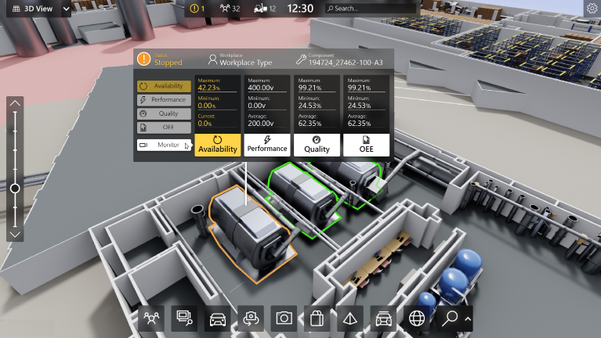

1.  based Solution

UCT is one of the early adopters of LoRAWAN teschnology and providing solution in Agritech, Smart cities, Industrial Monitoring, Smart Street Light, Smart Water/ Gas/ Electricity metering solutions etc.

1. Predictive Maintenance

UCT is providing Industrial Machine health monitoring and Predictive maintenance solution leveraging Embedded system, Industrial IoT and Machine Learning Technologies by finding Remaining useful life time of various Machines used in production process.



## About upskill Campus (USC)

upskill Campus along with The IoT Academy and in association with Uniconverge technologies has facilitated the smooth execution of the complete internship process.

USC is a career development platform that delivers **personalized executive coaching** in a more affordable, scalable and measurable way.



Seeing need of upskilling in self paced manner along-with additional support services e.g. Internship, projects, interaction with Industry experts, Career growth Services

<https://www.upskillcampus.com/>

upSkill Campus aiming to upskill 1 million learners in next 5 year

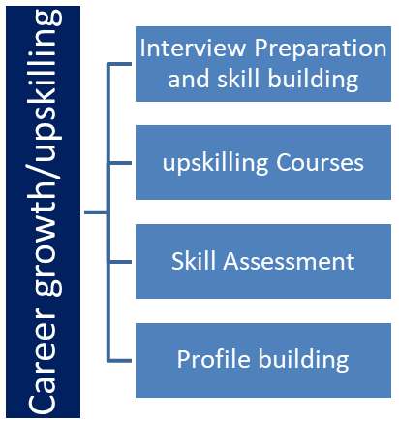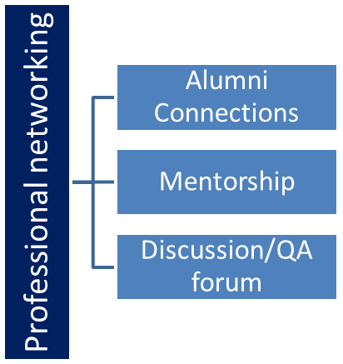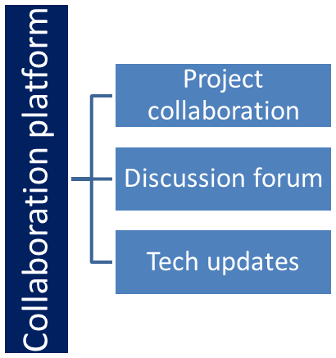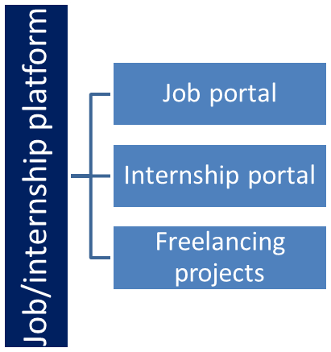

## The IoT Academy

The IoT academy is EdTech Division of UCT that is running long executive certification programs in collaboration with EICT Academy, IITK, IITR and IITG in multiple domains.

## Objectives of this Internship program

The objective for this internship program was to

 ☛ get practical experience of working in the industry.

 ☛ to solve real world problems.

 ☛ to have improved job prospects.

 ☛ to have Improved understanding of our field and its applications.

 ☛ to have Personal growth like better communication and problem solving.

## Reference

[1] GitHub

[2] YouTube

[3] AI platform

# Problem Statement

* Quiz Game

Description: The quiz game is a Python project that quizzes users on various topics. It reads questions and answers from a file or database, presents them to the user, and keeps track of their score.

Scope: The scope of this project involves designing a user interface to display questions and collect user answers, implementing a database or file system to store quiz data, and developing a scoring algorithm to track the user's progress and calculate their final score.

# Existing and Proposed solution

Existing solutions for quiz gam in Python vary in complexity and features. Some basic implementations use simple file-based storage with encryption, while more advanced solutions may incorporate databases and additional security measures.

However, these solutions often have limitations. For example, some quiz games have time limit. Because of this user can not attempt all the questions.

Proposed Solution have no time limit. Also it has less number of questions so that user may not get bore.

## Code submission (Github link)

## Report submission (Github link) : first make placeholder, copy the link.

# Proposed Design/ Model

## High Level Diagram (if applicable)

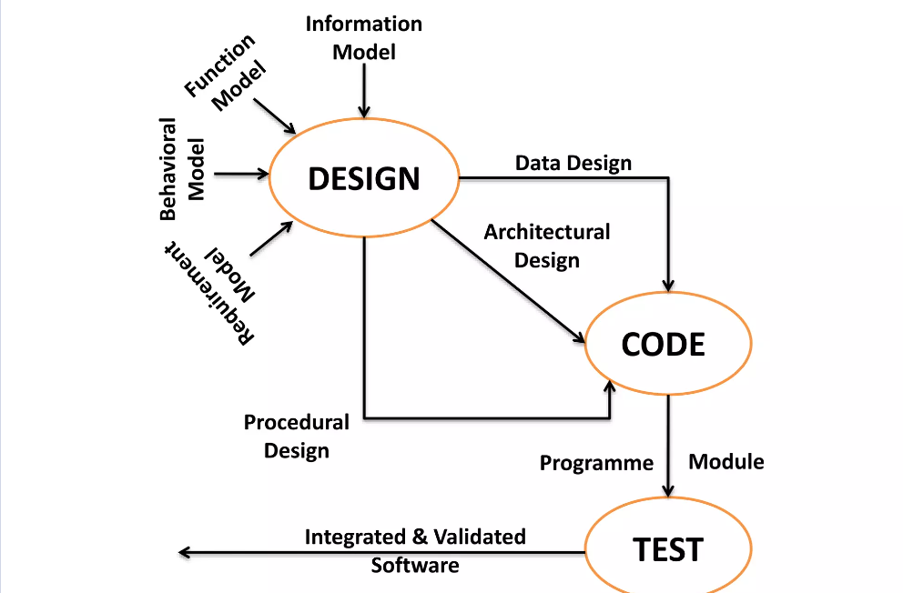

## Low Level Diagram (if applicable)

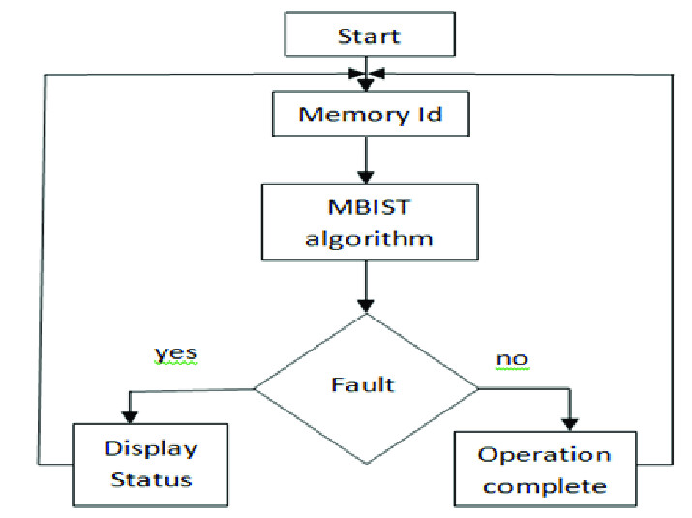

# Performance Test

This is very important part and defines why this work is meant of Real industries, instead of being just academic project.

Here we need to first find the constraints.

How those constraints were taken care in your design?

What were test results around those constraints?

Constraints can be e.g. memory, MIPS (speed, operations per second), accuracy, durability, power consumption etc.

In case you could not test them, but still, you should mention how identified constraints can impact your design, and what are recommendations to handle them.

## Test Plan/ Test Cases

* Encryption Test:

Test Case 1: Verify that user scores are encrypted before being stored.

Test Case 2: Verify that encrypted user scores are decrypted correctly when retrieved.

* Storage Test:

Test Case 3: Verify that user scores are stored securely and cannot be accessed without proper authentication.

Test Case 4: Verify that user scores are stored in a format that is not easily readable.

* User Interface Test:

Test Case 5: Verify that the user interface is intuitive and easy to navigate.

Test Case 6: Verify that users can start and complete the quiz easily.

* Compatibility Test:

Test Case 7: Verify that the quiz game works correctly on different operating systems (Windows, macOS, Linux).

* Question Randomization Test:

Test Case 8: Verify that questions are randomized for each quiz session, providing variety for players.

* Localization Test:

Test Case 20: Verify that the quiz game supports localization, allowing it to be translated into different languages for a global audience.

* Extensibility Test:

Test Case 18: Verify that the quiz game can be easily extended to add new features or modify existing ones without significant code changes.

* Usability Test:

Test Case 16: Verify that the quiz game is accessible and usable for players with different levels of experience and abilities.

## Performance Outcome

Performance is a critical aspect of a quiz game, impacting the user experience and overall satisfaction. Ensuring optimal response time is paramount, with the game needing to react promptly to user interactions such as selecting answers and navigating between questions. Scalability is also crucial; the game should accommodate a large number of concurrent users without sacrificing performance. Efficient resource usage is key, requiring careful optimization of CPU, memory, and network bandwidth to prevent slowdowns or crashes, especially under heavy load. Conducting thorough load testing helps identify potential bottlenecks and performance issues, allowing for preemptive optimization. Additionally, database performance plays a vital role, necessitating evaluation of query response times, indexing strategies, and caching mechanisms to enhance data retrieval efficiency. The efficiency of scoring algorithms and any complex calculations should also be optimized to minimize processing time. Ensuring client-side performance across different devices and browsers further enhances the user experience, while robust error handling mechanisms maintain system stability without compromising performance. Finally, third-party integrations should be carefully vetted to prevent latency or downtime that could adversely affect game performance. By prioritizing these performance outcomes, a quiz game can deliver a fast, reliable, and engaging experience for players of all levels.

# My learnings

In this Python project, I have focused on developing a quiz game. Through this project, I have enhanced my problem-solving skills and deepened my understanding of Python programming. I have learned about various concepts such as data encryption, file handling, and user interface design.

This project has not only improved my technical skills but also my ability to manage and organize complex information securely. As I progress in my career, these skills will be invaluable in roles that require software development, cybersecurity, or data management.

Overall, this project has been instrumental in my learning journey, equipping me with the skills and knowledge necessary for my career growth in the field of technology.

# Future work scope

Certainly! Here are some ideas that you could not work on due to time limitations but could be added in the future to enhance your Python project report:

1. Multiplayer Support: Introduce multiplayer functionality to allow users to compete against friends or other players online. This could involve real-time multiplayer quizzes or asynchronous gameplay where players can challenge each other's scores.
2. Social Integration: Implement social media integration to enable users to share their quiz results, achievements, and high scores with friends on platforms like Facebook, Twitter, or Instagram. This can enhance user engagement and promote viral growth.
3. Customizable Quizzes: Provide users with the ability to create and share their own quizzes on various topics. Allow customization of question types, difficulty levels, and time limits to cater to diverse interests and preferences.
4. Gamification Elements: Integrate gamification elements such as badges, achievements, leaderboards, and rewards to incentivize participation and encourage continued engagement. This can foster a sense of competition and progression among players.
5. Enhanced Question Types: Expand the range of question types beyond multiple-choice, including true/false, fill-in-the-blank, matching, and image-based questions. This adds variety to the gameplay experience and challenges players in different ways.
6. Dynamic Content Generation: Implement algorithms to dynamically generate quiz content based on user preferences, historical performance, or trending topics. This ensures that quizzes remain fresh and relevant over time.
7. Adaptive Difficulty: Incorporate adaptive difficulty levels that adjust the challenge based on the player's performance, ensuring an optimal balance between difficulty and enjoyment. This can help cater to players of varying skill levels.
8. Mobile Optimization: Optimize the quiz game for mobile devices with responsive design, touch-friendly controls, and offline support. Mobile optimization expands the potential user base and allows for on-the-go gameplay.
9. Accessibility Features: Enhance accessibility by incorporating features such as screen reader support, high contrast modes, and customizable font sizes. This ensures that the game is inclusive and accessible to users with disabilities.
10. Feedback Mechanisms: Implement feedback mechanisms to gather user input and suggestions for improving the game. Regularly solicit feedback through surveys, polls, or in-app feedback forms to identify areas for enhancement.