**Automated Meeting Room Booking System**  
  
***ProMeet***

**Team- *Pseudonerds***

**Members**

1. Aishwarya Phirke
2. Atharv Vilas Dixit
3. Jyoti Pachori
4. Mohit Tilokchandani
5. Riya Kapoor
6. Shreya Singh
7. Sumit Shrivastav
8. Kopal Agarwal
9. Prathna

**Use Case Diagram**

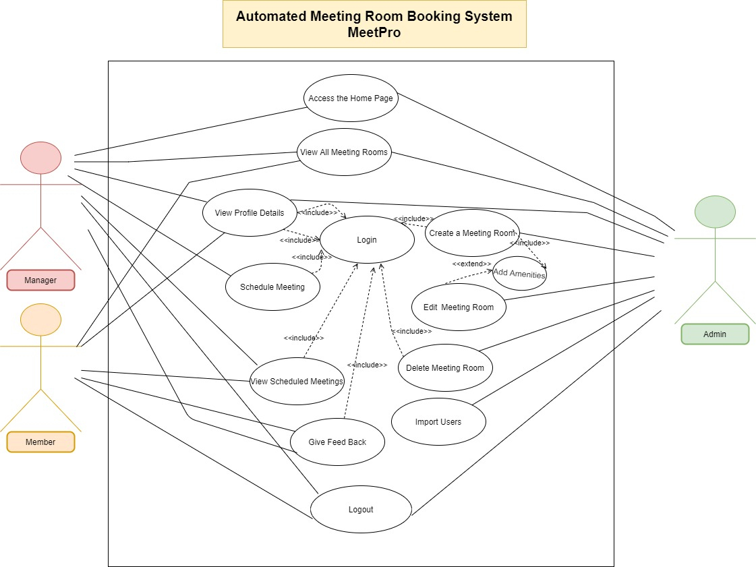

**Data Flow Diagram**

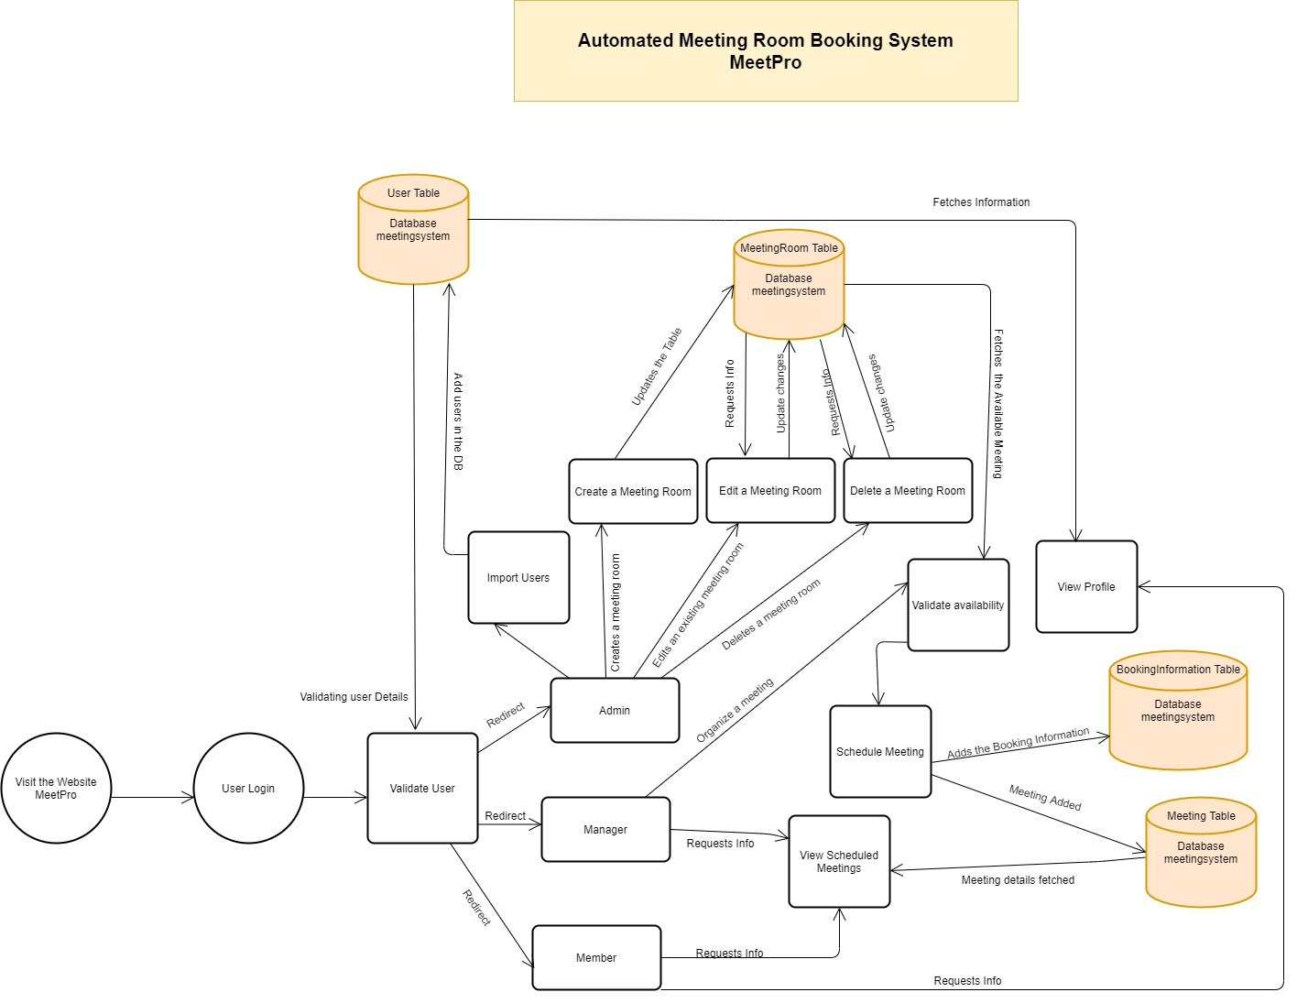

**Class Diagram**

**Entity Relationship Diagram**