# **Amazon Sales and Business Analysis using Power BI**

Name: AISHWARYA B ALVA

Table of Contents

1. Introduction
2. Objective of the Project
3. Dataset Overview
4. Tools & Technologies Used
5. Data Cleaning & Preparation
6. Dashboard Design
7. Key Visualizations
8. Insights & Analysis
9. Conclusion
10. Future Scope
11. Screenshots of Dashboard
12. References

1. Introduction

The project aims to analyze Amazon sales data using Power BI. The analysis helps in understanding sales trends, customer behavior, product performance, and profitability. The dashboard supports business decision-making by highlighting key KPIs and insights.

2. Objective of the Project

* To create an interactive dashboard to visualize Amazon’s sales performance
* To identify top-performing categories, subcategories, and products
* To analyze regional sales distribution and customer behavior
* To study the impact of discounts on profit
* To assist stakeholders in data-driven decision-making

3. Dataset Overview

- Source: Excel dataset (Amazon Sales Data)  
- Attributes Included:  
 - Order ID, Order Date, Ship Date  
 - Product ID, Product Name, Category, Sub-Category  
 - Customer ID, Region, City, Segment  
 - Sales, Quantity, Discount, Profit  
- Total Rows: ~10,000+ records

4. Tools & Technologies Used

* Power BI Desktop
* DAX (Data Analysis Expressions)
* Power Query Editor
* Microsoft Excel

5. Data Cleaning & Preparation

* Removed null/missing values
* Corrected data types (date, numeric, categorical)
* Created new calculated columns (e.g., Profit = Sales – Cost)
* Built relationships between tables (Orders, Products, Customers, Regions)
* Applied conditional formatting for highlighting profit/loss

6. Dashboard Design

Main Pages Created:

* Sales Overview
* Category & Product Analysis
* Customer Analytics
* Regional Sales & Profitability

Design Elements:

* KPIs for Total Sales, Total Profit, Total Orders
* Slicers for date, region, category, and customer segment
* Charts: Bar, Line, Pie, Map, Donut, KPI Cards

7. Key Visualizations

|  |  |
| --- | --- |
| Visualization | Purpose |
| Line Chart | Monthly Sales & Profit Trend |
| Bar Chart | Top 10 Products by Sales |
| Pie/Donut Chart | Sales by Category/Sub-Category |
| Map | Regional Sales Distribution |
| KPI Cards | Quick metrics (Revenue, Profit, Orders) |
| Stacked Column Chart | Discount vs Profit Impact |

8. Insights & Analysis

* Top-Selling Categories: Technology and Furniture generated the highest revenue.
* High Performing Products: Certain electronic products contributed significantly to profit.
* Regional Insights: West and Central regions showed strong sales; however, profit margins varied.
* Customer Behavior: Corporate and Consumer segments made up the majority of orders.
* Profitability Trends: High discounts reduced profit margins in several categories, despite strong sales volume.

9. Conclusion

This Power BI dashboard provides actionable insights into Amazon’s sales operations. It helps stakeholders understand performance across categories, products, regions, and customer segments. By analyzing profit drivers and discount strategies, the business can make informed decisions for future growth.

10. Future Scope

* Add real-time sales updates using Power BI Service
* Connect to SQL Server/Azure databases for advanced analytics
* Implement forecasting and predictive models using Power BI & AI
* Enhance customer segmentation analysis with ML clustering

11. Screenshots of Dashboard

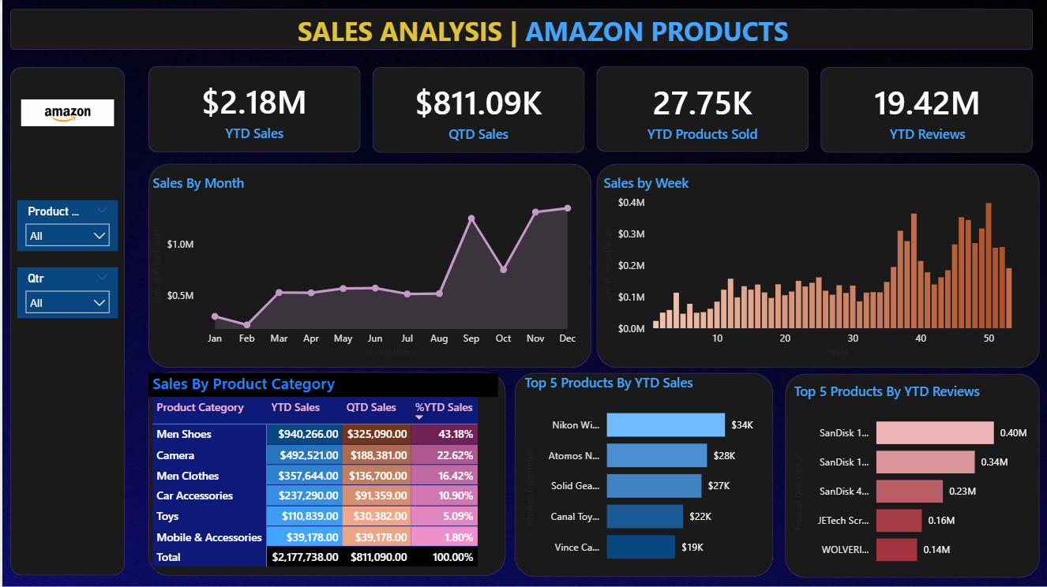

12. References

* Microsoft Power BI Documentation: https://learn.microsoft.com/en-us/power-bi/
* Dataset Source (if public): kaggel
* Other Tools: Microsoft Excel