# Introduction to Programming

## Lab Worksheet

### Week 3

**TASK**: Start the Python Interpreter and input the following expressions, noting each result.

10 < 100

100 != 100

50 >= 50

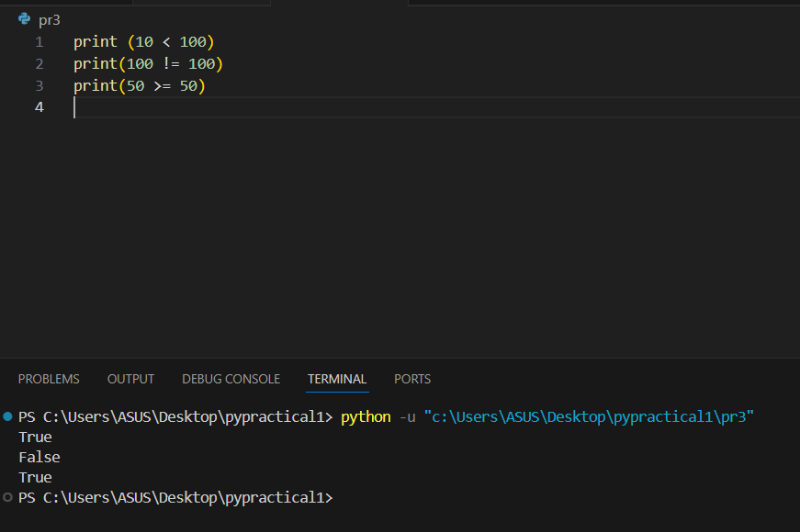

**TASK**: Input a program that defines a variable called ‘age’ that is initialised to your own age. Then type several boolean expressions that compare the variable to see whether it is less than ‘18’, ‘21’ then ‘31’.

Boolean expressions do not have to compare just numeric type values, they can also be used to compare other types.

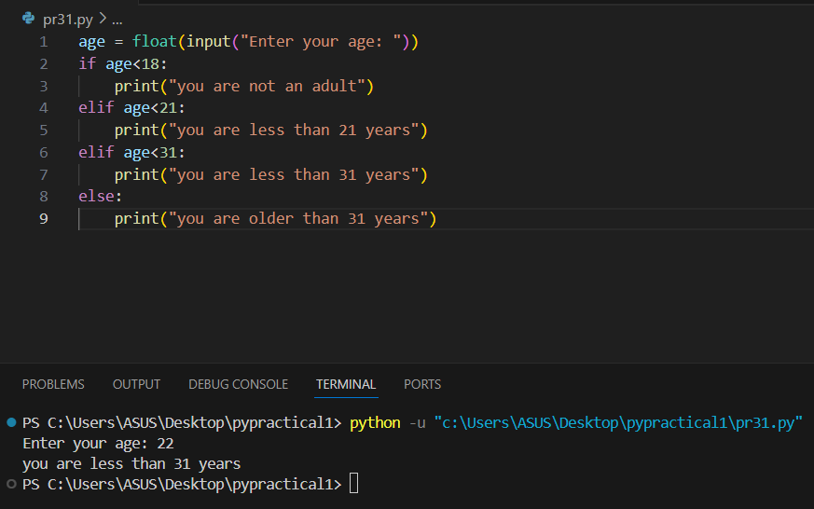

**TASK**: Try inputting the following code and note the results.

"a" < "b"

"b" < "a"

"John" < "Terry"

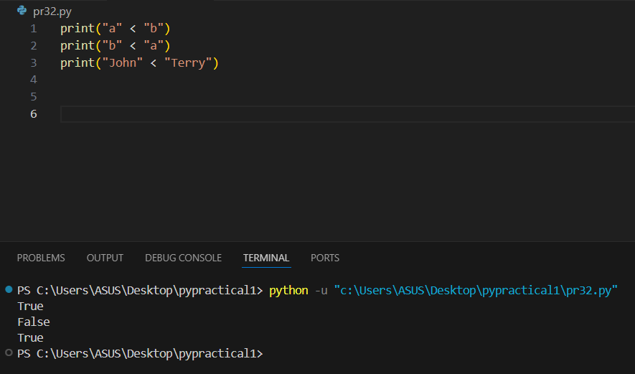

**TASK**: Try inputting the following code and note the result. Try to work out why the answer is different from the previous expression (look carefully, it *is* different).

"john" < "Terry"

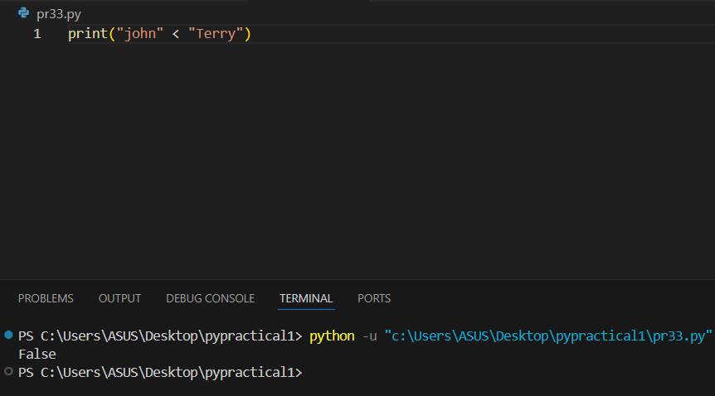

**TASK**: Try inputting the following code and note the results.

5 < 10.2

5 < "Monty"

5 < "5"

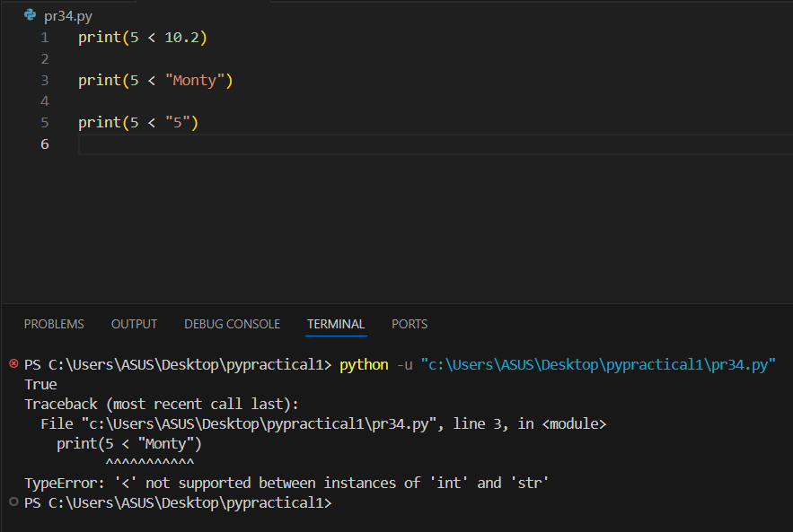

**TASK**: Try inputting the following code and examine the results.

age = 30

age >=18 and age <=65

age <18 or age >65

not age > 18

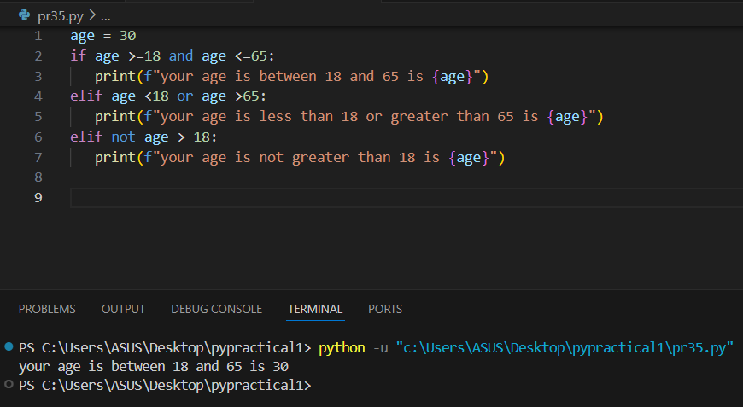

**TASK**: Try inputting the following code and examine the result.

age = 30

(age >=18 and age <=65) and (not age==30)

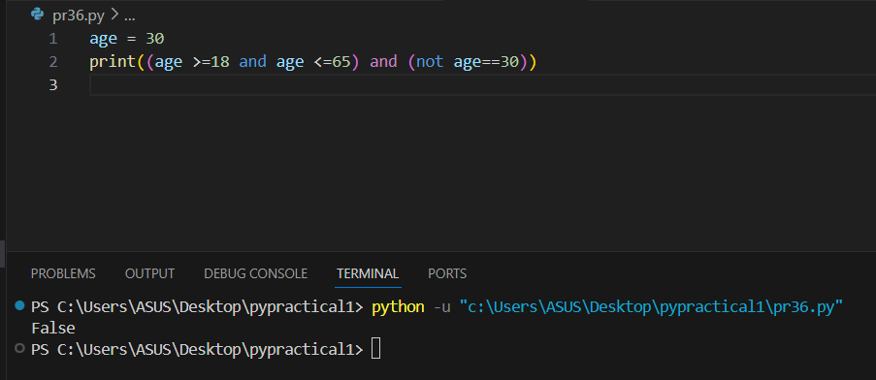

**TASK**: Try inputting two expressions that use operator chaining and are equivalent to the two expressions shown below. (note: you may first want to first assign values to the ‘weight’ and ‘height’ variables for testing purposes)

100 < weight and weight < 200

height > 131 and height < 160

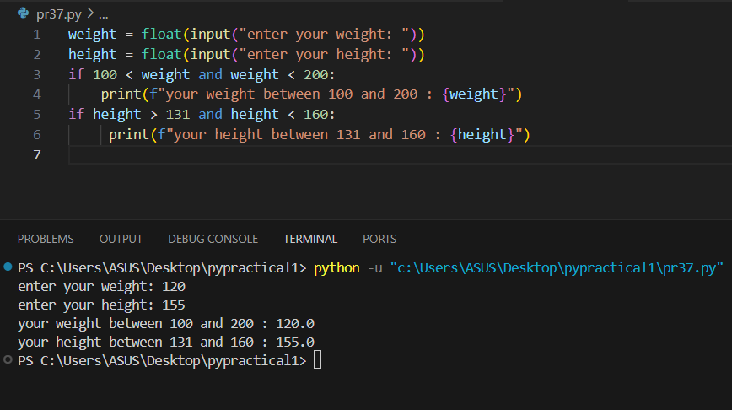

**TASK**: Input the examples above but with alternative operand values, that result in both True and False results.

>>> "Mark" not in names

True

>>> message = "Hello there, my name is John"

>>> "nam" in message

True

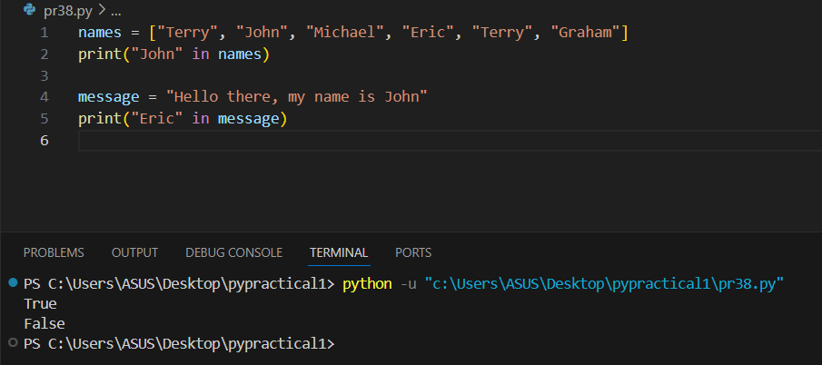

**TASK**: Try writing an if statement that checks if someone is between the ages of 18 and 30 inclusive. If they are, then print a message saying "you are still young!"

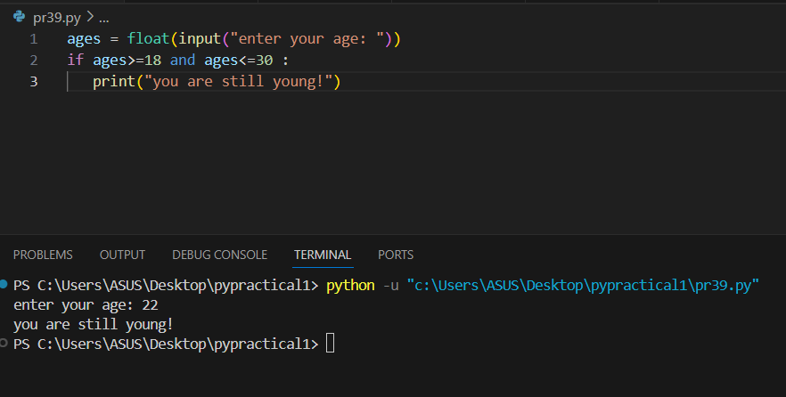

**TASK**: Try writing an if statement similar to the last example that includes an extra elif clause to check ages between 30-40. Print a suitable message in the associated code block.

if age > 100:

print("you are very old,")

print("well done!")

elif age > 80:

print("you are fairly old")

print("pretty good!")

elif age > 40:

print("you are middle aged")

print("never mind")

else:

print("you are not very old - yet")

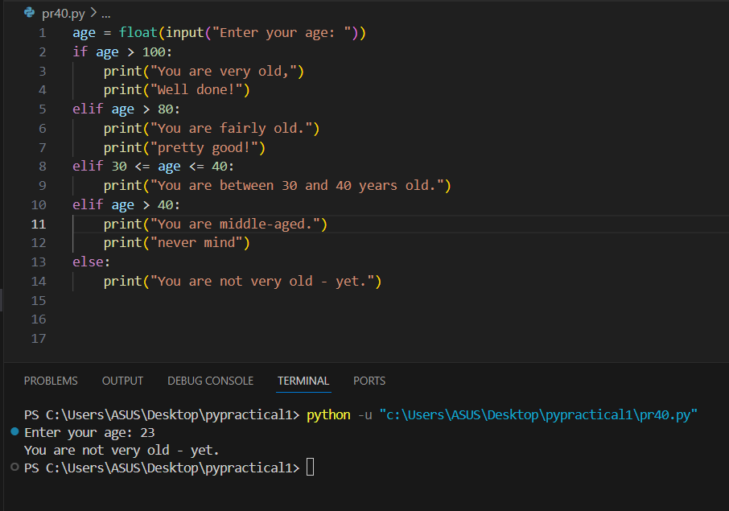

name = input("Enter your name: ")

if name:

print("Your name is", name)

else:

print("Name not entered")

*Hint:* It is often better to write a condition as a Boolean expression, since this leads to clearer code.

**TASK**: Rewrite the above code that inputs a name then prints a message, but change the condition so it explicitly uses a Boolean expression. Use the example below to help.

if total != 0:

print("Total is non-zero")

else:

print("Total is zero")

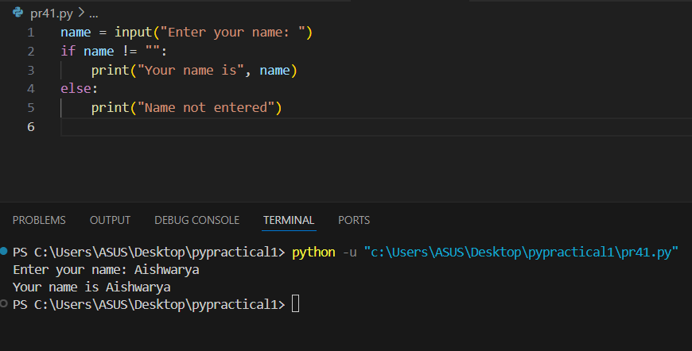

**TASK**: Rewrite the code shown below as a single line Ternary expression.

if age >= 18:

print("you are an adult")

else:

print("you are not an adult, yet!")

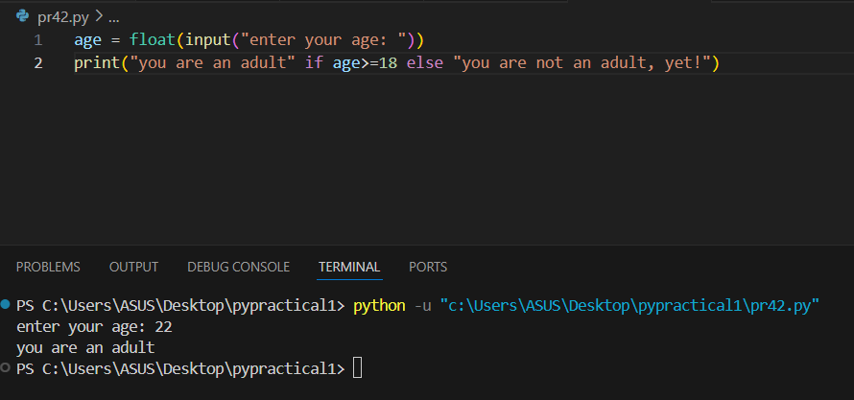

**TASK**: Input and execute a for loop that iterates over a list of four names, printing each of them to the screen.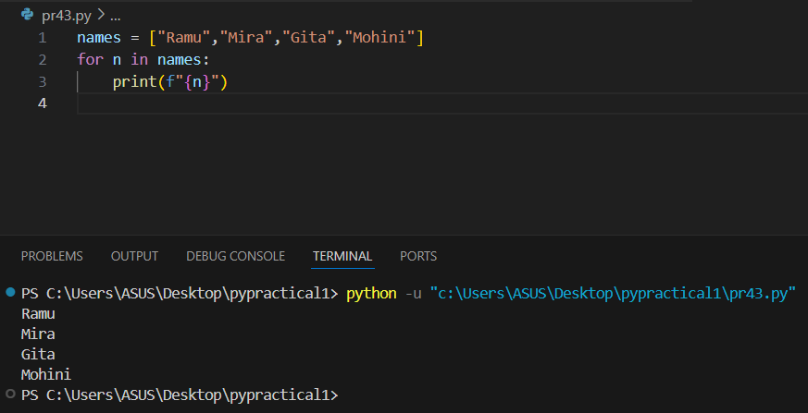

**TASK**: Input and execute a for loop that uses a range() function to generate the following output:

2 to the power of 2 = 4

4 to the power of 4 = 256

6 to the power of 6 = 46656

8 to the power of 8 = 16777216

10 to the power of 10 = 10000000000

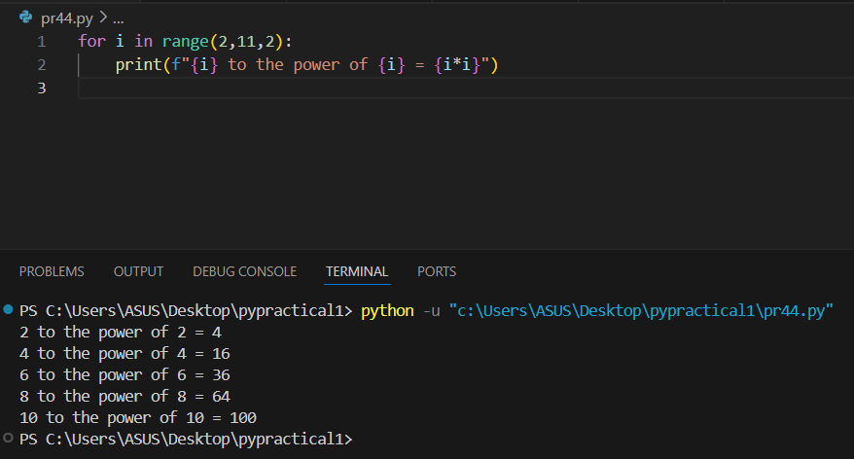

**TASK**: Input code containing a for loop that iterates over a list of numbers, printing a running total during each iteration. You may wish to first define the numbers list as follows:

>>> numbers = [10, 20 , 30, 90, 200, 30, 22, 11]

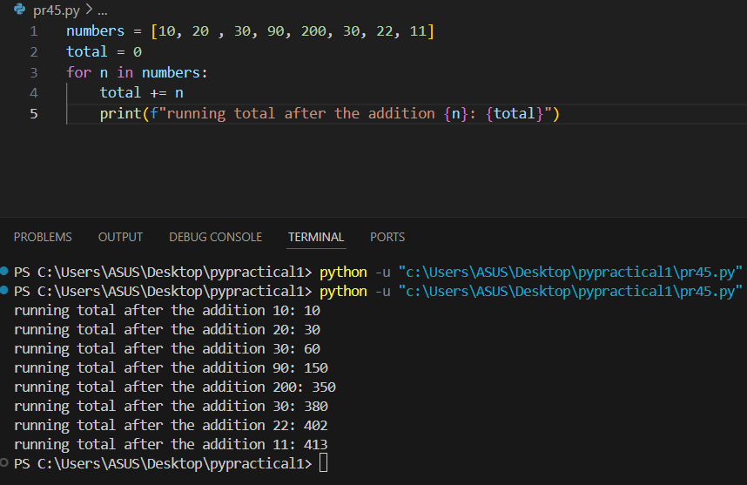

**TASK**: Amend your previous solution so that if any value within the list is found to be over 100 then the loop should break immediately.

