Task 1

1. For performing task 1 , I have installed git and created a Folder in Desktop with name “L3” and as You will see this screen.

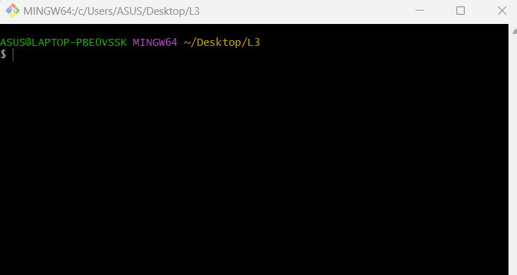

1. Checking git version with git –version as you can see the output.

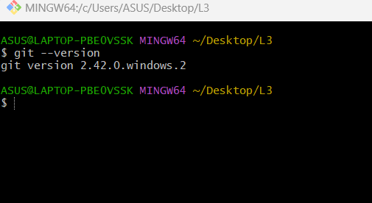

1. For adding files with this Command:

• touch index.html • touch about.html • touch resources.txt

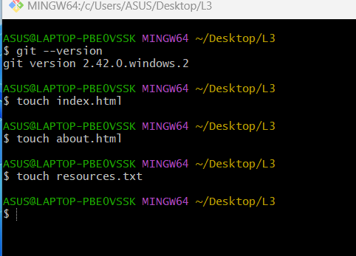

1. You can see my files in L3 folder.

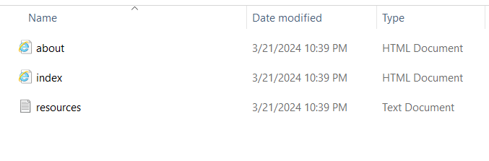

1. Adding lines of code as you can see in output & saving in notepad.

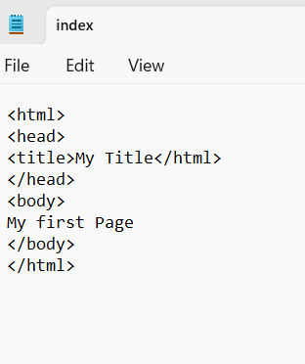

1. In the file resources.txt , I had written my name and Save this file.

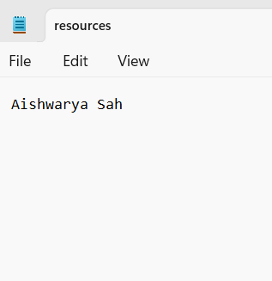

1. Configuring with my name and email,

I had Checked Status of Working directory with git status ,Added file with git add index.html ,

Again Checked Status of Working directory with git status and Committed chages in my working directory with git commit –m “Some git commit message”

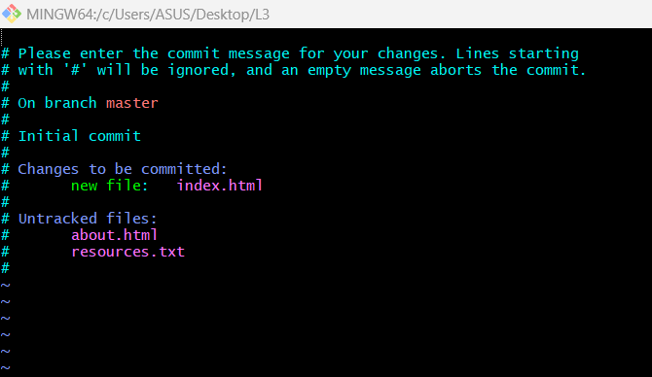

1. .After all commit, I Checked Status of Working directory that will show you message like nothing to commit, working tree clean Making changes to resources.txt. I again checked git status , Added file, Commit chages in my working directory with commit message with git commit -m ‘Changed resouces.txt’.

I again checked status and View commit history with git log,

As you can see the output below;

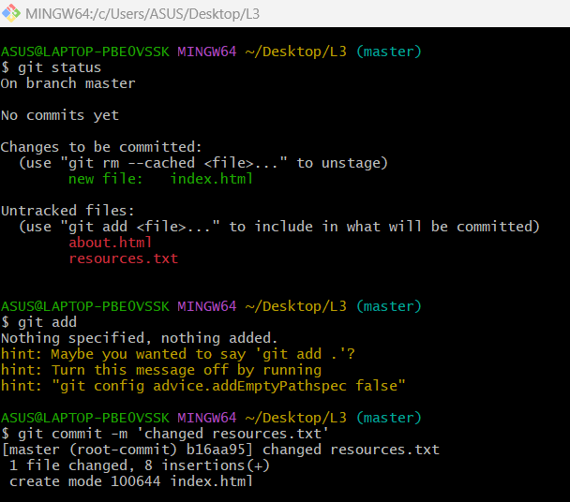

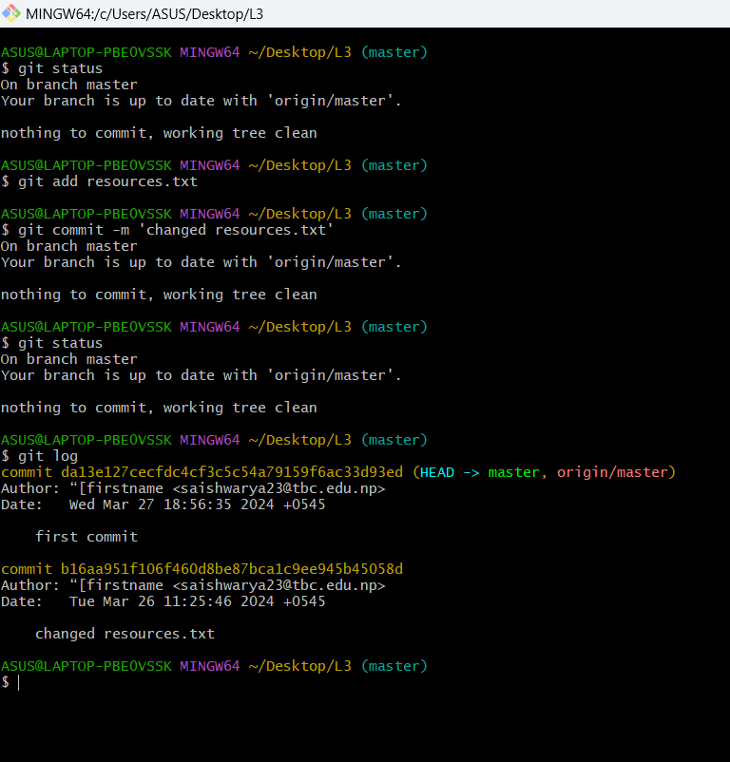

Task 2

1. After Creating an account on Github.com , I used Git Bash and Follow these commands: • git remote • git remote add origin <https://github.com/Aishwaryagithubit/L3.git>
2. Reloading my repository page & you can see added files then I Cloned my Github Repository with git clone <https://github.com/Aishwaryagithubit/L3.git>

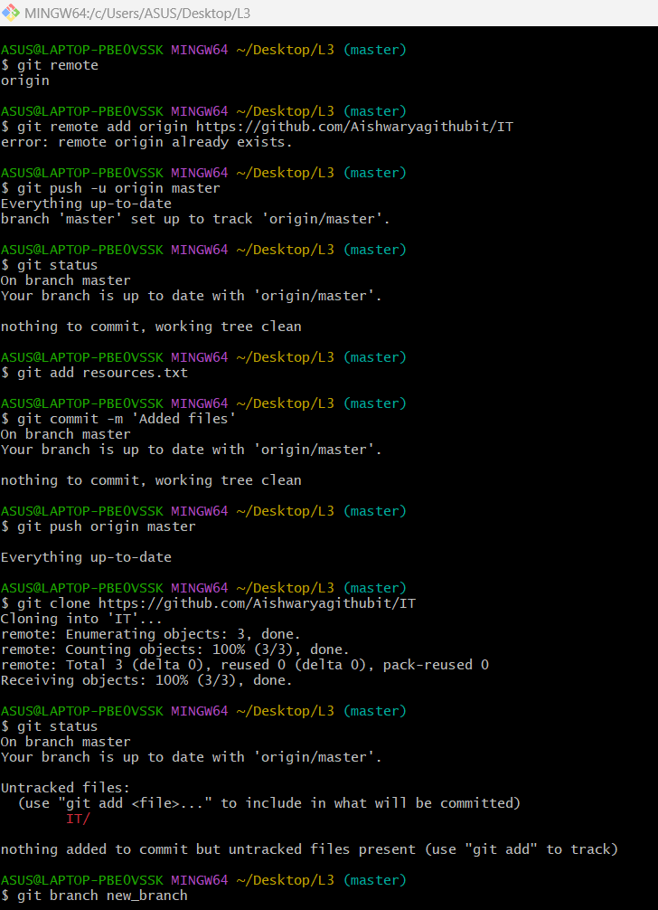

Task 3

1. Branching & Merging as you can see in the output below;

