**ASSIGNMENT 02 (NON-GRADED)**

1) A query to find the addresses (location_id, street_address, city, state_province, country_name) of all the departments.

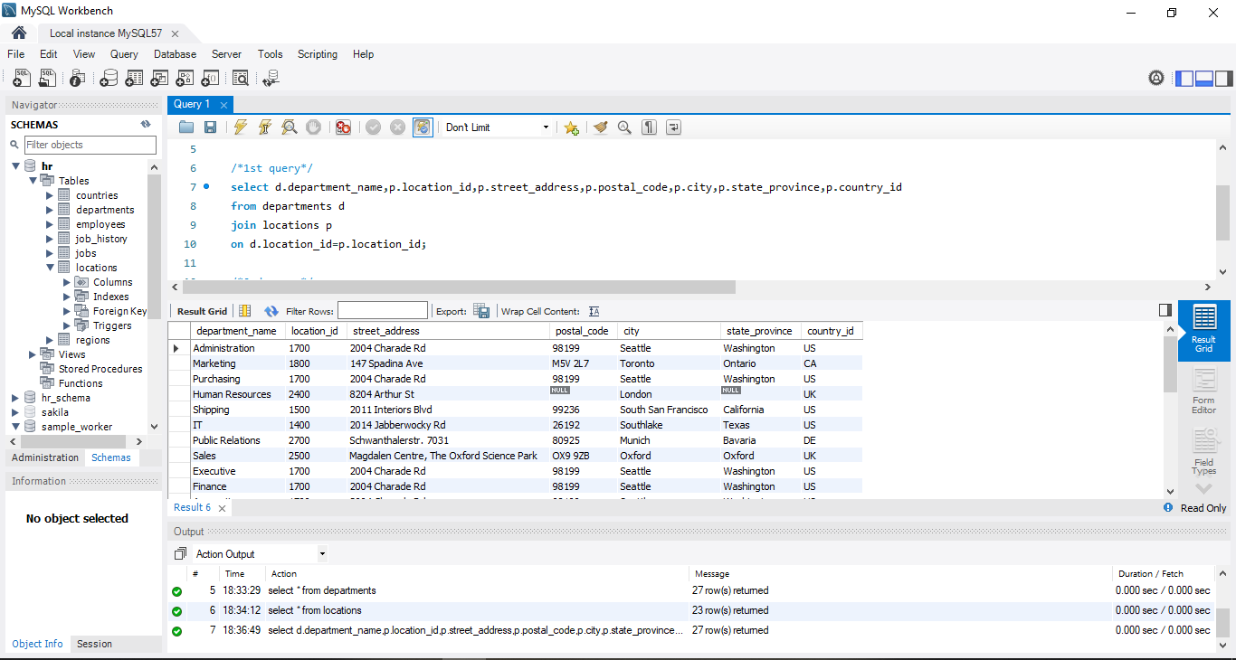

2) A query to find the name (first_name, last name), department ID and name of all the employees

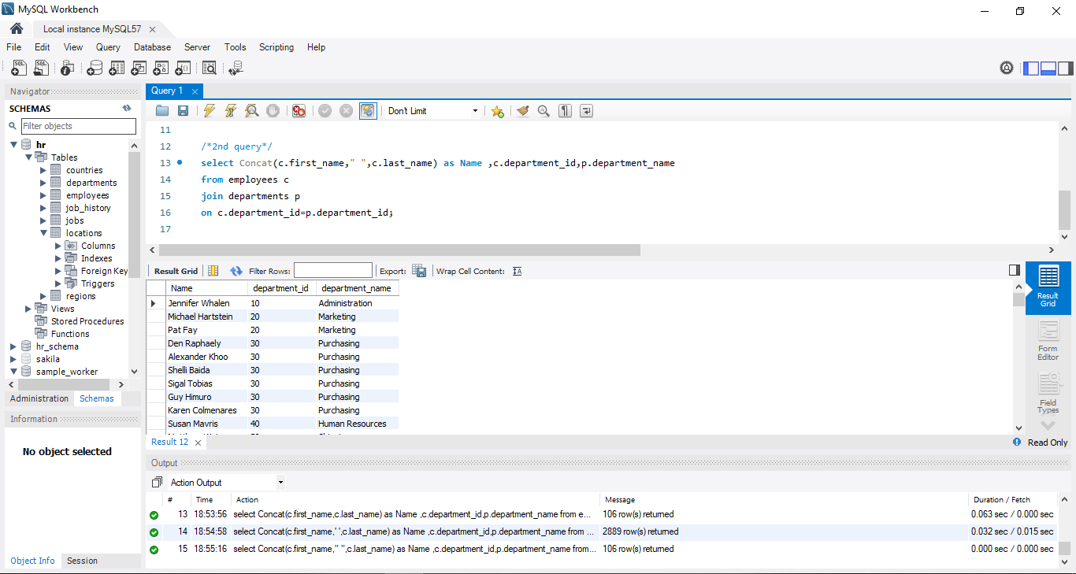

3) A query to find the name (first_name, last_name), job, department ID and name of the employees who works in London

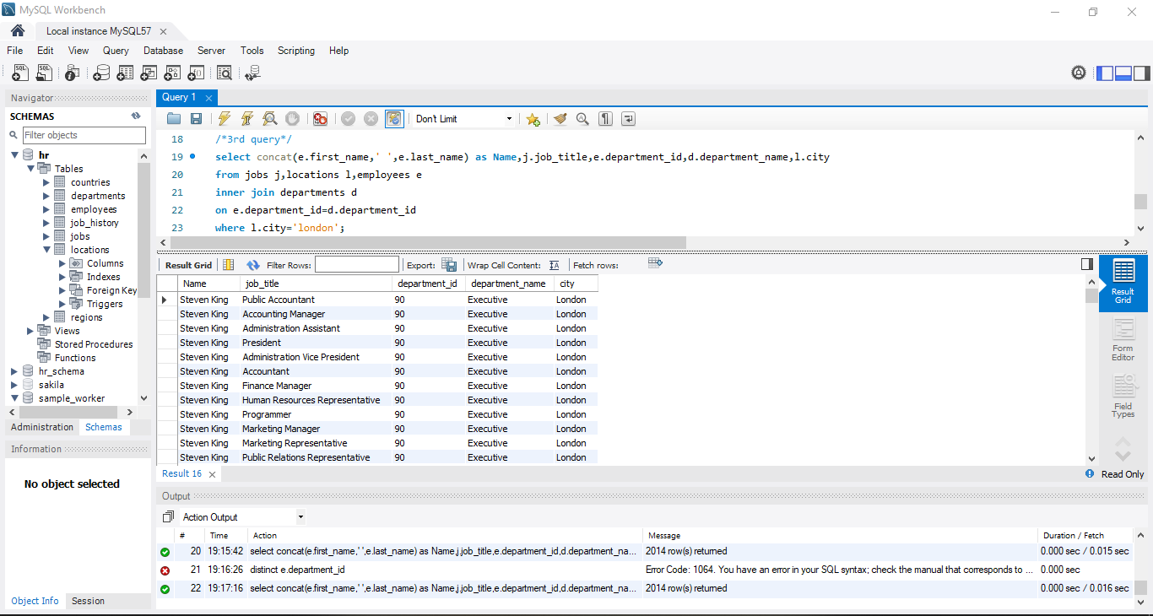

4) A query to find the employee id, name (last_name) along with their manager_id and name (last_name)



5) A query to find the name (first_name, last_name) and hire date of the employees who was hired after 'Jones'

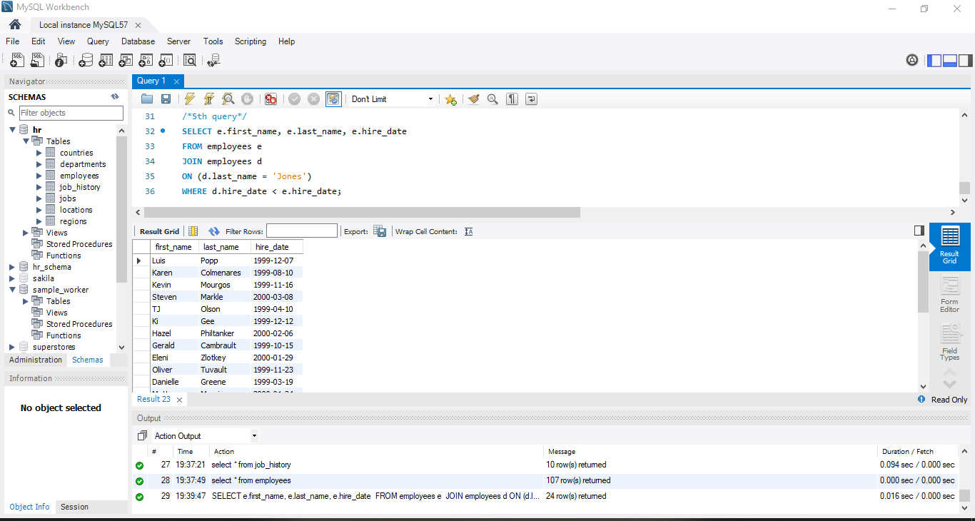

6) A query to get the department name and number of employees in the department



7) A query to display department name, name (first_name, last_name), hire date, salary of the manager for all managers whose experience is more than 15 years



8) A query to find the name (first_name, last_name) and the salary of the employees who have a higher salary than the employee whose last_name='Bull'

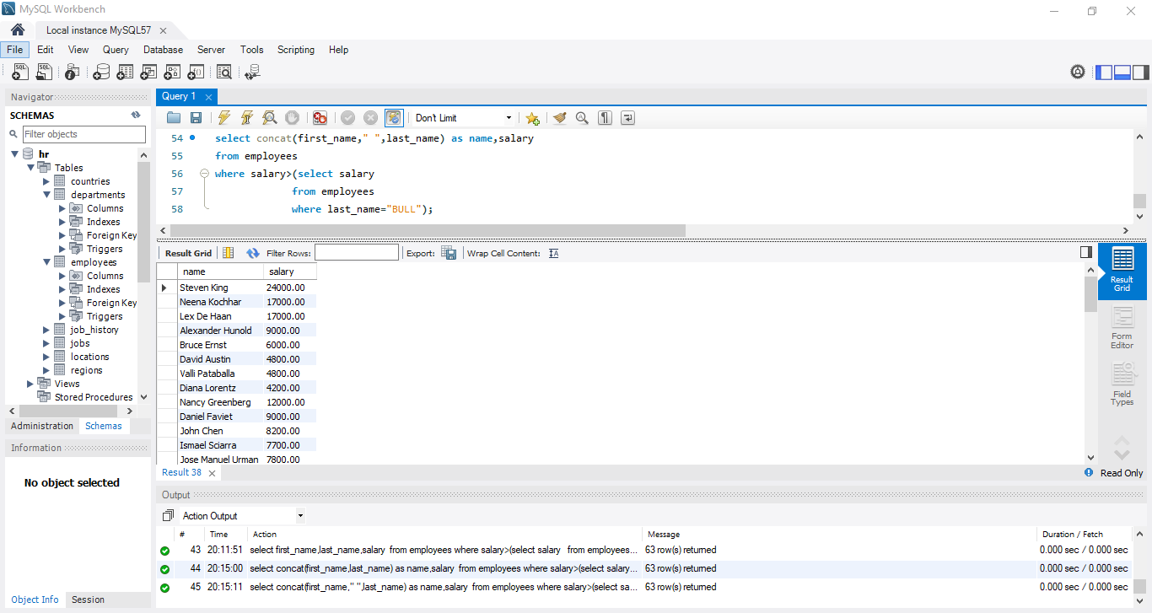

9) A query to find the name (first_name, last_name) of all employees who works in the IT department



10) A query to find the name (first_name, last_name) of the employees who have a manager and worked in a USA based department 11) A query to find the name (first_name, last_name), and salary of the employees whose salary is greater than the average salary



12) A query to find the name (first_name, last_name), and salary of the employees whose salary is equal to the minimum salary for their job grade



13) A query to find the name (first_name, last_name), and salary of the employees who earns more than the average salary and works in any of the IT departments

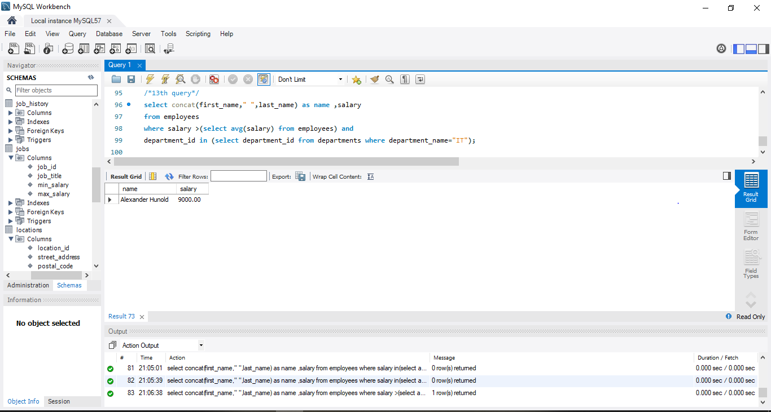

14) A query to find the name (first_name, last_name), and salary of the employees who earn the same salary as the minimum salary for all departments.

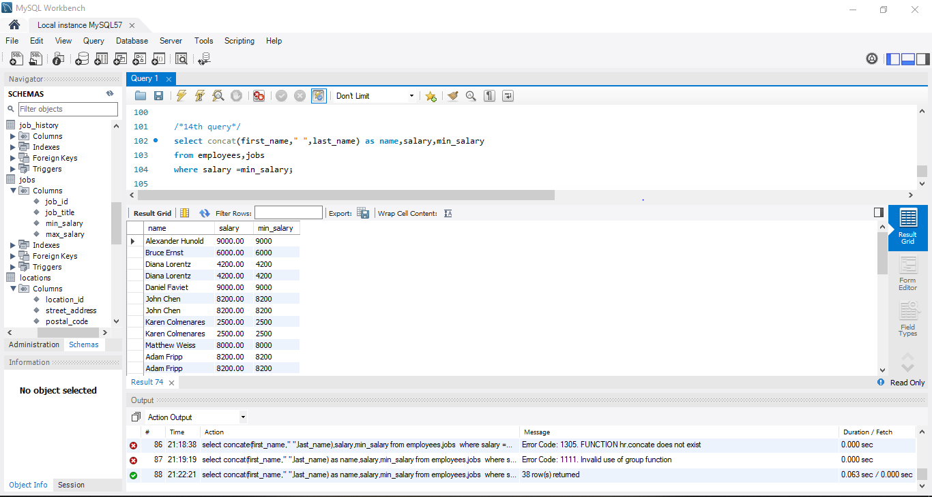

15) A query to find the name (first_name, last_name) and salary of the employees who earn a salary that is higher than the salary of all the Shipping Clerk (JOB_ID = 'SH_CLERK'). Sort the results of the salary of the lowest to highest.

