**ASSIGNMENT 5(NON GRADED)**

1) An SQL query to fetch “FIRST_NAME” from Worker table using the alias name as<WORKER_NAME>.

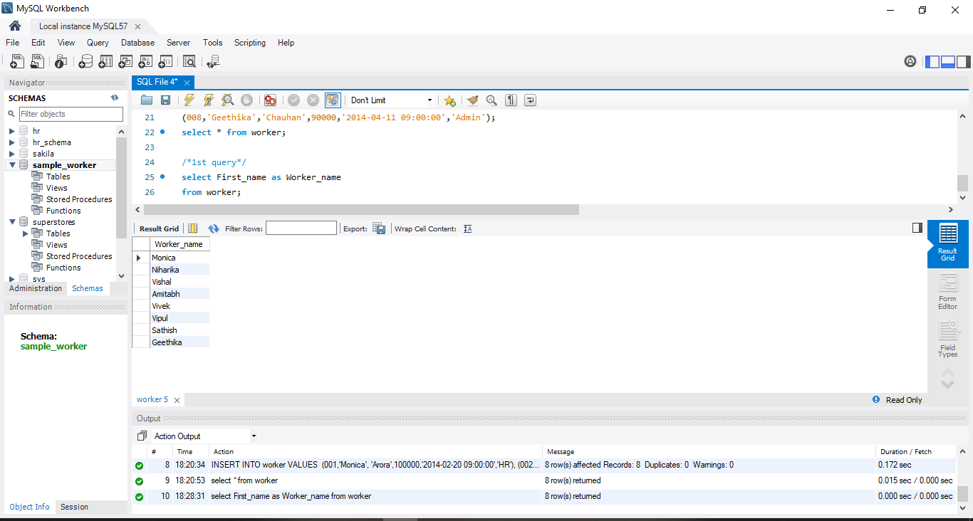

2) An SQL query to fetch “FIRST_NAME” from Worker table in uppercase.

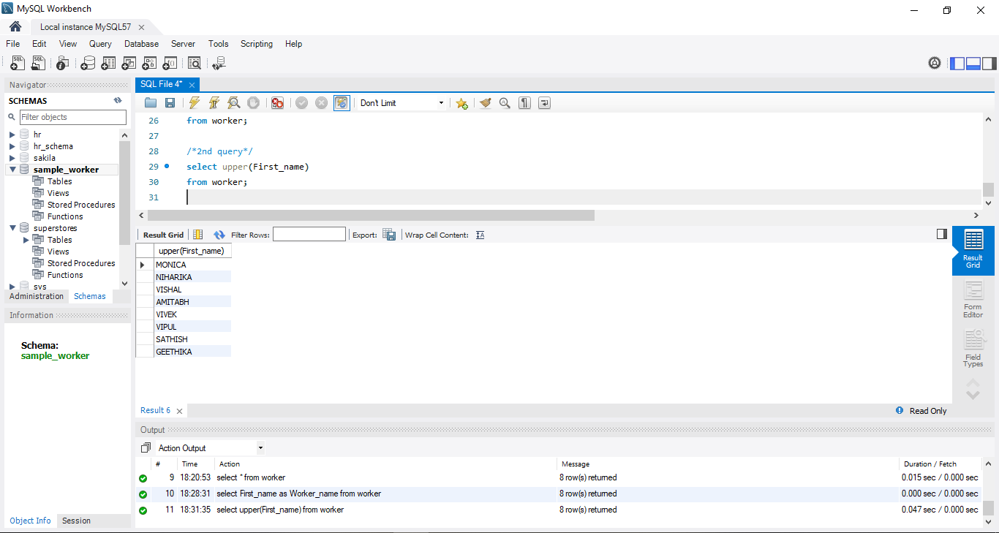

3) An SQL query to fetch unique values of DEPARTMENT from Worker table

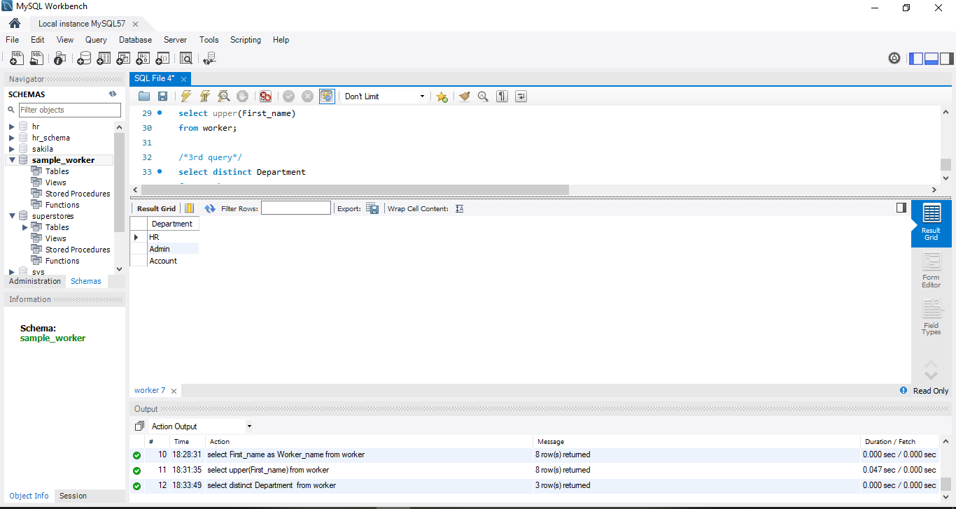

4) An SQL query to print the first three characters of FIRST_NAME from Worker table

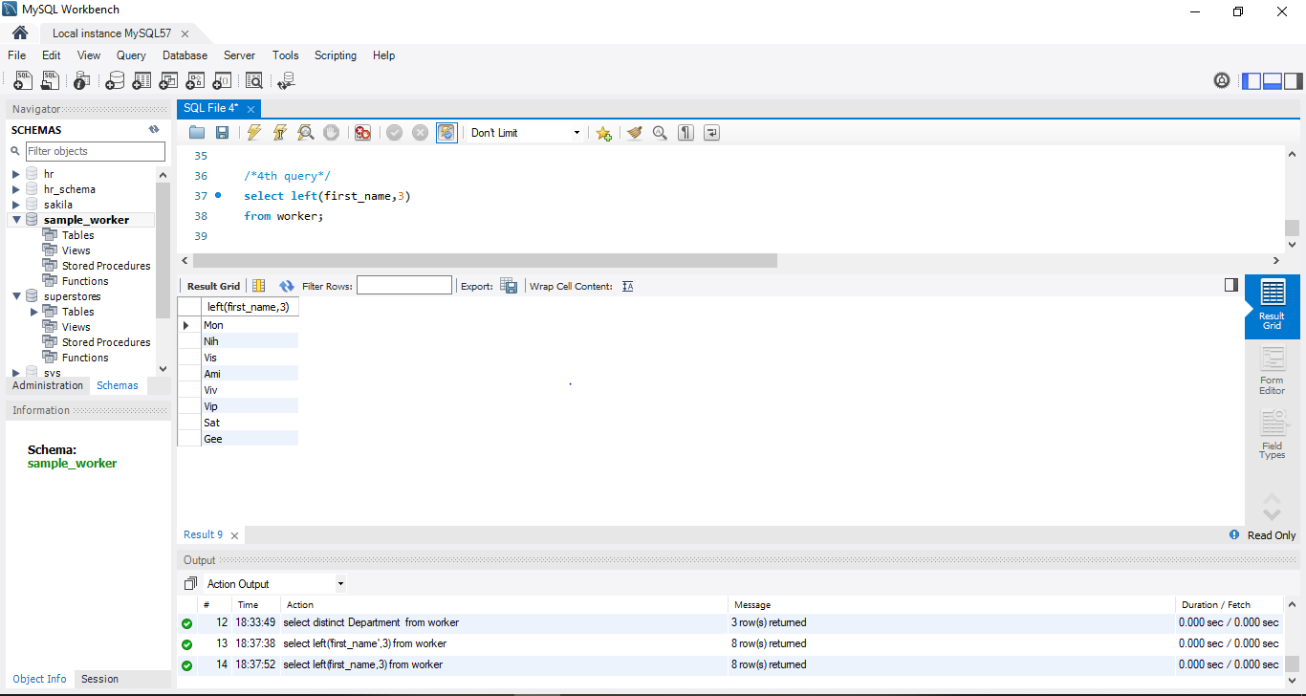

5) An SQL query to find the position of the alphabet (‘a’) in the first name column ‘Amitabh’ from Worker table.

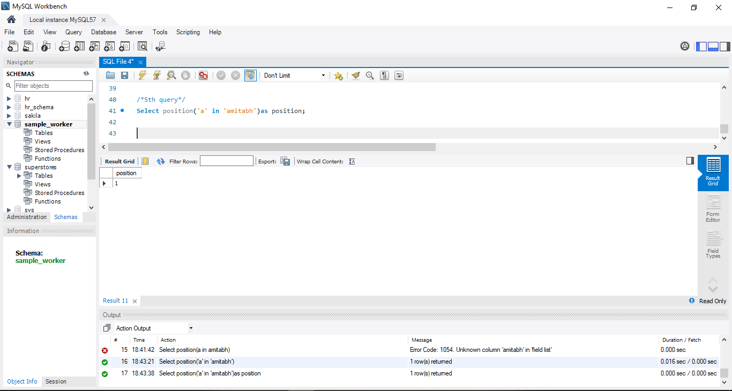

6) an SQL query to print the FIRST_NAME from Worker table after removing white spaces from the right side.

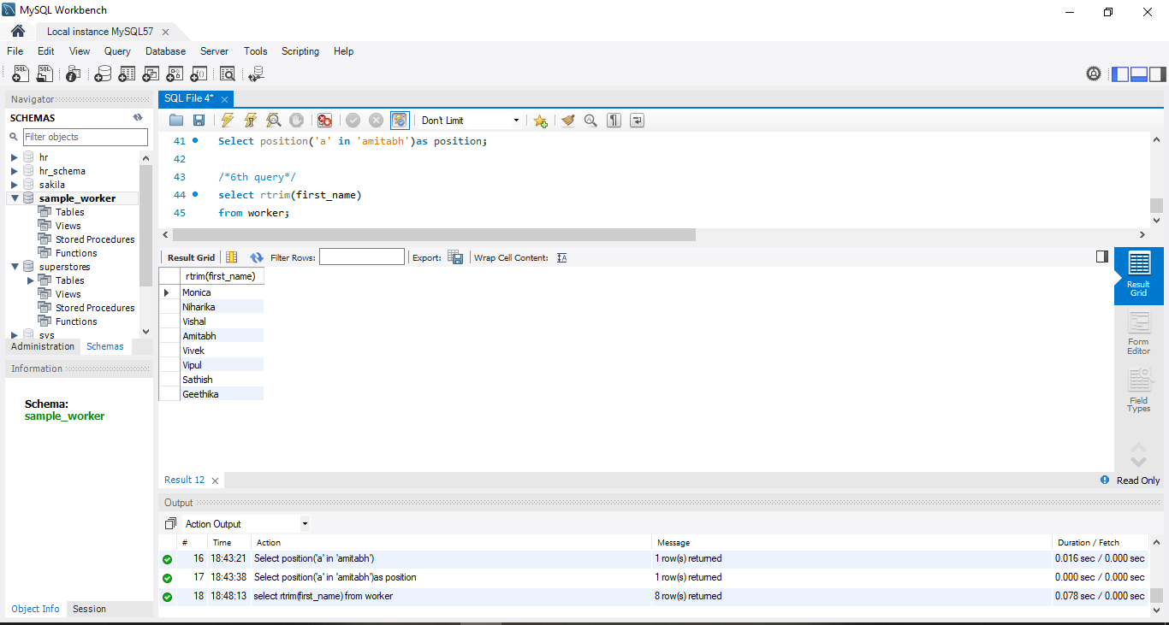

7) An SQL query to print the DEPARTMENT from Worker table after removing white spaces from the left side.

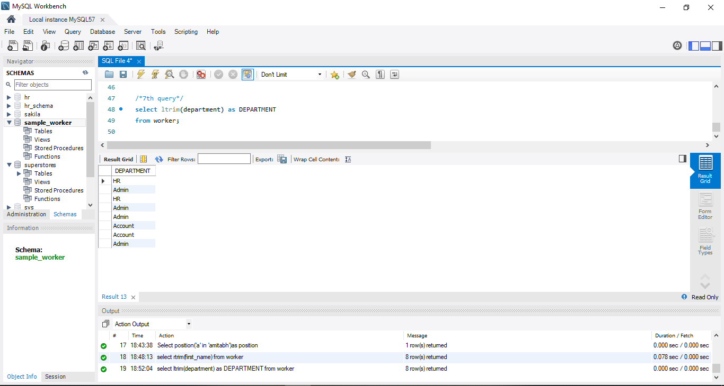

8) An SQL query that fetches the unique values of DEPARTMENT from Worker table and prints its length.

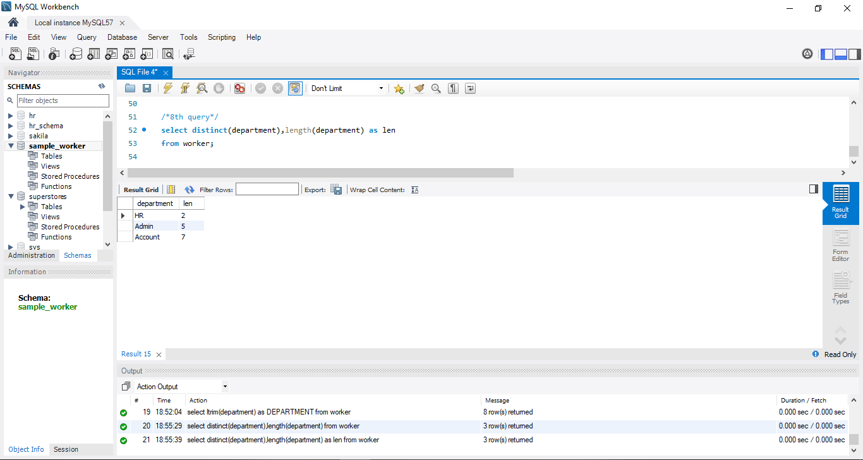

9) An SQL query to print the FIRST_NAME from Worker table after replacing ‘a’ with ‘A’

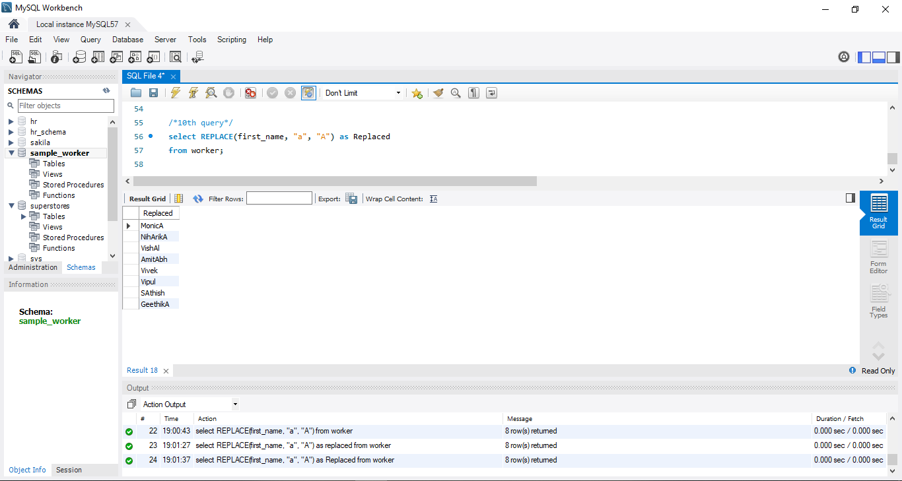

10) An SQL query to print the FIRST_NAME and LAST_NAME from Worker table into a single column COMPLETE_NAME. A space char should separate them.

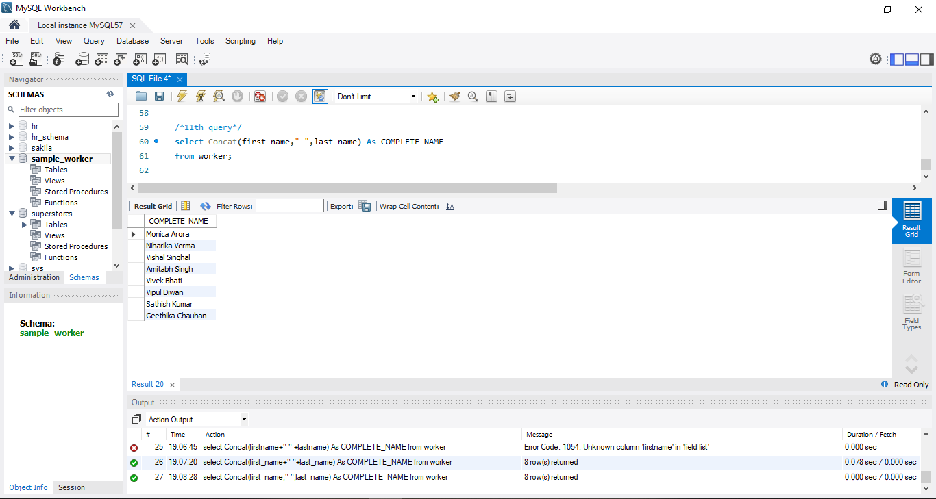

11) An SQL query to print all Worker details from the Worker table order by FIRST_NAME Ascending.

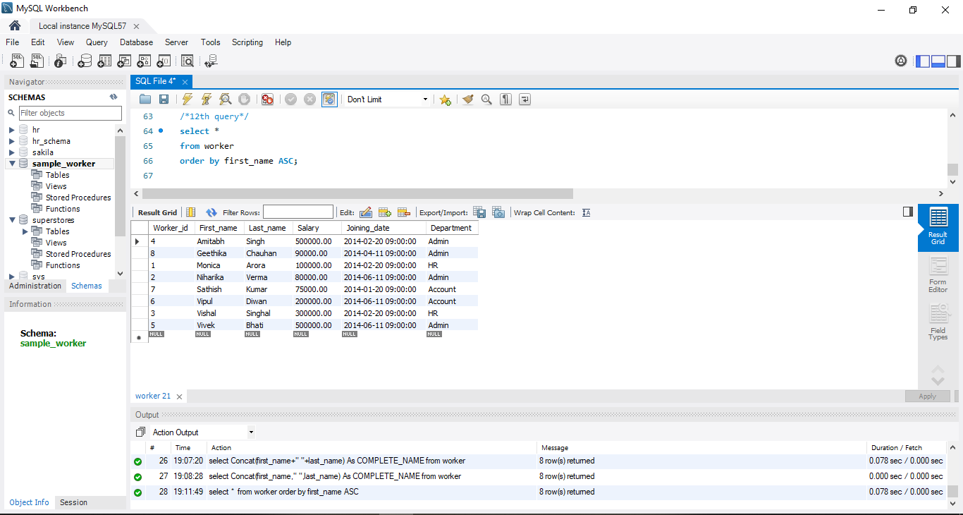

12) An SQL query to print all Worker details from the Worker table order by FIRST_NAME Ascending and DEPARTMENT Descending.

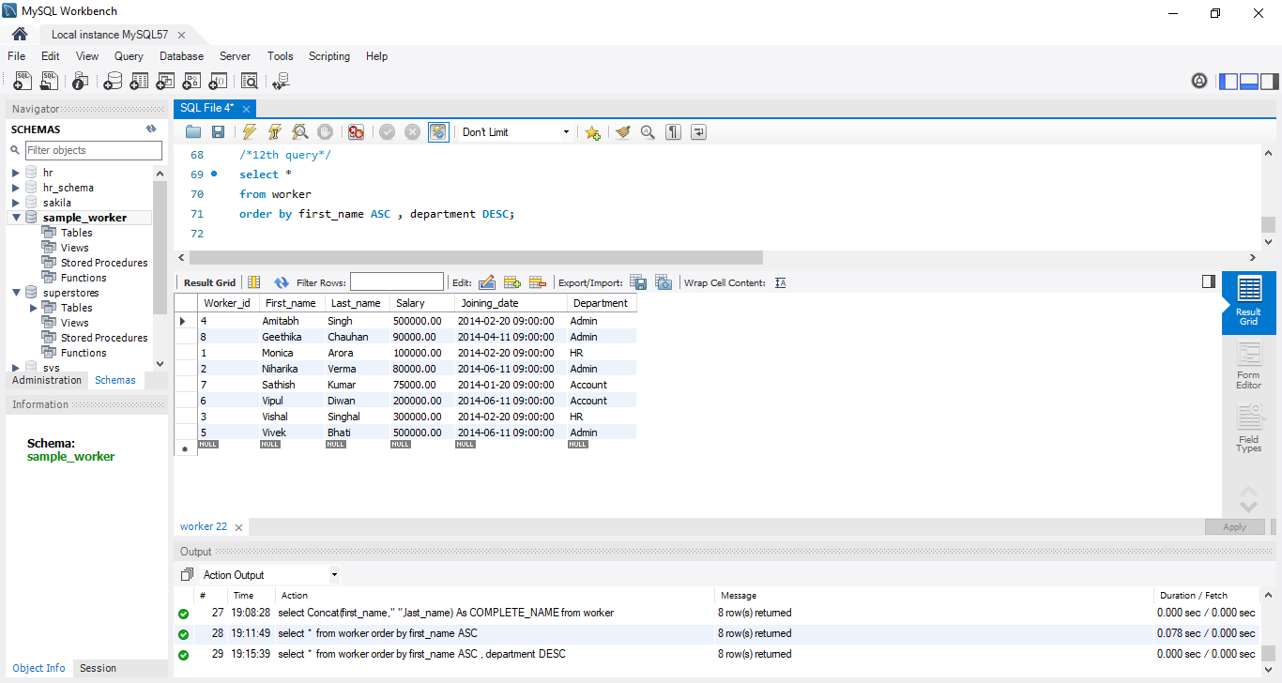

13) An SQL query to print details for Workers with the first name as “Vipul” and “Satish” from Worker table.

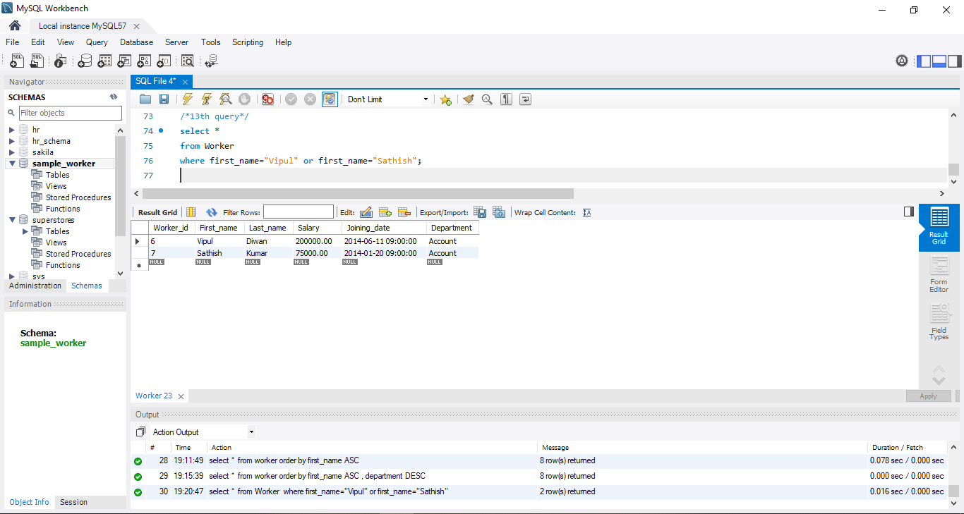

14) An SQL query to print details of workers excluding first names, “Vipul” and “Satish” from Worker table

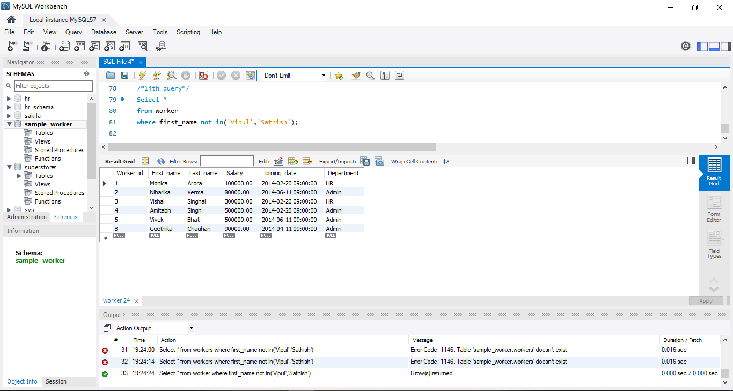

15) An SQL query to print details of Workers with DEPARTMENT name as “Admin”.

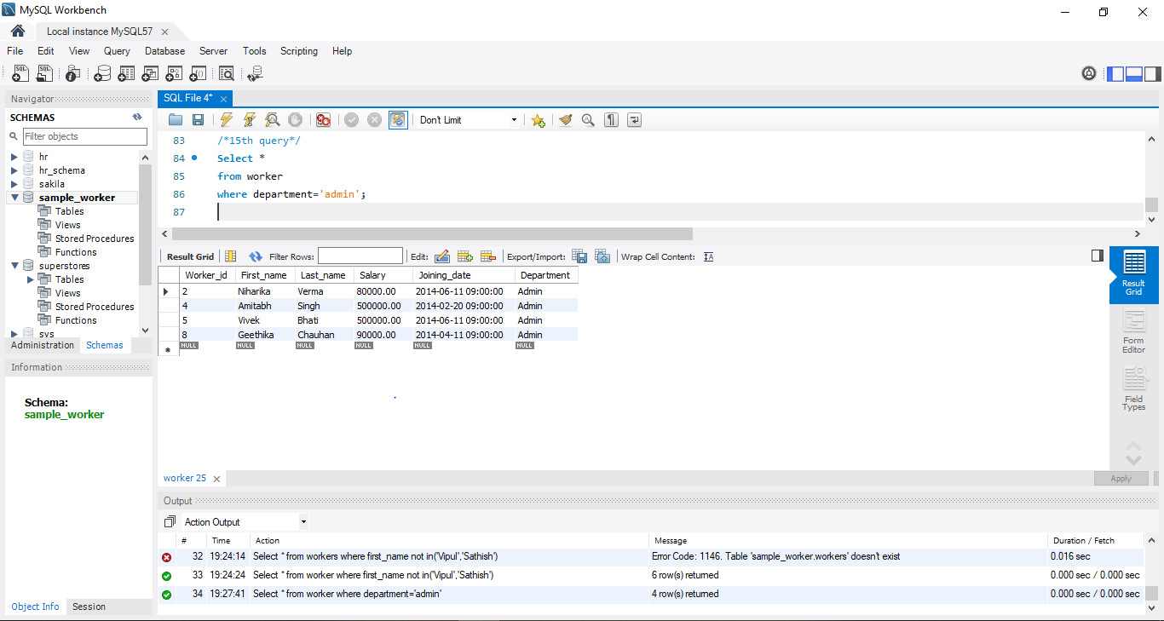

16) An SQL query to print details of the Workers whose FIRST_NAME contains ‘a’

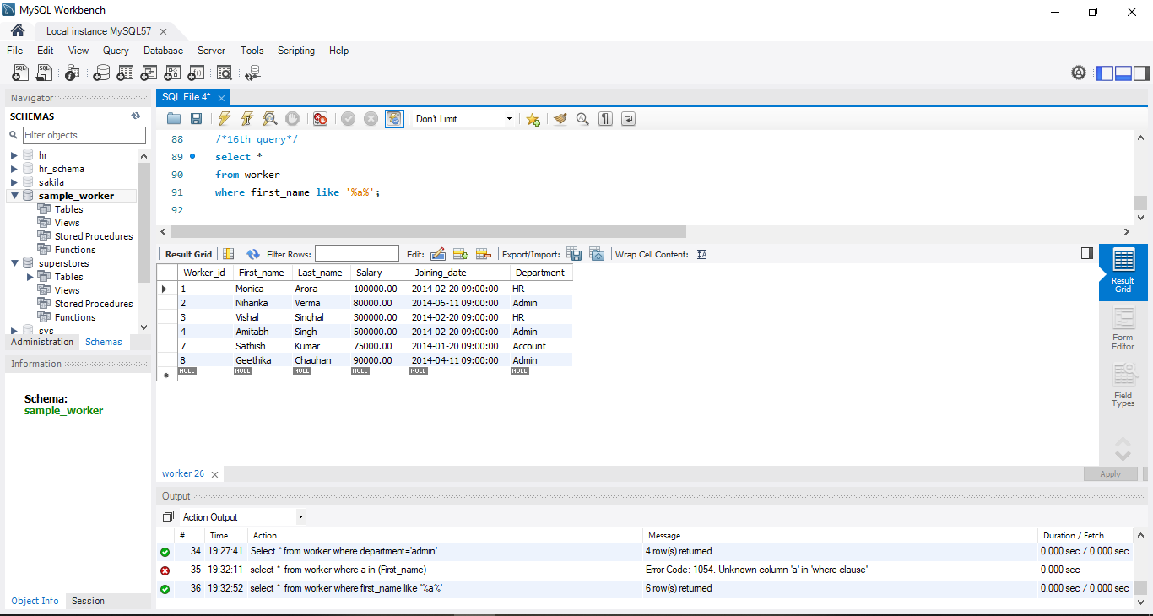

17) An SQL query to print details of the Workers whose FIRST_NAME ends with ‘a’.

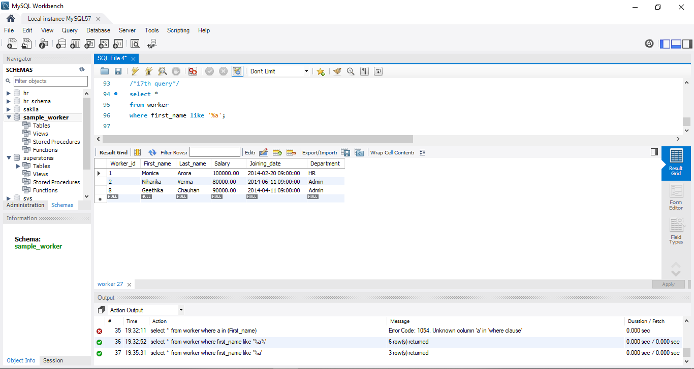

18) An SQL query to print details of the Workers whose FIRST_NAME ends with ‘h’ and contains six alphabets

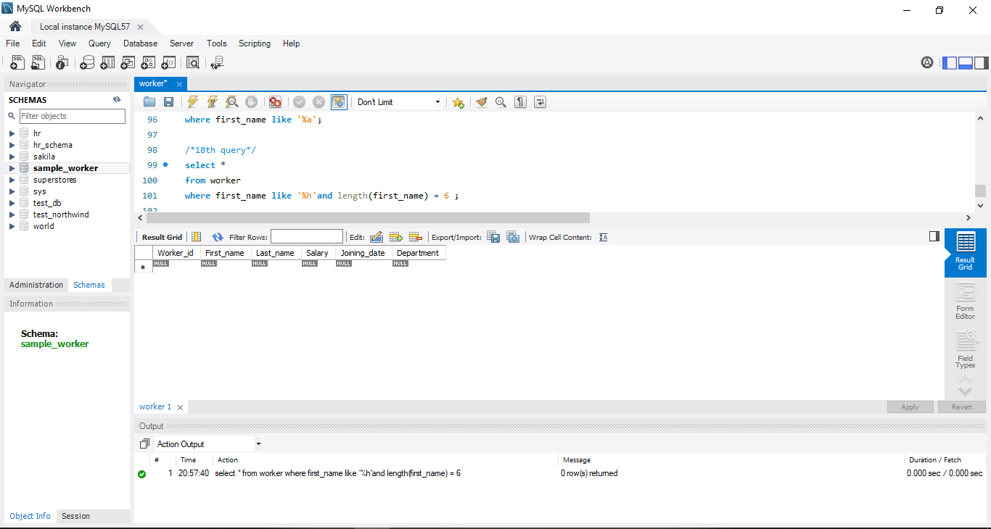

19) An SQL query to print details of the Workers whose SALARY lies between 100000 and 500000.

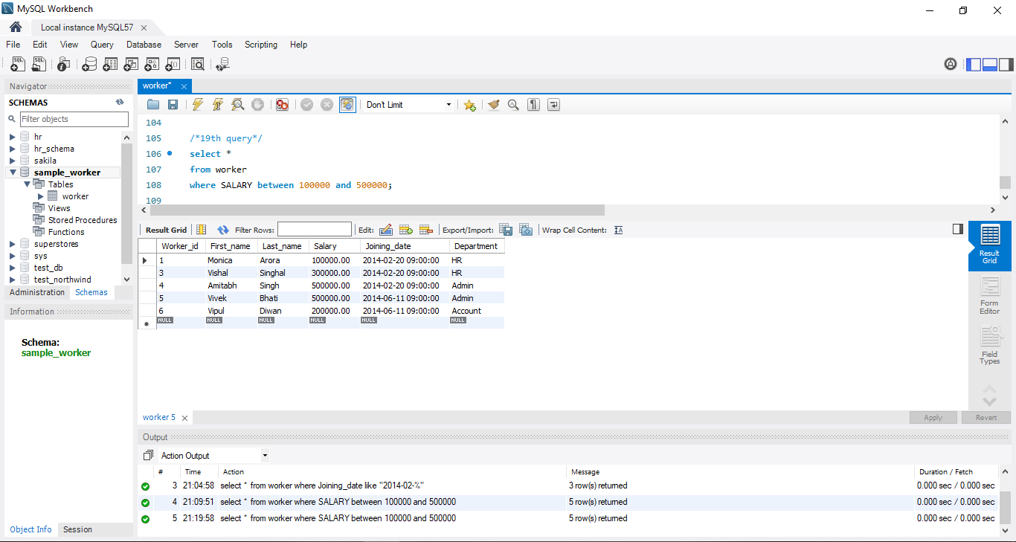

20) An SQL query to print details of the Workers who have joined in Feb’2014.

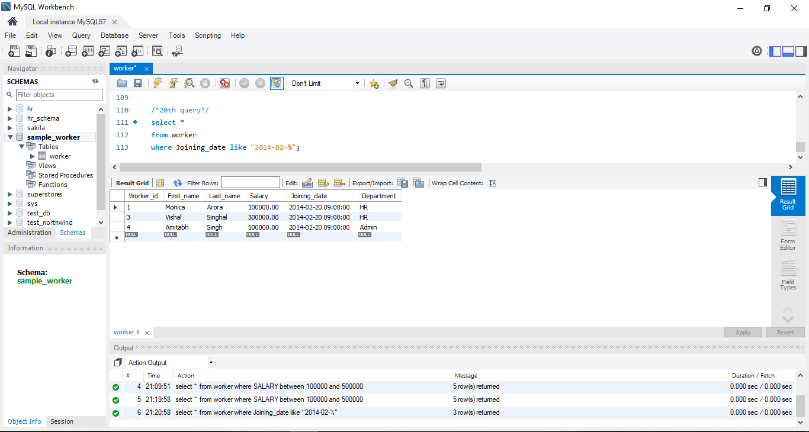

21) An SQL query to fetch the count of employees working in the department ‘Admin’.

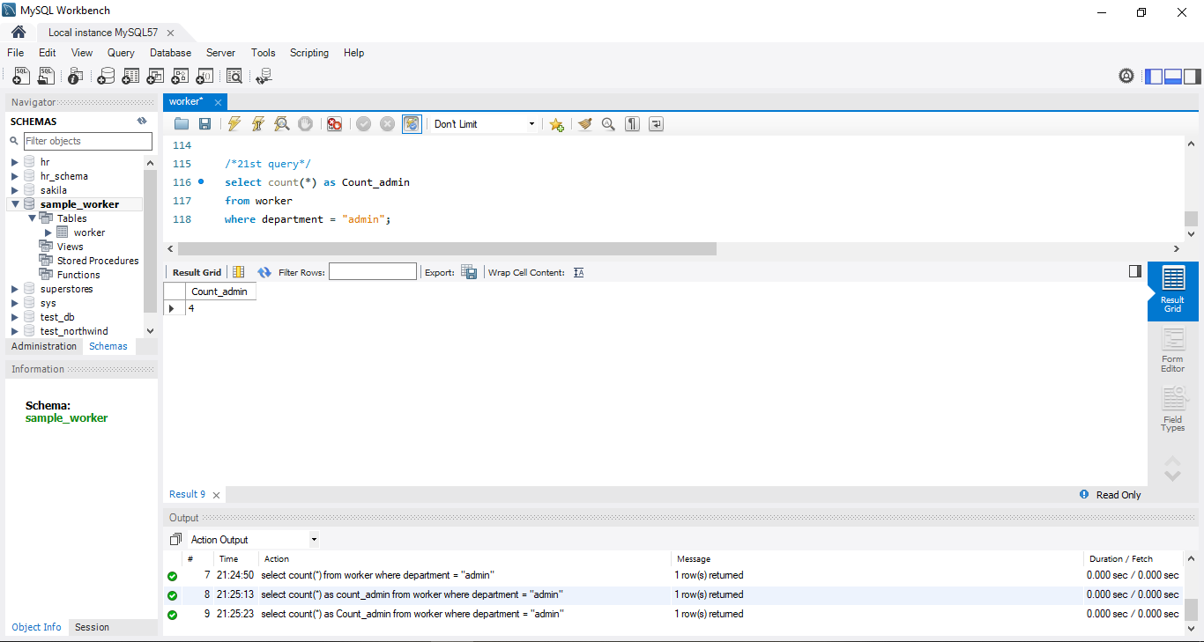

22) An SQL query to fetch worker names with salaries >= 50000 and <= 100000.

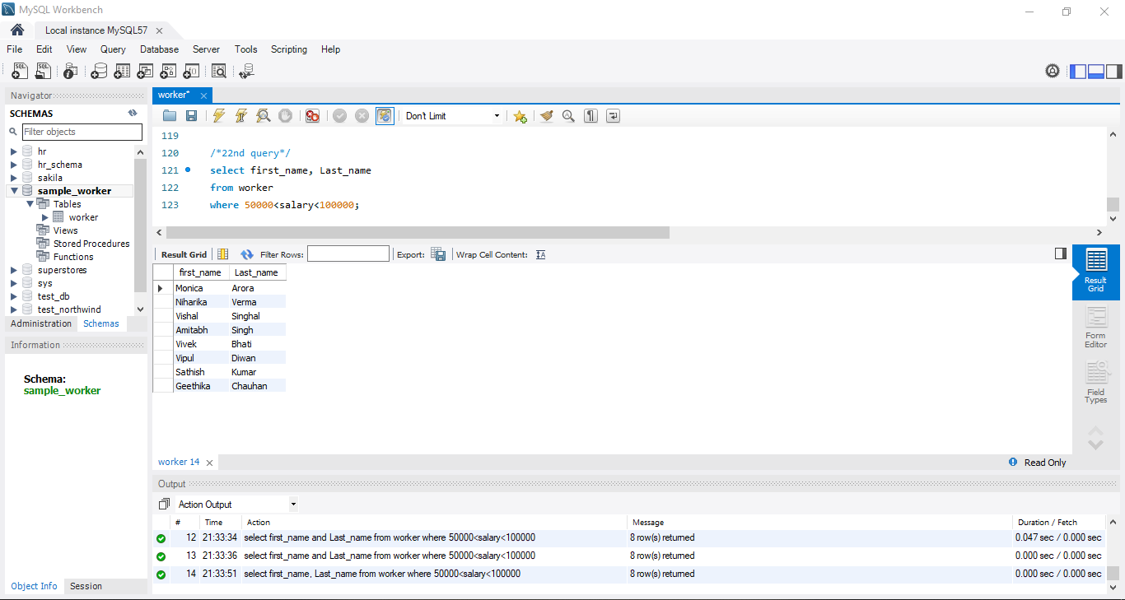

23) An SQL query to fetch the no. of workers for each department in the descending order.

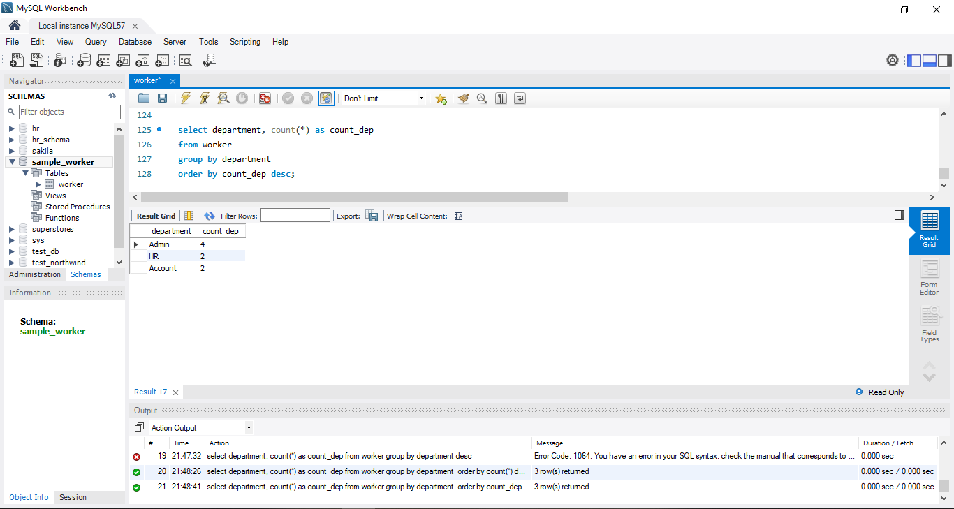

24) An SQL query to show only odd rows from the table

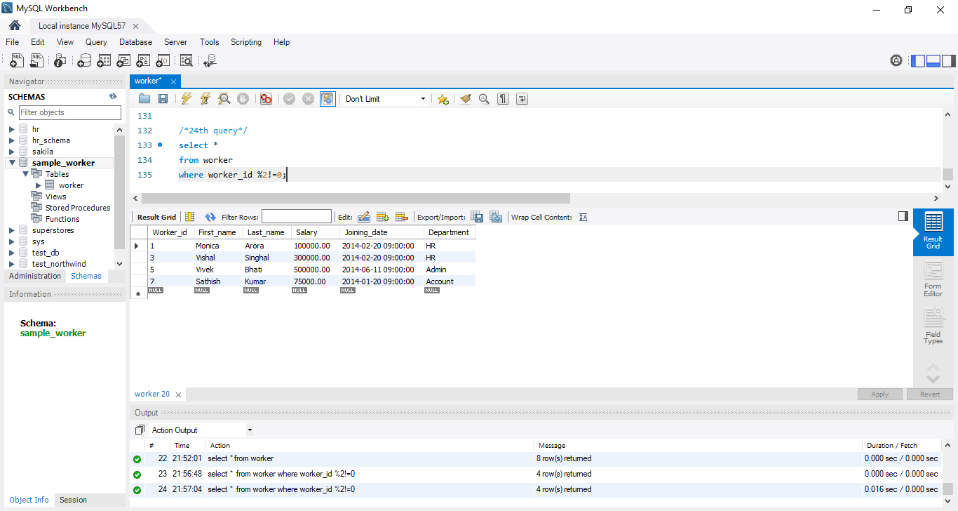

25) An SQL query to show the top 10 records of the table in terms of salary.

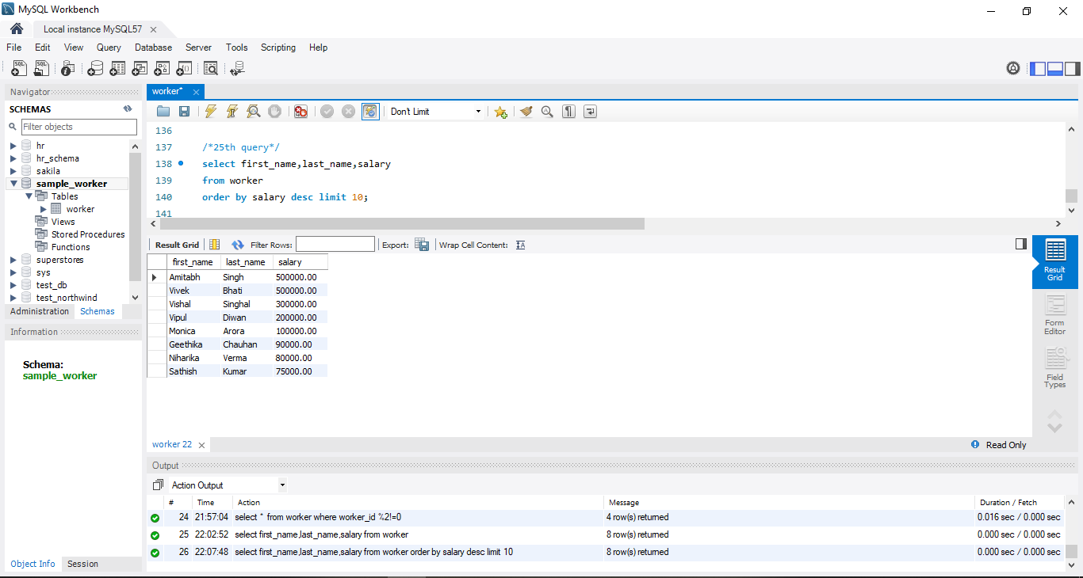

26) An SQL query to fetch the list of employees with the same salary.

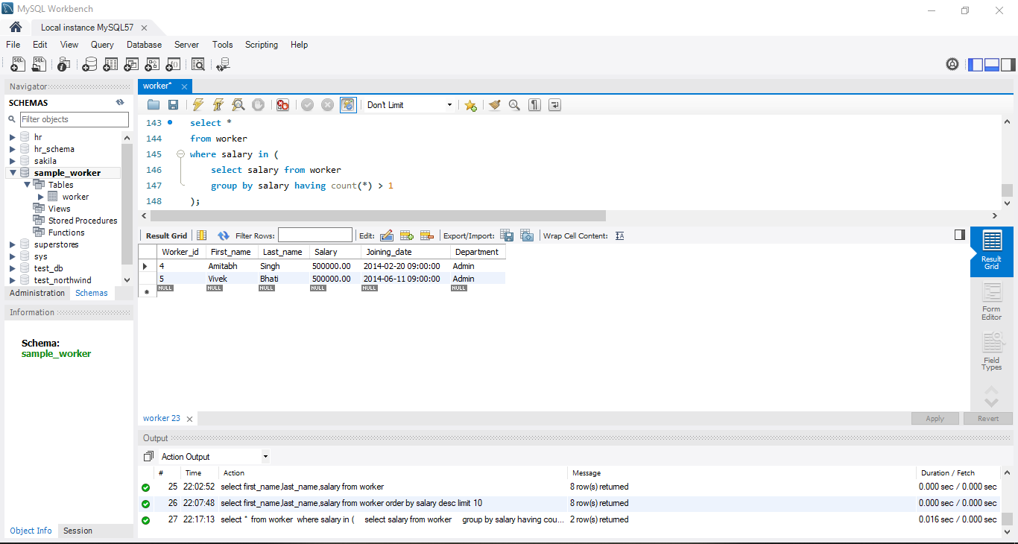

27) An SQL query to show the second highest salary from a table.

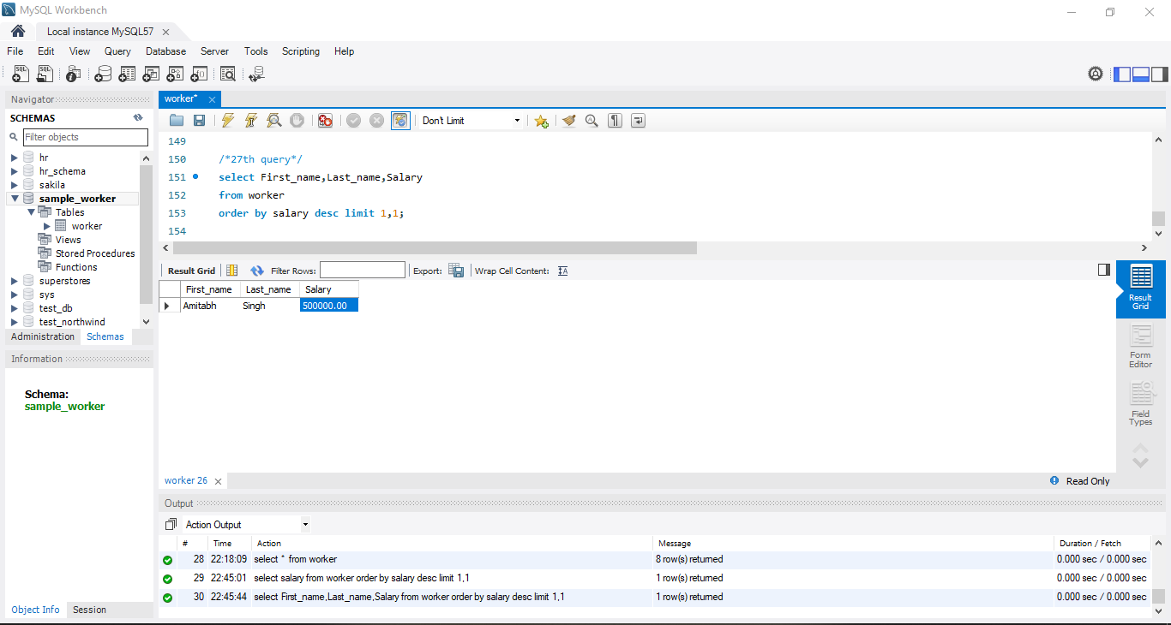

28) An SQL query to fetch the departments that have less than five people in it.

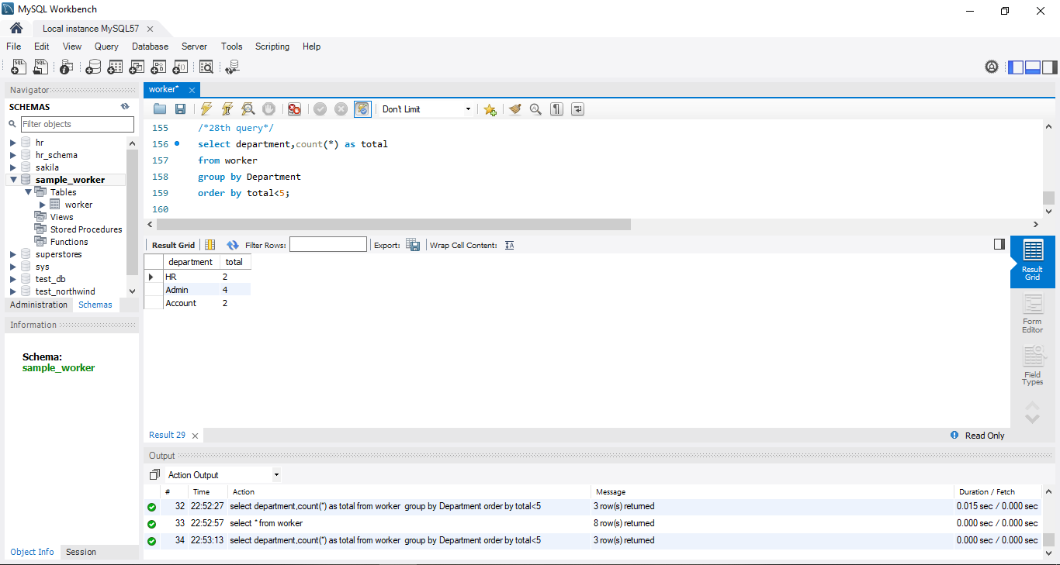

29) An SQL query to show all departments along with the number of people in there.

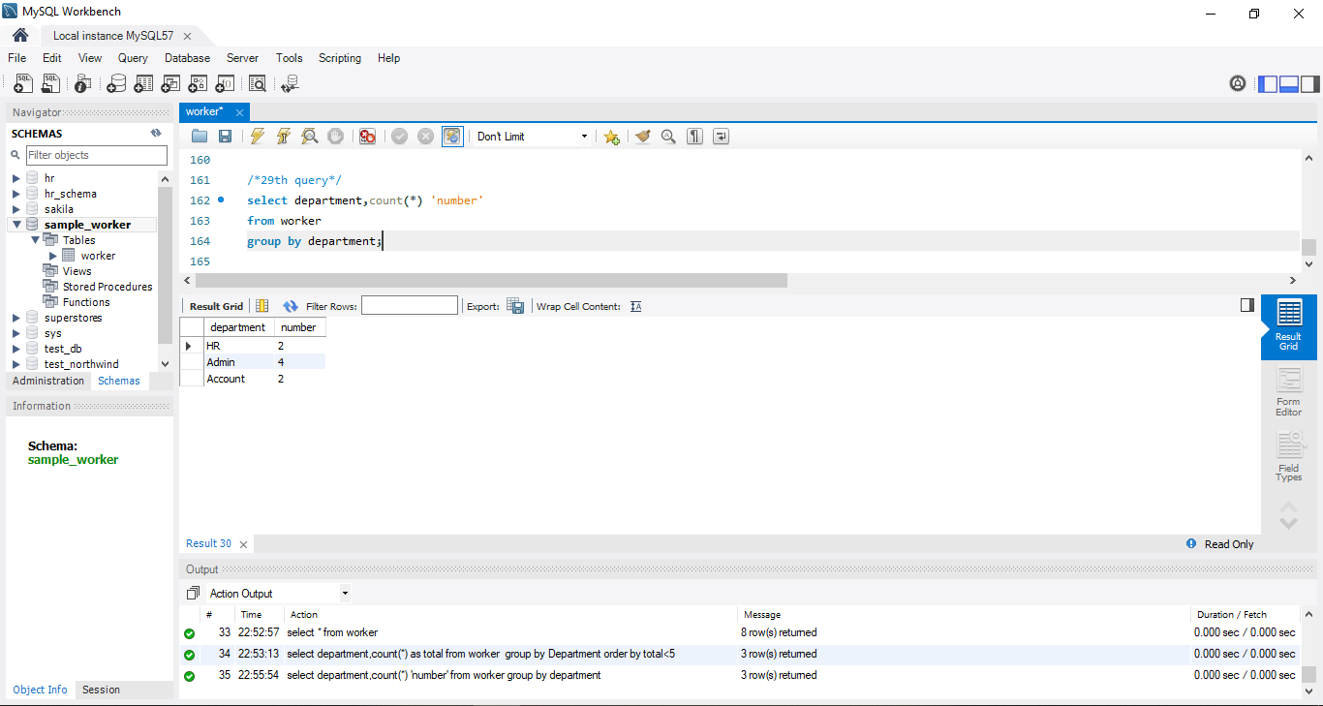

30) An SQL query to show the last record from a table.

