- Building the analysis model (Analysis Modelling in Software Engineering)

Analysis Model is a technical representation of the system.

It acts as a link between system description and design model.

In Analysis Modelling, information, behaviour, and functions of the system are defined and translated into the architecture, component, and interface level design in the design modelling.

Objectives of Analysis Modelling:
- It must establish a way of creating software design.
- It must describe the requirements of the customer.
- It must define a set of requirements that can be validated, once the software is built.

Elements of Analysis Model:

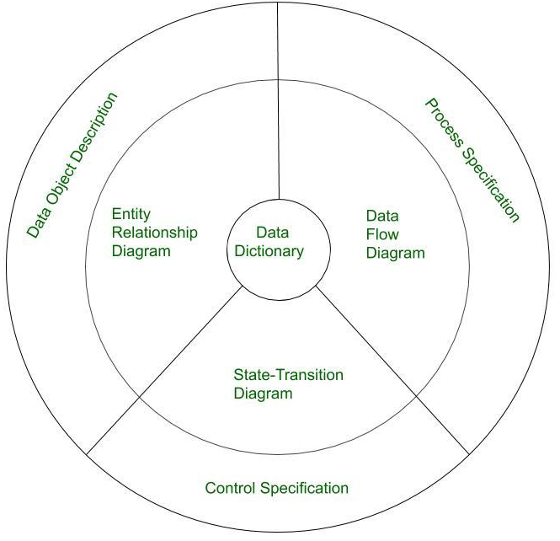

- Data Dictionary:
It is a repository that consists of a description of all data objects used by the software.
It stores the collection of data present in the software. It is a very crucial element of the analysis model.
It acts as a centralized repository and also helps in modelling data objects defined during software requirements.
- Entity Relationship Diagram (ERD):
It shows the relationship between data objects and is used in planning data modelling activities.
The details of each object in the Entity-Relationship Diagram can be explained using Data object description.
It provides the basis for activity related to data design.
- Data Flow Diagram (DFD):
It shows the functions that transform data flow and it also shows how data is transformed when moving from input to output.
It also gives extra details that help when studying the data and is used as a starting point for creating function models.
This helps engineers build models of both the processes and the data at the same time.

- State Transition Diagram:
It shows the different ways a system can behave (state) and how it moves from one state to another.
It also explains how the system reacts to things that happen outside of it.
It shows what causes the system to change and what the system does when those changes happen.
It also tells what actions the system takes when a certain event happens.

- Process Specification:
It records each function in the data flow diagram, describing the input, the algorithm used to process it, and the output.
It also includes any rules, limits, or design constraints that may affect how the process works.
- Control Specification:
It stores extra information about how the software controls its actions.
It shows how the software reacts when an event happens and which processes are triggered.
It also explains the processes used to handle these events.

- Data Object Description:
It stores and provides full information about data objects used in the software.
It also gives details of the data objects in the Entity-Relationship Diagram, including all their attributes.

7.1 Golden Rules:
The following are the golden rules stated by Theo Mandel that must be followed during the design of the interface.
Place the user in control:
- Define the interaction modes in such a way that does not force the user into unnecessary actions:
The user should be able to easily enter and exit the mode with no effort.
- Provide for flexible interaction:
Different people will use different interaction mechanisms, some might use keyboard commands, some might use mouse, some might use touch screen, etc, Hence all interaction mechanisms should be provided.
- Allow user interaction to be interruptible and undoable:
When a user is doing a sequence of actions the user must be able to interrupt the sequence to do some other work without losing the work that had been done. The user should also be able to do undo operation.
- Make interactions easier as skills improve, and allow customization
Advanced skilled user should be provided a chance to customize the interface as user wants which allows different interaction mechanisms so that user doesn’t feel bored while using the same interaction mechanism.
- Hide technical internals from casual users:
The user should not be aware of the internal technical details of the system. He should interact with the interface just to do his work.
- Design for direct interaction with objects that appear on screen:
The user should be able to use the objects and manipulate the objects that are present on the screen to perform a necessary task. By this, the user feels easy to control over the screen.
Reduce the user’s memory load:
- Reduce demand on short-term memory:
When users are involved in some complex tasks the demand on short-term memory is significant. So the interface should be designed in such a way to reduce the remembering of previously done actions, given inputs and results.
- Establish meaningful defaults:
Always initial set of defaults should be provided to the average user, if a user needs to add some new features then he should be able to add the required features.
- Define shortcuts that are intuitive:
Mnemonics should be used by the user. Mnemonics means the keyboard shortcuts to do some action on the screen.
- The visual layout of the interface should be based on a real-world metaphor:
Anything you represent on a screen if it is a metaphor for real-world entity then users would easily understand.
- Disclose information in a progressive fashion:
The interface should be organized hierarchically i.e. on the main screen the information about the task, an object or some behavior should be presented first at a high level of abstraction. More detail should be presented after the user indicates interest with a mouse pick.
Make the interface consistent:
- Allow the user to put the current task into a meaningful context:
Many interfaces have dozens of screens. So it is important to provide indicators consistently so that the user know about the doing work. The user should also know from which page has navigated to the current page and from the current page where can navigate.
- Maintain consistency across a family of applications:
The development of some set of applications all should follow and implement the same design, rules so that consistency is maintained among applications.
If past interactive models have created user expectations do not make changes unless there is a compelling reason.

Q. List and explain fundamental software design concepts.
ANS :-
4.2 Design Concepts
The main fundamental software design concepts are as follows:
- Abstraction
- A solution is explained in simple, broad terms using the language of the problem.
- A more detailed explanation comes at lower levels of abstraction.
- A procedural abstraction is a set of instructions that do a specific small task.
- A data abstraction is a group of data that describes a data object.
- Architecture
- The complete structure of the software is called its architecture.
- A good structure gives the system a clear and consistent design.
- Architecture shows how program modules (parts) interact with each other.
- Components use the structure of data.
- Software design starts by creating an architectural framework, then more detailed design is built on it.
- Patterns
- A design pattern is a reusable solution for a common design problem.
- Modularity
- Software is divided into separate, named parts called modules.
- Modules work together to solve the problem.
- Modularity makes software easier to manage and maintain.
- Information Hiding
- Each module should hide its internal details (like algorithms and data) from other modules that don’t need to know them.
- Functional Independence
- Modules should be independent in their functions.
- Related to modularity, abstraction, and information hiding.
- Measured using:
Cohesion:
  - A module is cohesive if it does one main task and has minimal interaction with other modules.
Coupling:
  - Coupling shows how much modules depend on each other. Less coupling is better.
- Refinement
- A top-down design approach.
- Breaks a system into smaller parts step by step.
- Each level adds more detail until you reach actual programming statements.
- Refactoring
- A technique to improve the design of modules without changing what they do.
- Makes the internal structure better while keeping the same behavior.
- Design Classes
- Software can be modeled as a set of design classes.
- Each class represents a part of the problem and focuses on features visible to the user.

Q. write down your Mini Project 1 problem statement with objects. Provide the list of identified functional and non-functional requirements of Mini Project-1
Ans:-

Mini Project 1: Wellora – Personalized Self-Care Assistant

Problem Statement
People today face common self-care problems like hair fall, acne, dark circles, stress, and poor diet. They often do not know the real cause of these problems and rely on random tips or products that may not work or could be unsafe. There is no single platform that gives personalized guidance combining home remedies, lifestyle tips, and product suggestions in a simple and safe way.

Objectives
- Build a web app where users can enter their personal care problems.
- Show possible causes of the problem based on user inputs.
- Suggest safe home remedies and lifestyle tips.
- Recommend suitable products for the user.
- Make the system easy to use with simple language and design.
- Prepare for future features like tracking progress and getting feedback.

Functional Requirements
Functional requirements describe what the system should do.
- User Management
  - Users can register with name, email, and password.
  - Users can log in and log out safely.
  - Users can update their profile.
- Problem Input & Tracking
  - Users can enter personal care problems like hair fall or acne.
  - Users can add details like habits, lifestyle, or diet.
  - Users can view past problems and track progress (future feature).
- Recommendations
  - System shows possible causes of the problem.
  - System gives safe home remedies.
  - System provides lifestyle tips like diet and exercise.
  - System recommends suitable products.
- Feedback
  - Users can give feedback on remedies and products.
  - Users can rate effectiveness (future feature).
- Admin Panel
  - Admin can add, edit, or delete remedies, tips, and products.
  - Admin can view user feedback.
- Search & Filter
  - Users can search for remedies or products.
  - Users can filter products by type, price, or rating.

Non-Functional Requirements
Non-functional requirements describe how the system should work.
- Easy to Use
  - The system should be simple and easy to understand.
  - Instructions must use clear, simple words.
- Performance
  - System should respond to user queries quickly.
  - Should work well even if many users use it at the same time.
- Reliability
  - System should work correctly and consistently.
  - Recommendations should be accurate.
- Security
  - User passwords should be safe and encrypted.
  - User data should not be accessed by unauthorized people.
- Scalability
  - System should allow adding new problems, remedies, and products later.
  - Should allow future API integration for products or expert advice.
- Maintainability
  - Admin should easily update remedies and products without coding.
  - System should be easy to maintain and upgrade.
- Compatibility & Accessibility
  - Should work on browsers (Chrome, Firefox, Edge) and mobile devices.
  - UI should be easy to read and navigate, with good colors and fonts.

