1. Create a local git repo with the name "MyRepo".
2. create one .txt file, five .c files and five .java files in the working area.

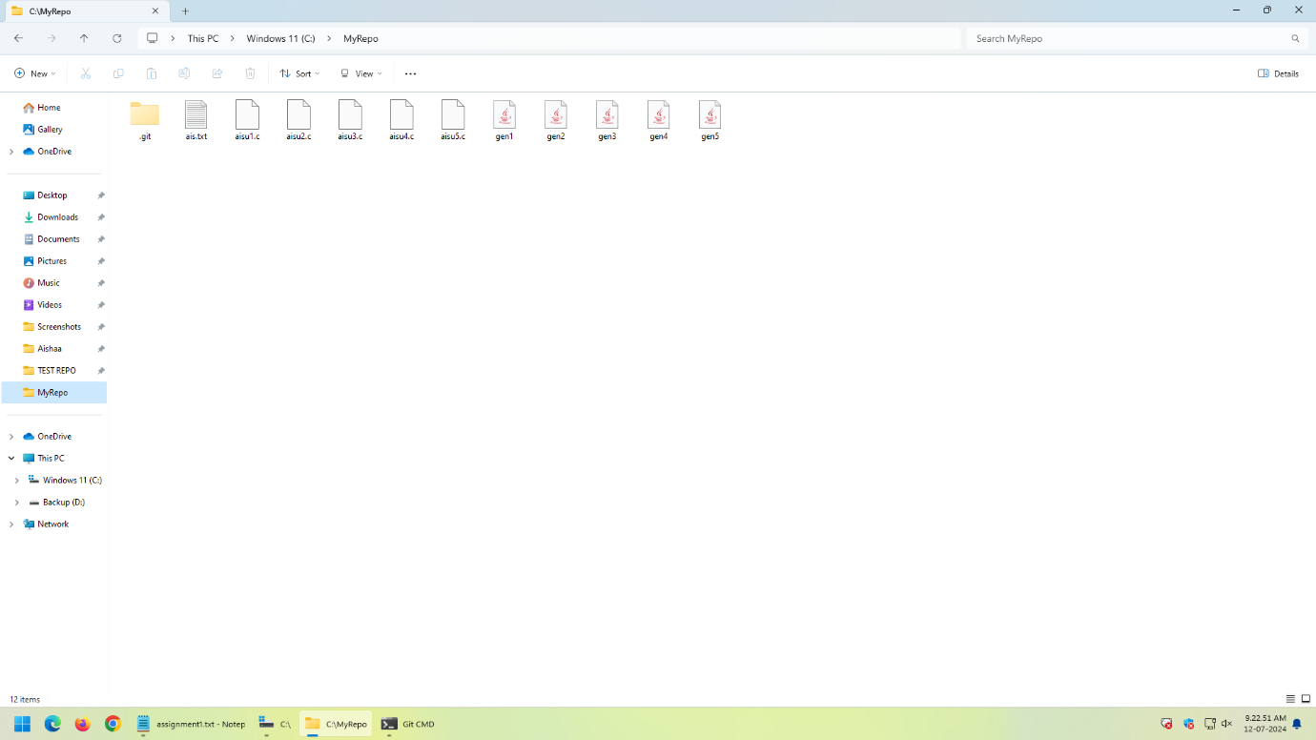

1. **Verify the git status**

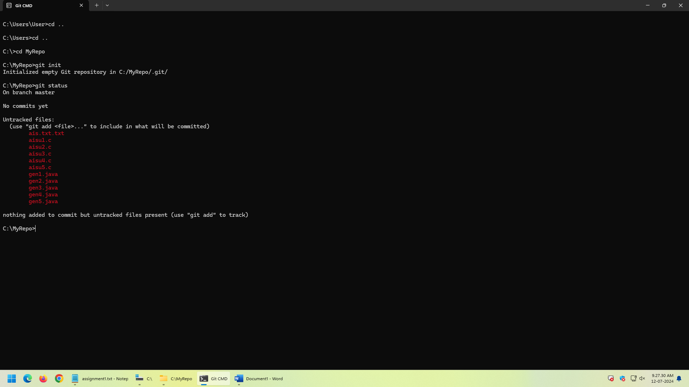

**4. Add only the .txt into the staging area**

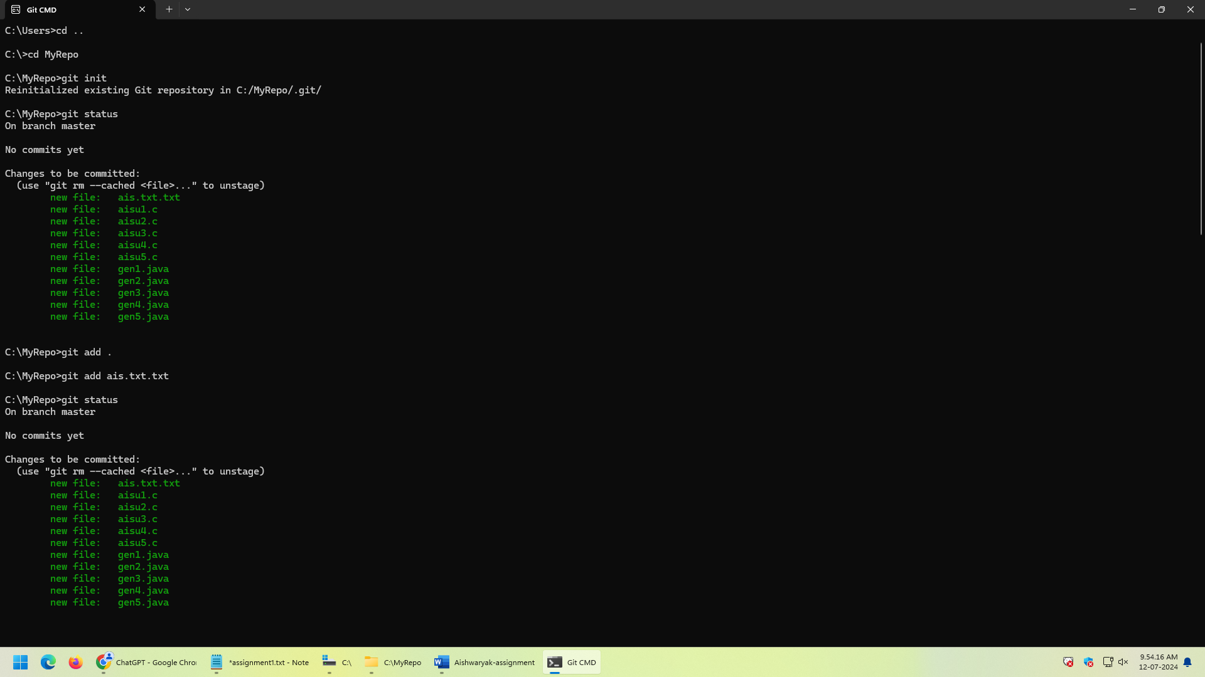

5. verify the git status

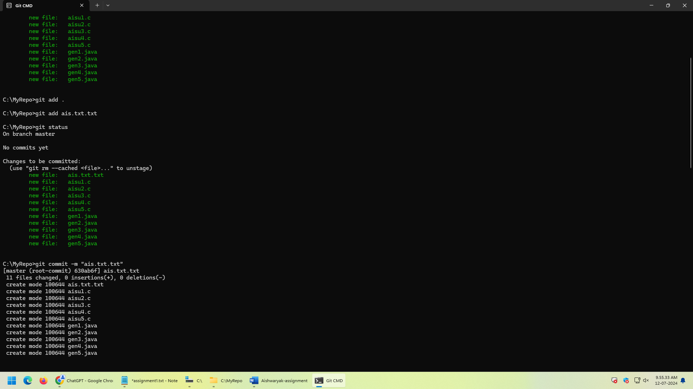

6. Make a commit with the name "TXT Commit"

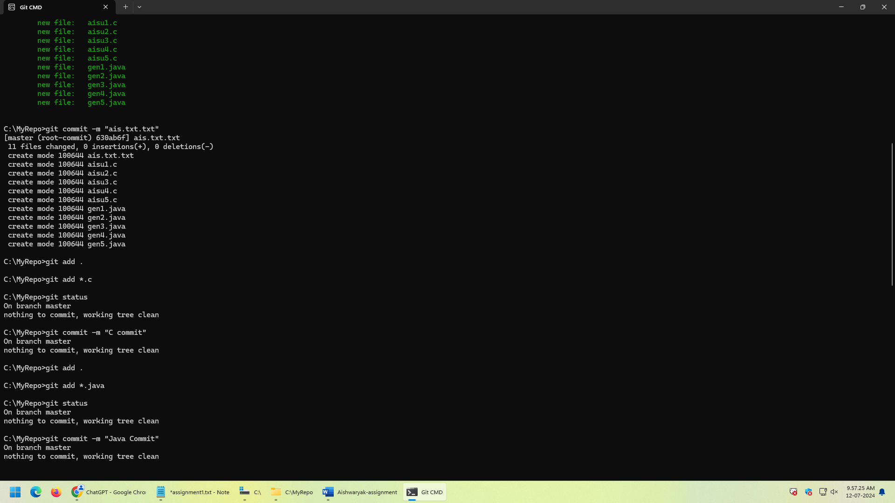

7. Add all .c files into the staging area

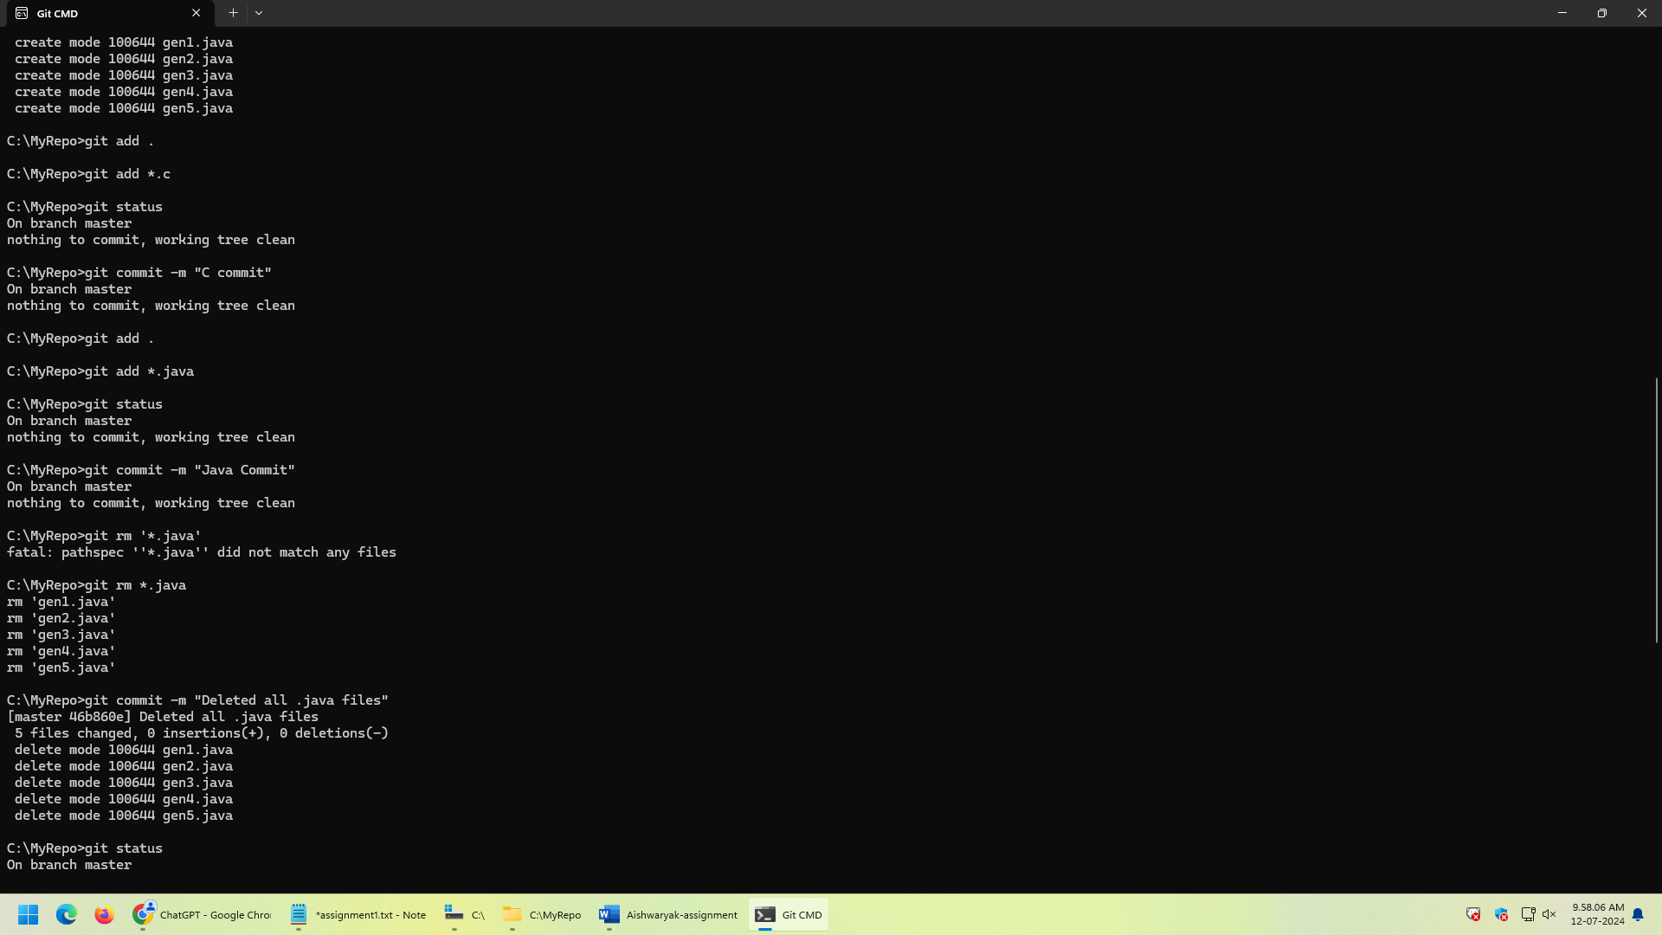

8. verify the git status

9. Make a commit with the name "C Commit"

10 .Add all .java files into the staging area

11. verify the git status

12. Make a commit with the name "Java Commit"

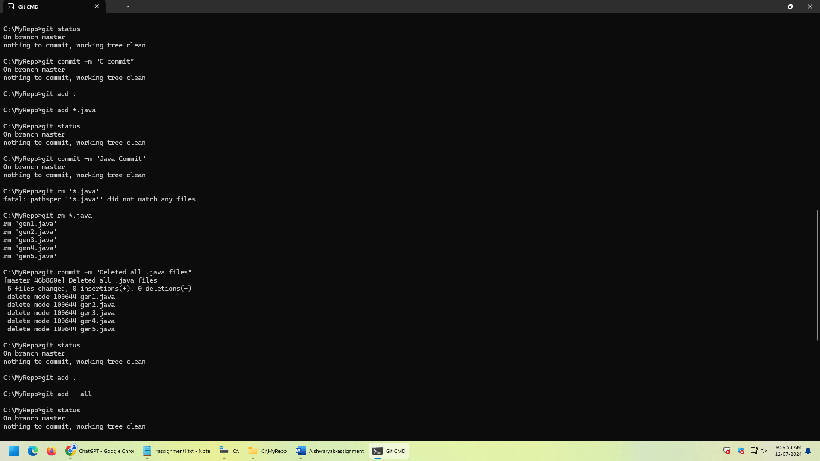

13. Delete all .java files from working area

14. Now see the status

15. add the changes into the staging area

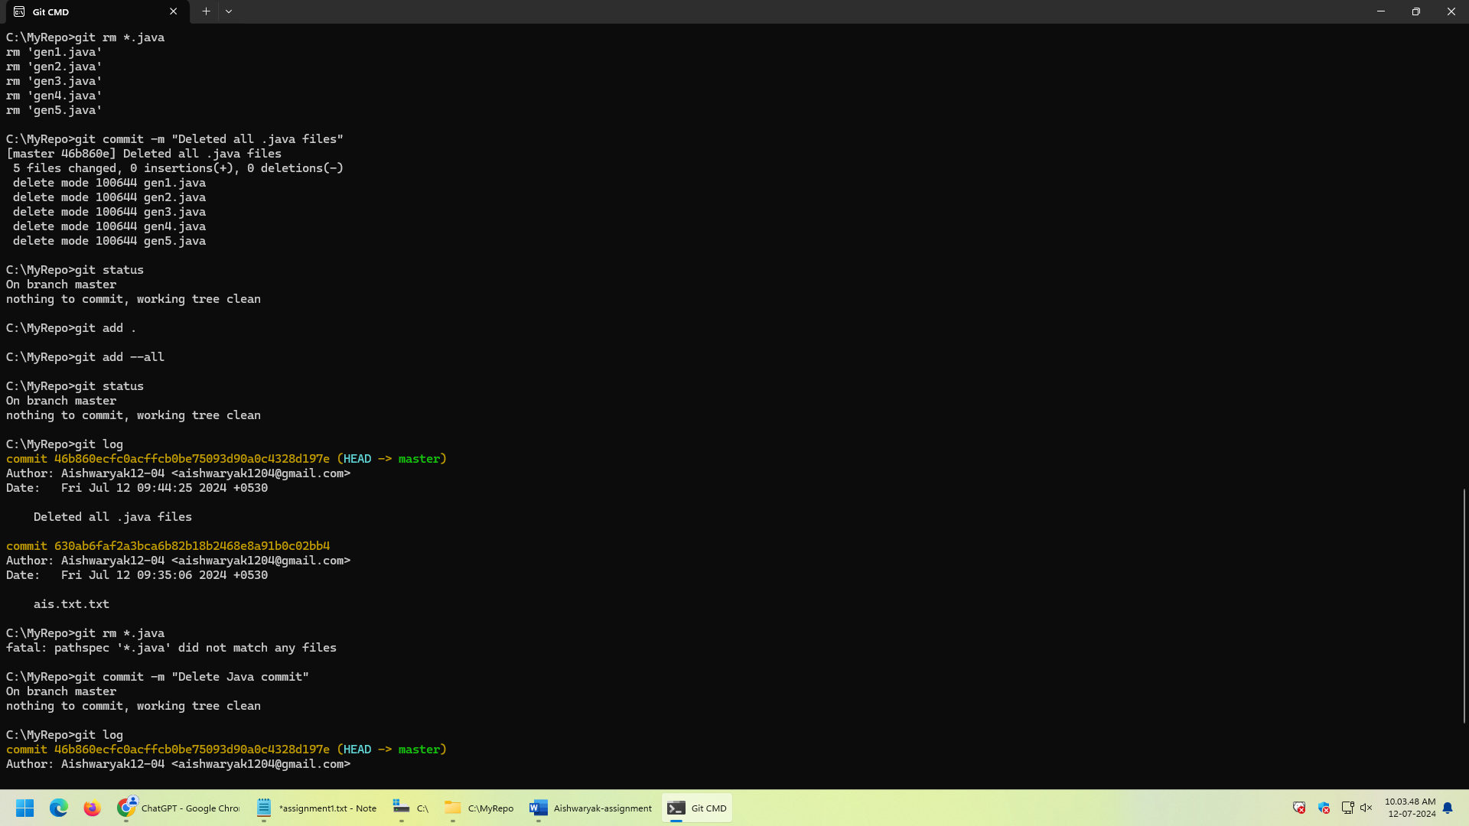

16. Make a commit with the name "Delete Java Commit"

17. display all commit

