**Cognizant Deep Skilling - Digital Nurture 4.0**

**Exercise 1: Implementing the Singleton Pattern**

**Problem Statement**

You need to ensure that a logging utility class in your application has only one instance throughout the application lifecycle to ensure consistent logging.

**Java Code**

**Logger.java**

public class Logger {

private static Logger instance;

private Logger() {

System.out.println("Logger instance created");

}

public static Logger getInstance() {

if (instance == null) {

instance = new Logger();

}

return instance;

}

public void log(String message) {

System.out.println("Log: " + message);

}

}

**Main.java**

public class Main {

public static void main(String[] args) {

Logger logger1 = Logger.getInstance();

logger1.log("First message");

Logger logger2 = Logger.getInstance();

logger2.log("Second message");

System.out.println("Same instance? " + (logger1 == logger2));

}

}

**Output**

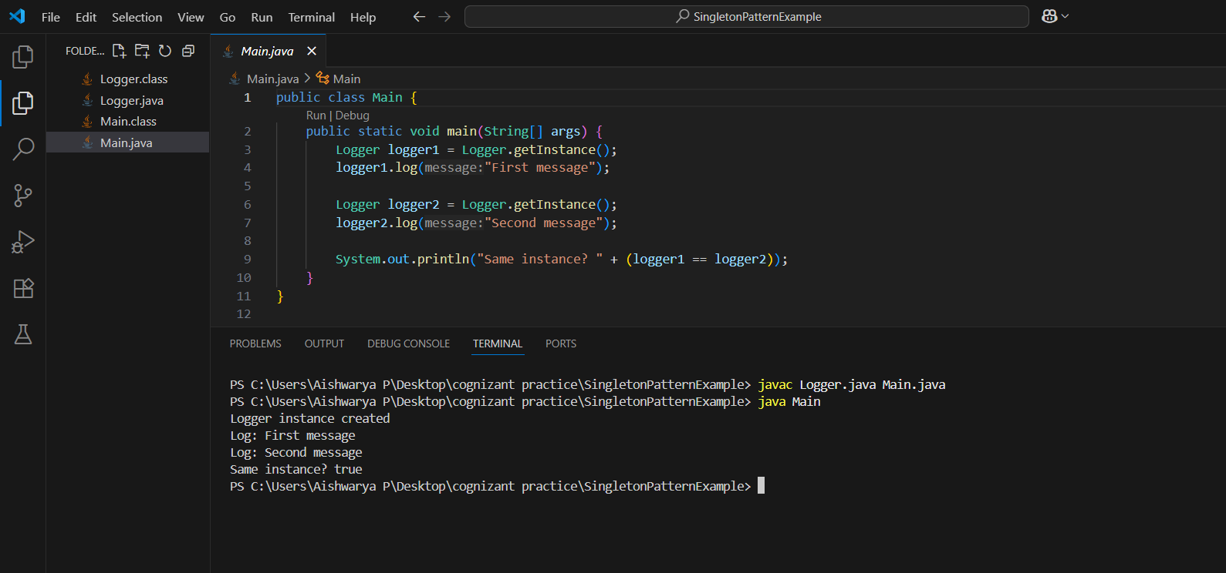

**Exercise 2: Implementing the Factory Method Pattern**

**Problem Statement**

You are developing a document management system that needs to create different types of documents (e.g., Word, PDF, Excel). Use the Factory Method Pattern to design the system.

**Java Code**

**Document.java**

public interface Document {

void open();

}

**WordDocument.java**

public class WordDocument implements Document {

public void open() {

System.out.println("Opening Word document...");

}

}

**PdfDocument.java**

public class PdfDocument implements Document {

public void open() {

System.out.println("Opening PDF document...");

}}

**ExcelDocument.java**

public class ExcelDocument implements Document {

public void open() {

System.out.println("Opening Excel document...");

}

}

**DocumentFactory.java**

public abstract class DocumentFactory {

public abstract Document createDocument();

}

**WordDocumentFactory.java**

public class WordDocumentFactory extends DocumentFactory {

public Document createDocument() {

return new WordDocument();

}

}

**PdfDocumentFactory.java**

public class PdfDocumentFactory extends DocumentFactory {

public Document createDocument() {

return new PdfDocument();

}

}

**ExcelDocumentFactory.java**

public class ExcelDocumentFactory extends DocumentFactory {

public Document createDocument() {

return new ExcelDocument();

}

}

**Main.java**

public class Main {

public static void main(String[] args) {

DocumentFactory wordFactory = new WordDocumentFactory();

Document word = wordFactory.createDocument();

word.open();

DocumentFactory pdfFactory = new PdfDocumentFactory();

Document pdf = pdfFactory.createDocument();

pdf.open();

DocumentFactory excelFactory = new ExcelDocumentFactory();

Document excel = excelFactory.createDocument();

excel.open();

}

}

**Output**

