**Cognizant Deep Skilling - Digital Nurture 4.0**

**Spring Core and Maven**

**Exercise 1: Configuring a Basic Spring Application**

**Scenario:**

Your company is developing a web application for managing a library. You need to use the Spring Framework to handle the backend operations.

**Pom.xml**

<project xmlns="http://maven.apache.org/POM/4.0.0" xmlns:xsi="http://www.w3.org/2001/XMLSchema-instance"  
 xsi:schemaLocation="http://maven.apache.org/POM/4.0.0 http://maven.apache.org/xsd/maven-4.0.0.xsd">  
 <modelVersion>4.0.0</modelVersion>  
  
 <groupId>com.library</groupId>  
 <artifactId>LibraryManagement</artifactId>  
 <version>1.0-SNAPSHOT</version>  
 <packaging>jar</packaging>  
  
 <name>LibraryManagement</name>  
 <url>http://maven.apache.org</url>  
  
 <properties>  
 <project.build.sourceEncoding>UTF-8</project.build.sourceEncoding>  
 </properties>  
  
 <dependencies>  
 <dependency>  
 <groupId>org.springframework</groupId>  
 <artifactId>spring-context</artifactId>  
 <version>5.3.34</version>  
 </dependency>  
  
 <dependency>  
 <groupId>junit</groupId>  
 <artifactId>junit</artifactId>  
 <version>4.13.2</version>  
 <scope>test</scope>  
 </dependency>  
  
 </dependencies>  
  
 <build>  
 <plugins>  
 <plugin>  
 <groupId>org.apache.maven.plugins</groupId>  
 <artifactId>maven-compiler-plugin</artifactId>  
 <version>3.11.0</version>  
 <configuration>  
 <source>23</source>  
 <target>23</target>  
 </configuration>  
 </plugin>  
 </plugins>  
 </build>  
  
</project>

**applicationContext.xml**

<?xml version="1.0" encoding="UTF-8"?>  
<beans xmlns="http://www.springframework.org/schema/beans"  
 xmlns:xsi="http://www.w3.org/2001/XMLSchema-instance"  
 xsi:schemaLocation="http://www.springframework.org/schema/beans  
 https://www.springframework.org/schema/beans/spring-beans.xsd">  
  
 <bean id="bookRepository" class="com.library.repository.BookRepository" />  
  
 <bean id="bookService" class="com.library.service.BookService">  
 <property name="bookRepository" ref="bookRepository" />  
 </bean>  
</beans>

**BookRepository.java**

package com.library.repository;  
  
public class BookRepository {  
 public void saveBook(String title) {  
 System.*out*.println("Book '" + title + "' saved to the repository.");  
 }  
}  
**BookService.java**

package com.library.service;  
import com.library.repository.BookRepository;  
  
public class BookService {  
 private BookRepository bookRepository;  
  
 public void setBookRepository(BookRepository bookRepository) {  
 this.bookRepository = bookRepository;  
 }  
  
 public void addBook(String title) {  
 System.*out*.println("Adding book: " + title);  
 bookRepository.saveBook(title);  
 }  
}

**MainApp.java**

package com.library;  
import com.library.service.BookService;  
import org.springframework.context.ApplicationContext;  
import org.springframework.context.support.ClassPathXmlApplicationContext;  
  
public class MainApp {  
 public static void main(String[] args) {  
  
 ApplicationContext context = new ClassPathXmlApplicationContext("applicationContext.xml");  
  
  
 BookService bookService = (BookService) context.getBean("bookService");  
  
  
 bookService.addBook("Spring in Action");  
 }  
}

**Output:**

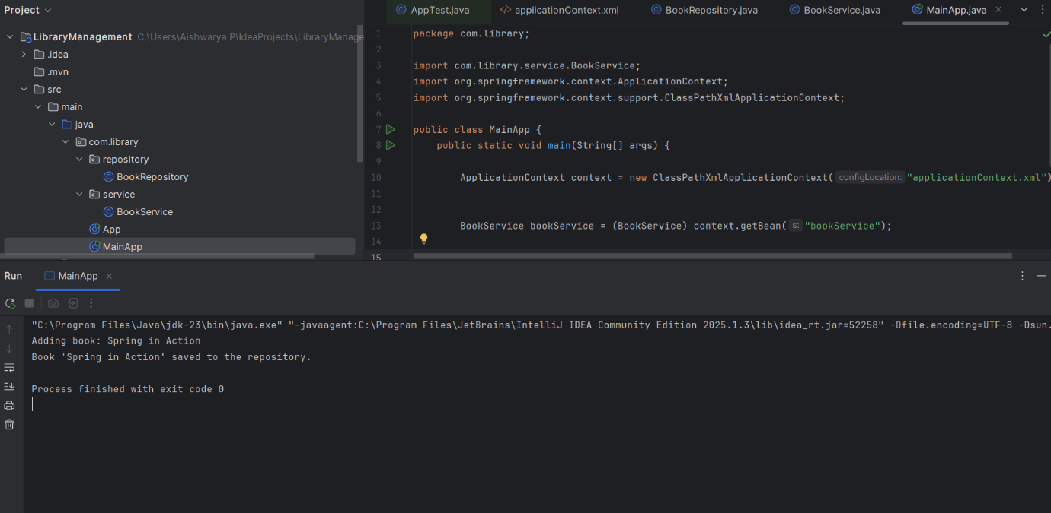

**Exercise 2: Implementing Dependency Injection**

**Scenario:**

In the library management application, you need to manage the dependencies between the BookService and BookRepository classes using Spring's IoC and DI.

**LibraryManagementApplication.java**

package com.library;

import com.library.service.BookService;

import org.springframework.context.ApplicationContext;

import org.springframework.context.support.ClassPathXmlApplicationContext;

public class MainApp {

public static void main(String[] args) {

ApplicationContext context = new ClassPathXmlApplicationContext("applicationContext.xml");

BookService bookService = (BookService) context.getBean("bookService");

bookService.displayBooks();

}

}

**BookRepository.java**

package com.library.repository;

import java.util.Arrays;

import java.util.List;

public class BookRepository {

public List<String> getBooks() {

return Arrays.asList("Java Fundamentals", "Spring Framework", "Data Structures");

}

}

**BookService.java**

package com.library.service;

import com.library.repository.BookRepository;

public class BookService {

private BookRepository bookRepository;

public void setBookRepository(BookRepository bookRepository) {

this.bookRepository = bookRepository;

}

public void displayBooks() {

bookRepository.getBooks().forEach(System.out::println);

}

}

**applicationContext.xml**

<?xml version="1.0" encoding="UTF-8"?>

<beans xmlns="http://www.springframework.org/schema/beans"

xmlns:xsi="http://www.w3.org/2001/XMLSchema-instance"

xsi:schemaLocation="

http://www.springframework.org/schema/beans

http://www.springframework.org/schema/beans/spring-beans.xsd">

<bean id="bookRepository" class="com.library.repository.BookRepository" />

<bean id="bookService" class="com.library.service.BookService">

<property name="bookRepository" ref="bookRepository"/>

</bean>

</beans>

**Pom.xml**

<project xmlns="http://maven.apache.org/POM/4.0.0" xmlns:xsi="http://www.w3.org/2001/XMLSchema-instance"  
 xsi:schemaLocation="http://maven.apache.org/POM/4.0.0 http://maven.apache.org/xsd/maven-4.0.0.xsd">  
 <modelVersion>4.0.0</modelVersion>  
  
 <groupId>com.library</groupId>  
 <artifactId>LibraryManagement</artifactId>  
 <version>1.0-SNAPSHOT</version>  
 <packaging>jar</packaging>  
  
 <name>LibraryManagement</name>  
 <url>http://maven.apache.org</url>  
  
 <properties>  
 <project.build.sourceEncoding>UTF-8</project.build.sourceEncoding>  
 </properties>  
  
 <dependencies>  
 <dependency>  
 <groupId>org.springframework</groupId>  
 <artifactId>spring-context</artifactId>  
 <version>5.3.34</version>  
 </dependency>  
  
 <dependency>  
 <groupId>junit</groupId>  
 <artifactId>junit</artifactId>  
 <version>4.13.2</version>  
 <scope>test</scope>  
 </dependency>  
  
 </dependencies>  
  
 <build>  
 <plugins>  
 <plugin>  
 <groupId>org.apache.maven.plugins</groupId>  
 <artifactId>maven-compiler-plugin</artifactId>  
 <version>3.11.0</version>  
 <configuration>  
 <source>23</source>  
 <target>23</target>  
 </configuration>  
 </plugin>  
 </plugins>  
 </build>  
  
</project>

**Output:**

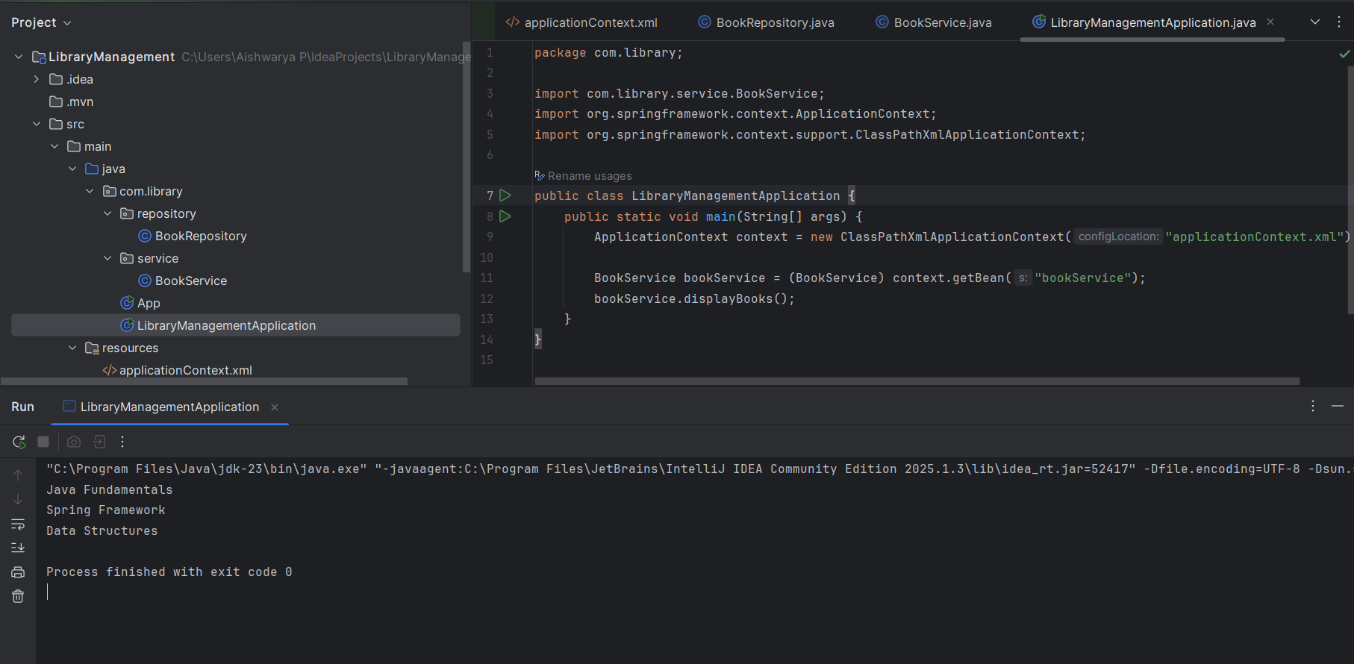

**Exercise 4: Creating and Configuring a Maven Project**

**Scenario:**

You need to set up a new Maven project for the library management application and add Spring dependencies.

**Pom.xml**

<project xmlns="http://maven.apache.org/POM/4.0.0"  
 xmlns:xsi="http://www.w3.org/2001/XMLSchema-instance"  
 xsi:schemaLocation="http://maven.apache.org/POM/4.0.0  
 http://maven.apache.org/xsd/maven-4.0.0.xsd">  
 <modelVersion>4.0.0</modelVersion>  
  
 <groupId>com.library</groupId>  
 <artifactId>LibraryManagement</artifactId>  
 <version>1.0-SNAPSHOT</version>  
 <packaging>jar</packaging>  
  
 <name>LibraryManagement</name>  
  
 <properties>  
 <project.build.sourceEncoding>UTF-8</project.build.sourceEncoding>  
 </properties>  
  
 <dependencies>  
  
 <dependency>  
 <groupId>org.springframework</groupId>  
 <artifactId>spring-context</artifactId>  
 <version>5.3.36</version>  
 </dependency>  
  
 <dependency>  
 <groupId>org.springframework</groupId>  
 <artifactId>spring-aop</artifactId>  
 <version>5.3.36</version>  
 </dependency>

<dependency>  
 <groupId>org.springframework</groupId>  
 <artifactId>spring-webmvc</artifactId>  
 <version>5.3.36</version>  
 </dependency>

<dependency>  
 <groupId>junit</groupId>  
 <artifactId>junit</artifactId>  
 <version>4.13.2</version>  
 <scope>test</scope>  
 </dependency>  
 </dependencies>  
  
 <build>  
 <plugins>  
 <plugin>  
 <groupId>org.apache.maven.plugins</groupId>  
 <artifactId>maven-compiler-plugin</artifactId>  
 <version>3.11.0</version>  
 <configuration>  
 <source>1.8</source>  
 <target>1.8</target>  
 <compilerArgs>  
 <arg>-Xlint:-options</arg>  
 </compilerArgs>  
 </configuration>  
 </plugin>  
 </plugins>  
 </build>

</project>

**Output:**

