**Cognizant Deep Skilling - Digital Nurture 4.0**

**Microservices with Spring Boot 3 and Spring Cloud**

**Filename - 2. Microservices with API gateway**

**Creating Microservices for account and loan**

**Objective:**

To create two independent Spring Boot Microservices for a bank:

* **Account Microservice**
* **Loan Microservice**

**STEP 1 : Create Account Microservice**

**AccountController.java**

package com.cognizant.account;

import org.springframework.web.bind.annotation.GetMapping;

import org.springframework.web.bind.annotation.PathVariable;

import org.springframework.web.bind.annotation.RestController;

@RestController

public class AccountController {

@GetMapping("/accounts/{number}")

public Account getAccount(@PathVariable String number) {

return new Account(number, "savings", 234343);

}

}

class Account {

private String number;

private String type;

private double balance;

public Account(String number, String type, double balance) {

this.number = number;

this.type = type;

this.balance = balance;

}

public String getNumber() { return number; }

public String getType() { return type; }

public double getBalance() { return balance; }

}

**AccountApplication.java**

package com.cognizant.account;

import org.springframework.boot.SpringApplication;

import org.springframework.boot.autoconfigure.SpringBootApplication;

@SpringBootApplication

public class AccountApplication {

public static void main(String[] args) {

SpringApplication.*run*(AccountApplication.class, args);

}

}

**Pom.xml**

<?xml version="1.0" encoding="UTF-8"?>

<project xmlns="http://maven.apache.org/POM/4.0.0" xmlns:xsi="http://www.w3.org/2001/XMLSchema-instance"

xsi:schemaLocation="http://maven.apache.org/POM/4.0.0 https://maven.apache.org/xsd/maven-4.0.0.xsd">

<modelVersion>4.0.0</modelVersion>

<parent>

<groupId>org.springframework.boot</groupId>

<artifactId>spring-boot-starter-parent</artifactId>

<version>3.5.3</version>

<relativePath/>

</parent>

<groupId>com.cognizant</groupId>

<artifactId>account</artifactId>

<version>0.0.1-SNAPSHOT</version>

<name>account</name>

<description>Demo project for Spring Boot</description>

<url/>

<licenses>

<license/>

</licenses>

<developers>

<developer/>

</developers>

<scm>

<connection/>

<developerConnection/>

<tag/>

<url/>

</scm>

<properties>

<java.version>21</java.version>

</properties>

<dependencies>

<dependency>

<groupId>org.springframework.boot</groupId>

<artifactId>spring-boot-starter-web</artifactId>

</dependency>

<dependency>

<groupId>org.springframework.boot</groupId>

<artifactId>spring-boot-devtools</artifactId>

<scope>runtime</scope>

<optional>true</optional>

</dependency>

<dependency>

<groupId>org.springframework.boot</groupId>

<artifactId>spring-boot-starter-test</artifactId>

<scope>test</scope>

</dependency>

</dependencies>

<build>

<plugins>

<plugin>

<groupId>org.springframework.boot</groupId>

<artifactId>spring-boot-maven-plugin</artifactId>

</plugin>

</plugins>

</build>

</project>

**Output:**

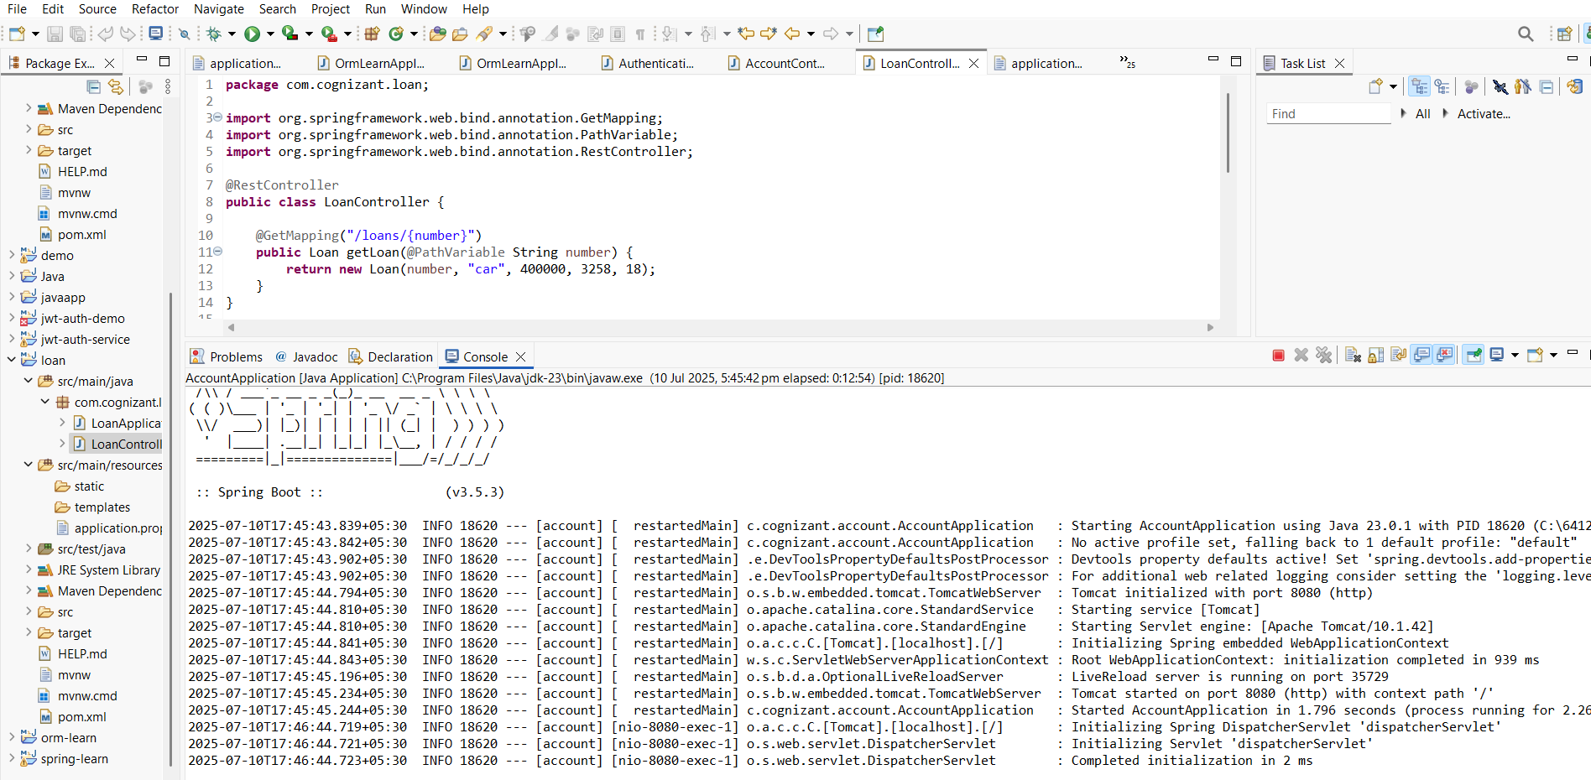

**Request :** [**http://localhost:8080/accounts/00987987973432**](http://localhost:8080/accounts/00987987973432)

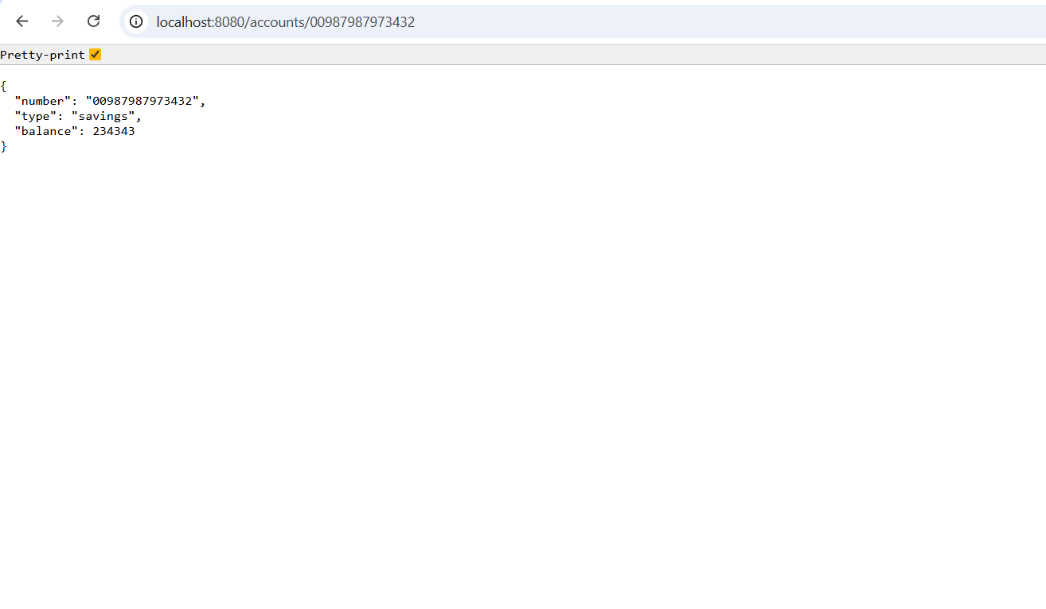

**STEP 2: Create Loan Microservice**

**LoanController.java**

package com.cognizant.loan;

import org.springframework.web.bind.annotation.GetMapping;

import org.springframework.web.bind.annotation.PathVariable;

import org.springframework.web.bind.annotation.RestController;

@RestController

public class LoanController {

@GetMapping("/loans/{number}")

public Loan getLoan(@PathVariable String number) {

return new Loan(number, "car", 400000, 3258, 18);

}

}

class Loan {

private String number;

private String type;

private double loan;

private int emi;

private int tenure;

public Loan(String number, String type, double loan, int emi, int tenure) {

this.number = number;

this.type = type;

this.loan = loan;

this.emi = emi;

this.tenure = tenure;

}

public String getNumber() { return number; }

public String getType() { return type; }

public double getLoan() { return loan; }

public int getEmi() { return emi; }

public int getTenure() { return tenure; }

}

**LoanApplication.java**

package com.cognizant.loan;

import org.springframework.boot.SpringApplication;

import org.springframework.boot.autoconfigure.SpringBootApplication;

@SpringBootApplication

public class LoanApplication {

public static void main(String[] args) {

SpringApplication.*run*(LoanApplication.class, args);

}

}

**application.properties**

server.port=8081

**pom.xml**

<?xml version="1.0" encoding="UTF-8"?>

<project xmlns="http://maven.apache.org/POM/4.0.0" xmlns:xsi="http://www.w3.org/2001/XMLSchema-instance"

xsi:schemaLocation="http://maven.apache.org/POM/4.0.0 https://maven.apache.org/xsd/maven-4.0.0.xsd">

<modelVersion>4.0.0</modelVersion>

<parent>

<groupId>org.springframework.boot</groupId>

<artifactId>spring-boot-starter-parent</artifactId>

<version>3.5.3</version>

<relativePath/>

</parent>

<groupId>com.cognizant</groupId>

<artifactId>loan</artifactId>

<version>0.0.1-SNAPSHOT</version>

<name>loan</name>

<description>Demo project for Spring Boot</description>

<url/>

<licenses>

<license/>

</licenses>

<developers>

<developer/>

</developers>

<scm>

<connection/>

<developerConnection/>

<tag/>

<url/>

</scm>

<properties>

<java.version>21</java.version>

</properties>

<dependencies>

<dependency>

<groupId>org.springframework.boot</groupId>

<artifactId>spring-boot-starter-web</artifactId>

</dependency>

<dependency>

<groupId>org.springframework.boot</groupId>

<artifactId>spring-boot-devtools</artifactId>

<scope>runtime</scope>

<optional>true</optional>

</dependency>

<dependency>

<groupId>org.springframework.boot</groupId>

<artifactId>spring-boot-starter-test</artifactId>

<scope>test</scope>

</dependency>

</dependencies>

<build>

<plugins>

<plugin>

<groupId>org.springframework.boot</groupId>

<artifactId>spring-boot-maven-plugin</artifactId>

</plugin>

</plugins>

</build>

</project>

**Output:**

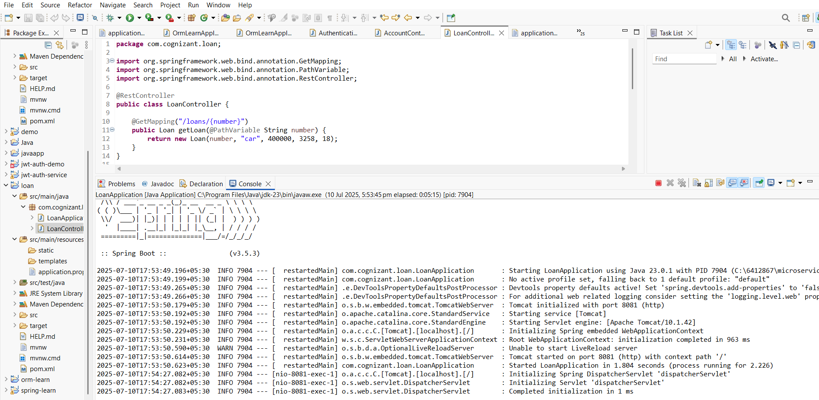

**Request :** [**http://localhost:8081/loans/H00987987972342**](http://localhost:8081/loans/H00987987972342)

