**Cognizant Deep Skilling - Digital Nurture 4.0**

**React**

**Filename - 1. ReactJS-HOL**

**App.js**

function App() {

return (

<div>

<h1>Welcome to the first session of React</h1>

</div>

);

}

export default App;

**Start the React App:**

npm start

**Output:**

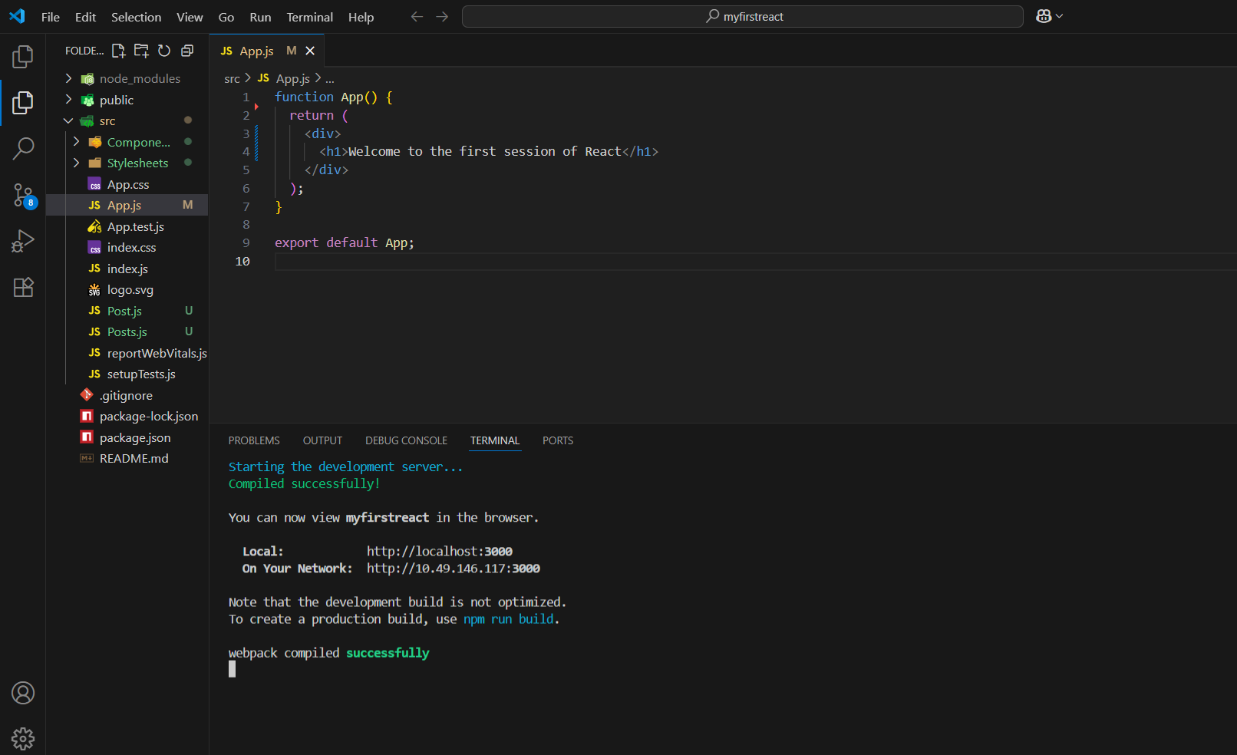

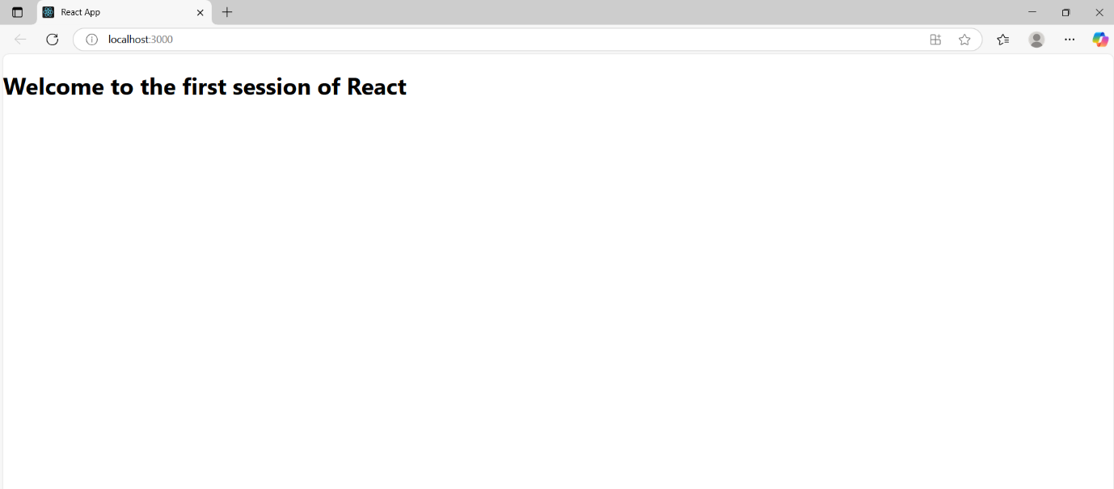

**Filename - 2. ReactJS-HOL**

**Home.js**

import React from 'react';

function Home() {

return (

<div>

<h1>Welcome to the Home page of Student Management Portal</h1>

</div>

);

}

export default Home;

**About.js**

import React from 'react';

function About() {

return (

<div>

<h1>Welcome to the About page of Student Management Portal</h1>

</div>

);

}

export default About;

**Contact.js**

import React from 'react';

function Contact() {

return (

<div>

<h1>Welcome to the Contact page of Student Management Portal</h1>

</div>

);

}

export default Contact;

**App.js**

import React from 'react';

import Home from './Components/Home';

import About from './Components/About';

import Contact from './Components/Contact';

function App() {

return (

<div>

<Home />

<About />

<Contact />

</div>

);

}

export default App;

**Start the React App:**

npm start

**Output:**

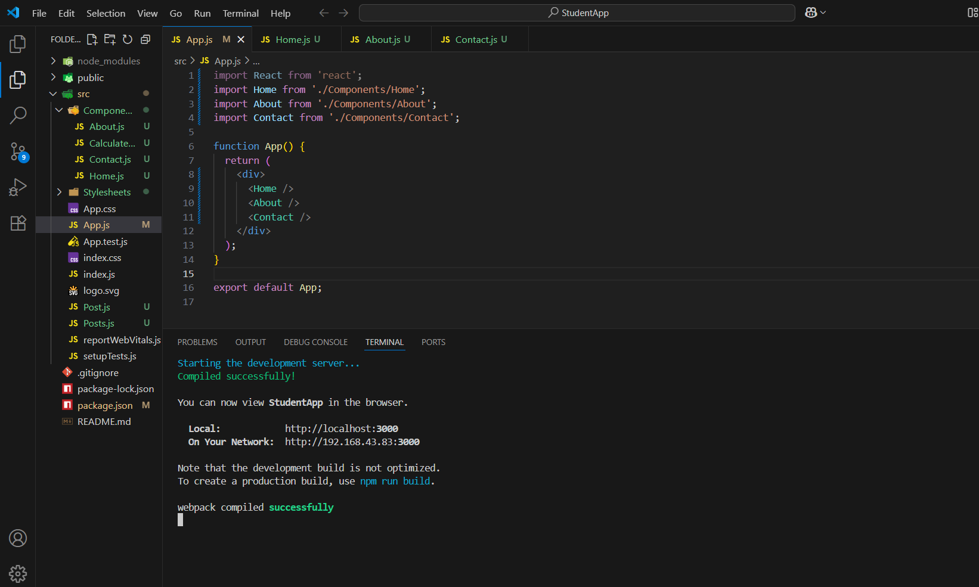

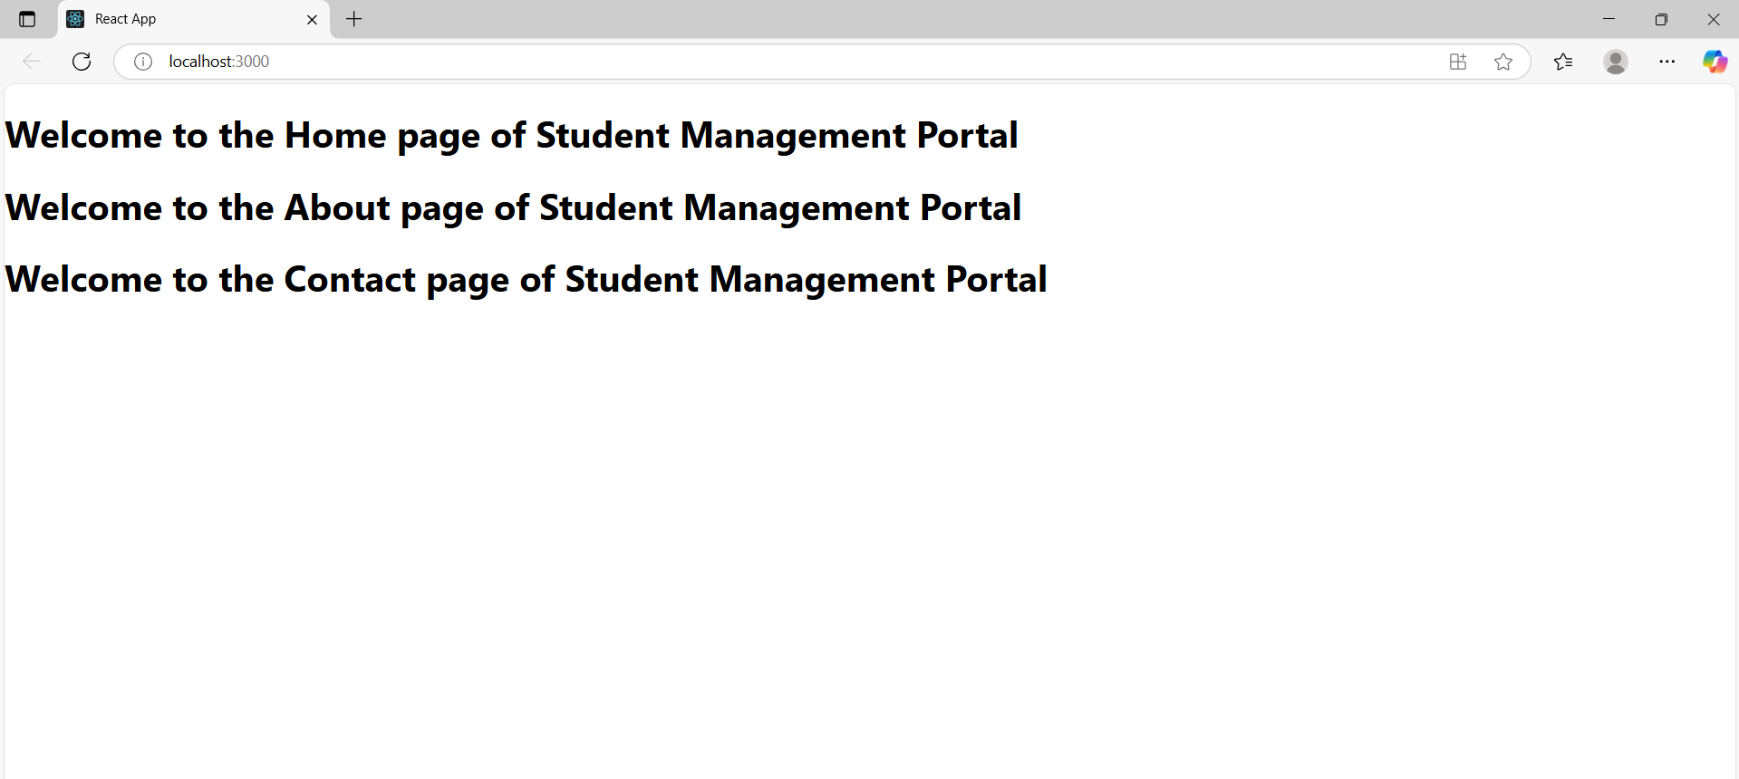

**Filename - 3. ReactJS-HOL**

**CalculateScore.js**

import '../Stylesheets/mystyle.css';

const percentToDecimal = (decimal) => {

return (decimal.toFixed(2) + '%');

};

const calcScore = (total, goal) => {

return percentToDecimal(total / goal);

};

export const CalculateScore = ({ Name, School, total, goal }) => (

<div className="formatstyle">

<h1 style={{ color: 'brown' }}>Student Details:</h1>

<div className="Name">

<b><span>Name: </span></b>

<span>{Name}</span>

</div>

<div className="School">

<b><span>School: </span></b>

<span>{School}</span>

</div>

<div className="Total">

<b><span>Total: </span></b>

<span>{total}</span>

<span> Marks</span>

</div>

<div className="Score">

<b>Score: </b>

<span>

{calcScore(total, goal)}

</span>

</div>

</div>

);

**mystyle.css**

.Name {

font-weight: 300;

color: blue;

}

.School {

color: crimson;

}

.Total {

color: darkmagenta;

}

.formatstyle {

text-align: center;

font-size: large;

}

.Score {

color: forestgreen;

}

**App.js**

import { CalculateScore } from '../src/components/CalculateScore';

function App() {

return (

<div>

<CalculateScore

Name={"Steeve"}

School={"DNV Public School"}

total={284}

goal={3}

/>

</div>

);

}

export default App;

**Start the React App:**

npm start

**Output:**

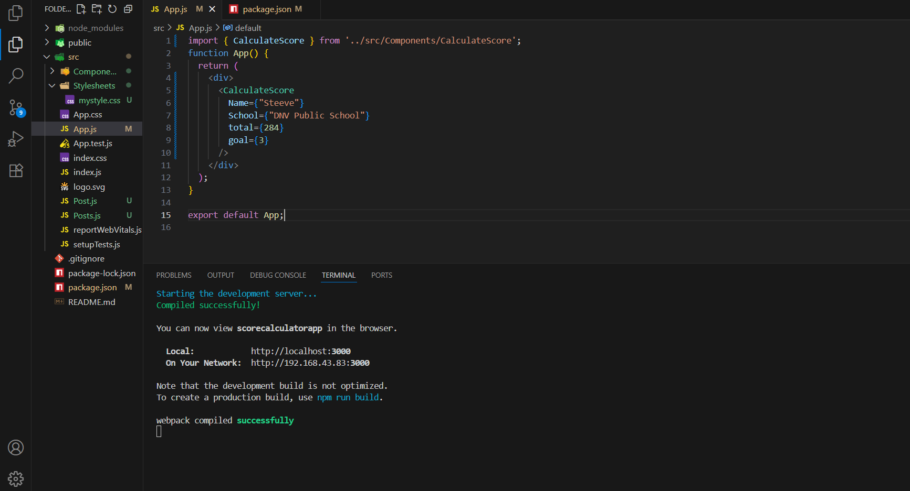

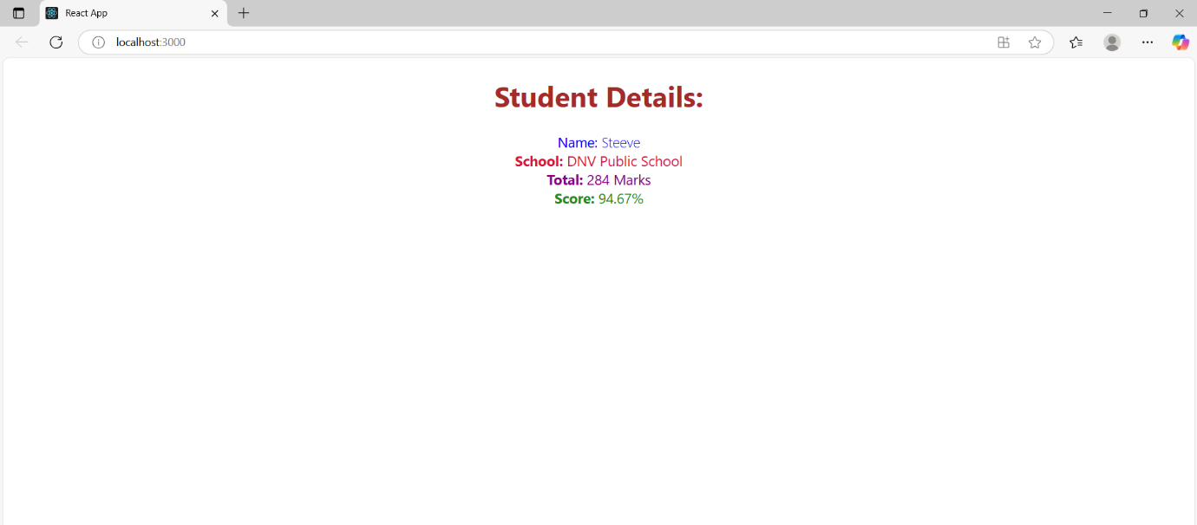

**Filename - 4. ReactJS-HOL**

**Post.js**

class Post {

constructor(id, title, body) {

this.id = id;

this.title = title;

this.body = body;

}

}

export default Post;

**Posts.js**

import React, { Component } from 'react';

import Post from './Post';

class Posts extends Component {

constructor(props) {

super(props);

this.state = {

posts: [],

};

}

loadPosts() {

fetch('https://jsonplaceholder.typicode.com/posts')

.then(response => response.json())

.then(data => {

const posts = data.map(item => new Post(item.id, item.title, item.body));

this.setState({ posts });

})

.catch(error => {

console.error('Error fetching posts:', error);

});

}

componentDidMount() {

this.loadPosts();

}

componentDidCatch(error, info) {

alert("An error occurred in the Posts component: " + error);

}

render() {

return (

<div>

<h1>Blog Posts</h1>

{this.state.posts.map(post => (

<div key={post.id}>

<h2>{post.title}</h2>

<p>{post.body}</p>

</div>

))}

</div>

);

}

}

export default Posts;

**App.js**

import React from 'react';

import Posts from './Posts';

function App() {

return (

<div>

<Posts />

</div>

);

}

export default App;

**Start the React App:**

npm start

**Output:**

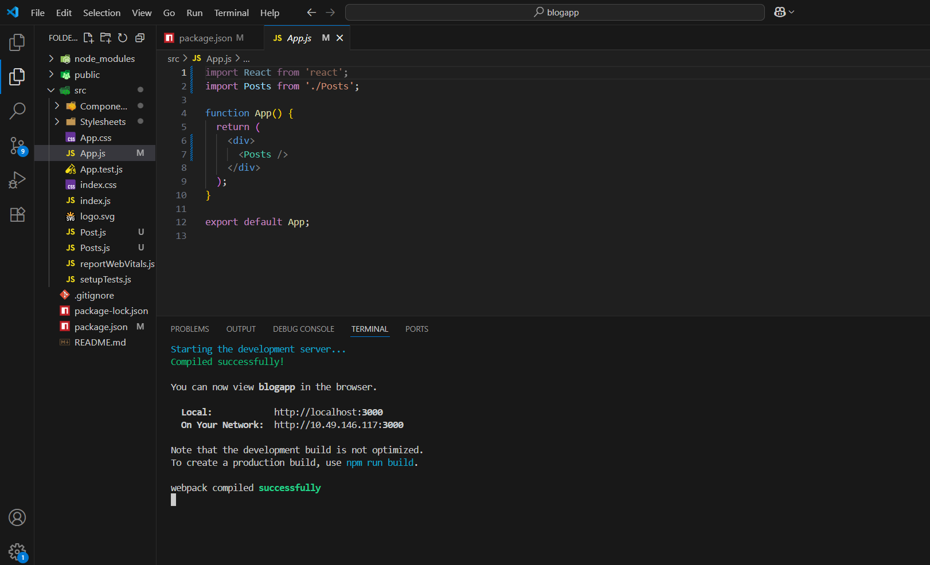

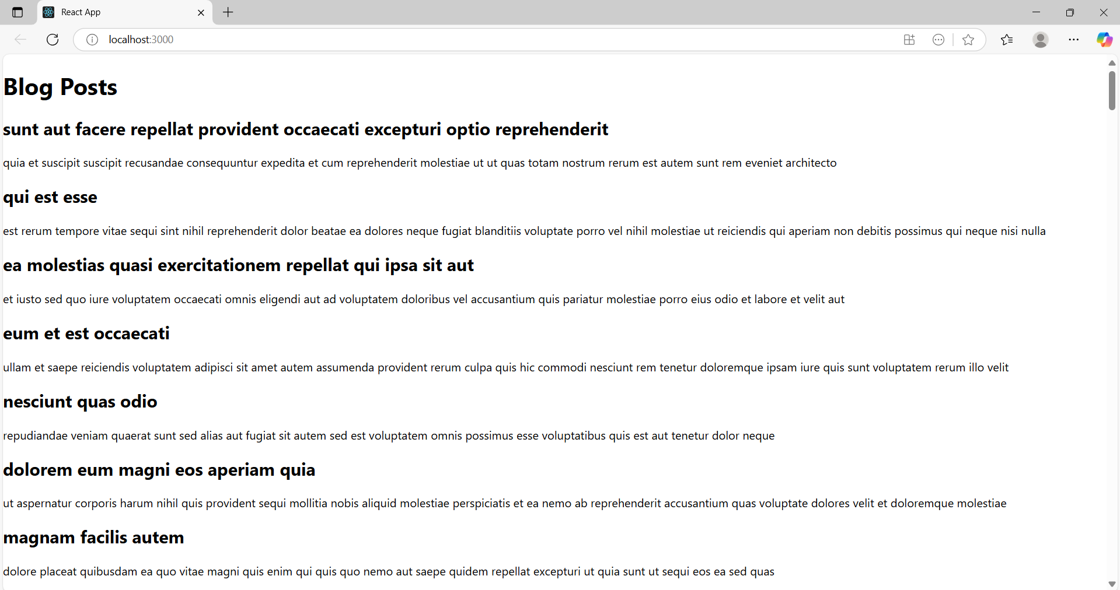

**Filename - 5. ReactJS-HOL**

**App.js**

import logo from './logo.svg';

import './App.css';

import { CohortsData} from './Cohort'

import CohortDetails from './CohortDetails';

function App() {

  return (

  <div>

    <h1>Cohorts Details</h1>

    {CohortsData.map(cohort => <CohortDetails cohort={cohort}/>)}

  </div>

  );

}

export default App;

**CohortDetails.js**

import styles from './CohortDetails.module.css';

function CohortDetails(props) {

  return (

    <div className={styles.box}>

      <h3 style={{ color: props.cohort.currentStatus === 'Ongoing' ? 'green' : 'blue' }}>

        {props.cohort.cohortCode} -

        <span>{props.cohort.technology}</span>

      </h3>

      <dl>

        <dt>Started On</dt>

        <dd>{props.cohort.startDate}</dd>

        <dt>Current Status</dt>

        <dd>{props.cohort.currentStatus}</dd>

        <dt>Coach</dt>

        <dd>{props.cohort.coachName}</dd>

        <dt>Trainer</dt>

        <dd>{props.cohort.trainerName}</dd>

      </dl>

    </div>

  );

}

export default CohortDetails;

**CohortDetails.module.css**

.box {

  width: 300px;

  display: inline-block;

  margin: 10px;

  padding: 10px 20px;

  border: 1px solid black;

  border-radius: 10px;

}

dt {

  font-weight: 500;

}

**Cohort.js**

class Cohort {

    constructor(cohortCode,

        startDate,

        technology,

        trainerName,

        coachName,

        currentStatus) {

        this.cohortCode = cohortCode;

        this.coachName = coachName;

        this.trainerName = trainerName;

        this.technology = technology;

        this.startDate = startDate;

        this.currentStatus = currentStatus;

    }

}

const CohortsData =[

    new Cohort('INTADMDF10','22-Feb-2022', '.NET FSD', 'Jojo Jose','Aathma', 'Scheduled'),

    new Cohort('ADM21JF014','10-Sep-2021', 'Java FSD', 'Elisa Smith','Apoorv', 'Ongoing'),

    new Cohort('CDBJF21025','24-Dec-2021', 'Java FSD', 'John Doe','Aathma', 'Ongoing'),

    new Cohort('INTADMJF12','22-Feb-2022', 'Java FSD', 'To Be Assigned','Ibrahim', 'Scheduled'),

    new Cohort('CDE22JF011','24-Dec-2021', 'Java FSD', 'Emma Swan','Apoorv', 'Ongoing'),

    new Cohort('INTADMDF09','22-Feb-2022', 'Dataware Housing', 'Babjee Rao','Aathma', 'Scheduled'),

    new Cohort('ADM22DF001','10-Sep-2021', '.NET FSD', 'Marie Curie','Ibrahim', 'Ongoing'),

];

export {Cohort, CohortsData};

**Start the React App:**

npm start

**Output:**

