Business Insights
Power BI Customer Overview and RFM Analysis
Chart spaces are intentionally left blank for screenshots to be added later.

1. Business Overview Dashboard
The dashboard reports 5,881 customers, $17.37 million in revenue, a 50.86% churn rate, and average customer value of $2,954.40. The figures provide a high-level view of customer scale, revenue, and retention.

Customer segments
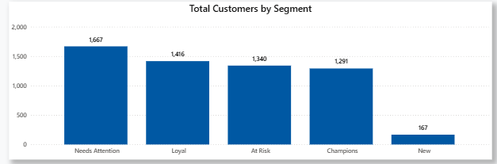
Needs Attention is the largest segment with 1,667 customers (28.3%). Loyal has 1,416 (24.1%), At Risk 1,340 (22.8%), Champions 1,291 (21.9%), and New 167 (2.8%). Needs Attention and At Risk together represent 3,007 customers (51.1%), making retention and re-engagement important priorities.

Retention by segment
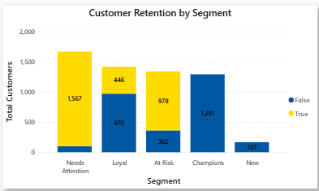
Needs Attention includes 1,567 churned customers, while At Risk includes 978 churned customers. Loyal has 970 retained and 446 churned customers; Champions has 1,291 retained customers shown. The dashboard suggests that churn is concentrated in weaker relationship segments.

Customer counts over time
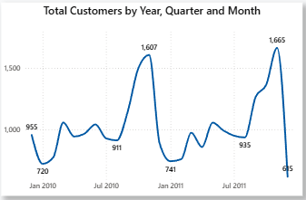
Monthly customer counts rise from 1,213 in January to 2,584 in November, then decline to 1,812 in December. Quarterly counts increase from 2,747 in Q1 to 4,101 in Q4. The annual chart rises from about 1.0K in 2009 to about 4.2K in 2010 and stays near 4.2K in 2011. Confirm whether these visuals count distinct customers or activity before comparing them with the 5,881-customer KPI.

2. RFM Analysis Dashboard
The RFM page reports 5,726 customers and $16,170,022.68 in revenue. Average Recency, Frequency, and Monetary scores are 3.98, 4.34, and 4.33. Frequency and monetary scores are slightly stronger than recency, suggesting that customers generally purchase repeatedly and contribute value, while some may need more recent engagement.

Country performance
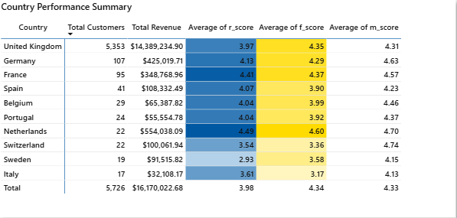
The United Kingdom contributes $14.39M from 5,353 customers—about 89.0% of RFM revenue. Germany contributes $425K from 107 customers, France $349K from 95, and the Netherlands $554K from 22. The Netherlands has the strongest displayed average R, F, and M scores (4.49, 4.60, and 4.70), but its sample is small. Revenue is highly concentrated in the UK.
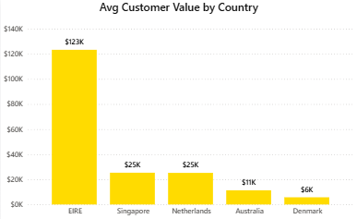
The chart shows EIRE at approximately $123K, Singapore and the Netherlands at $25K each, Australia at $11K, and Denmark at $6K. Verify how this value is aggregated before using it to compare markets.

Churn trends
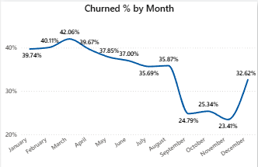
Monthly churn peaks at 42.06% in March, falls to 23.41% in November, and rises to 32.62% in December. The sharp September decline and December increase should be checked for seasonality, campaign effects, or calculation and date-filter issues.
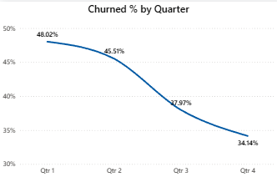
Quarterly churn decreases from 48.02% in Q1 to 34.14% in Q4, an improvement of 13.88 percentage points. This is a positive trend, but the underlying customer counts should be reviewed alongside the percentages.
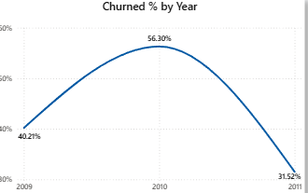
Yearly churn rises from 40.21% in 2009 to 56.30% in 2010, then falls to 31.52% in 2011. The 2011 improvement is substantial; confirm that each year has comparable coverage and uses the same churn definition.

3. Recommendations Based on the Dashboards
- Prioritize at-risk customers. Start with the 3,007 customers in Needs Attention and At Risk. Use targeted reminders, service outreach, or relevant incentives, and measure reactivation and retained revenue.
- Build separate retention plans by segment. Use proactive support and personalized offers for Needs Attention; identify early warning signals for At Risk; reward Loyal and Champions with relevant benefits rather than blanket discounts.
- Investigate churn movement over time. Review the September drop and December increase in monthly churn, plus the 2010 annual peak. Check campaign timing, customer cohorts, seasonality, and whether the churn measure is calculated consistently.
- Protect the UK revenue base while testing other markets. Because the UK represents about 89% of RFM revenue, monitor UK retention closely. Test small, measurable campaigns in markets with strong RFM scores, such as the Netherlands, before scaling.
- Validate dashboard definitions and totals. Business Overview shows 5,881 customers and $17.37M, while RFM shows 5,726 customers and $16.17M. Confirm whether RFM excludes customers or transactions and document the reason for the difference.
- Track outcomes, not only segment size. For each retention action, monitor churn rate, repeat purchase rate, reactivated customers, and revenue retained. Compare results against a baseline or control group where possible.
s

