**Assignment1**

**Activity life cycle**

Changes in UI and implementing functionality to add text view for activity B

And on restart() functionality for both activity.

Submitted By: Aishwarya Lodhi

1.Open application Page, thread counter =0

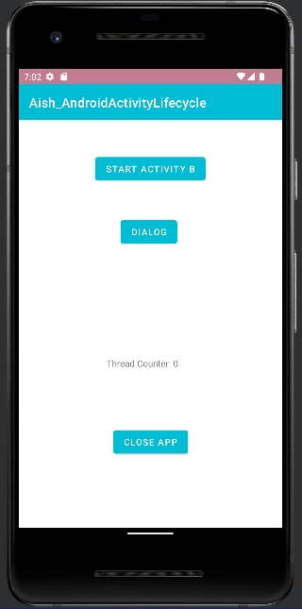

2.Clicking activity B added text view .

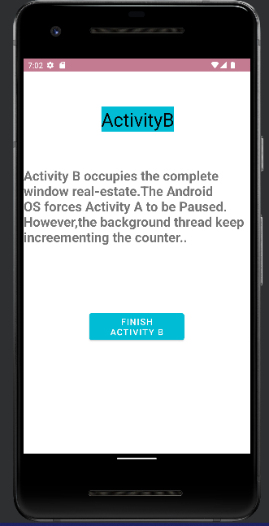

3. on Click of Activity B,Thread counter of main is called and incremented by 1.

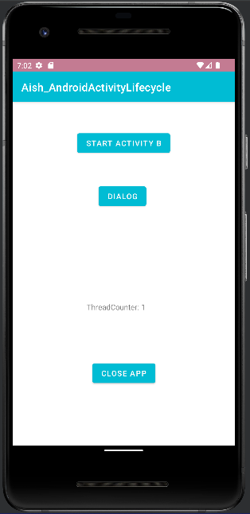

4.On click of Dialog ,dialog appears.

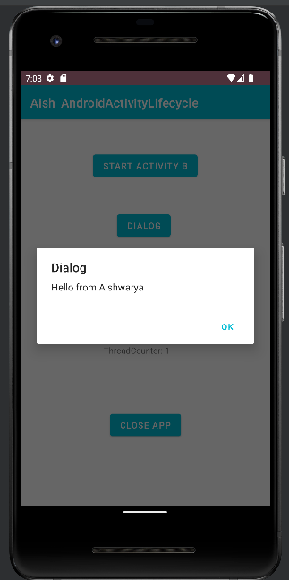

Thread counter does not increase.

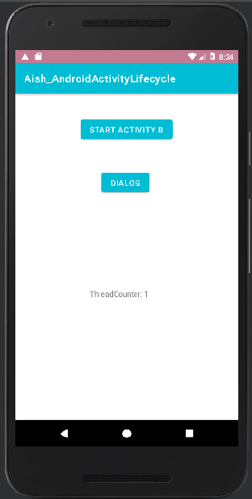

On Restart of application : thread counter of main activity is called and increments’ by 1 so now thread counter is 2.

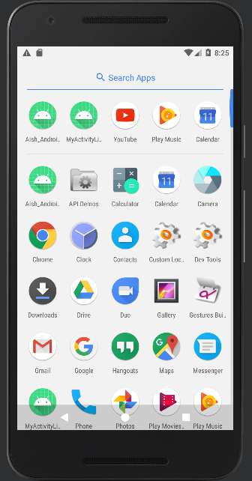

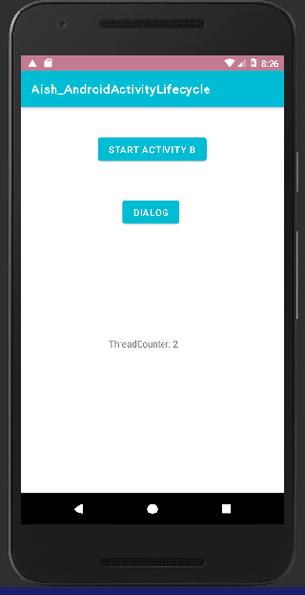

5. Go inside Activity B and close application

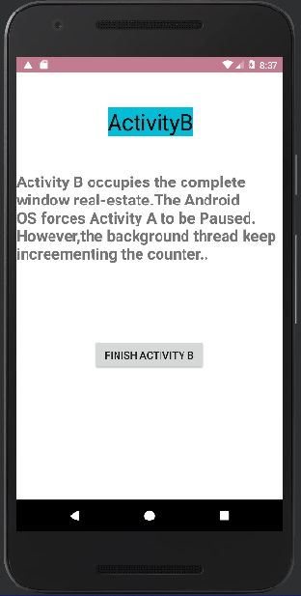



On Restart of Activity B: thread counter increases by 2. As Restart of activity B is called which increments by 1 and restart of Main activity is called which increments counter by 1.

Thread counter is 4 now.

