1. Creating and Renaming Files/Directories

Create a directory named test_dir using mkdir.

Inside test_dir, create an empty file called example.txt.

Rename example.txt to renamed_example.txt using mv

**Solution:-**

**Commands**

mkdir test_dir

cd test_dir

touch example.txt

mv example.txt renamed_example.txt

**Explanation**

* mkdir creates a directory.
* touch creates an empty file.
* mv renames the file.

**Screenshot**

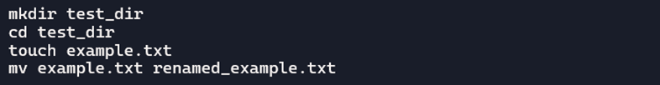

2. Viewing File Contents

Use cat to display the contents of /etc/passwd.

Display only the first 5 lines of /etc/passwd using head.

Display only the last 5 lines of /etc/passwd using tail.

**Solution:-**

**Commands**

cat /etc/passwd

head -n 5 /etc/passwd

tail -n 5 /etc/passwd

**Explanation**

* cat: Displays the full contents of the file.
* head -n 5: Shows the first 5 lines.
* tail -n 5: Shows the last 5 lines.

**Screenshot**



3.Searching for Patterns

Use grep to find all lines containing the word "root" in /etc/passwd.

**Solution :-**

**Commands**

grep "root" /etc/passwd

**Explanation**

* grep "root": Searches for lines containing the word "root" in the file.

**Screenshot**



4. Zipping and Unzipping

Compress the test_dir directory into a file named test_dir.zip using zip.

Unzip test_dir.zip into a new directory named unzipped_dir.

**Solution :-**

**Commands**

zip -r test_dir.zip test_dir

unzip test_dir.zip -d unzipped_dir

**Explanation**

* zip -r: Compresses the directory recursively.
* unzip -d: Extracts the contents into a new directory.

**Screenshot **

5. Downloading Files

Use wget to download a file from a URL (e.g.,<https://example.com/sample.txt>).

**Solution :-**

**Commands**

wget https://example.com/sample.txt

**Explanation**

* wget: Downloads the file from the specified URL

**Screenshot**



6. Changing Permissions

Create a file named secure.txt and change its permissions to read-only for everyone using chmod.

**Solution :-**

**Commands**

touch secure.txt

chmod 444 secure.txt

**Explanation**

* touch: Creates the file.
* chmod 444: Sets read-only permissions for all users.

**Screenshot**



7. Working with Environment Variables

Use export to set a new environment variable called MY_VAR with the value "Hello, Linux!".

**Solution :-**

**Commands**

export MY_VAR="Hello, Linux!"

echo $MY_VAR

**Explanation**

* export: Sets the environment variable.
* echo $MY_VAR: Displays its value.

**Screenshot**

