Database Security Lab
These 5 experiments cover all major areas of database security:
- Access control
- Injection attacks
- Auditing
- Encryption
- Role-based access control
1. User Management with GRANT and REVOKE
Objective: To study database access control using user roles and privileges.
a) Create Users
CREATE USER 'student1'@'localhost' IDENTIFIED BY 'pass123';
CREATE USER 'student2'@'localhost' IDENTIFIED BY 'pass123';

b) Grant Privileges
GRANT ALL PRIVILEGES ON labdb.* TO 'student1'@'localhost';
GRANT SELECT, INSERT ON labdb.* TO 'student2'@'localhost';

c) Revoke Privilege
REVOKE INSERT ON labdb.* FROM 'student2'@'localhost';

d) Verify
SHOW GRANTS FOR 'student1'@'localhost';
SHOW GRANTS FOR 'student2'@'localhost';

Output:
a)
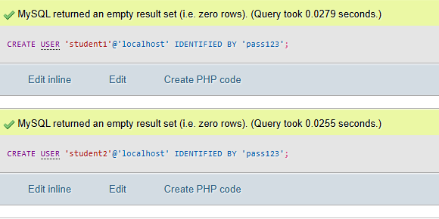

b)
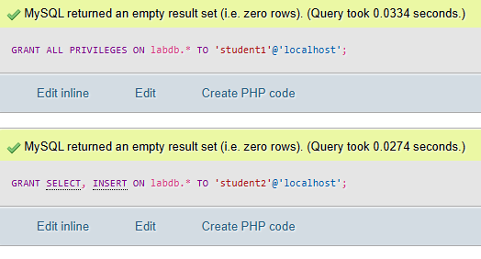

c)
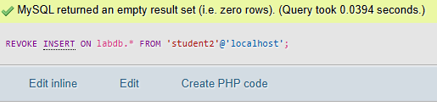

d)
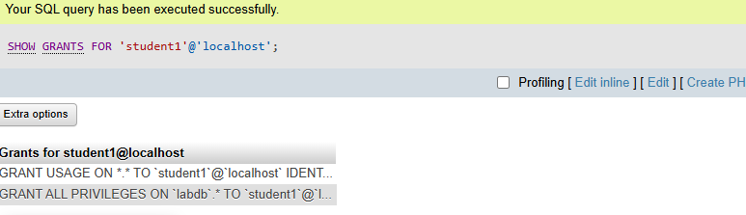
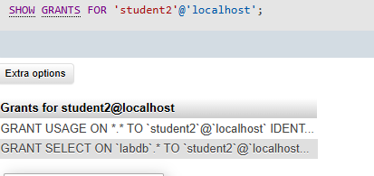

2. Experiment SQL Injection Demonstration
Objective: To demonstrate SQL injection and its prevention.
CREATE DATABASE labdb;
USE labdb;

CREATE TABLE users (
id INT AUTO_INCREMENT PRIMARY KEY,
username VARCHAR(50),
password VARCHAR(50)
);

INSERT INTO users (username, password) VALUES
('admin', 'admin123'),
('student', 'stud123');

Injection Example:
Input:
Username: admin
Password: ' OR '1'='1
Query becomes:
SELECT * FROM users WHERE username='admin' AND password='' OR '1'='1';
Bypasses authentication.
Prevention: Use prepared statements (parameterized queries)
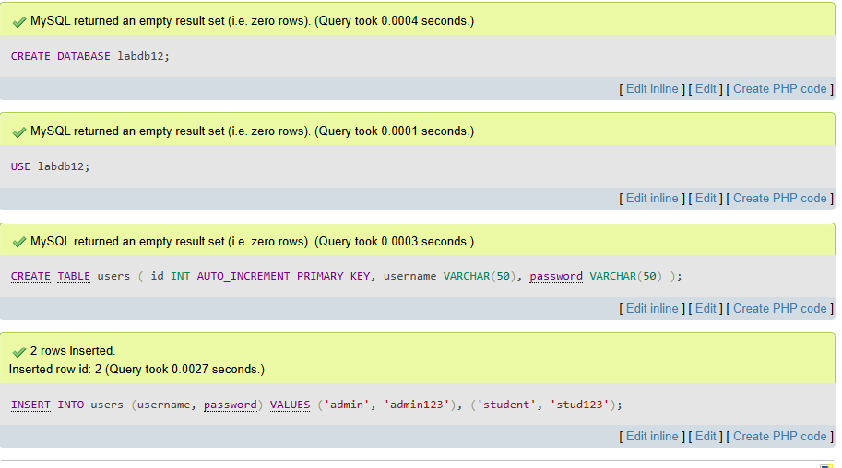

3. Experiment Database Auditing
Objective: To enable logging and track changes to the database.
Procedure:
-- Enable general log (MySQL)
SET GLOBAL general_log = 'ON';
SET GLOBAL general_log_output = 'TABLE';

-- View logged queries
SELECT * FROM mysql.general_log ORDER BY event_time DESC LIMIT 10;

Output:
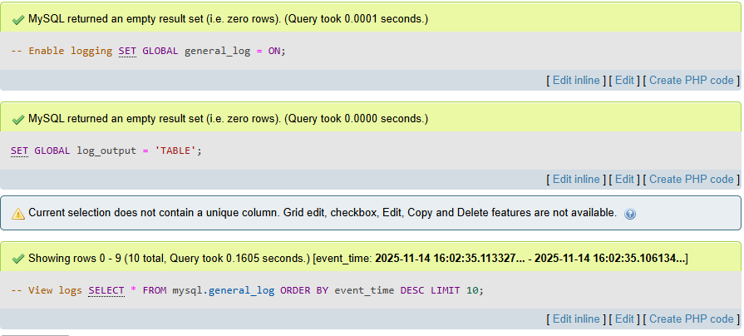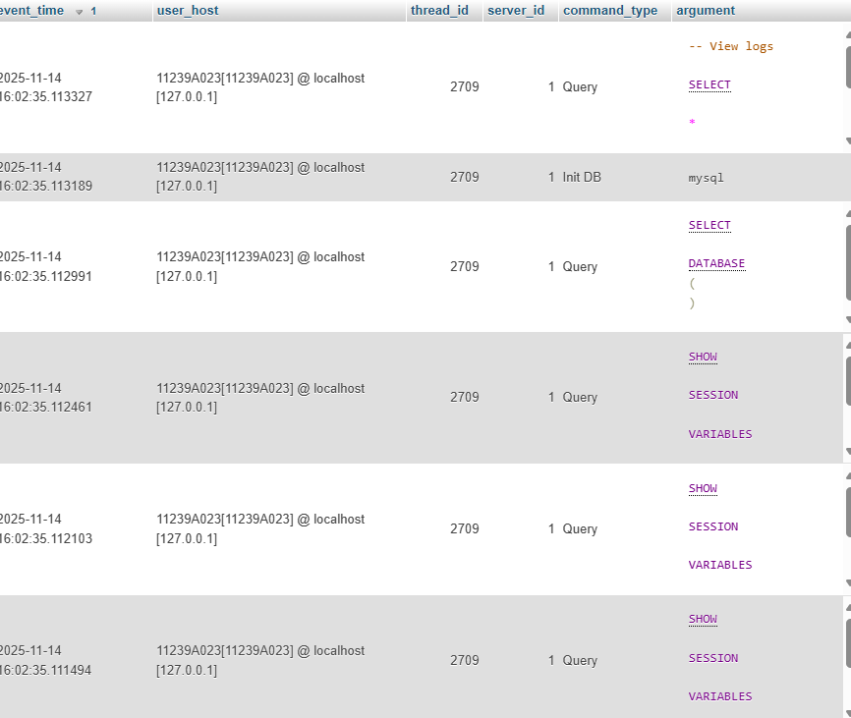

4. Experiment 4: Encryption in Database
Objective: To secure data using encryption functions.
a) CREATE TABLE secure_data (
id INT AUTO_INCREMENT PRIMARY KEY,
secret VARBINARY(255)
);

b) Insert encrypted data (AES)
INSERT INTO secure_data(secret) VALUES (AES_ENCRYPT('mysecretpassword', 'key123'));

c) Decrypt data
SELECT AES_DECRYPT(secret, 'key123') AS decrypted_value FROM secure_data;

Output:
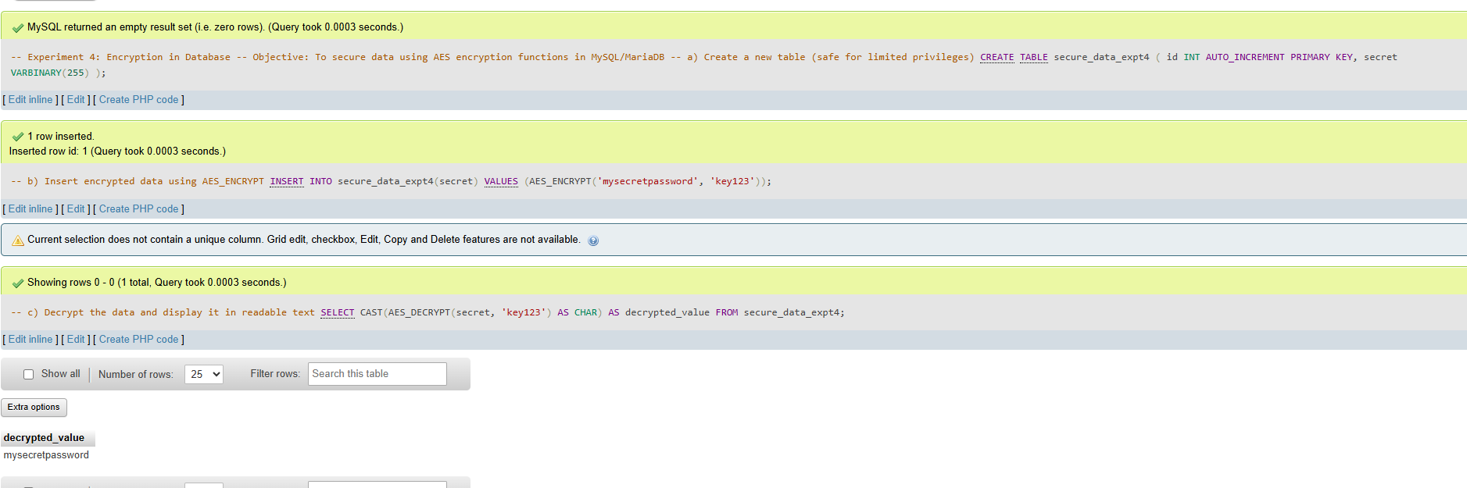

5: Role-Based Access Control (RBAC)
Objective: To implement RBAC in a database.
Procedure:
a) Create a role
CREATE ROLE 'manager';

b) Assign privileges to role
GRANT SELECT, UPDATE ON labdb.* TO 'manager';

c) Create user and assign role
CREATE USER 'alice'@'localhost' IDENTIFIED BY 'alice123';
GRANT 'manager' TO 'alice'@'localhost';

d) Verify
SHOW GRANTS FOR 'alice'@'localhost';

Output:
a)
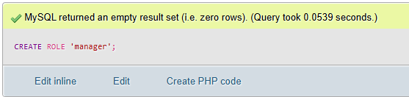
b)
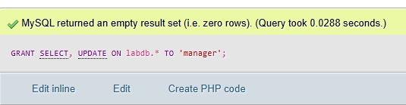

c)
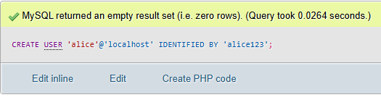
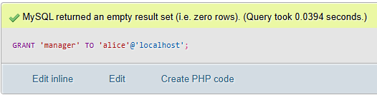
d)
