Assignment No 2 : Linux Commands

- Search for a specific word “apple” in a file and count it.
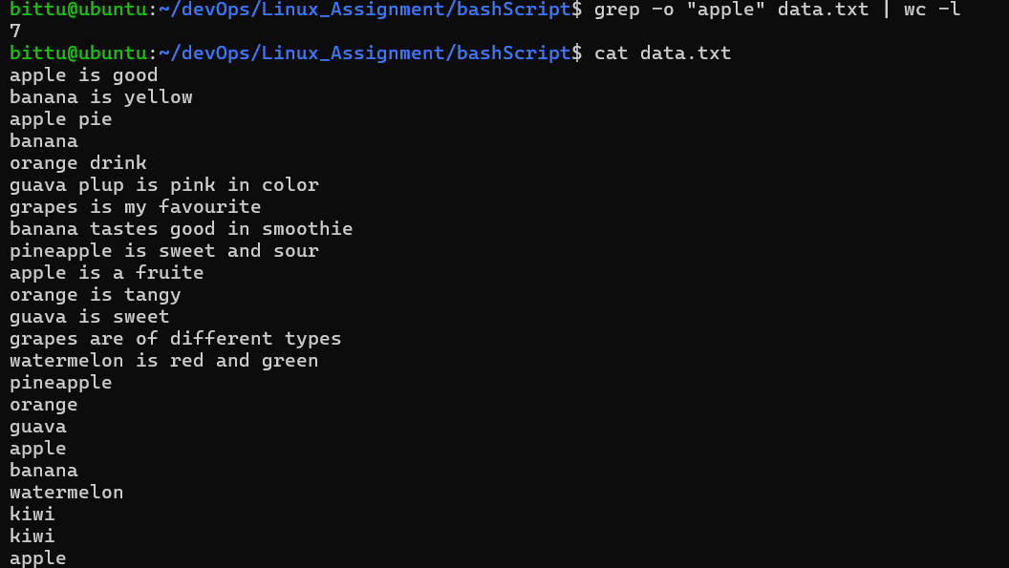

- Show current users logged in.
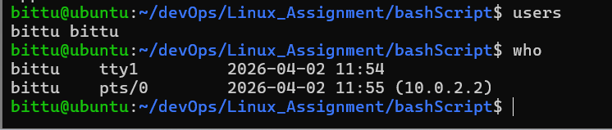
- Show total number of .txt files in current directory.
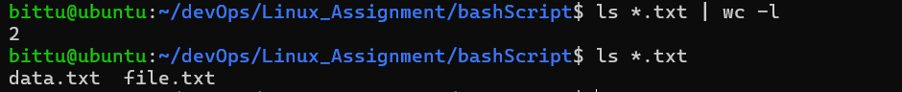

- Show list of all system users from /etc/passwd.
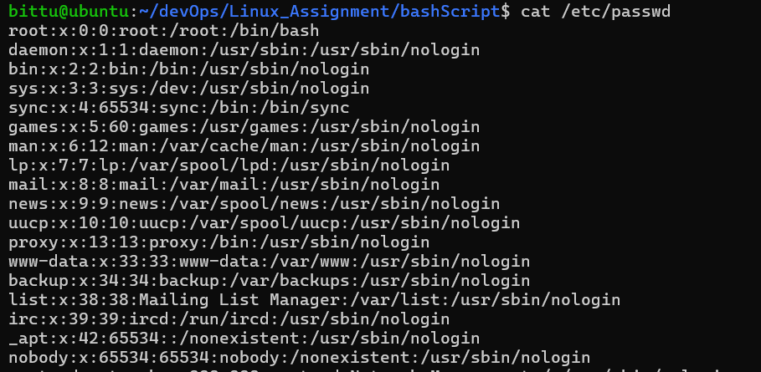

- Find how many times a word and each match should be on newline.
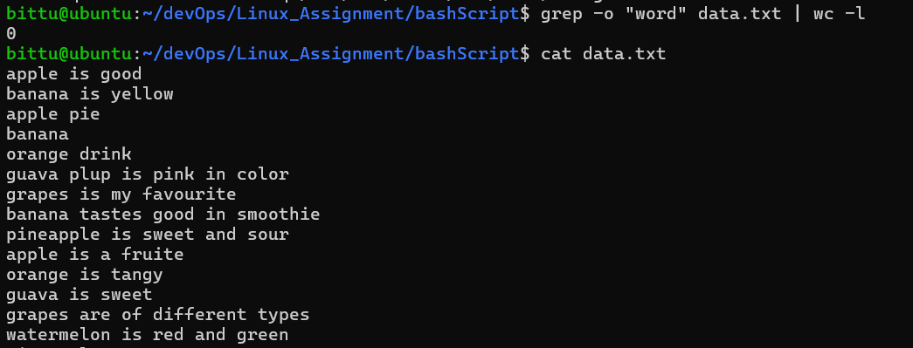

- Show running processes and search for &quot;root&quot;.
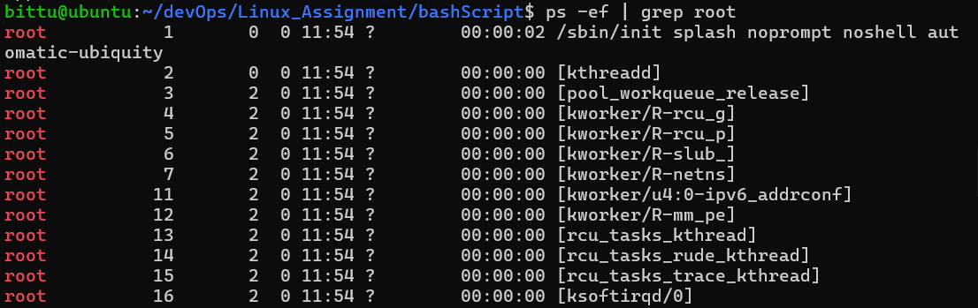

- Show only .log files and sort them alphabetically.
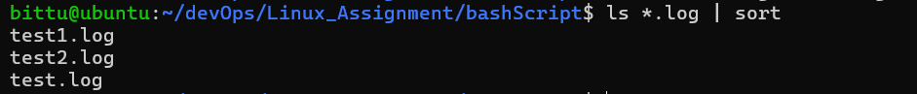

- See disk space and filter &quot;drivers”.

- Sort names alphabetically and remove duplicates.
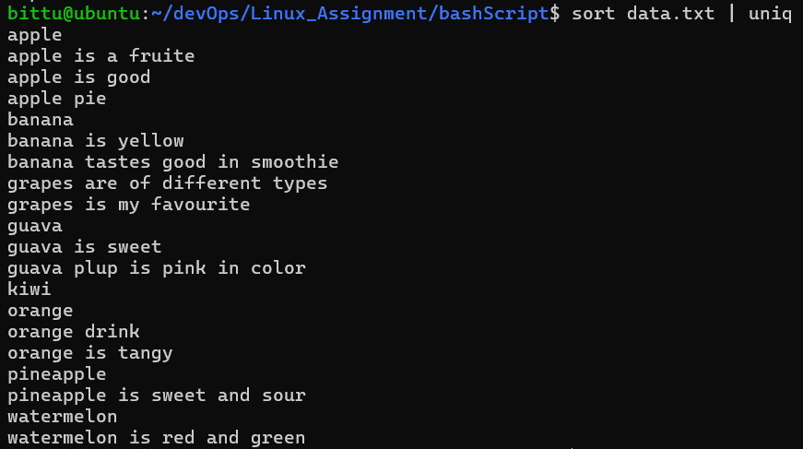

- Find all .log files modified in last 1 day.
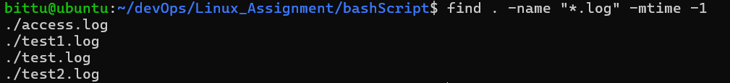

- Delete .tmp files older than 7 days.
Cmd : find . -name "*.tmp" -mtime +7 -delete

- Count how many .java files exist in a project.
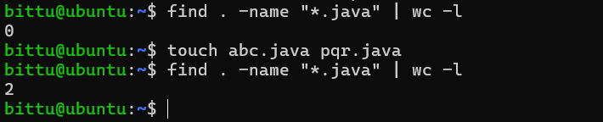

- Count how many times the log was accessed.
- Show only lines where status code is 404
- List all unique IPs that accessed the server. Please note, IP means example,
- 192.168.0.2.
- Count how many requests were POST
- List all requested URLs
- Find which IPs triggered 404 errors
