CHAPTER I
INTRODUCTION

  - Subheading 1
<content>

  - Subheading 2
<content>

…….

CHAPTER II
CHAPTER 2 NAME

2.1 Subheading 1
<content>

2.2 Subheading 2
<content>

…….

REFERENCES

<references with numbering in square bracket>

NOTE:
- Any number of images and tables are allowed, but their numbering must be according to the chapter (e.g., 1.1, 2.4).
- The content can be in any font size, font type, and any alignment.
- Chapter numbers and names must be in the given format (e.g., CHAPTER I INTRODUCTION, CHAPTER II CHAPTER 2 NAME, and subheadings like 1.1, 2.1).
Format to add images:

Example:

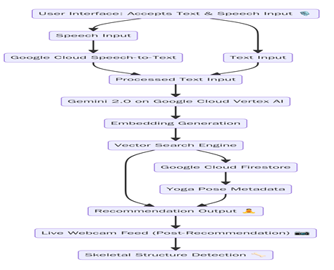
Caption: Fig 4.1: Work Flowchart

Format to add tables:

No. | Test  Scenario | Test input | Expected Results | Actual  Results | Pass/Fail
1 | User has sustained a neck injury from an accident | Give poses for neck pain (Text input) | 3 recommended yoga poses for neck pain, skeletal overlay near neck | As expected | Pass
2 | User wants relaxing poses after work | I need yoga for stress relief (Voice input via Web Speech API) | 3 calming poses, audio instructions, key point mapping on torso | As expected | Pass

Table 5.1 Test cases

