GPS

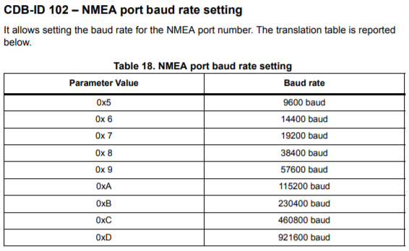

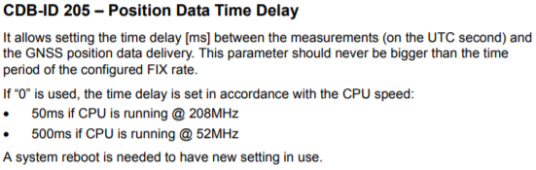

Interruptas nuo pps pasižiūrėt

Jutikliai

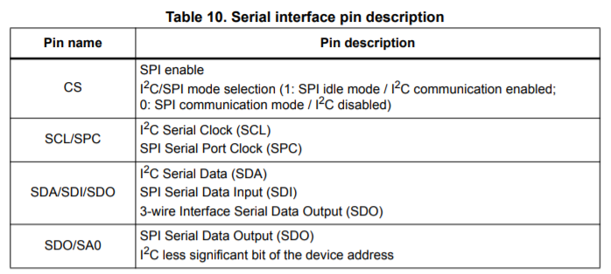

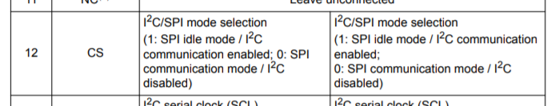

Akselerometras

XL_HM_MODE bit in CTRL6_C (15h). If XL_HM_MODE is set to '0', high-performance mode is valid for all ODRs (from 12.5 Hz up to 6.66 kHz). To enable the low-power and normal mode, the XL_HM_MODE bit has to be set to '1'. Lowpower mode is available for lower ODRs (1.6, 12.5, 26, 52 Hz) while normal mode is available for ODRs equal to 104 and 208 Hz. (akselerometro low ir high mode)

Registras interruptams realizuot

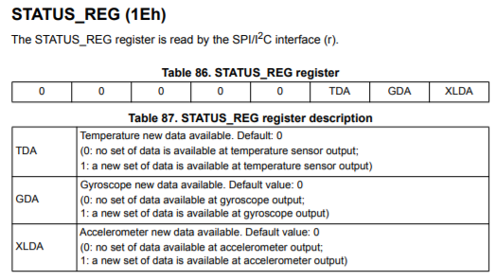

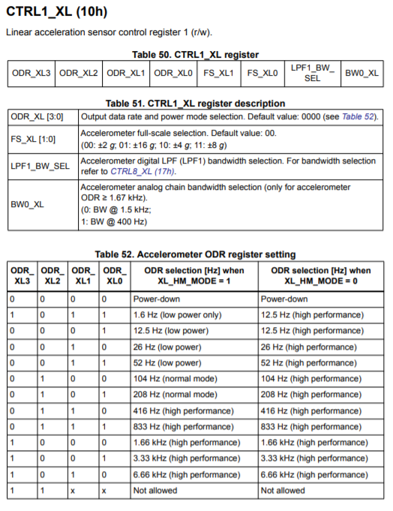

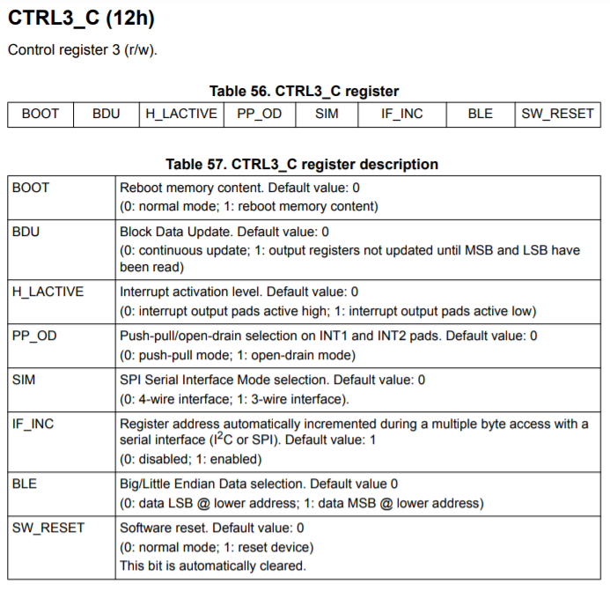

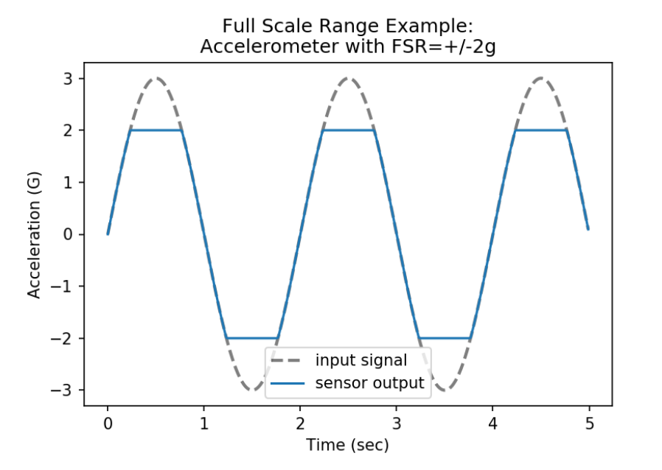

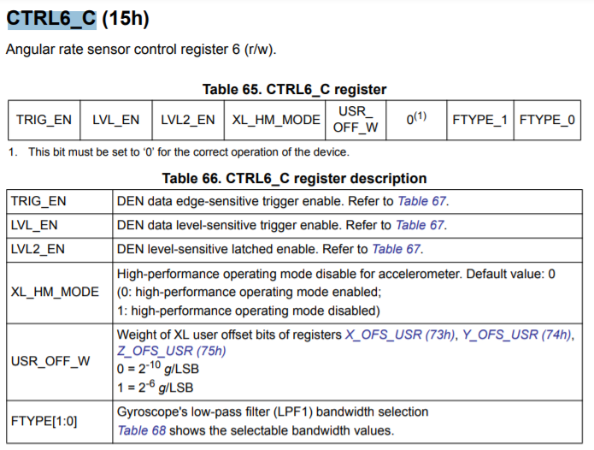

Giroskopas

G_HM_MODE bit in CTRL7_G (16h). If G_HM_MODE is set to '0', high-performance mode is valid for all ODRs (from 12.5 Hz up to 6.66 kHz). To enable the low-power and normal mode, the G_HM_MODE bit has to be set to '1'. Lowpower mode is available for lower ODRs (12.5, 26, 52 Hz) while normal mode is available for ODRs equal to 104 and 208 Hz. (giroskopo low ir high mode)

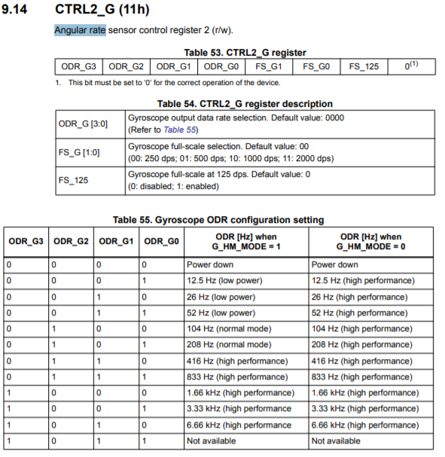

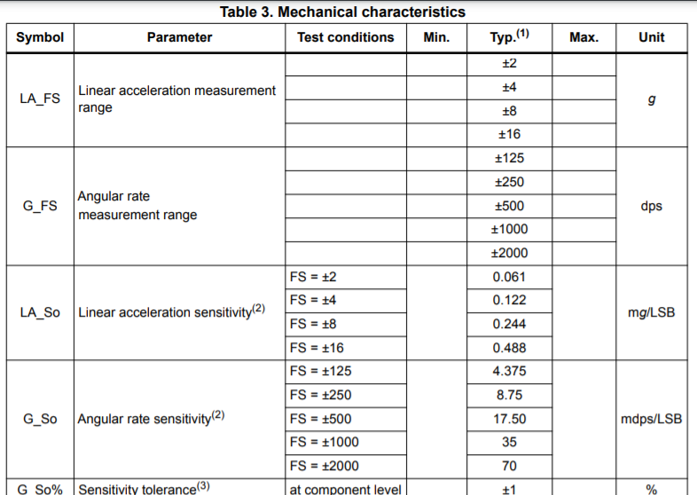

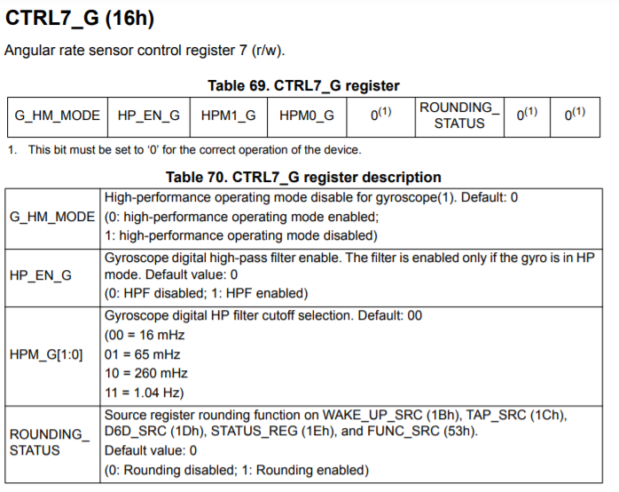

Humidity

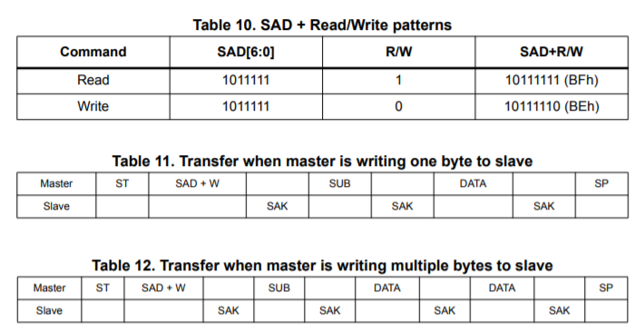

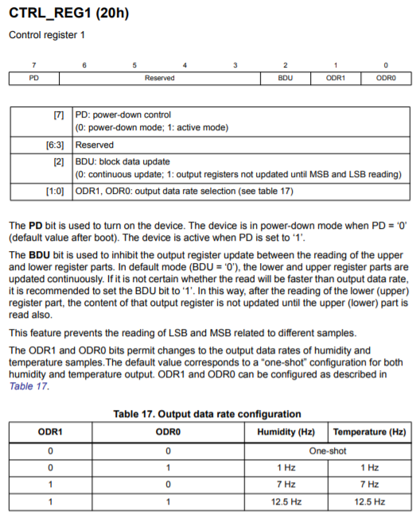

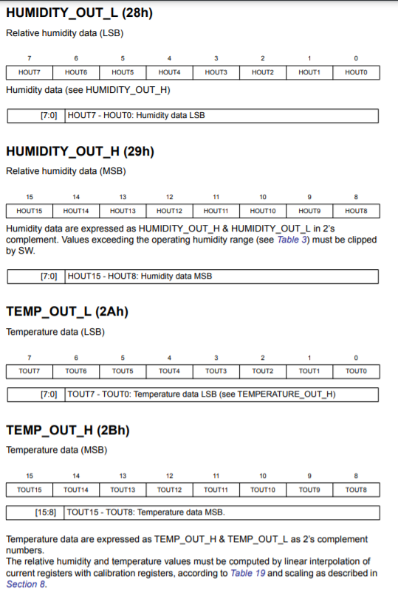

Akselerometras ir magnetometras

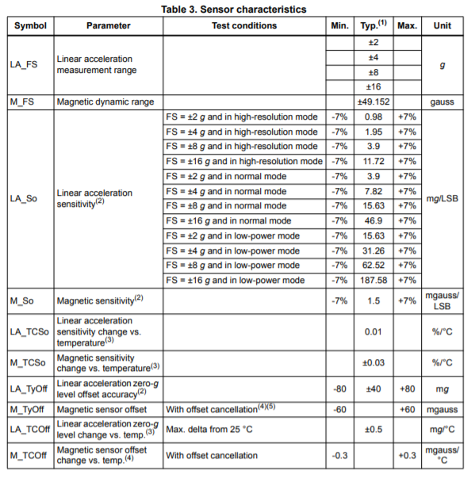

Magnetometrui: 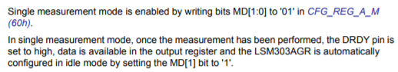

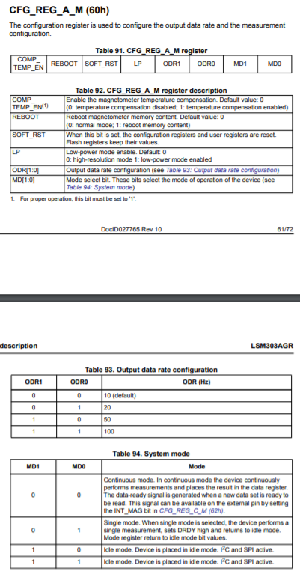



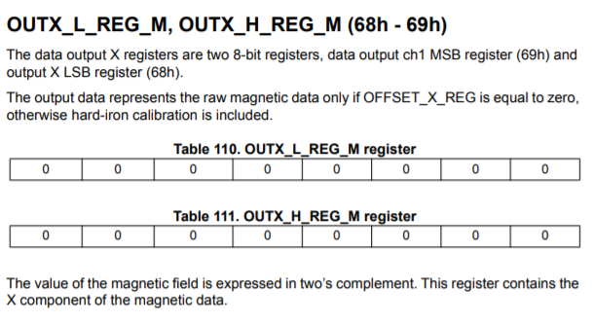

ABIEMS

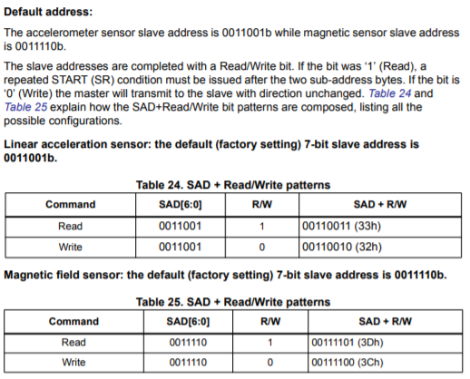

Akselerometrui

