**Formative Assessment 1**

**Global super store Sales Analysis**

**Due on 4th August 24**

**Submitted by Aiswarya Jayaprakash**

Here is the dataset of a store, which has branches all over the world. The stakeholders require the detailed report on their sale transaction.

* Perform the basic data cleaning (Score: 2)
* Segment the visuals using country, region, market (Score: 1)

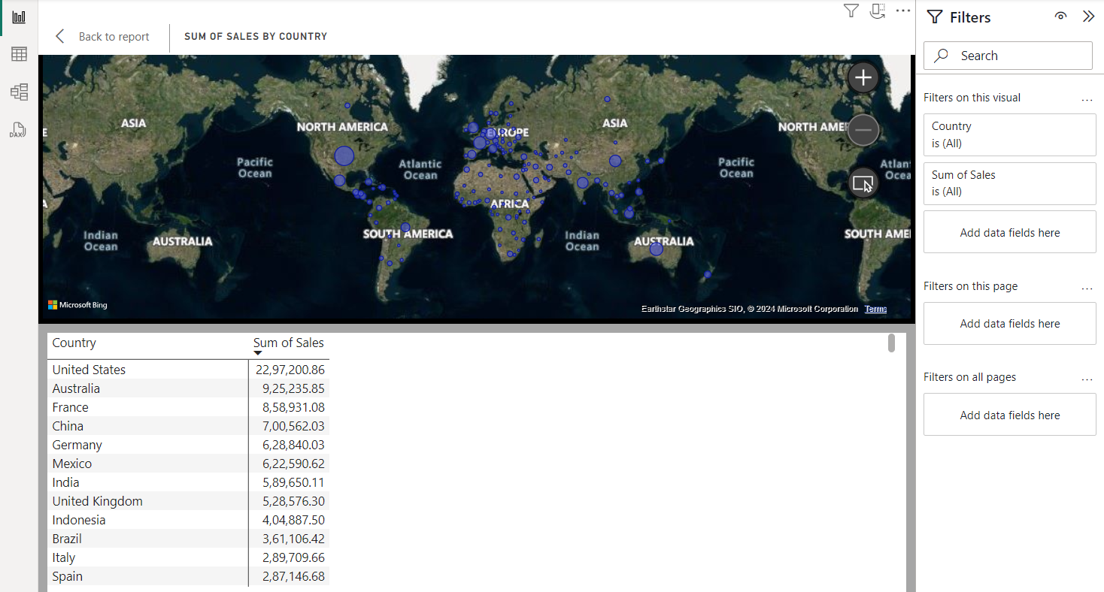

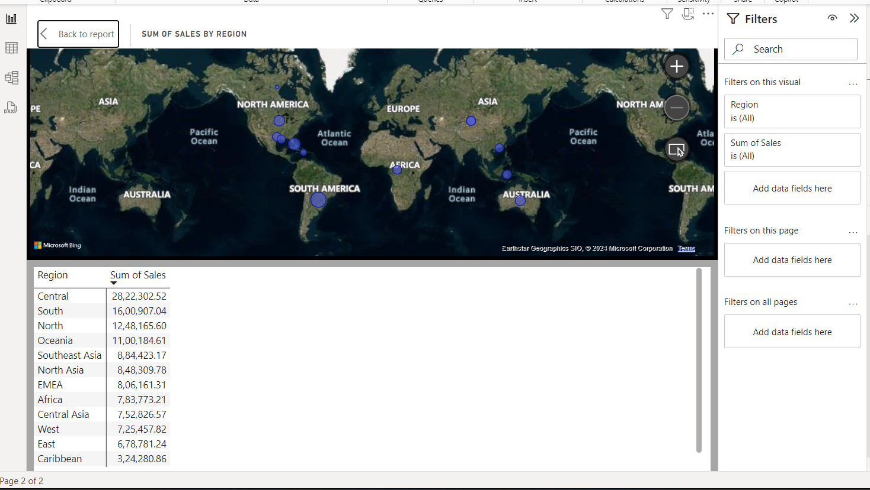

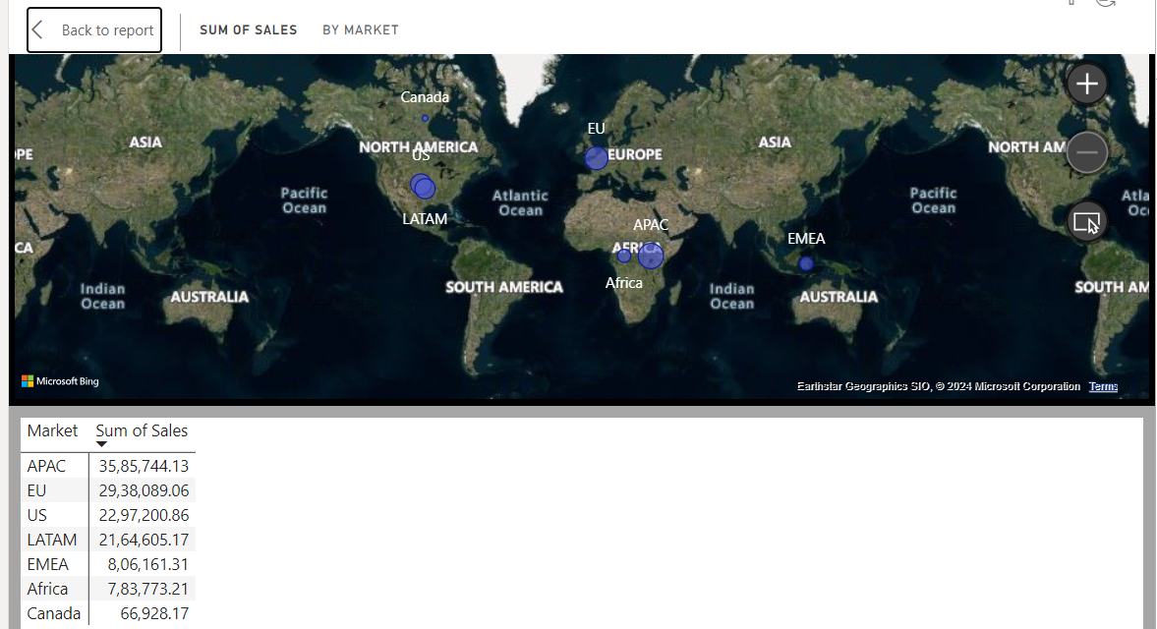

* Analyze the data by visualizing the percentage of shipping based on ship mode.(Score:1)

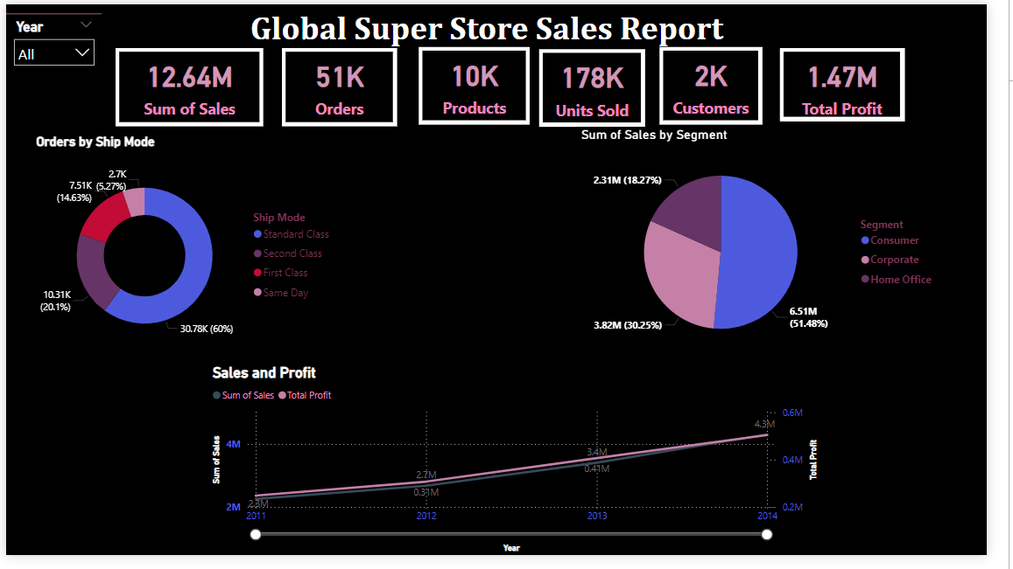

* Give the report to see sales over the city, states, region and market. (Score: 1)

