**WEEK 2 - JUnit Testing Exercises**

**MANDATORY**

**Exercise 1: Setting Up Junit:**

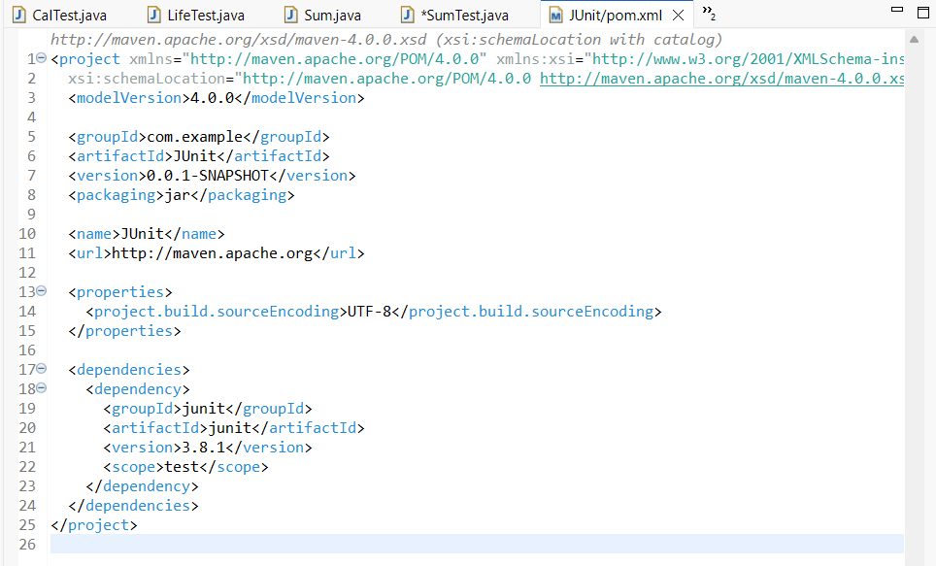

**Exercise 2 : Writing Basic Junit Tests:**

**Calculator.java:**

package demo;

public class Calculator {

public int add(int a, int b) {

return a + b;

}

public int subtract(int a, int b) {

return a - b;

}

}

**CalTest.java:**

package demo;

import static org.junit.Assert.*;

import org.junit.Test;

public class CalTest {

@Test

public void testAdd() {

Calculator calc = new Calculator();

*assertEquals*(5, calc.add(2, 3));

}

@Test

public void testSubtract() {

Calculator calc = new Calculator();

*assertEquals*(1, calc.subtract(4, 3));

}

}

**OUTPUT:**

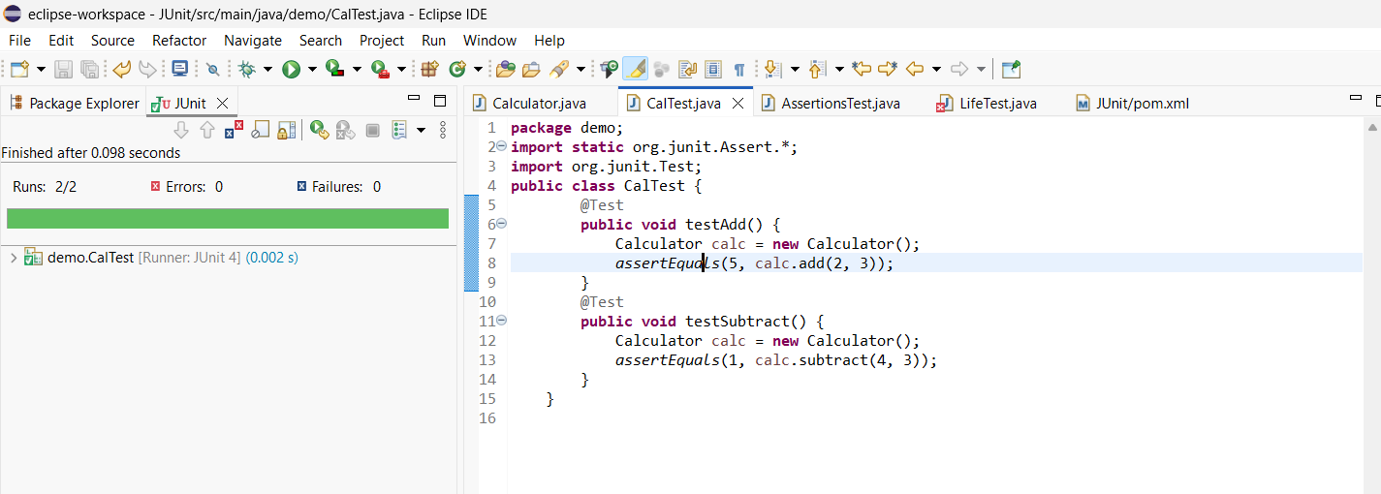

**Exercise 3: Assertions in Junit**

**CODE:**

package demo;

import static org.junit.Assert.*;

import org.junit.Test;

public class AssertionsTest {

@Test

public void testAssertions() {

*assertEquals*(5, 2 + 3);

*assertTrue*(5 > 3);

*assertFalse*(5 < 3);

*assertNull*(null);

*assertNotNull*(new Object());

}

}

**OUTPUT:**

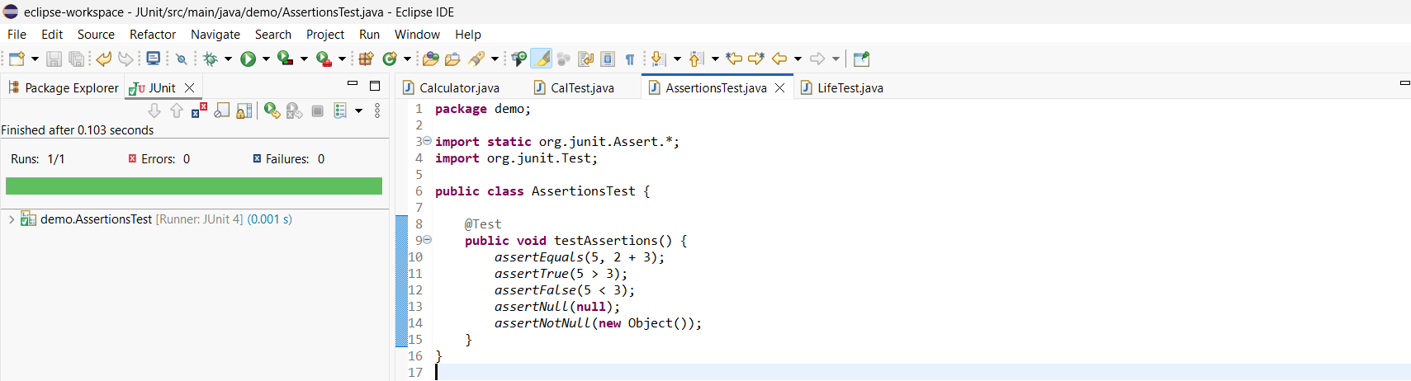

**Exercise 4: Arrange-Act-Assert (AAA) Pattern, Test Fixtures, Setup and Teardown Methods in Junit:**

**CODE:**

**Calculator.Java:**

package demo;

public class Calculator {

public int add(int a, int b) {

return a + b;

}

public int subtract(int a, int b) {

return a - b;

}

public int multiply(int a, int b) {

return a * b;

}

public int divide(int a, int b) {

if (b == 0) {

return 0;

}

return a / b;

}

}

**CalTest.java:**

package demo;

import static org.junit.Assert.*;

import org.junit.Test;

public class CalTest {

@Test

public void testAdd() {

Calculator calc = new Calculator();

*assertEquals*(5, calc.add(2, 3));

}

@Test

public void testSubtract() {

Calculator calc = new Calculator();

*assertEquals*(1, calc.subtract(4, 3));

}

@Test

public void testMultiply() {

Calculator calc = new Calculator();

*assertEquals*(20, calc.multiply(4, 5));

}

@Test

public void testDivide() {

Calculator calc = new Calculator();

*assertEquals*(2, calc.divide(10, 5));

}

@Test

public void testDivideByZero() {

Calculator calc = new Calculator();

*assertEquals*(0, calc.divide(10, 0));

}

}

**OUTPUT:**

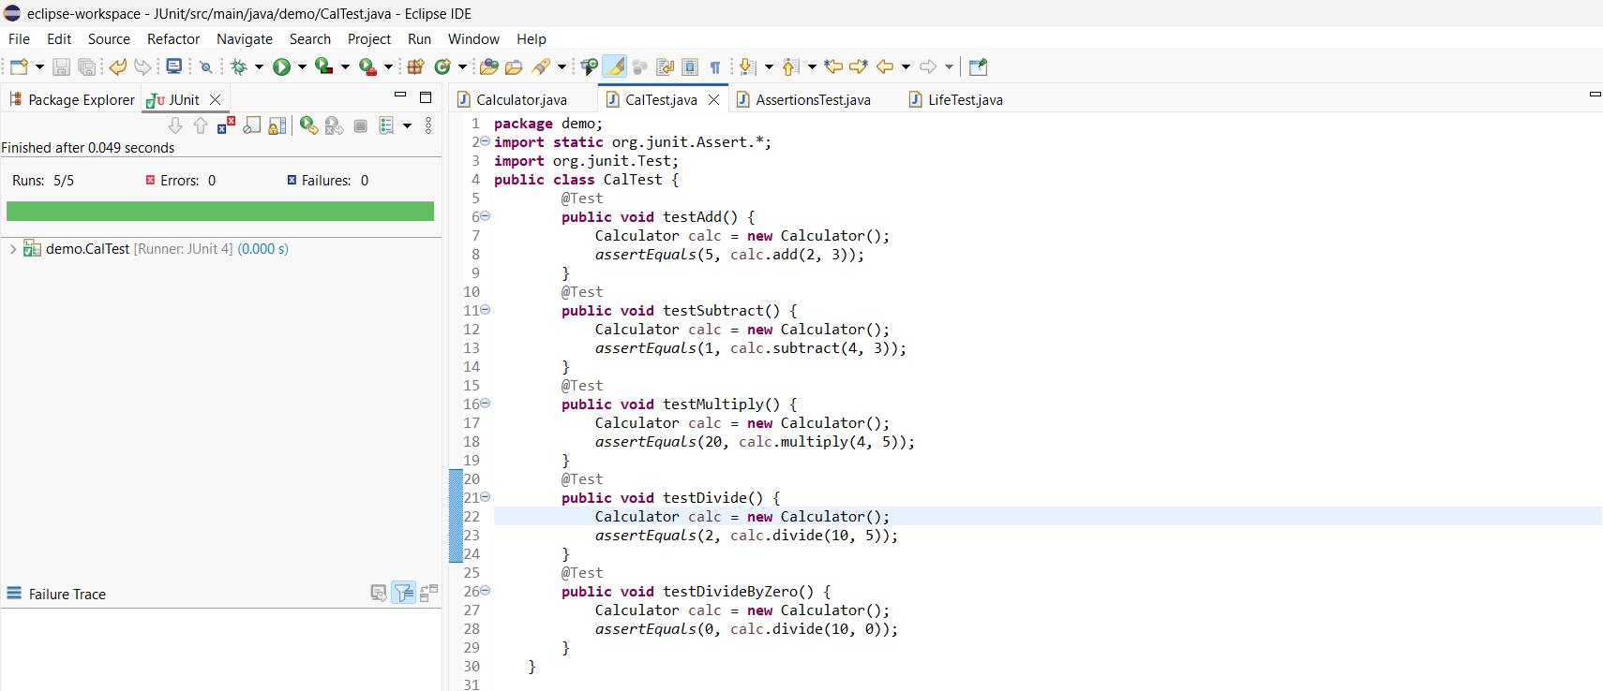

**LifeTest.java:**

package demo;

import static org.junit.Assert.*;

import org.junit.*;

public class LifeTest {

private Calculator calc;

@Before

public void setUp() {

System.*out*.println("Setting up Calculator");

calc = new Calculator();

}

@Test

public void testAdd() {

*assertEquals*(30, calc.add(10, 20));

}

@Test

public void testSubtract() {

*assertEquals*(10, calc.subtract(20, 10));

}

@Test

public void testMultiply() {

*assertEquals*(30, calc.multiply(6, 5));

}

@Test

public void testDivide() {

*assertEquals*(5, calc.divide(20, 4));

}

@Test

public void testDivideByZero() {

*assertEquals*(0, calc.divide(20, 0));

}

@After

public void tearDown() {

System.*out*.println("Test completed");

calc = null;

}

}

**OUTPUT:**

