1. **SPRING-REST**

**HANDSON**

**Create a Spring Web Project using Maven:**

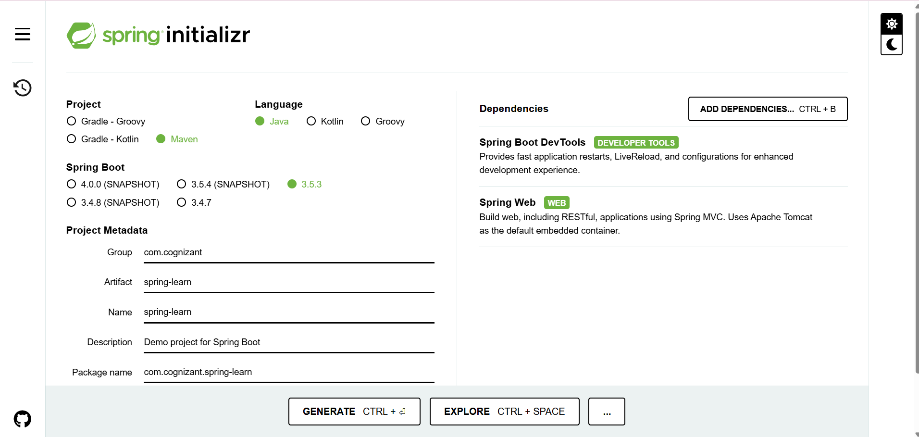

**SpringLearnApplication.java:**

package com.cognizant.spring_learn;

import org.springframework.boot.SpringApplication;

import org.springframework.boot.autoconfigure.SpringBootApplication;

@SpringBootApplication

public class SpringLearnApplication {

public static void main(String[] args) {

SpringApplication.run(SpringLearnApplication.class, args);

}

}

**HelloController.java:**

package com.cognizant.spring_learn;

import org.springframework.web.bind.annotation.GetMapping;

import org.springframework.web.bind.annotation.RestController;

@RestController

public class HelloController {

@GetMapping("/hello")

public String hello() {

return "Hello from Spring Web!";

}

}

**Application.properties:**

server.port=8090

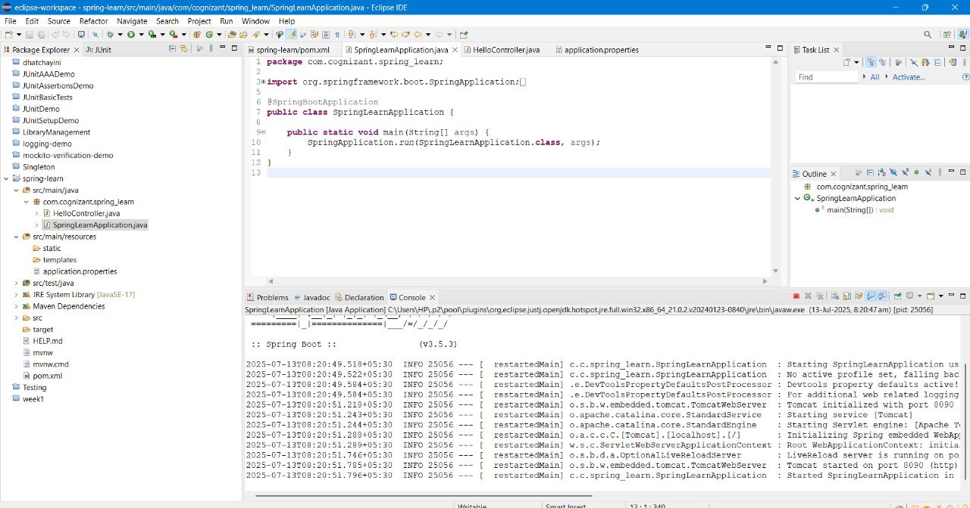

**OUTPUT:**

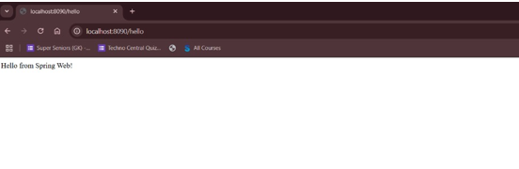

**Spring Core – Load Country from Spring Configuration XML**

**SpringLearnApplication.java:**

package com.cognizant.spring_learn;

import com.cognizant.spring_learn.model.Country;

import org.slf4j.Logger;

import org.slf4j.LoggerFactory;

import org.springframework.context.ApplicationContext;

import org.springframework.context.support.ClassPathXmlApplicationContext;

public class SpringLearnApplication {

private static final Logger LOGGER = LoggerFactory.getLogger(SpringLearnApplication.class);

public static void main(String[] args) {

LOGGER.info("START");

displayCountry();

LOGGER.info("END");

}

public static void displayCountry() {

ApplicationContext context = new ClassPathXmlApplicationContext("country.xml");

Country country = context.getBean("country", Country.class);

LOGGER.debug("Country: {}", country);

}

}

**Country.java**

package com.cognizant.spring_learn.model;

import org.slf4j.Logger;

import org.slf4j.LoggerFactory;

public class Country {

private static final Logger LOGGER = LoggerFactory.getLogger(Country.class);

private String code;

private String name;

public Country() {

LOGGER.debug("Inside Country Constructor.");

}

public String getCode() {

LOGGER.debug("getCode() called.");

return code;

}

public void setCode(String code) {

LOGGER.debug("setCode() called.");

this.code = code;

}

public String getName() {

LOGGER.debug("getName() called.");

return name;

}

public void setName(String name) {

LOGGER.debug("setName() called.");

this.name = name;

}

@Override

public String toString() {

return "Country [code=" + code + ", name=" + name + "]";

}

}

**OUTPUT:**

