**2. Spring-Rest**

**HandsOn**

**Hello World RESTful Web Service**

**SpringLearnApplication.java:**

package com.cognizant.spring_learn;

import org.springframework.boot.SpringApplication;

import org.springframework.boot.autoconfigure.SpringBootApplication;

@SpringBootApplication

public class SpringLearnApplication {

public static void main(String[] args) {

SpringApplication.*run*(SpringLearnApplication.class, args);

}

}

**HelloController.java**

package com.cognizant.spring_learn.controller;

import org.slf4j.Logger;

import org.slf4j.LoggerFactory;

import org.springframework.web.bind.annotation.GetMapping;

import org.springframework.web.bind.annotation.RestController;

@RestController

public class HelloController {

private static final Logger *LOGGER* = LoggerFactory.*getLogger*(HelloController.class);

@GetMapping("/hello")

public String sayHello() {

*LOGGER*.info("START");

String message = "Hello World!!";

*LOGGER*.info("END");

return message;

}

}

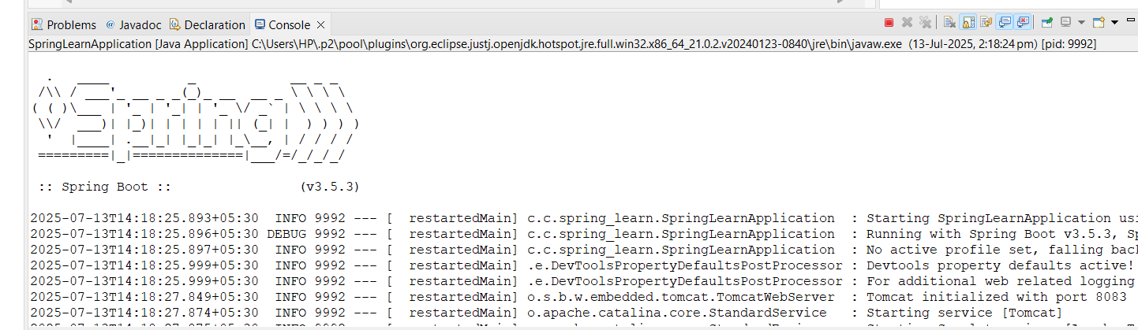

**OUTPUT:**

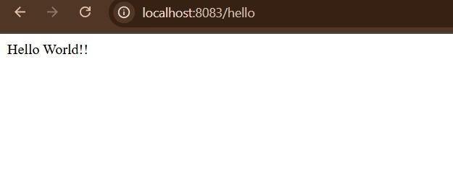

**REST - Country Web Service**

**SpringLearnApplication.java**

package com.cognizant.spring_learn;

import org.springframework.boot.SpringApplication;

import org.springframework.boot.autoconfigure.SpringBootApplication;

@SpringBootApplication

public class SpringLearnApplication {

public static void main(String[] args) {

SpringApplication.*run*(SpringLearnApplication.class, args);

}

}

**Country.java**

package com.cognizant.spring_learn.model;

public class Country {

private String code;

private String name;

public Country() {}

public Country(String code, String name) {

this.code = code;

this.name = name;

}

public String getCode() {

return code;

}

public void setCode(String code) {

this.code = code;

}

public String getName() {

return name;

}

public void setName(String name) {

this.name = name;

}

}

CountryController.java

package com.cognizant.spring_learn.controller;

import com.cognizant.spring_learn.model.Country;

import org.slf4j.Logger;

import org.slf4j.LoggerFactory;

import org.springframework.web.bind.annotation.GetMapping;

import org.springframework.web.bind.annotation.RestController;

@RestController

public class CountryController {

private static final Logger LOGGER = LoggerFactory.getLogger(CountryController.class);

@GetMapping("/country")

public Country getCountry() {

LOGGER.info("START getCountry()");

Country country = new Country("IN", "India");

LOGGER.info("END getCountry()");

return country;

}

}

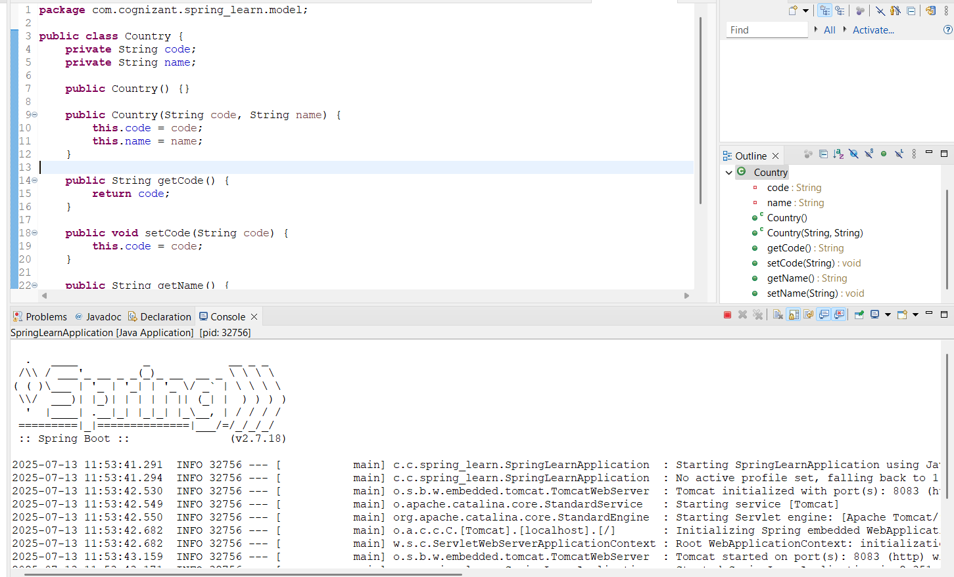

**OUTPUT:**

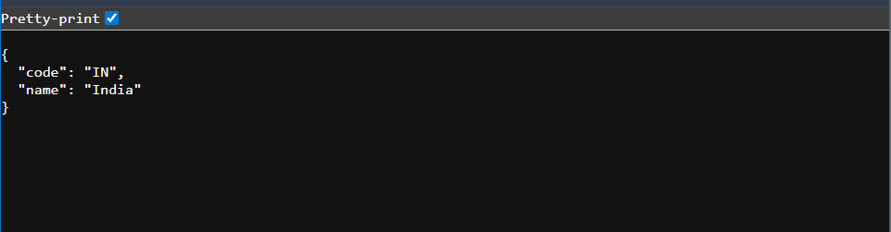 **REST - Get country based on country code** 

**SpringLearnApplication.java:**

package com.cognizant.spring_learn;

import org.springframework.boot.SpringApplication;

import org.springframework.boot.autoconfigure.SpringBootApplication;

@SpringBootApplication

public class SpringLearnApplication {

public static void main(String[] args) {

SpringApplication.*run*(SpringLearnApplication.class, args);

}

}

**CountryController.java:**

package com.cognizant.spring_learn.controller;

import com.cognizant.spring_learn.model.Country;

import com.cognizant.spring_learn.service.CountryService;

import org.springframework.beans.factory.annotation.Autowired;

import org.springframework.web.bind.annotation.*;

@RestController

public class CountryController {

@Autowired

private CountryService countryService;

@GetMapping("/countries/{code}")

public Country getCountry(@PathVariable String code) {

return countryService.getCountry(code);

}

}

**Country.java**

package com.cognizant.spring_learn.model;

public class Country {

private String code;

private String name;

public String getCode() {

return code;

}

public void setCode(String code) {

this.code = code;

}

public String getName() {

return name;

}

public void setName(String name) {

this.name = name;

}

}

**CountryService.java:**

package com.cognizant.spring_learn.service;

import com.cognizant.spring_learn.model.Country;

import org.springframework.context.ApplicationContext;

import org.springframework.context.support.ClassPathXmlApplicationContext;

import org.springframework.stereotype.Service;

import java.util.List;

@Service

public class CountryService {

public Country getCountry(String code) {

ApplicationContext context = new ClassPathXmlApplicationContext("country.xml");

List<Country> countryList = (List<Country>) context.getBean("countryList");

return countryList.stream()

.filter(country -> country.getCode().equalsIgnoreCase(code))

.findFirst()

.orElse(null);

}

}

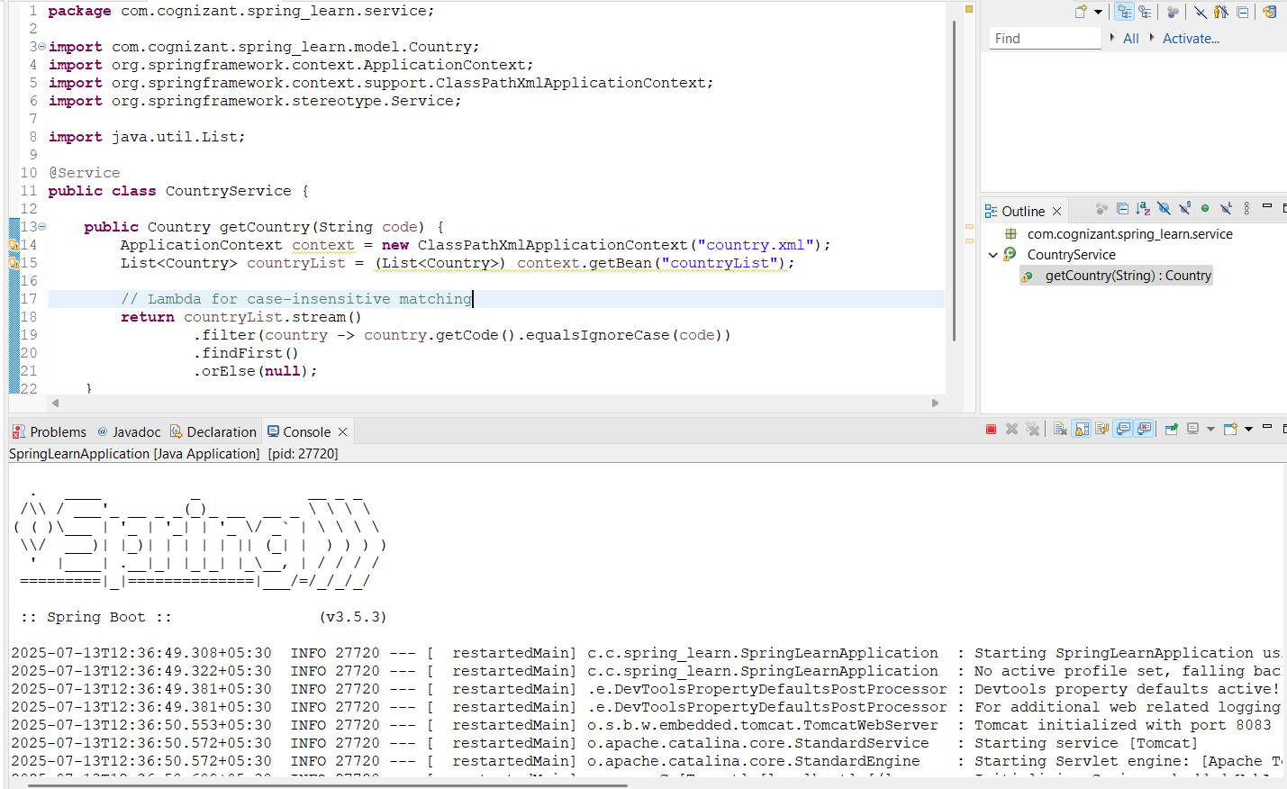

**OUTPUT:**

