**Git**

HandsOn 1

HP@HP MINGW64 ~

$ git --version

git version 2.49.0.windows.1

HP@HP MINGW64 ~

$ git config --global user.name "dhatchayini"

HP@HP MINGW64 ~

$ git config --global user.email "dhatchayinirajavelu845@gmail.com"

HP@HP MINGW64 ~

$ git config --global --list

user.name=dhatchayini

user.email=dhatchayinirajavelu845@gmail.com

core.editor=notepad++.exe multiInst -nosession -noPlugin

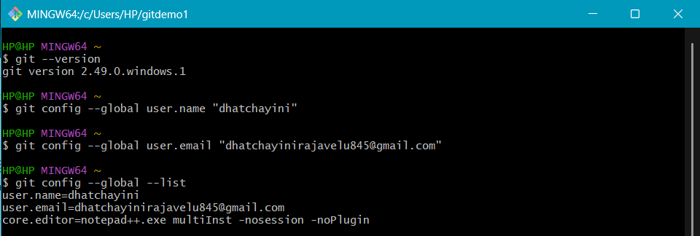

HP@HP MINGW64 ~

$ mkdir gitdemo1

HP@HP MINGW64 ~

$ cd gitdemo1

HP@HP MINGW64 ~/gitdemo1

$ git init

Initialized empty Git repository in C:/Users/HP/gitdemo1/.git/

HP@HP MINGW64 ~/gitdemo1 (master)

$ echo "Hello from gitdemo" >welcome.txt

HP@HP MINGW64 ~/gitdemo1 (master)

$ cat welcome.txt

Hello from gitdemo

HP@HP MINGW64 ~/gitdemo1 (master)

$ git add welcome.txt

warning: in the working copy of 'welcome.txt', LF will be replaced by CRLF the next time Git touches it

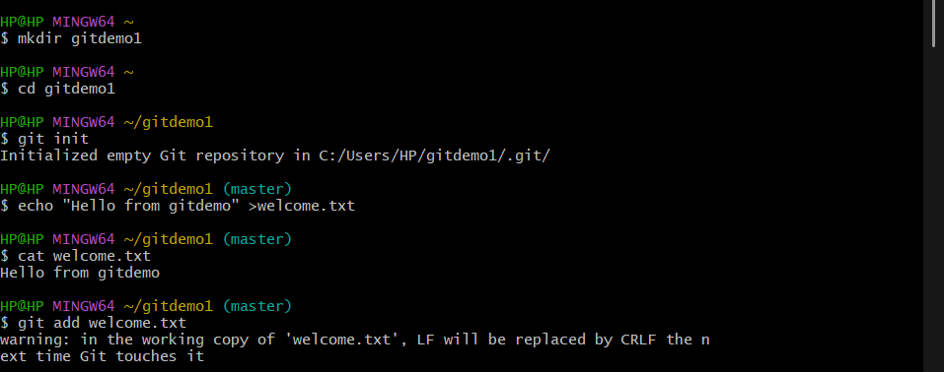

HP@HP MINGW64 ~/gitdemo1 (main)

$ git remote add origin <https://gitlab.com/dhatchayini/gitdemo1.git>

HP@HP MINGW64 ~/gitdemo1 (main)

$ git push -u origin main

Enumerating objects: 4, done.

Counting objects: 100% (4/4), done.

Delta compression using up to 4 threads

Compressing objects: 100% (2/2), done.

Writing objects: 100% (3/3), 311 bytes | 155.00 KiB/s, done.

Total 3 (delta 0), reused 0 (delta 0), pack-reused 0 (from 0)

To https://gitlab.com/dhatchayini/gitdemo1.git

5a6a88a..c50a175 main -> main

branch 'main' set up to track 'origin/main'.

