**Git**

HandsOn 2

**1.Explain git ignore:**

* .Keeps the repository clean.
* Prevents sensitive information (like passwords in .env files) from being uploaded.
* Saves space by ignoring large temporary files.
* Avoids conflicts from system-specific files (e.g., .DS_Store on Mac, Thumbs.db on Windows).

**2.Explain how to ignore unwanted files using git ignore:**

**Step 1: Create .gitignore file**

In your project’s root directory:

touch .gitignore

Or create it manually using any text editor.

**Step 2: Add patterns to ignore**

Write the file/folder names or patterns you want to ignore.

Examples:

# Ignore log files

*.log

# Ignore a folder named log

log/

# Ignore environment files

.env

# Ignore node_modules folder

node_modules/

# Ignore all .tmp files anywhere

*.tmp

**Step 3: Save the file and check**

You can see which files are being ignored:

git status --ignored

Step 4: Important — Remove already tracked files

If a file is already tracked by Git, adding it to .gitignore won’t stop Git from tracking it until you remove it from tracking:

git rm --cached filename

Example:

git rm --cached .env

Then commit the changes:

git commit -m "Updated .gitignore"

HP@HP MINGW64 ~ (master)

$ cd /c/Users/HP/Documents/git-handson2

HP@HP MINGW64 ~/Documents/git-handson2 (master)

$ git clone https://gitlab.com/dhatchayini/git-handson2.git

Cloning into 'git-handson2'...

remote: Enumerating objects: 3, done.

remote: Counting objects: 100% (3/3), done.

remote: Compressing objects: 100% (2/2), done.

remote: Total 3 (delta 0), reused 0 (delta 0), pack-reused 0 (from 0)

Receiving objects: 100% (3/3), done.

HP@HP MINGW64 ~/Documents/git-handson2 (master)

$ cd git-handson2

HP@HP MINGW64 ~/Documents/git-handson2/git-handson2 (main)

$ notepad++ .gitignore

HP@HP MINGW64 ~/Documents/git-handson2/git-handson2 (main)

$ echo "This is a log file"> example.log

HP@HP MINGW64 ~/Documents/git-handson2/git-handson2 (main)

$ mkdir log

HP@HP MINGW64 ~/Documents/git-handson2/git-handson2 (main)

$ echo "log folder file" > log/test.txt

HP@HP MINGW64 ~/Documents/git-handson2/git-handson2 (main)

$ git status --ignored

On branch main

Your branch is up to date with 'origin/main'.

Untracked files:

(use "git add <file>..." to include in what will be committed)

.gitignore

Ignored files:

(use "git add -f <file>..." to include in what will be committed)

example.log

log/

nothing added to commit but untracked files present (use "git add" to track)

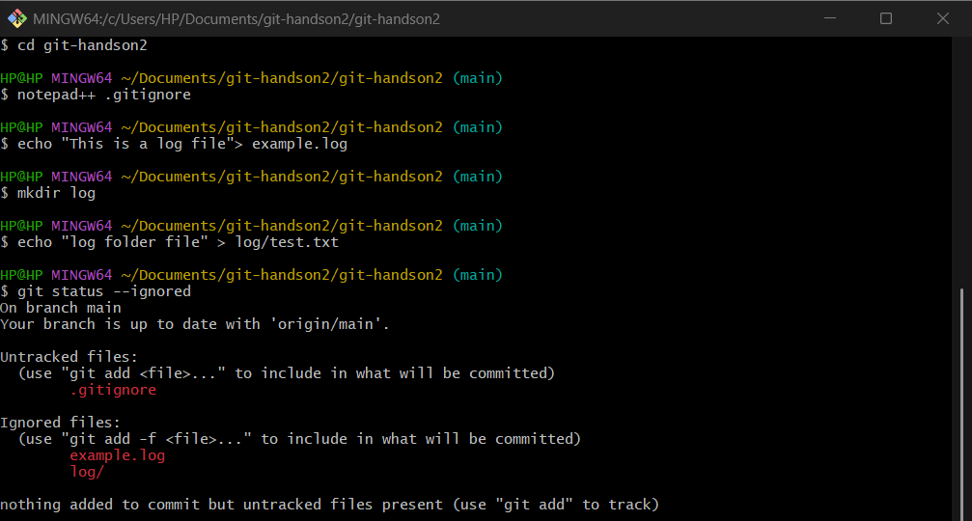

HP@HP MINGW64 ~/Documents/git-handson2/git-handson2 (main)

$ git add .gitignore

HP@HP MINGW64 ~/Documents/git-handson2/git-handson2 (main)

$ git commit -m "Added .gitignore to ignore .log files and log folder"

[main 06a8342] Added .gitignore to ignore .log files and log folder

1 file changed, 2 insertions(+)

create mode 100644 .gitignore

HP@HP MINGW64 ~/Documents/git-handson2/git-handson2 (main)

$ git push origin main

Enumerating objects: 4, done.

Counting objects: 100% (4/4), done.

Delta compression using up to 4 threads

Compressing objects: 100% (2/2), done.

Writing objects: 100% (3/3), 315 bytes | 315.00 KiB/s, done.

Total 3 (delta 0), reused 0 (delta 0), pack-reused 0 (from 0)

To https://gitlab.com/dhatchayini/git-handson2.git

d233976..06a8342 main -> main

