**INDEED JOB SCRAPPER USING DIALOGFLOW**

Authored by: Aiswarya

AIM

To create a chatbot that scrapes data from the jobsite Indeed.com (<https://www.indeed.co.in/>).

REQUIREMENTS

Python (version 3.7)

Dialogflow

Ngork

IMPLEMENTATION

1. Install all required packages in python mentioned in requirements.txt
2. This is the Indeed job portal website.

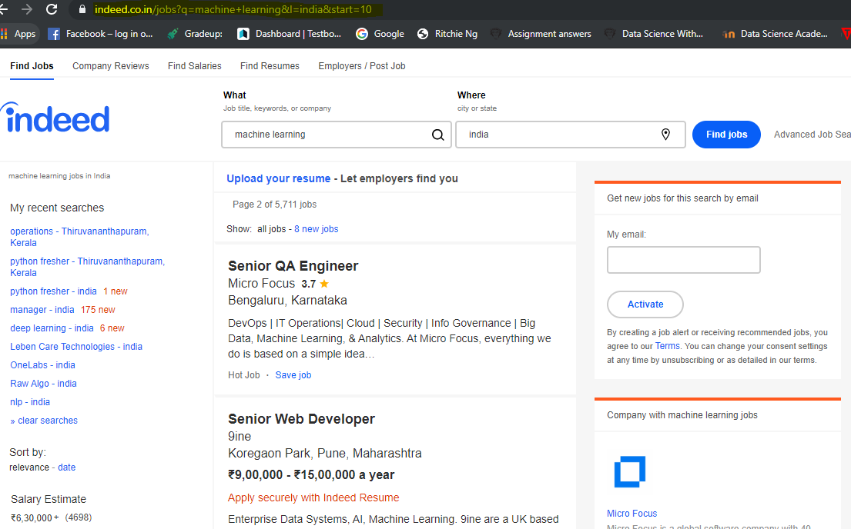

1. Install ngrok
2. Create a Dialogflow Agent ([https://dialogflow.com/#](https://dialogflow.com/))
3. In Dialogflow console under Settings ⚙ > Restore from Zip using the My_BOT.zip.

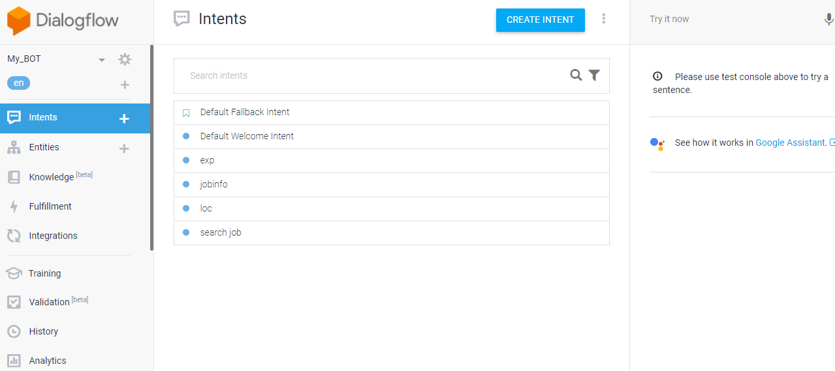

1. Go to all intents and enable webhook

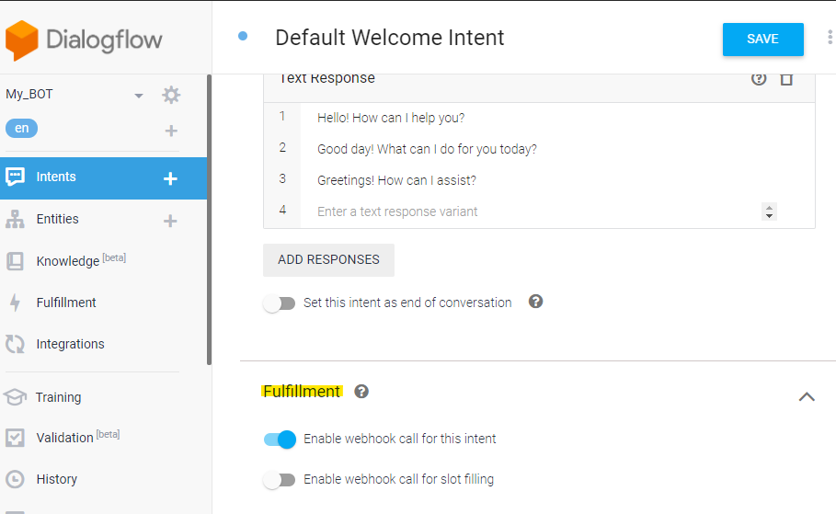

1. Run the python files.
2. This will run the program in default link https 5000
3. Open ngrok , run command ngrok.exe http 5000

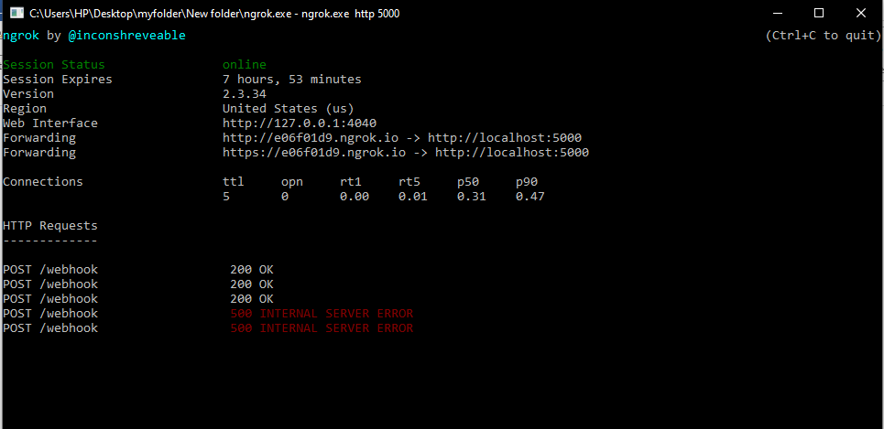

1. Copy the link obtained(e.g. <https://e06f01d9.ngrok.io>)
2. Paste the link in: Dialogflow🡪 Fullfillment🡪Webhook🡪Enable switch🡪paste URL

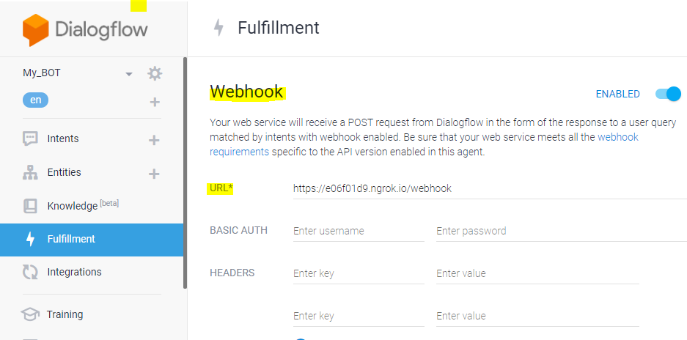

1. This is done to enable a webhook with our chatbot. Each session will be live for 8 hours.
2. Chat with the bot in the “try now” section and get the results.

ISSUES FACED:

Dialogflow webhooks need to response within 5 seconds or Dialogflow considers the fulfillment to have timed out and the response defined in Dialogflow’ s console will be surfaced (if present).

If the scrapping takes time more than 5 seconds, then the session will time out and webhook call fails.