**LINKEDIN ACCOUNT-LOGIN TESTCASES**

Case 1-Login Credentials(Invalid)-->Invalid username,Invalid password.

Login failed**.**

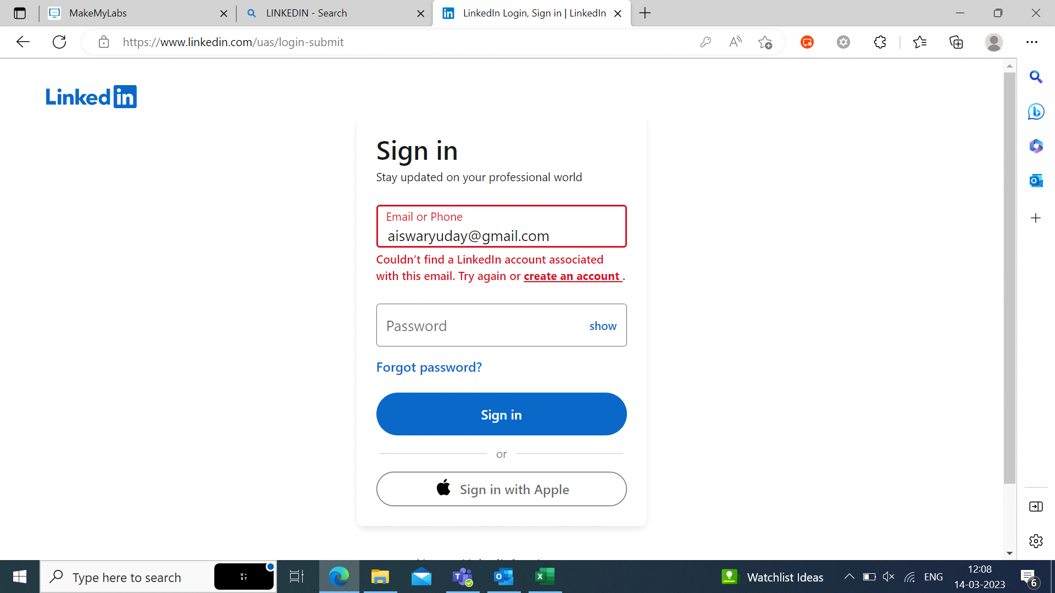

Case 2-LoginCredentials(Invalid)-->Invalid username,Valid password.

Login Failed.



Case 3-Login Credentials(Invalid)-->Valid username,Invalid password.

Login Failed.

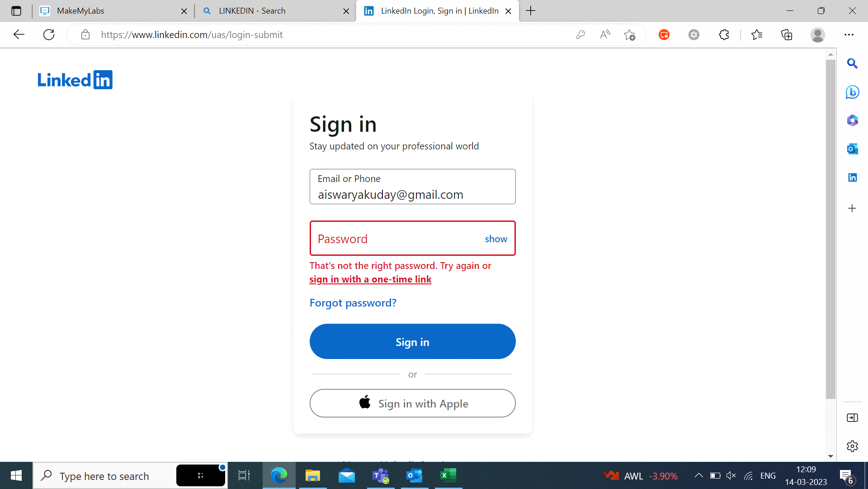

Case 4-Login Credentials(Valid)-->Valid username,Valid password.

Login Sucessfull.

