LINKEDIN ACCOUNT-LOGIN TESTCASES

Case 1-Login Credentials(Invalid)-->Invalid username,Invalid password.
Login failed.

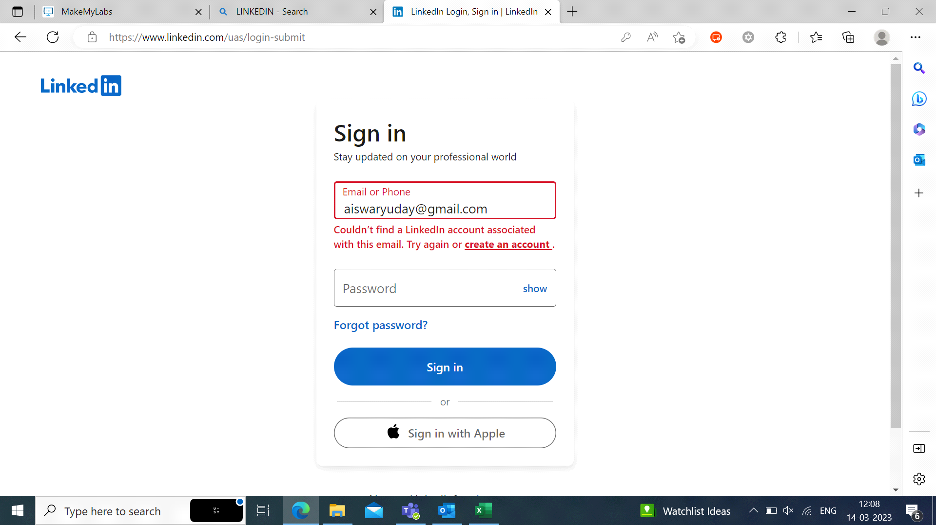

Case 2-LoginCredentials(Invalid)-->Invalid username,Valid password.
Login Failed.



Case 3-Login Credentials(Invalid)-->Valid username,Invalid password.
Login Failed.

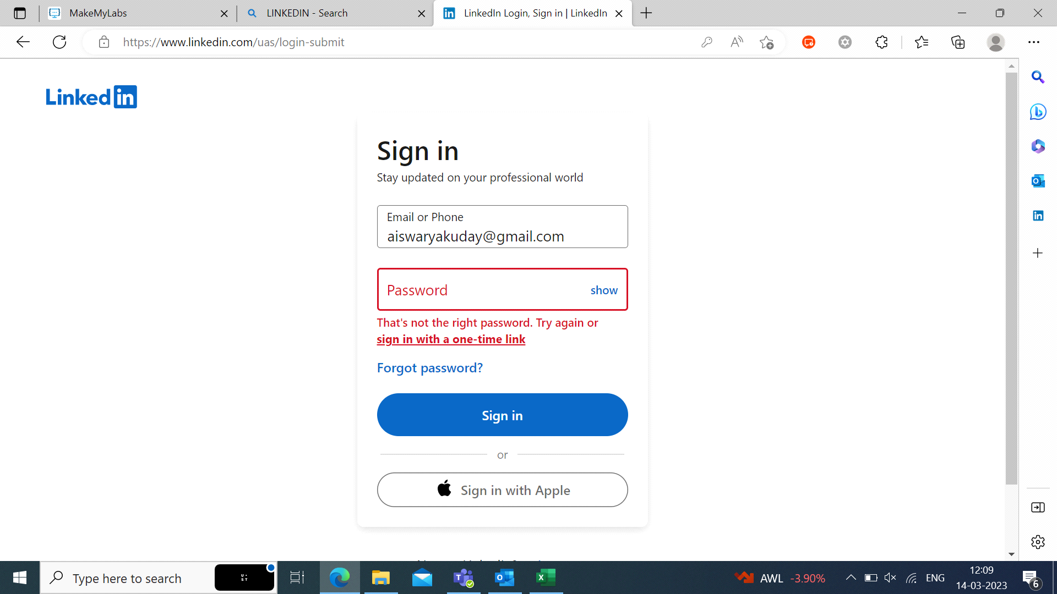

Case 4-Login Credentials(Valid)-->Valid username,Valid password.
Login Sucessfull.

