Task 2

Date: 6-11-2020

How do you copy by value a composite data type?

There are basically five ways to do it.

1. Using spread *operator(…)*.
2. Using *Object.assign()* method.
3. Using the *JSON.stringify()* and *JSON.parse()* methods.
4. Using *Slice()* method in JavaScript.
5. Using Array.map().

1.Using Spread

Spread operator is used to spread elements in an array into their individual property. For instance if there is a function and addition is to be performed between two variables and if it’s values are in the form of an array, then by using spread operator, it spreads the elements of the array into their individual datatype(here i.e number)and performs the addition. As shown in the example below.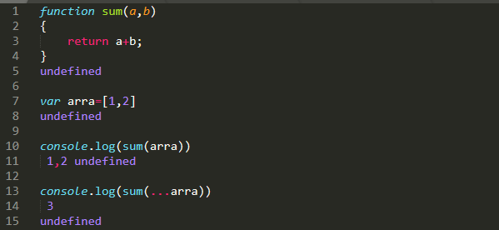

This ability of Spread operator to spreads the elements of the array into their individual datatype, helps us to clone the object and copy the elements by value. In the example below when copied variable value is changed but original variable value remain same.

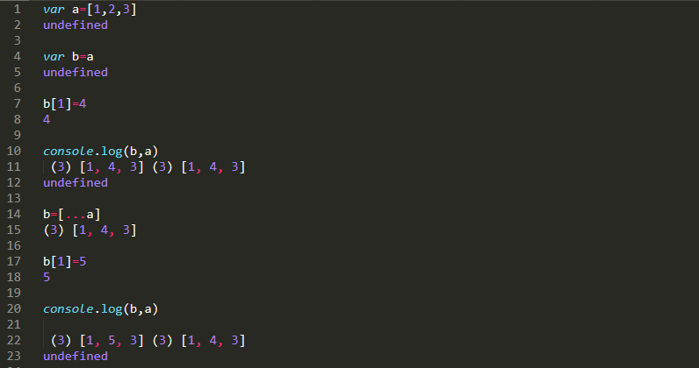

2. Using Object.assign()

The ***Object.assign()*** method copies all elements own properties from one or more *source objects* to a *target object*. Note the empty *[]* as the first argument, this will ensure you don’t mutate the original object.

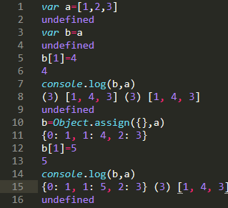

In the above example when the variable b is assigned to a, and the value of b is altered, the corresponding index value of a also altered. But when Object.assign() is used, a clone of b is made and values altered in this clone does not affect the values in a.

3. Using JSON.parse() and JSON.stringify()

The JSON object, available in all modern browsers, has two useful methods to deal with JSON-formatted content: parse and stringify.

JSON.stringify() takes a JavaScript object and transforms it into a JSON.

JSON.parse() takes a JSON string and transforms it into a JavaScript object.

so we can use it here, first convert the object to string using stringify() method and then convert it back to object using parse().

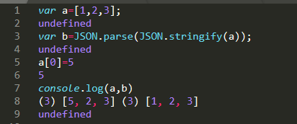

**4.Using slice()**

This method is normally used to return a subset of the elements, starting at a specific index and optionally ending at a specific index of the original array. When using array.slice()you will end up with a copy of the original array.

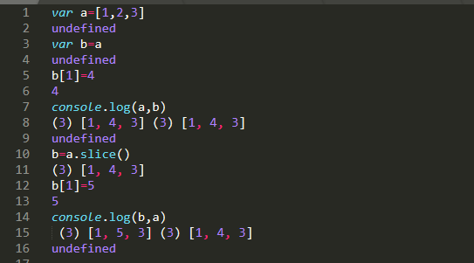

**5.Using Array.map()**

This methods will return a new array with all (or some) values of the original one. While doing that, you can also modify the values, which comes in very handy:

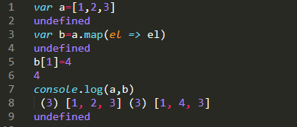

2.why there is a difference in behavior for copying contents in primitive and non primitive type?

When we assign a value to a variable, the JavaScript engine will determine whether the value is a primitive or reference value.

If the value is a primitive value, and when we access the variable, we manipulate the **actual value** stored in that variable. In other words, the variable that stores a primitive value is **accessed by value**.

Unlike a primitive value, when we manipulate an object, we work on the **reference** of that object, rather than the actual object. It means a variable that stores an object is **accessed by reference.**

**This is the Major difference when store data in primitive and nn primitive data type.**

**3.** **Use typeof in all the datatypes and check the result**

**typeof(1)//number**

**typeof(1.1)//number**

**typeof("1.1")//string**

**typeof(true)//boolean**

**typeof(null)//object**

**typeof(undefined)//undefined**

**typeof([])//object**

**typeof({})//object**

4. Write a blog about objects and its internal representation in Javascript?

Blog : https://aishwaryakalimuthu.medium.com/

6.What is the difference between window, screen, and document in Javascript?

Window:

Window is the main JavaScript object root, aka the global object in a browser, also can be treated as the root of the document object model.

window is the first thing that gets loaded into the browser. This window object has the majority of the properties like length, innerWidth, innerHeight, name, if it has been closed, its parents, and more.

* setTimeout() and setInterval() binding event handlers to a timer
* location giving the current URL
* history with methods back() and forward() giving the tab's mutable history
* navigator describing the browser software

Document:

The document object is your html, aspx, php, or other document that will be loaded into the browser. The document actually gets loaded inside the window object and has properties available to it like title, URL, cookie, etc. What does this really mean? That means if you want to access a property for the window it is window.property, if it is document it is window.document.property which is also available in short as document.property.

 E.g., in the HTML snippet

<body>

<p id="holyCow"> This is the first paragraph.</p>

</body>

the paragraph element can be referenced by any of the following:

* window.holyCow or window["holyCow"]
* document.getElementById("holyCow")
* document.querySelector("#holyCow")
* document.body.firstChild
* document.body.children[0]

Screen:

The window object also has a screen object with properties describing the physical display:

* screen properties width and height are the full screen
* screen properties availWidth and availHeight omit the toolbar

The portion of a screen displaying the rendered document is the **viewport** in JavaScript, which is potentially confusing because we call an application's portion of the screen a window when talking about interactions with the operating system. The getBoundingClientRect() method of any document element will return an object with top, left, bottom, and right properties describing the location of the element in the viewport.

7.Extract and print the flag url of all the countries in console. use the html template.

<https://restcountries.eu/rest/v2/all>

index.html

<!DOCTYPE html>

<html lang="en">

<head>

<title>GUVI App</title>

</head>

<body>

<script src="script.js"></script>

</body>

</html>

Script.js

var request = new XMLHttpRequest();

request.open('GET', 'https://restcountries.eu/rest/v2/all', true)

request.send();

request.onload = function () {

var data = JSON.parse(this.response);

console.log(data);

When you give inspect element in browser and under console tab you will find the all the countries extracted.