1.Generate an API key with given link below

* + [https://openweathermap.org/guide](https://meet.google.com/linkredirect?authuser=1&dest=https%3A%2F%2Fopenweathermap.org%2Fguide)
  + Print the current weather data in console- By city name, By city ID, By lat lang

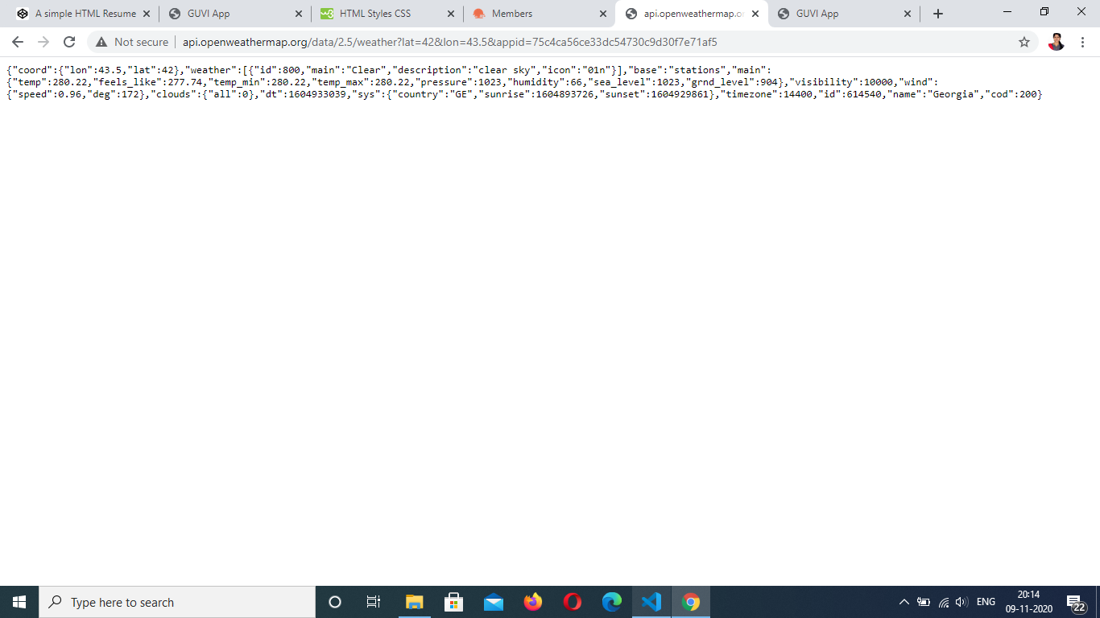

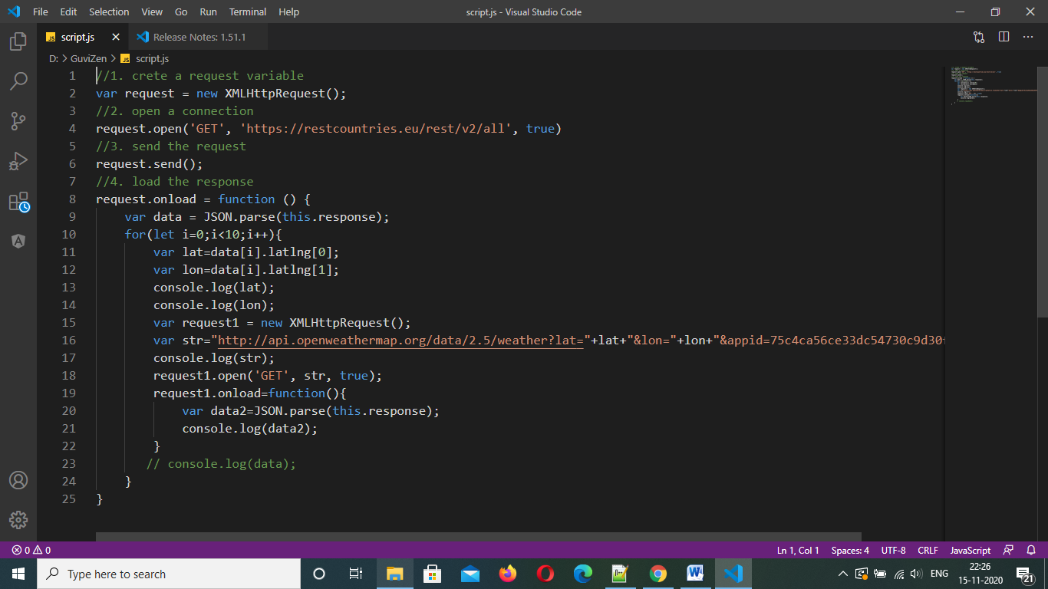

2.Use HTML tags to create your simple Resume

