TASK 5

1.Get all the countries from Asia continent using Filter function

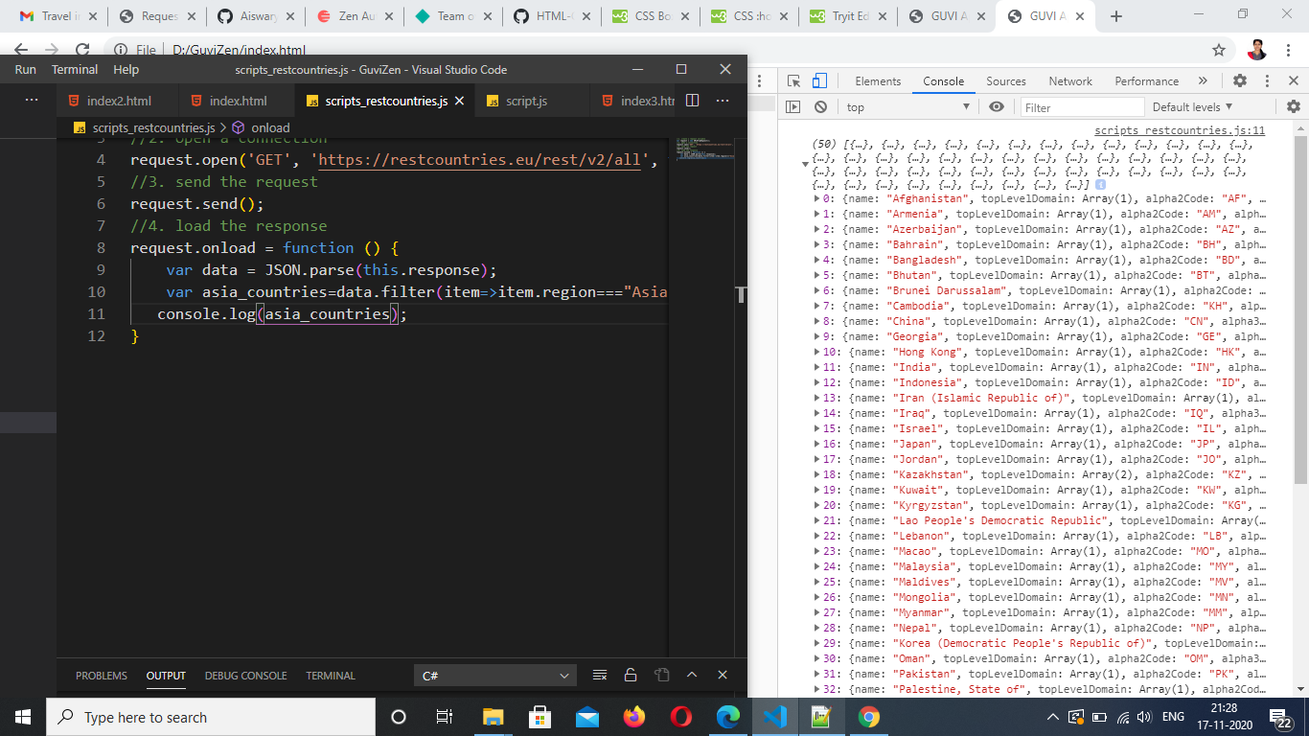

2.Get all the countries with population of less than 2 lacs using Filter function

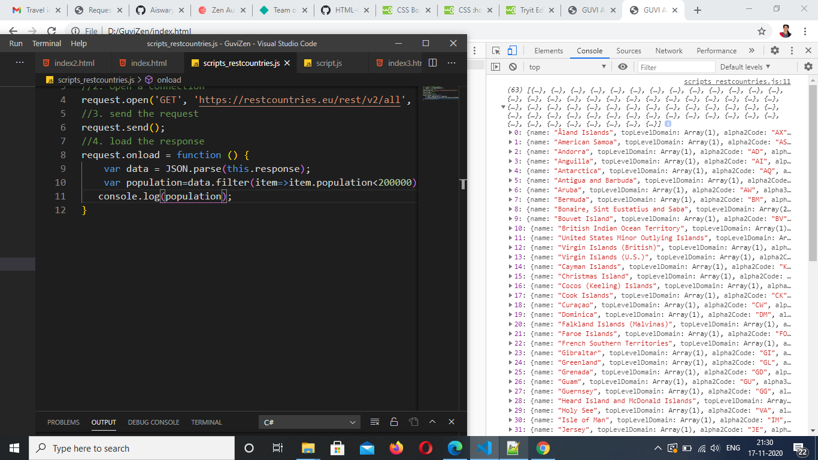

3.Print the following details name, capital, flag using forEach

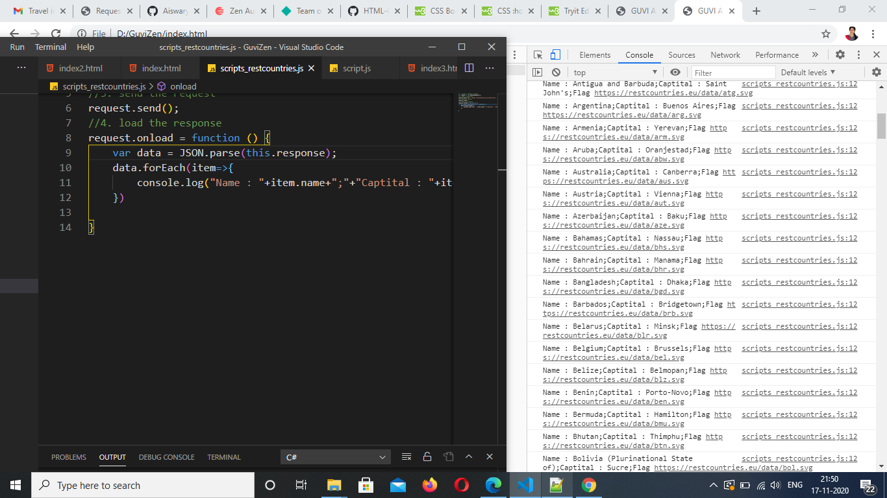

4.Print the total population of countries using reduce function

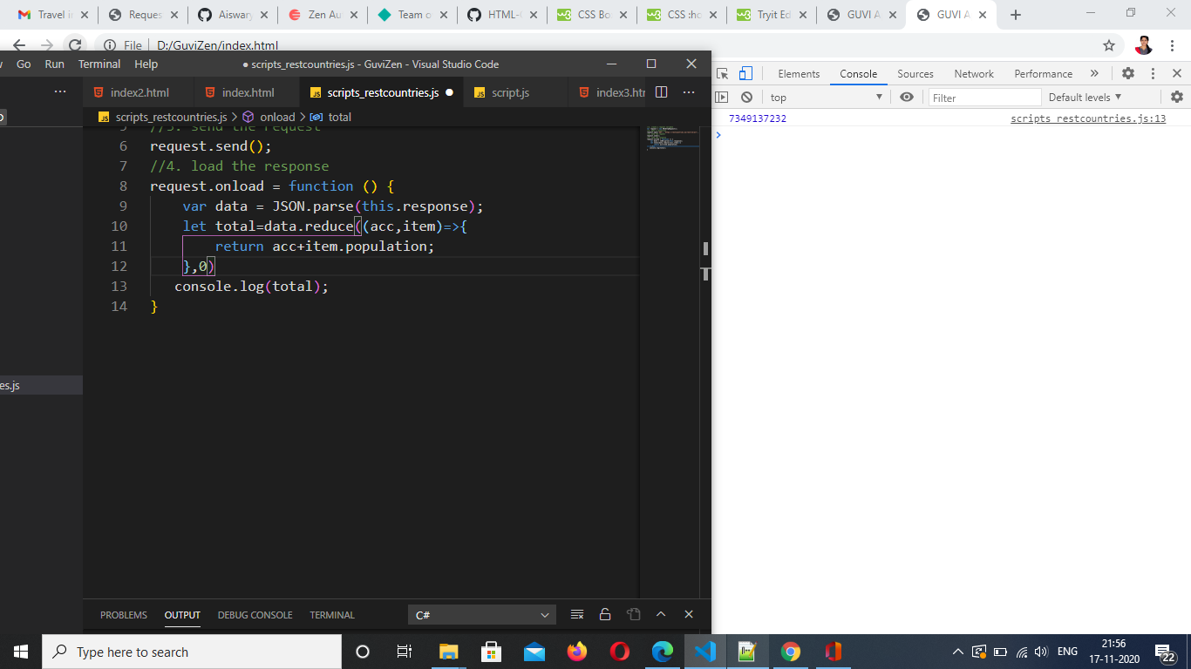

5.Print the total population of countries in Asia continent using reduce and

filter function

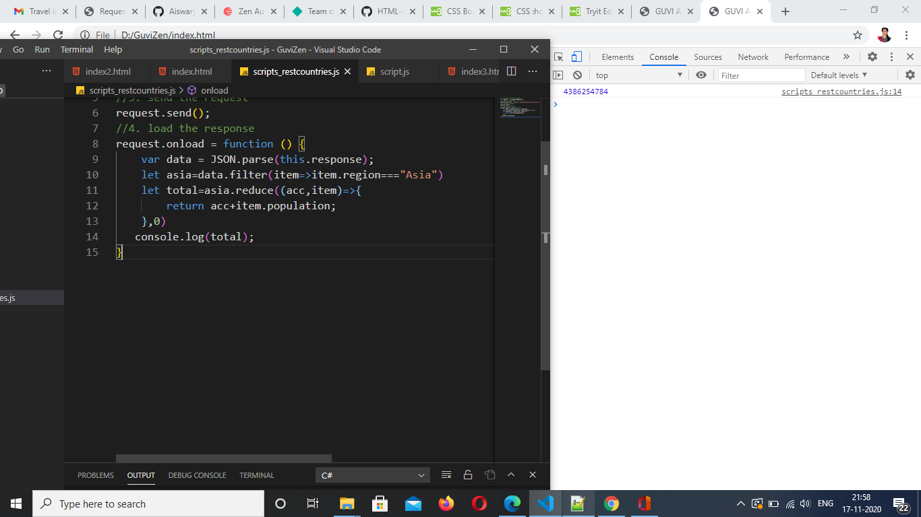

6.Print the country which use US Dollars as currency.

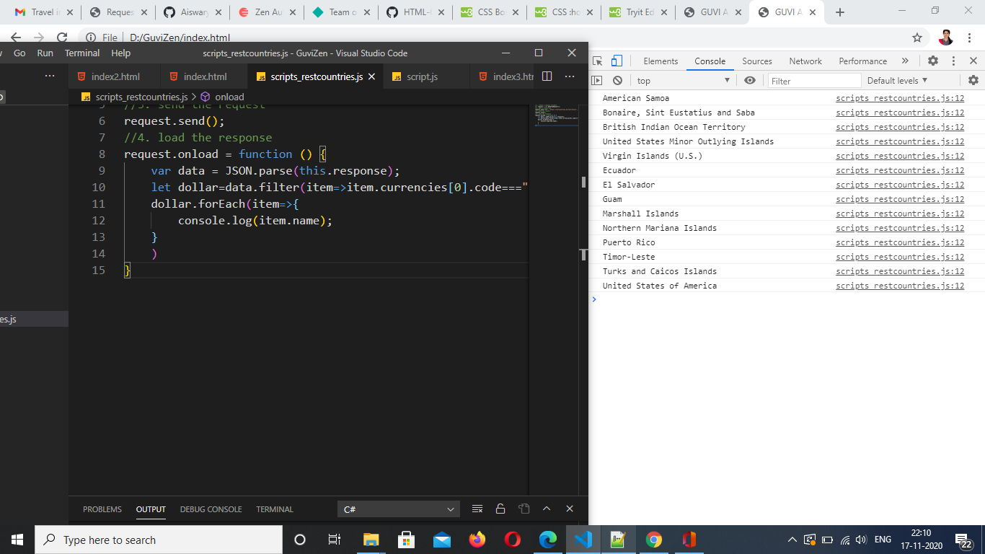

7.Add error handling to the xml http request code

