

**KGiSL INSTITUTE OF TECHNOLOGY**

(Approved By AICTE, New Delhi, Affiliate to Anna University

Recognized by UGC, Accredited by NBA(IT)

265, KGISL Campus, Thudiyalur Road, Saravanampatti, Coimbatore-641035**.)**

**DEPARTMENT OF**

**ARTIFICIAL INTELLIGENCE AND DATA SCIENCE**

**NAAN MUDHALVAN - INTERNET OF THINGS**

**NOISE POLLUTION MONITORING**

**NAME:** AISWARYA SGI

**REG NO:** 711721243006

**NM ID:** au711721243006

**TEAM MENTOR:** Mr**.** Mohankumar M

**TEAM EVALUATOR:** Ms. Akilandeeshwari M

**Phase 3: Development Part 1**

**Building a Noise pollution Monitoring system using IoT sensors and Raspberry Pi integration**

**Hardware and Software Components Needed:**

**Hardware :**

1. Raspberry Pi (with internet connectivity)

2. Sound Sensor (such as the KY-038 Microphone sound sensor)

3. Jump wires

4. Noise Sensor:Use a noise sensor (such as a sound level sensor) to measure the noise levels.

5. Microcontroller: ESP8266 or ESP32 boards can be used for this purpose, which can communicate with the internet using Wi-Fi.

6. Cloud Service: Use a cloud service like Thing Speak or Firebase to store and analyse the data.

7. Display Unit: You can use an LCD screen or LEDs to display real-time noise levels locally.

**Software :**

* Python installed on Raspberry Pi
* Requests library for making HTTP requests (install it using pip install requests)

**1. Microcontroller Code (Python on MicroPython):**

* Connect the noise sensor to the microcontroller.
* Read data from the sensor.
* Send data to the cloud service at regular intervals.

**2. Data Analysis and Visualization:**

* Retrieve data from the database.
* Analyse noise patterns over time.
* Visualize the data using libraries like Matplotlib or Plotly.

**3. Cloud Service (Python using Flask for API):**

* Create a REST API using Flask to receive data from the microcontroller.
* Store the received data in a database.
* Implement endpoints for data retrieval and analysis.

**Procedure:**

**Step 1: Define Project Requirements and Components**

* Define Project Scope: Determine the area you want to monitor for noise pollution and establish specific goals for the monitoring system.
* Select Components: Choose suitable noise sensors (such as sound level sensors or microphones), Raspberry Pi board, and necessary accessories (wires, resistors, breadboard, etc.).
* Choose IoT Platform: Select an IoT platform (e.g., ThingSpeak, AWS IoT, Google Cloud IoT) for storing and analyzing sensor data.

**Step 2: Set Up Raspberry Pi and Connect Sensors**

* Set Up Raspberry Pi: Install the latest Raspbian OS on your Raspberry Pi. Configure Wi-Fi and update packages using terminal commands: sudo apt-get update and sudo apt-get upgrade.
* Connect Noise Sensor: Connect the noise sensor to the Raspberry Pi's GPIO pins. Refer to the sensor's datasheet for wiring instructions.

**Step 3: Write Python Code for Data Collection**

* Install Necessary Libraries: Install Python libraries for GPIO control and sensor communication (e.g., RPi.GPIO, Adafruit_GPIO, Adafruit_ADS1x15).
* Write Python Code: Write Python code to read data from the noise sensor. Use appropriate libraries and communication protocols (e.g., I2C, SPI) based on your sensor's specifications.
* Test Sensor Reading: Verify that your Raspberry Pi can read data from the noise sensor accurately. Print sensor values to the console for testing.

**Step 4: Set Up IoT Platform**

* Create Account: Sign up for an account on the chosen IoT platform (e.g., ThingSpeak).
* Create Channels: Create channels to store noise level data. Define fields for storing sensor values and metadata.
* Generate API Key: Obtain an API key from the IoT platform to authenticate your Raspberry Pi for data transmission**.**

**Step 5: Write Python Code for Data Transmission**

* Install Requests Library: Install the requests library for making HTTP requests: pip install requests.
* Write Transmission Code: Write Python code to send sensor data to the IoT platform using HTTP requests. Include the API key and appropriate endpoint URLs in your code.
* Implement Error Handling: Implement error handling in your code to handle network issues and server errors gracefully**.**

**Step 6: Schedule Data Transmission (Optional)**

* Use Cron Jobs: Set up a cron job on your Raspberry Pi to run the Python script at regular intervals (e.g., every 5 minutes).
* Ensure Stability: Test the scheduled data transmission to ensure the system works reliably over extended periods.

**Step 7: Data Visualization and Analysis**

* Retrieve Data: Implement code to retrieve data from the IoT platform's API for visualization and analysis.
* Visualize Data: Use libraries like Matplotlib or Plotly to create graphs and charts visualizing noise levels over time.
* Implement Analysis: Implement basic analysis algorithms to identify noise patterns, peaks, and trends.

**Step 8: Documentation and Reporting**

* Document Your Project: Create detailed documentation covering hardware connections, software components, code explanations, and system architecture.
* Write Project Report: Prepare a comprehensive project report detailing the objectives, methodology, implementation, challenges faced, and results obtained. Include visualizations and analysis findings in your report.

**Step 9: Testing and Calibration**

* Test System: Conduct thorough testing of the entire system to ensure sensor accuracy, data transmission reliability, and notification functionality (if implemented).
* Calibration: If required, calibrate the sensors to ensure accurate measurement based on real-world noise levels.

**Step 10: Deployment**

* Deploy the System: Install the noise pollution monitoring system in the target location.
* Monitor and Maintain: Regularly monitor the system's performance and address any issues promptly. Maintain the system to ensure continuous and accurate operation**.**

**SOURCE CODE:**

import time  
import requests  
from gpiozero import InputDevice  
from flask import Flask, request, jsonify  
  
# Define the GPIO pin connected to the noise sensor  
noise_sensor = InputDevice(17)  # Replace 17 with the actual GPIO pin  
  
# Define the endpoint of your noise pollution information platform  
platform_url =  "<https://noisepollution.com/api/noise-data>"   
  
app = Flask(__name)  
  
@app.route('/update', methods=['POST'])  
def update_noise_level():  
    try:  
        noise_level = request.json.get('noise_level')  
        if noise_level is not None:  
            # Simulate sending data to the platform  
            print(f"Received noise level: {noise_level}")  
            return jsonify({"message": "Data received successfully"})  
        else:  
            return jsonify({"error": "Invalid data format"}), 400  
    except Exception as e:  
        return jsonify({"error": str(e)}), 500  
  
def send_noise_data():  
    while True:  
        try:  
            noise_level = noise_sensor.value  
  
            # Create a JSON payload with the noise data  
            data = {"noise_level": noise_level}  
  
            # Send the data to the platform  
            response = [requests.post](http://requests.post/)(platform_url, json=data)  
  
            if response.status_code == 200:  
                print("Data sent successfully")  
            else:  
                print(f"Failed to send data. Status code: {response.status_code}")  
  
            # Adjust the frequency of data transmission as needed  
            time.sleep(60)  # Send data every 60 seconds  
        except Exception as e:  
            print(f"An error occurred: {str(e)}")  
  
if __name__ == '__main__':  
    send_noise_data()  
    app.run(host='0.0.0.0', port=8080)

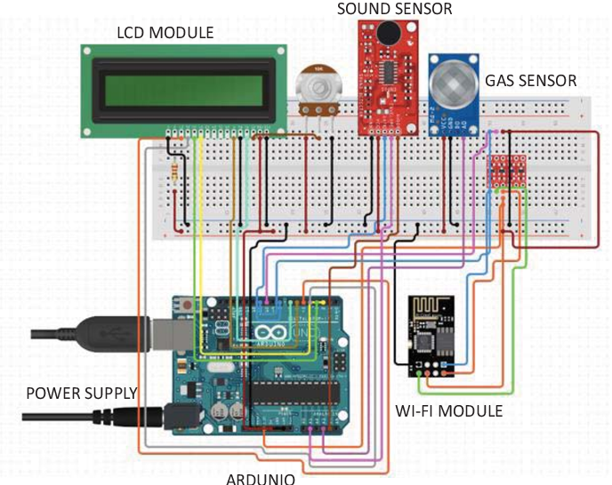

**CONCLUSION:**

In conclusion, building a Noise Pollution Monitoring using IoT sensors and Raspberry Pi integration is a valuable. Project that offers solutions to Noise Pollution challenges. By following the step-by-step procedure outlined above, we can create a reliable and efficient Noise Monitoring system.